Economic Implications of BREXIT for Pakistan
Muhammad Aamir Khan, Muhammad Iftikhar ul Husnain
ABSTRACT
Pakistan’s trading relationship with the United Kingdom (UK) is governed through the European Union’s (EU) Single Market regulations & tariffs. Pakistan has granted a Generalized Scheme of Preferences (GSP) plus status by the EU, which allows Pakistan commodities duty-free access to the European market. Britain’s decision to leave the EU popularly quoted as “Brexit” can have implications for Pakistan. Pakistan will no more enjoy duty-free access to the UK market. With this backdrop, this research used a new global economic trade model calibrated using the latest GTAP Database and latest Social Accounting Matrix (SAM) 2013 of Pakistan to quantify the impact of Brexit on Pakistan's Economy. Results show that with Brexit, Pakistan's Exports to the UK will decrease by 48 percent. This research recommends the Pakistani government to revisit its trade relations with the UK and should launch negotiations with the UK for attaining unilateral preferential access like EU GSP Plus.
Keyword : BREXIT , Preferential Arrangement, GSP Plus, Pakistan.

1- Introduction

Trade liberalization widens trade and, on average, have direct and substantial positive impacts on economic growth (Busse and Koniger, 2012). These effects usually come from an increase in productivity growth while some effects coming through the investment channel. However, benefits from trade depend upon the level of development, trade specialization, and time (Golley, 2004). Pakistan is a developing country and currently facing huge current account deficits. Its exports are stagnant over a couple of years while imports showing a continuous upward trend (Khan et. al 2018). The policy focus has been shifted towards the increase in export to overcome the burgeoning export-import gap. Pakistan like many developing economies, has, therefore, joined various regional and bilateral trade agreements in the hope of raising their trade performance to achieve economic growth.
Pakistan and the United Kingdom have shared traditional strong economic cooperation since the creation of Pakistan (Samir, 2017). The UK accounted for 22% of the total EU exports from Pakistan in 2017 (Figure 1). Pakistan’s current trade with the UK is governed by EU GSP plus status which allows Pakistan to export its commodities at preferential rates. United Kingdom is the largest export market for Pakistan in the EU and Brexit could make Pakistan lose its GSP plus rates for exports reaching the United Kingdom which can have serious implications for already dwindling exports and trade deficit.

Figure 1: Pakistan Exports to the European Union (Percentage Share) in 2018
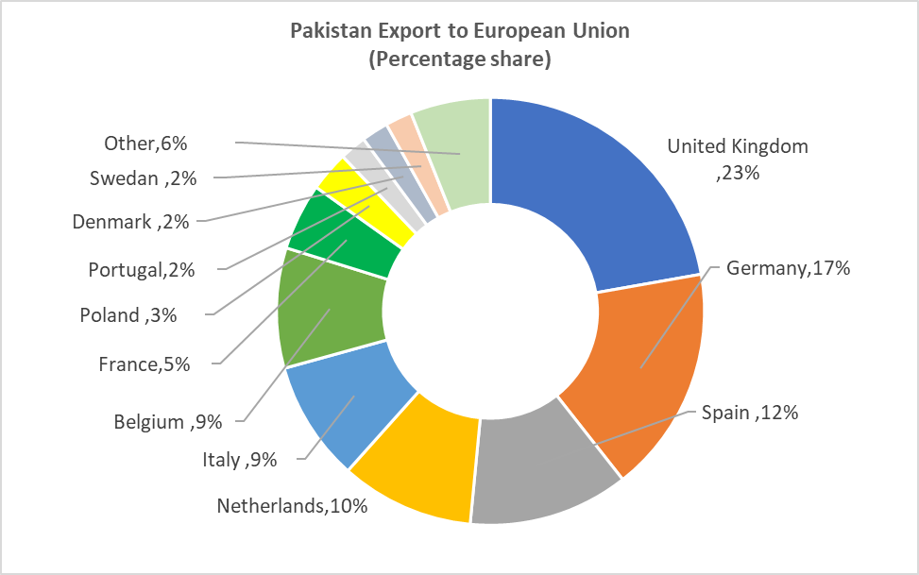
Source: Based on data extracted from WITS
Many studies have identified the economic impact of the UK-exit from the European Union. For Instance, studies of Noor et al. (2016) consider the impact on Bangladesh, Dhingra et.al (2016) and Minford (2019) on the United Kingdom, Wilson (2017) considers the impact on emerging Economies, Anderson and Strutt (2015) examines the impact on Asia, Africa, and Latin America, Morales et. al (2018) on China, Hosoe (2018) on European Union, Yu et.al (2017) on Denmark, Roy and Mathur (2016) for India and Kawasaki (2018) for Japan. It is pertinent to mention that Brexit will have a more negative impact on the trade relation of the UK with countries with which the EU has preferential trade arrangements like Pakistan. There are 3 major types of Preferential arrangements as awarded by the EU; Everything but Arm, Generalized Scheme of Preferences (GSP) plus and Standard GSP. Pakistan was granted a Generalized Scheme of Preferences (GSP) plus status by the EU in December 2013 (Iqbal et.al 2016). Brexit has economic implications for export-driven economies like Pakistan.

Table 1 below illustrates Pakistan’s Top export Items to the UK and tariffs applied by the UK under GSP Plus and the preferential or Most Favoured Nation (MFN) tariff. The UK share in Total Exports of Pakistan is 7.6 Percent. Pakistan is a typical developing country with no such export diversification. The top 3 products made up around 80 percent of Pakistan’s exports to the UK (Table 1). These items included products from the textile industry such as made-up textile articles, articles of clothing, accessories, and articles of not knitted clothing. Without GSP + scheme, the MFN tariﬀs, if applied, would be considerably higher. It will be tough for Pakistan to compete with competitors like China, Bangladesh, Vietnam, and India with this much high tariff on Textile products.

Table 1: Pakistan Top Export Items to UK and Tariff Applied by UK (Million US Dollars)
HS 2 Digit Code | Product Label | Pakistan Exports to UK | Share in Total Exports to UK | Share in Total Exports of the World | Tariff Applied by UK (GSP +) | Tarif Applied by UK (MFN %)
 | All Products | 1558 | 100 % | 7.6 %
 | Top 5 Products | 1333 | 85.6 % | 9 %
63 | Other Made-up Textile articles, worn, clothing… | 575 | 37 % | 2.8 % | 0 % | 10.10
61 | Articles of Apparel and clothing accessories knitted | 357 | 23% | 9.4 % | 0 % | 11.7
62 | Articles of Apparel and clothing accessories …. | 286 | 18.4 % | 12.2 % | 0 % | 11.30
52 | Cotton | 68 | 4.4 % | 3 % | 0 % | 6.10
42 | Articles of leather, Saddlery and harness, travel goods, bags… | 47 | 3 % | 1.33 % | 0 % | 4.6
Source: Author calculation based on ITC and Samir (2017)

With this backdrop, this research adopted a new global economic trade model using the latest Social Accounting Matrix of Pakistan to quantify the impact of Brexit on Pakistan's economy. First, this research quantifies the economic implications of BREXIT by implementing MFN tariffs for Pakistani exports destined for the UK and duty-free exports to (EU-UK). Secondly, this research also studies the impact of a potential Free Trade Agreement (FTA) between the UK & Pakistan in the post-Brexit era.

2- Data & Methodology

Economists used models based on real data sets to compute the impact of various economic policies and implications. There are 3 major model types researchers used widely for data analysis. These include Computable General Equilibrium, Input-Output (IO), and econometric models (Shoven and Whalley (1984). All these have the same purpose which is to compute the impacts of various policies. Keeping in view how econometric models are different from CGE or I-O models; econometric models do not rely on neoclassical microeconomic theories. They are tailored to observe the impact on a specific sector or industry. These models are stochastic by nature and longer time series reduces the capacity to identify inter-sectoral linkages. Thus, to study the economic implications of BREXIT for Pakistan, general equilibrium is a tailor-made tool for analysis.

This research used the latest GTAP Database 10a with the base year 2014 and Pakistan Social Accounting Matrix (SAM) 2013. The MyGTAP model, developed by Walmsley and Minor (2013), is an extended version of the GTAP model (Hertel and Tsigas 1997) which facilitates the inclusion of multiple household types, additional factors of production, inflow, and outflow of remittances and foreign Aid. The GTAP database (Aguiar, Narayanan, and McDougall, 2019), upon which the model is based, contains input-output tables for 141 countries/regions and 65 sectors, linked through bilateral trade data. To facilitate computation, the sectors are aggregated to 11(Appendix II) and regions by 30 (Appendix I). Each country in the GTAP model has a regional household that collects all income (from factors of production and taxes). This research removes the regional household and incorporates multiple Households from Pakistan SAM. The relevant shares from the Pakistani SAM are then used to disaggregate factor use, and the income and consumption of each household using the facility developed by (Minor and Walmsley, 2013). These modifications are made in such a way that the total returns to factors and consumption are consistent with the original GTAP Database. The process is undertaken in many steps (depicted in Figure 2). First, remittances and the incomes earned by the 12 factors of production provide the sources of income to the 16 households, based on each household’s ownership of those factors. Secondly, the government, which is separated in the MyGTAP model, collects income from taxes and foreign aid which it uses to consume (with the difference being the government surplus/deficit). Thirdly, transfers between the government and the 16 households, as well as between the 16 households can be incorporated; and finally the private consumption and savings by each of the 16 households are included.

Figure 2: Modifications made to the GTAP Data and Model
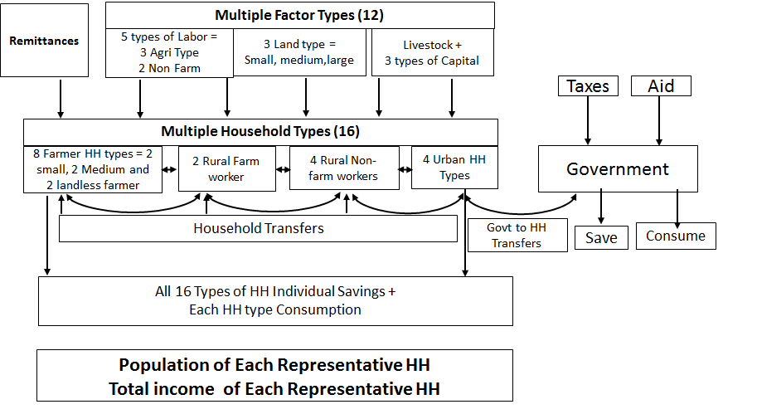
Source: Author own design based on MYGTAP approach

Research Simulation / Experiment
This research investigates the economic implications of Brexit for Pakistan. Two realistic simulations are designed as illustrated in Table 2.

 | CODE | Simulation Detail
SIM-I | BREXIT | MFN/ Preferential tariff of 9.6 percent applied by the UK on Pakistani goods.
SIM-II | Pak-UK FTA | Bilateral Removal of Tariffs on all tradable commodities

3- Results and Discussion
3.1 Impact of Brexit on Pakistan’s real GDP, Welfare and Total Exports
Table 3 illustrates the impact of Brexit and Potential Pak-UK FTA on the standard macroeconomic measures used in CGE models, namely real GDP, welfare, or equivalent variation (EV) and Total exports. As expected, with no more duty-free access to the UK market, and with Preferential or MFN tariffs on Pakistani goods/commodities, there will be a negative impact on Pakistan's economy. In Monetary terms, Real GDP decreases by 36 Million US Dollars, Welfare, or Equivalent Variation (EV) by 210 Million US dollars. The major sectors that will be affected are textiles and wearing apparel. Welfare measure is a combination of ‘allocative efficiency’, ‘terms of trade’ and ‘change in capital stock’. Allocative efficiency’ implies optimal domestic production. In other words, when the marginal costs of production are equal to the marginal utility of that output, this is called allocative efficiency. Improvements in the terms of trade (TOT) also leads to an increase in overall welfare as it leads to avail higher prices of exports as compared to what is paid for imports. The increase in tariffs further effects many factors at the domestic level which lead to a change in GDP e.g. increase (decrease) in prices, changes in factor wages, labor market changes, and supply & demand patterns, terms of trade, the scale of production, economies of scale. The provision of zero tariffs increases the production of export commodities in Pakistan as producers gain a cost advantage in the form of zero tariffs.
Results of Potential Pakistan-UK Free Trade Agreement show that FTA creates a positive impact on the GDP of Pakistan and compensates for some of the losses created due to Brexit. The net effect created by FTA on the GDP of Pakistan is US$ 30 million. It is to be noted that FTA creates no significant impact on the UK as Pakistan is not a major exporting partner to the UK. UK export portfolio to Pakistan is composed of manufactured goods of which Pakistan is a big importer from China and Japan. Pakistan has signed FTA with China which allows Pakistan to fulfill its demand from Chinese imports which face minimum tariffs and must bear the least transportation costs as compared to the UK.
Table 3: Impact on Pakistan’s real GDP and Welfare

 | Real GDP  (US$ Millions) | Welfare  (US$ Millions)
BREXIT | -36 | -210
Pak-UK FTA | 30 | -72
Source: Author calculations

3.2 Impact on Sectoral Exports
The GSP Plus status allows Pakistan commodities duty-free access to the European market with more than 500 million consumers. UK is the top export destination for Pakistan in the EU and the second-largest import source for Pakistan in the EU after Germany. The increase in tariffs for exports of Pakistan eliminates the cost advantage that Pakistani producers gain due to GSP plus status. Though due to BREXIT, Pakistan will lose worth 890 Million US dollars exports in the UK market, this will allow Pakistan exporters to look for other markets for their export. For instance, Pakistan exports to the European Union will increase by 167, United States of America (USA) by 127, and China by 80 Million US Dollars. Table 2 illustrates the impact of both simulations on Pakistan’s sectoral exports to the UK. As discussed earlier, Pakistan Top export items are Textile, wearing apparel, Light Manufacturing (include Leather, Chemical, rubber, and plastic). Due to Brexit, Pakistan Exports of Textile and Apparels will decrease by 720 Million US$, Light Manufacturing by 78 Million US$, and Grain crops by 23 Million US$ (Table 4).
Table 4: Impact on Pakistan’s Sectoral Exports to the United Kingdom

 | Pak Exports to UK | BREXIT  (Sim-I) | Difference | Pak-UK FTA  (Sim-II) | Difference
 | (Million US Dollars)
Grain Crops | 121.79 | 98.95 | - 22.84 | 169.73 | 48
Veg-Fruit | 20.81 | 14.38 | - 6.43 | 20.84 | 0.03
Proc-Food | 21.93 | 15.82 | - 6.11 | 24.62 | 2.69
Tex-Wapp | 1388.76 | 668.48 | - 720.28 | 1392.08 | 3.32
Light Mnfc | 159.51 | 81.12 | - 78.39 | 161.79 | 2.28
Heavy Mnfc | 33.14 | 15.15 | - 17.99 | 33.47 | 0.33
Trans Comm | 111 | 75.73 | - 35.27 | 111.87 | 0.87
Total | 1856.94 | 969.63 | -887.31 | 1914.4 | 57.46
Source: Author calculations
Table 4 also illustrates the sectoral impact of the potential Pakistan UK Free Trade Agreement. FTA results show a significant increase in export volumes of Pakistan which compensates for the loss created due to BREXIT. FTA allows Pakistani exporters to regain their cost advantage to the UK and exports are almost restored to their previous GSP plus status level.

Conclusion

Pakistan has benefitted from EU GSP Plus status as it has allowed Pakistan to increase its volume of exports to the European Union. Britain’s decision to leave EU popularly quoted as “Brexit” has implications for trade between the two countries as Pakistan’s trade with the UK will no longer be governed by EU Single Market regulations & tariffs and unilateral preferential access under GSP Plus status will no longer apply to exports of Pakistan entering UK. MFN or Preferential tariffs will impact Pakistan’s exports to the UK. We find that with Brexit, Pakistani commodities face higher tariffs that result in deterioration in the volume of exports, overall welfare and Real GDP of Pakistan. The main sectors that will be affected are Textile, wearing apparels, agricultural commodities and light manufacturing. The study also proposed FTA between Pakistan & UK and the result show an improvement for various factors of the economy of Pakistan but lost potential due to UK exit from the EU is not fully restored. UK was the biggest supporter of granting GSP Plus status to Pakistan. Now, it is of great need that Pakistan should find a supporter like UK in EU to maintain GSP plus status. It affects Pakistan’s economy through several pathways, like foreign direct investment, remittances, trade etc. The macroeconomic variables and sectorial exports of Pakistan faces decline which will lead to a fall in economic growth.
This research recommends Pakistan to revisit its trade relations with UK. Pakistan should launch negotiations with UK for attaining unilateral preferential access like EU GSP Plus after Brexit as unilateral tariff reduction would be more beneficial to Pakistan. If not granted unilateral access by UK, then Pakistan should negotiate for bilateral tariff reduction with UK in the form of either FTA or Preferential Tarde Agreement PTA to maintain its exports to UK.

Authors’ contributions
All authors have equally contributed to designing of the research, the process of data collection and calculation as well as drafting and revision of the manuscript. All authors read and approved the final manuscript.
Acknowledgments
None.
Competing interests
The authors declare that they have no competing interests.
Consent for publication
Not applicable.
Availability of data and materials
The dataset supporting the conclusions of this article is available in and bought from the GTAP database version 10a and Social Accounting Matrix of Pakistan 2013.
Declaration
Ethics approval and consent to participate
Not applicable.
Funding
Not applicable.
Appendix:
Appendix I: Regional Aggregation used in this study
Region | Description
Pakistan | Pakistan
China | China
India | India
USA | USA
Bangladesh | Bangladesh
United Kingdom | United Kingdom
Indonesia | Indonesia
Malaysia | Malaysia
Singapore | Singapore
Thailand | Thailand
Turkey | Turkey
Australia | Australia
New Zealand | New Zealand
Japan | Japan
Korea | Korea
Chile | Chile
Canada | Canada
Peru | Peru
Iran | Iran
Brunei | Brunei
Saudi Arabia | Saudi Arabia
UAE | United Arab Emirates
Vietnam | Vietnam
Mexico | Mexico
Egypt | Egypt
Rest of S. Asia | Rest of S. Asia
Other OECD | Australia, New Zealand, Japan, Korea, Canada, Mexico, Chile
Europe 27 | Austria, Belgium, Cyprus, Czech Rep, Denmark, Estonia, Finland, France, Germany, Greece, Hungary, Ireland, Italy, Latvia, Lithuania, Luxembourg, Malta, Netherlands, Poland, Portugal, Slovakia, Slovenia, Spain, Sweden, Norway, Rest of EFTA, Turkey, Albania, Bulgaria, Belarus, Croatia, Romania, Ukraine, Rest of E. Europe, Rest of Europe
Rest of Asia | Hong Kong, Taiwan, Rest of East Asia, Cambodia, Lao People's Democratic Republic, Philippines, Rest of Southeast Asia
Rest of World | Morocco, Tunisia, Bahrain, Argentina, Colombia, Ecuador, Paraguay, Uruguay, Venezuela, Rest of S. America, Cost Rica, Guatemala, Nicaragua, Panama, Rest of Central America, Caribbean, Israel, Kuwait, Oman, Qatar, Rest of N. Africa, Cameroon, Cote d'Ivore, Ghana, Nigeria, Senegal, Rest of W. Africa, Central Africa, South Central Africa, Ethiopia, Kenya, Madagascar, Malawi, Mauritius, Mozambique, Tanzania, Uganda, Zambia, Zimbabwe, Rest of E. Africa, Botswana, Namibia, South Africa, Rest of Southern Africa Customs Union, Rest of N. America, Rest of World,
Source: Author’s own aggregation using GTAP 10a Data Base
Appendix II : Sectoral Aggregation used in this study
Short name | Comprising GTAP sectorsª
Grain Crops | PDR, WHT, GRO, OSD, C_B, PFB, OCR, PCR
Vegetables & Fruit | V_F
Meat & Livestock | CTL, OAP, RMK, WOL, CMT, OMT
Extraction | FRS, FSH, COA, OIL, GAS, OXT
Processed Food | VOL, MIL, SGR, OFD, B_T
Textiles & Wearing Apparel | TEX, WAP
Light Manufacturing | LEA, LUM, PPP, FMP, MVH, OTN, OMF
Heavy Manufacturing | P_C, CRP, NMM, I_S, NFM, ELE, OME EEQ
Utilities & Construction | ELY, GDT, WTR, CNS
Transport & Communication | TRD, OTP, WTP, ATP, CMN
Other Services | OFI, ISR, OBS, ROS, OSG, DWE EDU HHT
a. See https://www.gtap.agecon.purdue.edu/databases/v10/v10_sectors.asp for a more detailed description of GTAP sector codes.
Source: Author’s own aggregation using GTAP 10a Data Base

References

Anderson, K. and A. Strutt (2014), ‘Emerging Economies, Productivity Growth and Trade with Resource‐Rich Economies by 2030’, the Australian Journal of Agricultural and Resource Economics, 58, 4, 590–606.
Busse, M., & Königer, J. (2012). Trade and economic growth: A re-examination of the empirical evidence. Available at SSRN 2009939.
Dhingra, S., Ottaviano, G. I., Sampson, T., & Reenen, J. V. (2016). Less trade and lower living standards in the UK: the price of Brexit. LSE Business Review.
Golley, S. D. (2004). Trade openness and Growth: Who Benefits? Oxford Review of Economic Policy, VOL.20., 19.
Hertel, T. W., & Tsigas, M. E. (1997). Structure of GTAP. Global Trade Analysis: modeling and applications, 13-73.

Hosoe, N. (2018). Impact of border barriers, returning migrants, and trade diversion in Brexit: Firm exit and loss of variety. Economic Modelling, 69, 193-204.

IFPRI, International Food Policy Research Institute (IFPRI).(2019). Pakistan Social Accounting Matrix, 2013. Islamabad, Pakistan: IFPRI’s Pakistan Strategy Support Program. (Access from pssp@idspak.com) .

Iqbal, M. S., Anwar, S., Mukhopadhay, K., & Khan, M. A. (2017). GSP Plus Status and Income Distribution: A CGE Model for Pakistan. Journal of Management Sciences, 4(1), 27-53.
Jackson, J. K., Akhtar, S. I., & Mix, D. E. (2016). Economic implications of a United Kingdom exit from the European Union (pp. 1-18). Congressional Research Service.
Khan, M. A., Mehmood, Q., Zakaria, M., & Husnain, M. I. U. (2018). A Household Level Analysis of the Pakistan–Malaysia Free Trade Agreement. Journal of Asian and African Studies, 53(7), 1062-1085.
Minford, P. (2019). The effects of Brexit on the UK economy. The World Economy, 42(1), 57-67.
Morales, L., & Andreosso-O’Callaghan, B. (2018). The impact of Brexit on the stock markets of the greater China region. International Journal of financial Studies, 6(2), 51.
Noor, T., Islam, S., Alam Nirob, K. J., & Hossain, M. (2016). Brexit and the Impact on Bangladesh. Imperial Journal of Interdisciplinary Research, 2(12), 68-76.
Roy, A., & Mathur, S. K. (2016). Brexit and India–EU free trade agreement. Journal of Economic Integration, 740-773.
Samir, S.A. (2017). Post-Brexit Feasibility of a Pakistan-UK Free Trade Agreement. Karachi: The Pakistan Business Council.
Walmsley, T., & Minor, P. (2013). MyGTAP Model: A Model for Employing Data from the MyGTAP Data Application—Multiple Households, Split Factors, Remittances, Foreign Aid and Transfers (No. 1237-2019-238).

Wilson, G. K. (2017). Brexit, Trump and the special relationship. The British Journal of Politics and International Relations, 19(3), 543-557.
Yu, W., Elleby, C., Lind, K. M. H., & Thomsen, M. N. (2017). Modeling the potential impacts of two BREXIT scenarios on the Danish agricultural sectors. Department of Food and Resource Economics, University of Copenhagen.

Assistant Professor, Department of Economics, COMSATS University Islamabad, Pakistan. Corresponding author email : m.aamir.khan@comsats.edu.pk
Assistant Professor, Department of Economics, COMSATS University Islamabad, Pakistan.
The special arrangement for least developed countries, providing them with duty-free, quota-free access for all products except arms and ammunition (https://ec.europa.eu).
It slashes these same tariffs to 0% for vulnerable low and lower-middle income countries that implement 27 international conventions related to human rights, labour rights, protection of the environment and good governance (https://ec.europa.eu).
This is for low and lower-middle income countries. This means a partial or full removal of customs duties on two third of tariff lines.
The model is solved using the software GEMPACK (Harrison and Pearson 1996).
Baseline or Business as Usual in 2014 (Base year of the model)

