The long-term effects of regional trading hubs and reshoring on environmental pressure in light of Covid-19

Rob Dellink, OECD Environment Directorate

N.B. All results in this draft are preliminary and will be updated. DO NOT CITE OR QUOTE.

Abstract
Recent events, including the Covid-19 pandemic and increased interest in more circular economies, imply an increased pressure to reduce global value chains. In this paper, a global dynamic CGE model is used to assess the consequences of reduced global trade and reshoring, in combination with a detailed assessment of the implications of the Covid-19 pandemic and recovery. The consequences of the Covid response measures and of regional trading shifts on sectoral and regional economic activity are linked to the consequences on regional and global emissions of greenhouse gases, air pollutants, the use of raw materials and plastics consumption and waste until 2035.
The scenario analysis clearly shows a short-term reduction in all environmental pressures considered in this paper as a result of the Covid-19 pandemic. But while the strength of this reduction fades over time, there are persistent effects on environmental pressure, primarily driven by changes in savings and investment behaviour, which has long-run consequences for economic activity and environmental pressure.
The results also indicate that the “localization” of international trade has negative consequences for economic activity in all countries that gradually increase over time. This especially hurts export-oriented sectors. Nonetheless, some domestic sectors are better off from being better shielded from international competitors.
The implications for environmental pressure are ambiguous: the reduced economic activity ceteris paribus leads to lower levels of emissions and resource use and waste, but there are significant differences across regions. Most of the improvements come in the export-intensive emerging economies, but at a cost of economic development in these regions.

Keywords: globalization, Covid-19, computable general equilibrium, economic growth, environmental pressure
JEL codes: D58, F15, F64, O41, Q53, Q54

Introduction
Recent events, including the Covid-19 pandemic and increased interest in more circular economies, imply an increased pressure to shorten value chains and make them less global. In fact, since the financial crisis of 2007-2008, global value chains – which had seen massive growth in the decades before – have already started to slowly become shorter, at least partially driven by considerations of the resilience of trade patterns against sudden shocks and by a resistance against globalization. The Covid-19 pandemic has added an urgent driver to this trend.
In this paper, the ENV-Linkages model is used to numerically investigate what the consequences would be of a re-alignment of trade patterns towards a stronger preference within specific trading blocks, at the expense of global trade, as well as a stronger preference for domestic suppliers (reshoring). This paper also contributes to the emerging literature on the effects of the Covid-19 pandemic and recovery on environmental pressure by using a state-of-the art large-scale modelling tool to identify sectoral and regional shocks to the economy from the pandemic and the associated lockdown and stimulus packages.
The first part of the analysis focuses on the consequences of the Covid pandemic and recovery measures on economic activity and environmental pressures. Then, the paper looks at a more permanent re-alignment of trade patterns and at hypothetical scenarios regarding the emergence of regional “trading hubs”. Finally, a scenario reflecting increased preference for producers and consumers to “buy local” is investigated. In all scenarios, detailed projections of the effects on economic activity are linked to the consequences on regional and global emissions of greenhouse gases, emissions of air pollutants, the use of raw materials and land use change.
How international trade will be affected by the Covid-19 pandemic, recovery packages, changes in emphasis on economic resilience and changes in preferences for regional origin of commodities, remains highly uncertain. Therefore, the reshoring and trading hubs scenarios are highly stylised, reflecting potential directions that could emerge, rather than predicting the future. The idea of these scenarios is not to identify specific trade relations that are better or worse from an environmental perspective, but rather to show mechanisms through which changes in trade preferences affect regional and global environmental pressures directly and (especially) indirectly, in light of the changed circumstances due to the Covid-19 pandemic.

Methodology

Modelling economic activity
The OECD ENV-Linkages model is a computable general equilibrium (CGE) model based on the GTAP national accounting database (Chateau, Dellink and Lanzi, 2014_{[1]}). It describes economic activities in different sectors and regions and how they interact. It is also a global economic model featuring all the main regions and countries of the world. The model relies on a consistent set of data describing the behaviour of production sectors and consumers in the different regions, with a focus on energy and international trade.
One of the main strengths of the model is to link economic activity to environmental pressures, such as greenhouse gas (GHG) emissions (OECD, 2015_{[2]}), air pollutant emissions (OECD, 2016_{[3]}), and the environmental impacts linked to materials use (OECD, 2019_{[4]}). The most recent model enhancement is a detailed calculation of the production, consumption and waste of plastics, differentiated by polymer and application. The ENV-Linkages model can also shed light on the medium- and long-term impact of environmental policies, such as resource efficiency and circular economy policies (Chateau and Mavroeidi, 2020_{[5]}; Dellink, 2020_{[6]}; Bibas, Chateau and Lanzi, 2021_{[7]}).
ENV-Linkages is a carefully calibrated dynamic CGE model, thus ideal to better understand the drivers of environmental pressures. Its sectoral and regional details can be exploited to assess the benefits of policy action, considering policy-induced changes in sectoral production and trade. Production is assumed to operate under cost minimization with perfect markets and constant return to scale technology.
The model adopts a putty/semi-putty technology specification, where substitution possibilities among factors are assumed to be higher with new vintage capital than with old vintage capital. In the short run, this ensures inertia in the economic system, with limited possibilities to substitute away from more expensive inputs, but in the longer run, this implies relatively smooth adjustment of quantities to price changes. Capital accumulation is modelled as in the traditional Solow-Swan neo-classical growth model.
The energy bundle is of particular interest for analysis of environmental issues. Energy is a composite of fossil fuels and electricity. In turn, fossil fuel is a composite of coal and a bundle of the “other fossil fuels”. At the lowest nest, the composite “other fossil fuels” commodity consists of crude oil, refined oil products and natural gas. The value of the substitution elasticities are chosen as to imply a higher degree of substitution among the other fuels than with electricity and coal.
Household consumption demand is the result of static maximization behaviour which is formally implemented as an “Extended Linear Expenditure System”. A representative consumer in each region– who takes prices as given– optimally allocates disposal income among the full set of consumption commodities and savings. Saving is considered as a standard good in the utility function and does not rely on forward-looking behaviour by the consumer. The government in each region collects various kinds of taxes in order to finance government expenditures. Assuming fixed public savings (or deficits), the government budget is balanced through the adjustment of the income tax on consumer income. In each period, investment net-of-economic depreciation is equal to the sum of government savings, consumer savings and net capital flows from abroad.
International trade is based on a set of regional bilateral flows. The model adopts the Armington specification, assuming that domestic and imported products are not perfectly substitutable. Moreover, total imports are also imperfectly substitutable between regions of origin. Market goods equilibria imply that, on the one side, the total production of any good or service is equal to the demand addressed to domestic producers plus exports; and, on the other side, the total demand is allocated between the demands (both final and intermediary) addressed to domestic producers and the import demand.
ENV-Linkages is fully homogeneous in prices and only relative prices matter. All prices are expressed relative to the numéraire of the price system that is arbitrarily chosen as the index of OECD manufacturing exports prices. Each region runs a current account balance, which is fixed in terms of the numéraire. One important implication from this assumption in the context of this paper is that real exchange rates immediately adjust to restore current account balance when countries start exporting/importing emission permits.
As ENV-Linkages is recursive-dynamic and does not incorporate forward-looking behaviour, price-induced changes in innovation patterns are not represented in the model. The model does, however, entail technological progress through an annual adjustment of the various productivity parameters in the model, including e.g. autonomous energy efficiency and labour productivity improvements. Furthermore, as production with new capital has a relatively large degree of flexibility in choice of inputs, existing technologies can diffuse to other firms. Thus, within the CGE framework, firms choose the least-cost combination of inputs, given the existing state of technology. The capital vintage structure also ensures that such flexibilities are large in the long-run than in the short run.

Linking economic activity to environmental pressure
The regional and sectoral structure of the ENV-Linkages model, the use of full production functions, as well as the detailed representation of the energy system, can be exploited to produce projections of environmental pressure: environmental pressures are linked to specific elements of economic activity. CO₂ emissions from combustion of energy are directly linked to the use of different fuels in production. Other GHG emissions are linked to output in a way similar to Hyman et al. (2003_{[8]}). The following non-CO₂ emission sources are considered: i) methane from rice cultivation, livestock production (enteric fermentation and manure management), fugitive methane emissions from coal mining, crude oil extraction, natural gas and services (landfills and water sewage); ii) nitrous oxide from crops (nitrogenous fertilizers), livestock (manure management), chemicals (non-combustion industrial processes) and services (landfills); iii) industrial gases (SF₆, PFCs and HFCs) from chemicals industry (foams, adipic acid, solvents), aluminium, magnesium and semi-conductors production. Over time, there is, however, some relative decoupling of emissions from the underlying economic activity through autonomous technical progress, implying that emissions grow less rapidly than economic activity (OECD, 2015_{[2]}).
Emissions of air pollutants have been included in ENV-Linkages by linking them to production activities in different key sectors. The main emission sources are similar to those of GHGs emissions: power generation and industrial energy use, due to the combustion of fossil fuels; agricultural production, due to the use of fertilisers; transport, especially due to fossil fuel use in road transport, and emissions from the residential and commercial sectors. The air pollutants tracked in the model are the following: sulphur dioxide (SO₂), nitrogen oxides (NO_{x}), black carbon (BC), organic carbon (OC), carbon monoxide (CO), volatile organic compounds (VOCs) and ammonia (NH₃). Even if this list does not cover all air pollutants, it includes the main precursors of Particulate Matter (PM) and ground level ozone (O₃), the concentration levels of which are the main causes of impact on human health and on crop yields. The data on air pollutants used for this report is the output of the GAINS (Greenhouse Gas and Air Pollution Interactions and Synergies) model (Amann, Klimont and Wagner, 2013_{[9]}; Wagner, Amann and Schoepp, 2007_{[10]}). The emissions per unit of the related economic activity (i.e. the emission coefficients) are time-, sector- and region-specific to reflect the different implementation rates of respective technologies required to comply with the existing emission legislation in each sector and region (OECD, 2016_{[3]}).
Material flows, covering 60 different materials including biotic resources, fossil fuels, metals and non-metallic minerals, are linked to the economic flows at the detailed sectoral level (see Table 1 for details). The dataset on physical material flows from the International Resource Panel (UNEP, 2018) is used as the basis for the projection of primary material extraction. The basic principle for linking is that physical flows (materials use in tonnes) for each material is attached to the corresponding economic flow (materials demand in USD). A coefficient of physical use per USD of demand is calculated and used to project materials use in the coming decades, i.e. efficiency improvements are assumed to affect both the physical and monetary material flows, and leave the physical use coefficient unchanged (OECD, 2019_{[4]}).

Table 1. Overview of materials included in the model
Category | Materials | Corresponding economic flow
Biotic resources | Grazed biomass, Other crop residues (sugar and fodder beet leaves etc.), Straw, Sugar crops, Timber (Industrial round wood), Wood fuel and other extraction, All other aquatic animals, Aquatic plants, Wild fish catch, Fruits, Nuts, Vegetables, Oil bearing crops, Fibres, Wheat, Rice, Cereals n.e.c., Other crops n.e.c., Pulses, Roots and tubers, Spice - beverage - pharmaceutical crops, Tobacco | Production of the corresponding agricultural sector
Fossil fuels | Anthracite, Other Bituminous Coal, Peat, Natural gas, Natural gas liquids, Crude oil, Oil shale and tar sands | Extraction of coal, gas and oil, respectively
Non-metallic  minerals | Gypsum, Limestone, Sand gravel and crushed rock, Structural clays | Non-metallic minerals used in construction*
Non-metallic  minerals | Ornamental or building stone | Mining inputs used in construction
Non-metallic  minerals | Chemical minerals n.e.c., Fertiliser minerals n.e.c., Salt | Mining inputs used in chemicals, rubber, plastics production
Non-metallic  minerals | Chalk, Dolomite, Industrial minerals n.e.c., Industrial sand and gravel, Other non-metallic minerals n.e.c., Specialty clays | Mining inputs used in non-metallic minerals production
Primary metals | Iron ores | Mining inputs used in iron and steel production
 | Bauxite and other aluminium ores | Mining inputs used in aluminium production
 | Copper ores | Mining inputs used in copper production
 | Chromium ores, Gold ores, Lead ores, Manganese ores, Nickel ores, Other metal ores, Platinum group metal ores, Silver ores, Tin ores, Titanium ores, Zinc ores | Mining inputs used in other non-ferrous metals production
Note: * The non-metallic minerals sector is not an extraction sector, but the assumption is made here that construction materials that need to be processed (e.g. cement) follow the economic flow of the non-metallic minerals processing sector into construction rather than the mining sector into non-metallic minerals.
Source: OECD (2019_{[4]}).
Land use change is proxied through harvested cropland area and output of the forestry sector. These are two key determinant of land use change (OECD, 2017_{[11]}), and the ones that are most likely to be affected by the Covid-19 pandemic and response measures. Land use change is captured through two key indicators: harvested area and output of the forestry. Land use change is governed by a multi-level substitution tree that differentiates between the types of land use, i.e. it is easier to switch between crops than from grassland to cropland, and easier to switch from grassland to cropland than to cultivate currently unmanaged land (OECD, 2017_{[11]}), The harvested area is directly linked to the land use by the crop sectors, using value to area coefficient calibrated to the IMPACT model (Robinson et al., 2015_{[12]}). Output of the forestry sector is measured in value terms.
[Note: after the publication of the OECD Global Plastics Outlook, projections for plastics consumption and waste will be added to the analysis.]

Scenarios

Pre-Covid baseline
The reference point for the scenario analysis is a counterfactual projection of how the economy might have evolved in absence of the Covid-19 pandemic. In this “pre-Covid baseline” scenario the economic projections follow the projected trends that were specified before the Covid-19 pandemic started affecting the economy. Specifically, this hypothetical scenario reflects the projections of future economic activity and environmental pressure outlined in the 2019 Global Material Resources Outlook, as described in (OECD, 2019_{[4]}).
Demographic trends play a key role in determining economic growth. Population projections by age, together with projections of participation and unemployment rates, determine future employment levels. Human capital projections, based on education level projections by cohort, drive labour productivity. These megatrends are country-specific. For example, the age structure of China’s population is quite different from that of India: aging will become a major force in China in the coming decades, while India has a much younger population.
Macroeconomic growth projections use the same methodology as (Dellink et al., 2017_{[13]}), but the calibration differs somewhat from SSP2 to reflect more recent data. Short-term macroeconomic projections for OECD countries are aligned with the OECD Economic Outlook no. 103 (May 2018) and the IMF forecasts of 2018. The long-term macroeconomic projections for OECD and G20 countries match the long-term macroeconomic projections of the OECD Economics Department (Guillemette and Turner, 2018_{[14]}).
Projections of the structure of the economy, and especially of future sectoral developments, start from a full accounting matrix of economic activity by country, based on the GTAP database (version 10). The sectoral assumptions are particularly important as different emission sources are linked to different sectoral economic activities. For instance, final energy demand and power generation affect emissions of a range of pollutants from combustion processes, and in agriculture emissions, especially of NH₃, are linked to the production processes of agricultural goods.
Projections of sectoral energy intensities are in line with the IEA’s World Energy Outlook “Current Policy Scenario” (CPS) (IEA, 2017_{[15]}). In fast-growing economies such as China, India and Indonesia, the IEA projects coal use to increase in the coming decades. In OECD regions, however, there will be a switch towards gas, not least in the USA, and this especially in the power generation sector. Further, in OECD economies, energy efficiency improvements are strong enough to imply a relative decoupling of energy use and economic growth, while for emerging economies the decoupling will only be effective in the coming decades. The increase in final energy demand is driven by electricity and by transport; in particular in emerging economies. In line with the trends of the IEA’s CPS scenario, electrification of transport modes is assumed to be limited globally.
The projections on agricultural yield developments (physical production of crops per hectare) as well as main changes in demands for crops as represented in the ENV-Linkages baseline are derived from dedicated runs with the International Food Policy Research Institute (IFPRI)’s IMPACT model (Robinson et al., 2015_{[12]}) using the socioeconomic baseline projections from ENV-Linkages and excluding feedbacks from climate change on agricultural yields. The underlying crop model used for the IMPACT model’s projections is the DSSAT model (Jones et al., 2003[43]). Agricultural production as measured in real value added generated in the agricultural sectors will more than double by 2060, partially reflecting a shift in diets towards higher-value commodities (e.g. fruits and vegetables). The large increase in agricultural production is characterised by a growing share of production in African countries. On the contrary, the market share of OECD countries is projected to decrease.
Annex B reproduces the main baseline projections that serve as a reference point for evaluating the impacts of the other scenarios.

Covid scenario
The implications of the Covid-19 pandemic and recovery are based on the following modelling assumptions:
- Increases in regional unemployment levels in 2020 are based on the OECD Economic Outlook 108 (OECD, 2020_{[16]}) and on the IMF Economic Outlook for the countries that are not covered by the OECD forecasts (IMF, 2020_{[17]}). For the few countries missing in both databases, ad-hoc assumptions are made based on effects in similar countries.
- Sectoral demand shocks are implemented for 2020 following Arriola et al. (forthcoming_{[18]}). For energy sectors, the shocks are based on (IEA, 2020_{[19]}).
- Government stimulus packages are implemented as a reduction in capital and labour taxes for firms, and as a reduction in income taxes for households. These are based on Arriola et al. (forthcoming_{[18]}).
- Trade shocks are implemented as an increase in the costs of international trade (“iceberg costs”), with a differentiation between services sectors and agriculture and manufacturing. This mimics the trade shocks in Arriola et al. (forthcoming_{[18]}).
- Reductions in regional labour productivity reflect productivity losses during lockdown (incl. effects of teleworking) and is included crudely as a uniform decline in productivity in all sectors and regions, based on Arriola et al. (forthcoming_{[18]}).
- Finally, regional total factor productivity shocks reflecting the combined effects of all elements not captured explicitly above are added based on the macroeconomic decline in GDP (OECD, 2020_{[16]}). This approach ensures that the immediate effects of the pandemic on the macro economy are scaled to reach the GDP growth rates for 2020 as forecast by (OECD, 2020_{[16]}) and by the IMF for the countries that are not covered by the OECD forecasts (IMF, 2020_{[17]}). In addition, a rebound effect on total factor productivity is included for 2021 and 2022 for those countries where the short-term forecasts are more optimistic than can be explained by the recovery rates calibrated in the model.
All shocks are assumed to gradually fade over time after 2020, each year becoming less strong than the year before. These recovery rates are region-specific and based on the GDP forecasts until 2025 made by IMF. However, long-term economic activity levels – and the associated environmental pressures – do not necessarily return to the levels as projected in the baseline excluding the Covid shocks; the main reason is that the shocks alter savings and investment behaviour and thus long-term economic growth and environmental pressure.
The analysis focuses on economic drivers and environmental consequences, and does not include e.g. excess mortality or changes in life expectancy. Estimates of demographic impacts and resulting changes in education and human capital are to the knowledge of the author not available and are thus not included in the analysis.

Regional trading and reshoring scenario
The “Regional trading and reshoring” scenario includes a set of policies that together reflect a partial withdrawal from the multilateral trading system. These policies are based on the assumptions in (Arriola et al., 2020_{[22]}).
Specifically, it includes:
- The Covid-19 related shocks as detailed in the Covid scenario.
- Global increases in import tariffs and non-tariff measures on all goods and services, gradually increasing to 25% (in addition to existing import tariffs) by 2030.
- Domestic support to capital and labour in agriculture and manufacturing (but not services) equal to 1% of GDP, again implemented gradually until 2030.
- Reduced import elasticities, both at the level of domestic versus foreign commodities, and at the level of the origin of imports. Between 2021 and 2030, import elasticities are reduced by 5% annually, leading to a long-term reduction of more than 40% compared to the baseline levels.

Regional hub scenarios
[These scenarios will be elaborated in a later version of this paper. For example, an “OECD Trading Hub” scenario that focuses on a further integration of the OECD countries as a regional trading hub including tariff escalation with non-OECD countries, but reduced tariffs within the OECD, and domestic support only in OECD countries. Similarly, an “Asian Trading Hub” scenario could explore the effects of a further integration of the Asian regions in the model, including both OECD and non-OECD countries. An “European Union Trading Hub” is also an interesting case, as these economies are already closely integrated.]

The effects of the Covid-19 pandemic and recovery on environmental pressure

Effects on domestic economic activity
As mentioned above, the effects of the Covid-19 pandemic and recovery on environmental pressures are determined by the changes in economic activity. Increased unemployment, reduced labour productivity, a collapse in demand for certain commodities and higher trade costs all depress economic activity. This is only partially compensated by government support to firms and households. The result is a significant contraction of global GDP in 2020, with the annual global GDP growth rate dropping from around +4% in 2019 to -3.5% in 2020 (Figure 1).
Figure 1. Effects of the Covid scenario on global GDP
Annual rate of growth (left panel); deviation from the pre-Covid baseline projection (right panel)
Source: ENV-Linkages model.
The projections for global GDP in 2021 follow the short-term forecasts of the OECD Economics Department for OECD countries and selected emerging economies and the International Monetary Fund (IMF) for the other non-OECD countries. Although unemployment levels are projected to remain at their high 2020 level, demand and productivity at least partially rebound, leading to a catch-up effect that causes a short spike in the growth rate of GDP (almost +6%). However, this growth spurt starts from a depressed GDP level, and – as the right panel shows – GDP levels remains well below the counterfactual pre-Covid baseline for decades.
In the longer run, GDP growth is projected to return to pre-Covid levels. But there is a long-term impact on GDP levels of almost 2% below the pre-Covid baseline. This is caused by effects of the short-term shocks on savings and investment, that in turn decelerate long-term capital growth.
Regional differences in the effects of Covid-19 on GDP are significant, though the short-term effects are significant in all regions (Figure 2) and the shape of recovery – though not the speed – is similar across countries. The pandemic is truly global and affects all economies directly. Moreover, economic integration means that regional economic effects propagate through all economies. Most OECD economies are projected to mostly recover within a decade or so, but the long-term effects are more significant in part of Africa and Asia, especially India, where the pandemic reversed a +8% expected growth rate in 2020 into a 6% contraction. In the long run, GDP growth in Africa is projected to outstrip that in the current emerging economies, building on an increased integration in the global economy, and thus this region has most to lose from the long-term effects of the global economic contraction.
Figure 2. Effects of the Covid scenario on regional GDP
Deviations from the pre-Covid baseline projection
Note: For an explanation of the regional aggregation see Annex A.
Source: ENV-Linkages model.
The structure of the economy plays a key role in how economic effects translate into changes in environmental pressures. Services sectors, which are among the most severely hit by the pandemic (Figure 3), are much less emissions- and materials-intensive than most industrial sectors. This suggests that overall reductions in environmental pressure in the short run could be smaller than the reductions in GDP. For the energy sectors, which are linked to many sources of GHG and air pollutant emissions, the effects are mixed: the reductions in demand for fossil fuels are quite large, not least through the effects of the lockdown measures on transport. Electricity demand also declines, especially in production, as firms close down temporarily, but less than fuel use. Construction activities are among the most severely affected in the short term, while the metals sectors are mostly indirectly affected, not least through the negative effects on construction and motor vehicles. Such indirect effects are significant however: iron and steel production is projected to decline by 5% below the pre-Covid baseline in 2020. The only sector that is projected to have a short-term increase in output is pharmaceuticals (as well as some subsectors that are aggregated in larger sectors in the modelling, such as online retail). But this boost is temporary, as the overall slump in economic growth also drags down production growth in this sector to below pre-Covid baseline levels after 2024 (while the sector can still grow in absolute terms); it is projected to remain performing better than other manufacturing sectors. In the longer run, services and agricultural sectors are projected to recover faster and more completely than manufacturing. This is directly related to the capital intensity of these sectors (and the basic goods nature of food): according to the ENV-Linkages model simulations, in the short run the negative effects are largest in labour intensive sectors (as labour productivity is directly affected), while in the long run the opposite is true (as capital growth is affected).
These sectoral effects may be significantly affected by recovery packages that are currently being implemented or considered; the analysis presented here includes short-term stimulus packages already implemented, but no longer-term recovery packages.
Figure 3. Effects of the Covid scenario on global output of selected sectors
Deviations from the pre-Covid baseline projection
Source: ENV-Linkages model.

Effects on international trade [to be elaborated]
As the economic effects diverge across sectors and regions, and trade barriers increase more for some commodities than for others, trade balances also shift (Figure 4). Some sectors in some regions can gain in competitiveness, if they are relatively less affected than competitors in other countries, while others lose. As on balance in 2020 the Asian economies were harder hit by the pandemic than the African economies and recovery is projected to be somewhat slower (except in China), some African manufacturers can grasp a larger share of the global market, at the expense of Asian competitors. The trade balance of other industries (which encompass energy, construction and utilities) moves in the opposite direction. As emission intensities differ across regions, even for the same commodities, this has consequences for global environmental pressures, as the regional composition of these pressures shifts.
Figure 4. Effects of the Covid scenario on regional trade balances in 2040
Deviations from the pre-Covid baseline projection
Note: For comparison, the total trade balance on the OECD vis-à-vis non-OECD countries in 2040 is projected to amount to -2 trillion USD, i.e. the OECD is a net importer.
Source: ENV-Linkages model.

Effects on environmental pressure
The reductions in economic activity caused by the Covid-19 pandemic lead to lower emissions of greenhouse gases. Emissions of CO₂ from fossil fuel combustion drop more than 7% below baseline levels in 2020 (Figure 5; top-left panel). This reduction is in line with the projections in the 2020 World Energy Outlook (IEA, 2020_{[19]}), as these emission impacts directly follow the assumed energy demand reductions that are aligned to the World Energy Outlook. Other greenhouse gases are projected to decline less: CH₄ by 4.6% and N₂O by 2.3% as their emission sources, which include agriculture, on average are reduced less. Until 2040, global GHG emissions remain more than 2% below baseline levels (while global GDP becomes less than 2% below the pre-Covid baseline by 2026, cf. Figure 1). This indicates that the long-term restructuring of the global economy outlined in Section 3.1 – activity levels in manufacturing that are more significantly below baseline levels than activity levels in agriculture and services – leads to a small but possibly permanent reduction in the emissions intensity of the global economy.
Air pollutant emissions follow a similar trend to GHG emissions (Figure 5; top-right panel), especially the gases that are most closely linked to energy use, i.e. NO_{x} and SO₂. The other gases, that have different emission sources, tend to be less affected and recover more quickly. NH₃ is the least affected (at least until 2030), as this gas is more strongly connected to agricultural activity, and given the essential goods nature of food, agricultural activities are less affected than most sectors (cf. Figure 3). Emissions of particulate matter (PM2.5), which includes black carbon and organic carbon, are somewhere in between.
The drivers of materials use are quite different than those of GHG or air pollutant emissions, except for the drivers of fossil fuel use. There are significant differences between the biotic materials and metals on the one hand, and fossil fuels and non-metallic minerals on the other (Figure 5; bottom-left panel). The former two are linked to agriculture and industrial activities, respectively, and these sectors are less severely affected in the short run – this is especially visible for metals use where the immediate decline is very small. But the slowdown of manufacturing production in the coming years gradually brings down metals use further below baseline levels. The effect for non-metallic minerals is linked to the sharp decline in construction activities in 2020. The larger permanent effects on energy and manufacturing are also reflected in the associated materials use, which remain around 2.5% below baseline levels until 2035, whereas biotic resources quickly rebound to around 1% below baseline.
Finally, while the effects of the pandemic and associated government responses on biodiversity and ecosystem services cannot be measured in this modelling framework, the implications for land use change can be assessed. The slow-down in economic activity may lead to a small reduction in land use change, but the effect is almost negligible (Figure 5; bottom-right panel). In the short run, the area devoted to cropland (harvested area) is more or less fixed, and the relatively rapid rebound of food demand ensures land use change remains very close to baseline levels. Effects on output of the forestry sector, the second indicator of land use change, are somewhat larger, but this indicator measures economic activity, and the implied effects on afforestation and deforestation are likely to be very small.
Figure 5. Effects of the Covid scenario on global environmental pressures
Deviations from the pre-Covid baseline projection
Source: ENV-Linkages model.
The regional differences in the effects on environmental pressure are significant (Figure 6). For climate change, this does not matter as GHG emissions uniformly mix in the atmosphere and the origin of the emissions does not matter. But for air pollution, these differences have significant effects on local air quality. As India is one of the countries with very high concentration levels of PM2.5, the relatively large decline in emissions of air pollutants in this country may reduce premature deaths from air pollution.
Regional changes in environmental pressures are only partially driven by what happens to the regional macro economy. In the short run (2025, as shown in Panel A), the pandemic and response measures lead to reductions in environmental pressures – or at least in GHG emissions and materials use – that are larger than reductions in economic activity in almost all regions, and these include many of the economically most severely affected regions. For PM2.5, 7 regions have higher emission reductions than GDP loss, while for harvested area this happens in none of the regions. Striking is the large reduction in GHG emissions and materials use in India, which is largely driven by the effects on the energy system in the region.
By 2040, both the economic losses and the reduced environmental pressures have partially faded away everywhere, but in most regions a small reduction in the carbon intensity and materials intensity of the economy remains. Reductions in environmental pressure are below the global average in most OECD regions, while the net environmental gains are mostly reaped outside the OECD albeit often at least partially at the expense of reduced economic activity.
Figure 6. Effects of the Covid scenario on selected regional environmental pressures
Deviations from the pre-Covid baseline projection
Panel A. Results for 2025
Panel B. Results for 2040
Note: For an explanation of the regional aggregation see Annex A.
Source: ENV-Linkages model.

The consequences of regional trading and reshoring on environmental pressure

Effects on domestic economic activity and international trade patterns
One potential effect of a re-assessment of trade relations and the quest for more resilient trade patterns could be an increased focus on reshoring economic activity and protectionism, thus reversing long-term trends of gradual global trade integration. This is explored in the Regional trading and reshoring scenario.
The hypothetical policy reversal towards regional trading and reshoring comes at an economic cost: comparative advantages are less finely exploited, and the global economic system becomes less efficient. Thus, global GDP drops below the baseline projection (Figure 7), while still growing in absolute terms. In the short run, the rebound effects from the Covid-19 shocks dominate, and global economic growth can bring economic activity closere to the pre-Covid baseline projection. But after a few years, the negative effects of the increased trade barriers start to dominate. By 2040, global GDP is more than 7% below the baseline level.
But the losses are not equally spread across countries (Figure 8). Some advanced economies, that can relatively easily produce most goods and services domestically, will be able to adapt without large economic costs. This includes most OECD countries, especially the USA and the OECD Oceania group (Australia and New Zealand). In contrast, economic costs are much higher in emerging economies that depend on strong export growth for their development, not least China and India.

Figure 7. Effects of the Regional trading and reshoring scenario on global GDP
Deviation from the pre-Covid baseline projection
Note: All results are preliminary and subject to revision.
Source: ENV-Linkages model.
Figure 8. Effects of the Regional trading and reshoring scenario on regional GDP
Deviations from the pre-Covid baseline projection
Note: All results are preliminary and subject to revision. For an explanation of the regional aggregation see Annex A.
Source: ENV-Linkages model.
The higher trade barriers naturally lead to lower global export volumes (Figure 9). By far the largest reduction in absolute terms is in the manufacturing sector; in percentage terms, gross exports of the various commodity groups all decline between 20% and 30% by 2040. The large reduction in manufacturing exports in OECD Europe is mostly due to the sheer size of the sector, while in Asia the drop is also quite significant in percentage terms.
Figure 9. Effects of the Regional trading and reshoring scenario on gross exports in 2040
Deviations from the pre-Covid baseline projection
Note: All results are preliminary and subject to revision.
Source: ENV-Linkages model.

Effects on environmental pressure
The contraction in economic activity caused by the changes in trade policies directly affect environmental pressure. The shape of the reduction is roughly similar to the impact on global GDP, but there are significant differences across regions and sectors, caused by the economic structure of the various economies, and how strongly specific sectors are affected.
The energy-related sectors decline somewhat more than average economic activity, and thus global CO₂ emissions from fossil fuel combustion by 2040 decline by more than 10% (Figure 10), more than the reduction in GDP of less than 8%. Thus, at global level, the emissions intensity of the economy declines somewhat. This is primarily driven by a transition away from heavy manufacturing, which is energy-intensive. Other greenhouse gases are slightly less affected by the policy.
For air pollution, the variation across gases is larger: some gases share many emission sources with CO₂, and are projected to observe a similar decline (not least NO_{x}). But other gases have significantly different economic drivers and are less affected. For example, the decline in emissions of nitrates (NH₃) links mostly to agricultural economic activity; as agricultural commodities are basic goods, their demand is much less sensitive to the policy shocks, and activity levels as well as emission levels remain in the short run much closer to the baseline projection, although in the longer run the depressive effect on the policy on income alsop afects the agricultural sectors and hence associated emissions.
Total materials use is projected to decline, but fossil fuel use is the exception. Although the energy sectors are declining worldwide in this scenario, there is an indirect effect in some countries where the energy mix used in electricity production shifts towards fossil fuels, causing an increase in fuel use. There is also an indirect effect in the model simulations that the increase in trade barriers, which are assumed to be smaller for energy than for other sectors, lead some countries, not least the Other Africa region, to stabilise their trade balance by shifting exports towards petroleum products as exports of other commodities are depressed. At the other extreme is the use of metals, which declines by 15%, as the heavy industries are faced with increased costs from the reduced availability of cheap imports and reduced export markets.
Finally, the main land use indicator, harvested area, declines substantially less than other environmental pressures. This is a combined effect of a relatively subdued impact of the policy on food production, and the relative inelasticity of agricultural production to shift away from the land input, driven by a fairly inelastic – though not completely exogenous – supply of agricultural land.
Figure 10. Effects of the Regional trading and reshoring scenario on global environmental pressures
Deviations from the pre-Covid baseline projection
Note: All results are preliminary and subject to revision. Results for fossil fuel use (left bottom panel) are influenced by preliminary policy assumptions on trade barriers for energy.
Source: ENV-Linkages model.
Regional emissions of greenhouse gases and air pollutants are projected to decline in most countries (Figure 11). But the effect is not universal: in some regions, most notably the non-OECD Europe region, the reduced trade opportunities imply an increase in polluting domestic industry. In those countries, there is no environmental benefit from reduced trade integration. On the other hand, the major exporters China and India couple a significant reduction in economic activity with a reduction in environmental pressures. At global level, emissions of greenhouse gases and materials use decline somewhat more than GDP, whereas air pollutant emissions decline roughly in line with GDP. As expected, the decline in harvested area is much smaller than the decline in GDP.
Figure 11. Effects of the Regional trading and reshoring scenario on selected regional environmental pressures in 2040
Deviations from the pre-Covid baseline projection
Note: All results are preliminary and subject to revision. For an explanation of the regional aggregation see Annex A.
Source: ENV-Linkages model.

Regional trading hubs
[Section to be elaborated in a later version of this paper.]

An alternative view on changing drivers of trade
The sections above assume that the changes in trading patterns, and the associated changes in economic activity and environmental pressure are driven primarily by trade policies. In this section, an alternative approach is explored, where the changes in trade patterns are driven by a change in the preferences of consumers for domestic products over imports.
[Section to be elaborated in a later version of this paper.]

Discussion
The results presented in this paper are surrounded by significant uncertainties. The impacts of the pandemic on sectoral economic activity is not clearly distilled yet. In addition, recovery packages are yet to be defined in many countries. Furthermore, while the start of vaccine campaigns implies that there is a lesser risk of a prolonged pandemic, the speed with which life “returns to normal” remains to be seen.
There are also uncertainties regarding the projections of environmental pressures. While many countries have announced that their recovery packages will be “green”, the model does not include specific support to environmental goods and services. Indeed, the extent to which recovery packages steers government support to specific environmentally relevant sectors should be further investigated.
Similarly, the scenarios on reshoring and regional trading hubs are – on purpose – highly stylised and distinct from ongoing policy discussions and geo-political trends and projections. They form a hypothetical reference point to assess how changes in trade patterns may affect environmental pressure, rather than making projectins on likely evolution of international trade.
Finally, the paper focuses on the implications for environmental pressures. Assessing what these imply for environment quality, ranging from concentrations of GHGs and particulate matter, to sea level rise and air pollution-related mortality, is beyond the scope of the current paper.

References

Amann, M., Z. Klimont and F. Wagner (2013), “Regional and Global Emissions of Air Pollutants: Recent Trends and Future Scenarios”, Annual Review of Environment and Resources, Vol. 38/1, pp. 31-55, http://dx.doi.org/10.1146/annurev-environ-052912-173303. | [9]
Arriola, C., P. Kowalski and F. Van Tongeren (forthcoming), Assessment of the Covid-19 pandemic: insights from the METRO model. | [18]
Bibas, R., J. Chateau and E. Lanzi (2021), “Policy scenarios for a transition to a more resource efficient and circular economy”, OECD Environment Working Papers, No. 169, OECD Publishing, Paris, https://dx.doi.org/10.1787/c1f3c8d0-en. | [7]
Chateau, J., R. Dellink and E. Lanzi (2014), “An Overview of the OECD ENV-Linkages Model: Version 3”, OECD Environment Working Papers, No. 65, OECD Publishing, Paris, https://dx.doi.org/10.1787/5jz2qck2b2vd-en. | [1]
Chateau, J. and E. Mavroeidi (2020), The jobs potential of a transition towards a resource efficient and circular economy. | [5]
de la Maisonneuve, C. and J. Oliveira Martins (2014), “The future of health and long-term care spending”, OECD Journal: Economic Studies, Vol. 2014/1, http://dx.doi.org/10.1787/eco_studies-2014-5jz0v44s66nw. | [24]
Dellink, R. (2020), “The Consequences of a more resource efficient and circular economy for international trade patterns: A modelling assessment”, OECD Environment Working Papers, No. 165, OECD Publishing, Paris, https://doi.org/10.1787/fa01b672-en. | [6]
Dellink, R. et al. (2017), “Long-term economic growth projections in the Shared Socioeconomic Pathways”, Global Environmental Change, Vol. 42, pp. 200-214, http://dx.doi.org/10.1016/j.gloenvcha.2015.06.004. | [13]
Eurostat (2018), “Population projections”, Eurostat (online data code: tps00002), http://ec.europa.eu/eurostat/web/products-datasets/-/tps00002 (accessed on July 2018). | [23]
Guillemette, Y. and D. Turner (2018), “The Long View: Scenarios for the World Economy to 2060”, OECD Economic Policy Papers, No. 22, OECD Publishing, Paris, http://dx.doi.org/10.1787/b4f4e03e-en. | [14]
Hyman, R. et al. (2003), “Modeling non-CO2 Greenhouse Gas Abatement”, Environmental Modeling and Assessment, Vol. 8/3, pp. 175-186, http://dx.doi.org/10.1023/A:1025576926029. | [8]
IEA (2020), World Energy Outlook 2020, OECD Publishing, Paris, https://dx.doi.org/10.1787/557a761b-en. | [19]
IEA (2017), World Energy Outlook 2017, OECD Publishing, Paris/IEA, Paris, http://dx.doi.org/10.1787/weo-2017-en. | [15]
IMF (2020), World Economic Outlook, October 2020: A Long and Difficult Ascent, International Monetary Fund, Washington, D.C., https://www.imf.org/en/Publications/WEO/Issues/2020/09/30/world-economic-outlook-october-2020 (accessed on 22 January 2021). | [17]
OECD (2020), OECD Economic Outlook, Volume 2020 Issue 2, OECD Publishing, Paris, https://dx.doi.org/10.1787/39a88ab1-en. | [16]
OECD (2020), Shocks, risks and global value chains: insights from the OECD METRO model. | [21]
OECD (2019), Global Material Resources Outlook to 2060: Economic Drivers and Environmental Consequences, OECD Publishing, Paris, https://dx.doi.org/10.1787/9789264307452-en. | [4]
OECD (2017), The Land-Water-Energy Nexus: Biophysical and Economic Consequences, OECD Publishing, Paris, https://dx.doi.org/10.1787/9789264279360-en. | [11]
OECD (2016), The Economic Consequences of Outdoor Air Pollution, OECD Publishing, Paris, https://dx.doi.org/10.1787/9789264257474-en. | [3]
OECD (2015), The Economic Consequences of Climate Change, OECD Publishing, Paris, https://dx.doi.org/10.1787/9789264235410-en. | [2]
OECD (2021; forthcoming), “Building resilience in global supply chains for all”, OECD Trade and Agriculture Directorate Working Papers, OECD Publishing, Paris. | [20]
OECD (2020, forthcoming), Policy scenarios for a transition to more resource efficient and circular economy, ENV/EPOC/WPIEEP(2019)11, OECD Publishing, Paris. | [26]
OECD (2021; forthcoming), The long-term implications of the Covid-19 pandemic and recovery measures on environmental pressure: a quantitative exploration. | [27]
Pilat, D. and A. Nolan (2016), “Benefiting from the next production revolution”, in Love, P. (ed.), Debate the Issues: New Approaches to Economic Challenges, OECD Publishing, Paris, http://dx.doi.org/10.1787/9789264264687-22-en. | [25]
Robinson, S. et al. (2015), “The International Model for Policy Analysis of Agricultural Commodities and Trade (IMPACT): Model description for version 3”, Discussion Paper, No. 01483, IFPRI, Wshington D.C., http://ebrary.ifpri.org/cdm/ref/collection/p15738coll2/id/129825 (accessed on 15 January 2018). | [12]
UN (2017), “World Population Prospects: key findings and advance tables”, https://esa.un.org/unpd/wpp/publications/Files/WPP2017_KeyFindings.pdf (accessed on 18 May 2018). | [22]
Wagner, F., M. Amann and W. Schoepp (2007), The GAINS Optimization Module as of 1 February 2007, IIASA, http://pure.iiasa.ac.at/8451/1/IR-07-004.pdf (accessed on 10 January 2018). | [10]

Model sectors and regions
Table A.1. Sectoral aggregation of ENV-Linkages
Agriculture, Fisheries and Forestry | Manufacturing
Paddy Rice | Food Products
Wheat and Meslin | Textiles
Other Grains | Wood products
Vegetables and Fruits | Chemicals
Oil Seeds | Basic pharmaceuticals
Sugar Cane and Sugar Beet | Rubber and plastic products
Fibres Plant | Pulp, Paper and Publishing products
Other Crops | Non-metallic Minerals
Cattle and Raw Milk | Fabricated Metal products
Other Animal products | Electronics
Fisheries | Electrical equipment
Forestry | Motor Vehicles
Non-manufacturing Industries | Other Transport Equipment
Coal extraction | Other Machinery and Equipment
Crude Oil extraction | Other Manufacturing incl. Recycling
Natural Gas extraction | Iron and Steel
Other Mining | Non ferrous metals
Petroleum and Coal products | Services
Gas distribution | Land Transport
Water Collection and Distribution | Air Transport
Construction | Water Transport
Electricity Transmission and Distribution | Insurance
Electricity Generation (8 technologies) | Trade services
Electricity generation: Nuclear Electricity; Hydro (and Geothermal); Solar; Wind; Coal-powered electricity; Gas-powered electricity; Oil-powered electricity; Other (combustible renewable, waste, etc). | Business services n.e.s.
 | Real estate activities
 | Accommodation and food service activities
 | Public administration and defence
 | Education
 | Human health and social work
Table A.2. ENV-Linkages model regions
Macro regions |  | ENV-Linkages countries and regions | Most important comprising countries and territories
OECD | OECD America | Canada | Canada
OECD | OECD America | USA | United States of America
OECD | OECD America | Other OECD America | Chile, Colombia, Costa Rica, Mexico
OECD | OECD Europe | OECD EU 22 | Austria, Belgium, Czech Republic, Denmark, Estonia, Finland, France, Germany Greece, Hungary, Ireland, Italy, Latvia, Lithuania, Luxembourg, Netherlands, Poland, Portugal, Slovak Republic, Slovenia, Spain, Sweden
OECD | OECD Europe | Other OECD Europe | Iceland, Israel¹, Norway, Switzerland, Turkey, United Kingdom
OECD | OECD Pacific | Australia and New-Zealand | Australia, New-Zealand
OECD | OECD Pacific | OECD Pacific | Japan, Korea
Non-OECD | Other America | Other Latin America | Non-OECD Latin American and Caribbean countries
Non-OECD | Eurasia | Other EU | Bulgaria, Croatia, Cyprus², Malta, Romania
Non-OECD | Eurasia | Other Europe and Caspian | Non-OECD European and Caspian countries, incl. Russian Federation
Non-OECD | Middle East and Africa | Middle East and North Africa | Algeria, Bahrain, Egypt, Iraq, Islamic Rep. of Iran, Kuwait, Lebanon, Lybia, Morocco, Oman, Qatar, Saudi Arabia, Tunesia, United Arab Emirates, Syrian Arab Rep., Western Sahara, Yemen
Non-OECD | Middle East and Africa | Other Africa | Sub-Saharan Africa
Non-OECD | Other Asia | China | People’s Rep. of China, Hong Kong (China)
Non-OECD | Other Asia | India | India
Non-OECD | Other Asia | Other non-OECD Asia | Other non-OECD Asian and Pacific countries
Notes:
¹ The statistical data for Israel are supplied by and under the responsibility of the relevant Israeli authorities. The use of such data by the OECD is without prejudice to the status of the Golan Heights, East Jerusalem and Israeli settlements in the West Bank under the terms of international law.
² Note by Turkey: The information in this document with reference to “Cyprus” relates to the southern part of the Island. There is no single authority representing both Turkish and Greek Cypriot people on the Island. Turkey recognises the Turkish Republic of Northern Cyprus (TRNC). Until a lasting and equitable solution is found within the context of the United Nations, Turkey shall preserve its position concerning the “Cyprus issue”.
Note by all the European Union Member States of the OECD and the European Union: The Republic of Cyprus is recognised by all members of the United Nations with the exception of Turkey. The information in this document relates to the area under the effective control of the Government of the Republic of Cyprus.

Key projections for the pre-Covid baseline projection
This Annex presents results for the baseline projection as presented in the Global Material Resources Outlook to 2060 (OECD, 2019_{[4]}). The text below is directly reproduced from that report.
World population has been increasing in recent decades and is projected to continue increasing in the coming decades. The central baseline scenario projects global population will reach more than 10 billion people by 2060 (see Figure B.1), drawing on the “medium scenario” of the World Population Prospects (UN, 2017_{[22]}) and the central scenario of Eurostat projections for European countries (Eurostat, 2018_{[23]}). The pace of population growth is slowing between 2011 and 2060, which contrasts with the past 40 years of strong growth. Over the next decades (between 2017 and 2060), global population is projected to grow by 0.7% per year on average, while the growth rate was 1.4% per year during the period 1980-2017.
Figure B.1. World population is projected to keep growing but less rapidly than in the past
Bln people
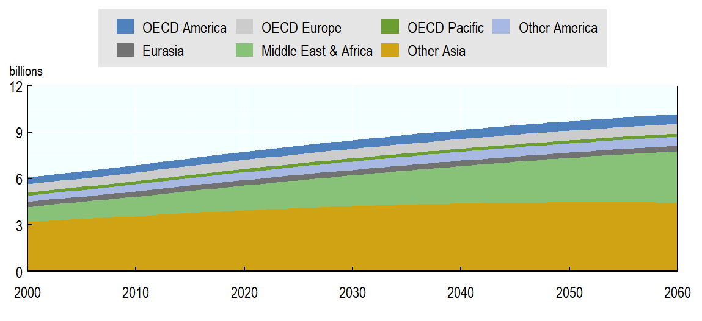
Source: Own calculation from The World Population Prospects: 2017 Revision (UN, 2017_{[22]}) and Eurostat (Eurostat, 2018_{[23]}).
This decline in population growth applies to all countries. However, population growth trends will vary across countries. Some countries with the most advanced demographic transition are projected to even face negative growth (many European countries, Japan, Korea, and China). At the other extreme, Sub-Saharan Africa (grouped with the other parts of Africa and the Middle East in the figure) is projected to experience very high population growth (over 2% per year over 2017-2060). As a result, more than 29% of world population in 2060 is projected to be settled in Africa, compared to 17% in 2017. In contrast, the OECD share shrinks from 14% in 2017 to 17% in 2060.
In the coming decades, the global population is projected to not only increase but also to become wealthier. Living standards (measured as GDP per capita) are projected to increase over the entire period, with most countries gradually converging towards OECD levels (Figure B.2). The improvements in living standards over the 2011-2060 projection period (blue bars) are projected to be greater for countries that currently have lower levels of per-capita GDP (those to the right of the graph, since the figure is sorted by GDP per capita in 2011 in grey). The poorer countries at the beginning of the period are thus projected to show important gains in living standards (including Sub-Saharan African countries, India, and other non-OECD Asian countries). Global income per capita is projected to reach the 2011 OECD level of living standards by 2060. The macroeconomic projections for OECD and G20 countries match the long-term macroeconomic projections of the OECD Economics Department (Guillemette and Turner, 2018_{[14]}). For the remaining countries, projections are provided by the ENV-Growth model.
Figure B.2. Living standards are projected to gradually converge
Real GDP per capita in USD (2011 PPP), sorted by GDP per capita in 2011
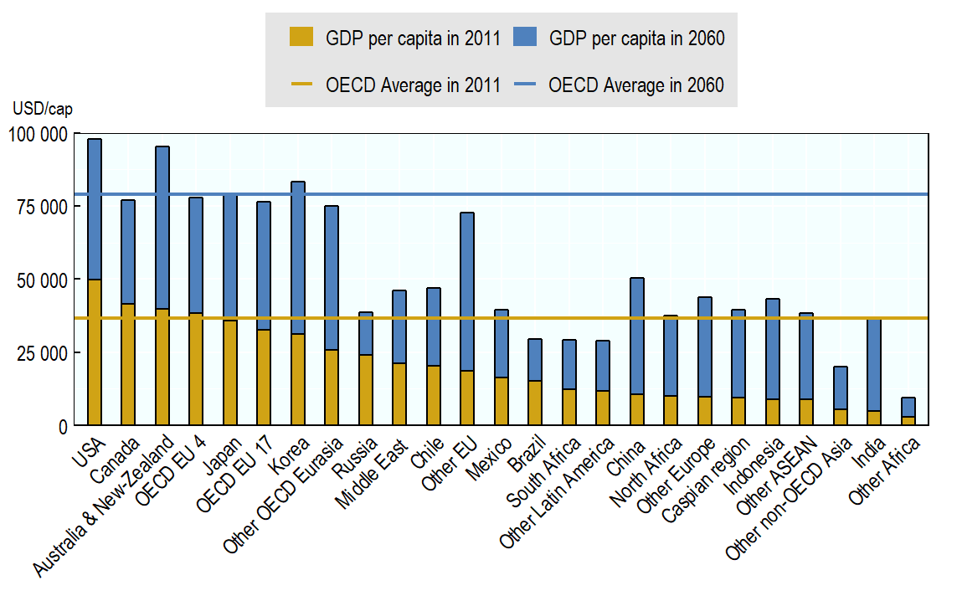
Note: See Annex A for regional definitions. In particular, OECD EU 4 includes France, Germany, Italy and the United Kingdom. OECD EU 17 includes the other 17 OECD EU member states. Other OECD Eurasia includes the EFTA countries as well as Israel and Turkey. Other EU includes EU member states that are not OECD members. Other Europe includes non-OECD, non-EU European countries excluding Russia. Other Africa includes all of Sub-Saharan Africa excluding South Africa; in the text, the term Other Africa is replaced with Sub-Saharan Africa to improve readability. Other non-OECD Asia includes non-OECD Asian countries excluding China, India, ASEAN and Caspian countries.
Source: OECD ENV-Growth model (OECD Environment Directorate) and OECD Economics Department (Guillemette and Turner, 2018_{[14]}).
Two categories of countries deviate from this pattern. Countries that are fossil-fuel exporters are projected to underperform compared to the standard pattern, as fossil fuel revenues do not grow as rapidly as other contributing factors to GDP. Countries in this category include the Russian Federation (hereafter Russia), Brazil and Middle Eastern countries. In contrast, European countries that are currently in a phase of integration to the European Union (EU), especially those labelled as “Other EU”, are projected to overperform.
Living standards in developing economies will still be far from those of OECD economies at the end of the time horizon, despite this convergence process. This can be seen in Figure B.2, which presents real GDP per capita in 2060 by region (shown as stacked bars in 2060, while the OECD average is presented as a horizontal line). Some countries are projected to not even have reached 2011 OECD levels by 2060; these include countries in Latin America, Other non-OECD Asia, and Sub-Saharan Africa. Mexico, North Africa, Russia and India are projected to reach in 2060 a level close to the 2011 OECD living standards.
As a result of increasing population and living standards, global GDP increases, as shown in Panel A of Figure B.3. GDP increases in all regions, even in countries where population is declining, since the growth of GDP per capita has a larger impact than population changes.
The share of OECD countries in global GDP in 2060 is projected to fall to 31% from 48% in 2011 (from 61% in 2000). This is explained by the large increase in the share of the Asian developing economies, and – to a lesser extent – Sub-Saharan African countries. Other regions, such as the Middle East, Other America (i.e. non-OECD Latin America) and the Eurasia group of countries are not projected to see their share in global GDP increase significantly. This pattern results from the fact that countries with more dynamic demographic changes, especially faster growing populations, are also countries with high gains in GDP per capita, so their shares in world total GDP increase substantially. It therefore appears that projected trends of GDP per capita and population growth generally move together.
The central baseline scenario projects that the global GDP growth rate will slow down and stabilise just below 2.5% after 2030, as shown in Panel B of Figure B.3. While India and large parts of Sub-Saharan Africa are projected to record high growth rates and then become important drivers of world growth in the 2020-2040 period, the projected slowdown of the Chinese economy after 2025 dominates. From around 2040, the most dynamic region is projected to be Sub-Saharan Africa, but its increasing share in world GDP growth is not sufficient to counterbalance the slowdown of China’s economic growth in this scenario.
Figure B.3. Emerging economies drive the projected global GDP growth
Panel A. Real GDP by aggregate region in tln USD (2011 PPP)
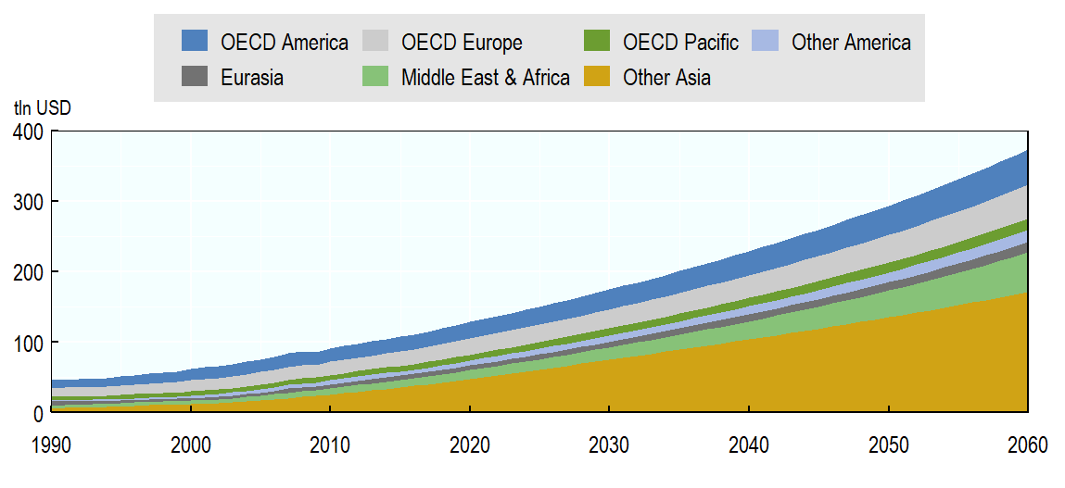
Panel B. Regional composition of global GDP growth in percentage
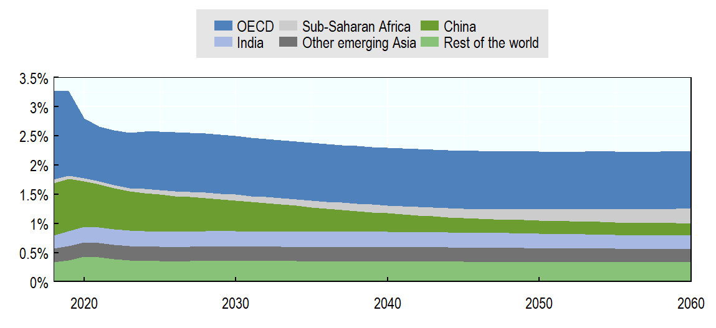
Note: Panel B uses a custom aggregation of regions to highlight the contribution of China and India.
Source: OECD ENV-Linkages model; short-term forecasts by OECD Economics Department (as of Summer 2018) and IMF (as of Spring 2018).
An increase in GDP does not mean that the proportion of each good produced and consumed remains constant. The structure of the economy evolves because living standards transform preferences; because society is changing with increasing ageing and urbanisation, and also because the nature of production is evolving, relying more on research and development (R&D) and services expenses. In particular, the model projects an increasing demand for services by households, government and firms.

As income per capita increases, final demand patterns change. The share of necessary commodities (food and agricultural products) in total expenditure decreases, while the share of luxury goods – such as recreational and leisure activities and other services (including health and education) – increases. This conventional effect is reinforced in the central baseline scenario by the assumption that in emerging and developing economies preferences gradually shift towards OECD standards. This includes changes in the size and direction of government expenditures, as well as shifts in household expenditures towards services. These preference shifts are partially driven by income growth, but also reflect the projected further digitalisation of the economy.
The share of manufacturing goods in households’ total expenditures is projected to decline slightly, but more importantly, expenditures on durable and equipment goods are projected to change. For example, they will shift away from equipment and paper, towards more electronics and vehicles.
Similar trends in the composition of government and investment expenditures are also projected, which include increasing shares of education and R&D expenditures.
Ageing also induces a shift of household and government demand towards more services, not least for health and other long-term elderly care expenditures. Even if public and private spending on health and long-term care vary considerably across countries, they are all projected to increase in the future (de la Maisonneuve and Oliveira Martins, 2014_{[24]}). The projected increase of health and long-term care spending is driven by a combination of ageing and other demographic factors, as well as the increase in income per capita and technical progress (de la Maisonneuve and Oliveira Martins, 2014_{[24]}). Regardless of the drivers, the result is an increase in the demand for the “other services” category, which includes health care as well as education and public services.
The changes in demand patterns are not only driven by modifications of final demand by households and governments, and for investment, but also by changes in intermediate demand, i.e. demand for produced goods and services by firms. This is reflected in an intensification of services as inputs to all sectors (including manufacturing processes), known as the “servitisation of manufacturing” (Pilat and Nolan, 2016_{[25]}). Both servitisation of manufacturing and service digitalisation result from the Information and Communication Technology (ICT) revolution, the intensification of R&D expenses, and the growth of the sharing economy.
This intensification of services in the economy goes further: it includes the shift in business models towards more and more services. The business of car companies for instance is increasingly geared towards services such as insurance, credit, and maintenance.
The main consequence of this structural transformation is that the services sectors, and especially the business services sector, are projected to grow faster than the rest of the economy in all countries over the period 2011-2060 (Figure B.4).
Figure B.4. Demand for services is projected to increase more than the economy-wide average
Panel A: OECD aggregate (sorted by total growth over 2011-2060)
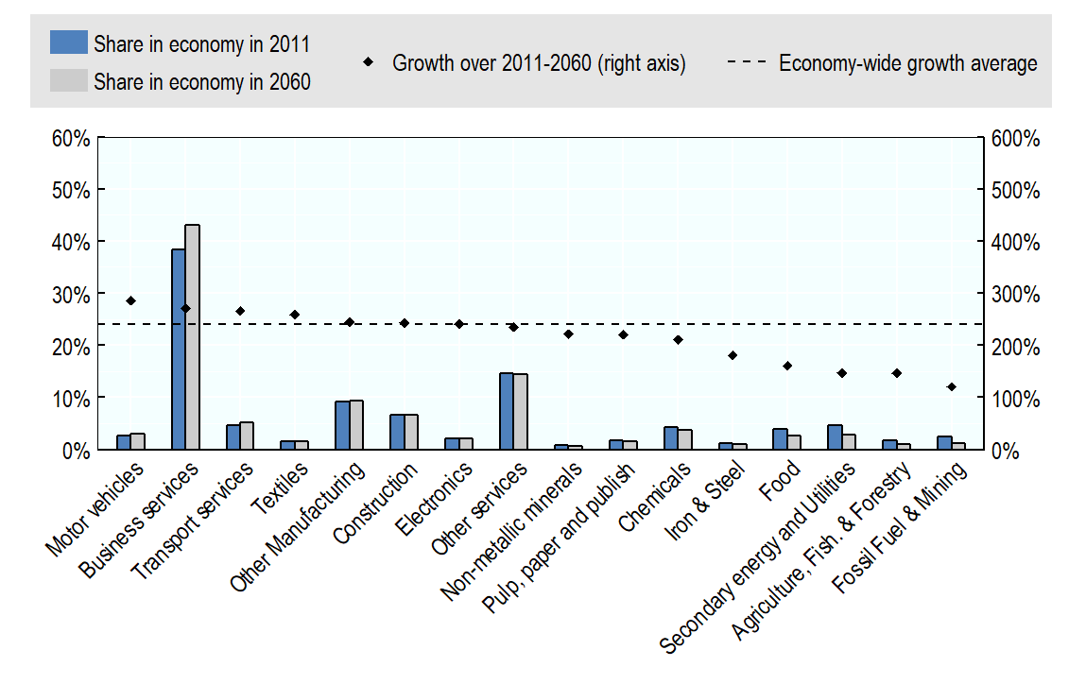
Panel B: Non-OECD aggregate
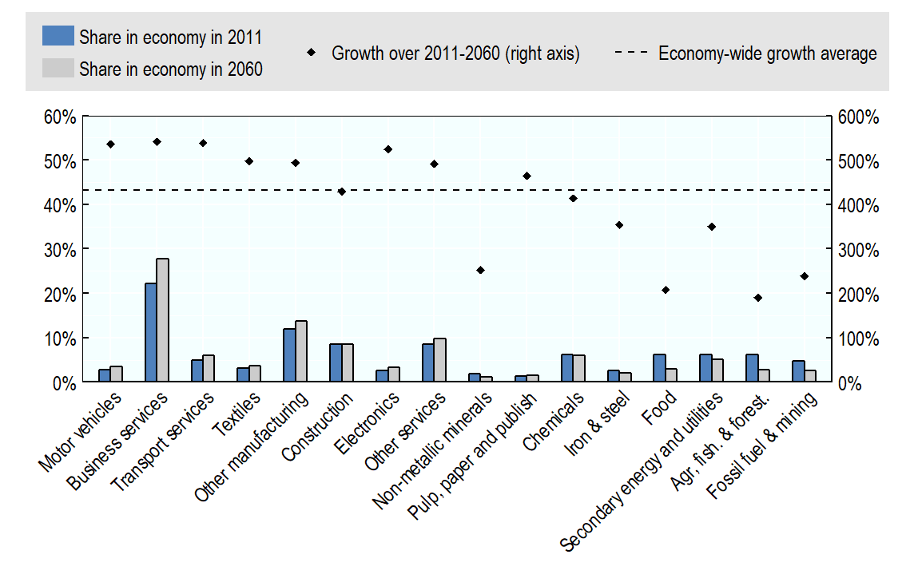
Source: OECD ENV-Linkages model.
In contrast, the output of the fossil fuel and mining sectors, as well as of energy intensive industries is projected to increase less than the economy-wide average, mainly in OECD countries but also in emerging economies. Similarly, the share of food and agricultural goods in total expenditures is projected to diminish significantly. However, the global demand for these goods is still projected to increase by almost 80% by 2060 compared with 2011 levels: agricultural and food expenditures increase, but less rapidly than expenditures on other goods and services.
The GDP changes described above are largely driven by the evolution of the main primary factors of production (capital and labour) as well as by technical progress. These changes can come from a wide range of drivers, including continued efforts to optimise existing production processes, adopting new business models, and the spreading of best available techniques. The change in GDP per capita can be broken down into changes in employment levels, in labour efficiency and in the amount of capital per worker (Figure B.5).
Changes in labour efficiency have the strongest influence on per-capita GDP growth. Long run labour efficiency gains are assumed to be driven by country-specific progress in education levels, investment in innovation, and improvement in the quality of institutions and market regulations, as well as other determinants. As shown in Figure B.5, and in accordance with traditional growth theory, in the long run the gains in living standards (diamond marks) converge.
However, in the short and medium run (2011-2030), the process of catching up through increases in capital-to-output ratios plays a non-negligible role. This mechanism is visible in Figure B.5 as a high contribution to GDP by increases in capital per worker. A relative shortage of capital implies that investments are the major source of economic growth, especially in emerging economies. In contrast, investment is slowing down in more advanced economies, not only because equipment and infrastructure expenditures have largely already been undertaken, but also due to the reduction of saving rates that characterise these ageing societies.
Furthermore, in the short and medium term employment rates fluctuate and influence the dynamics of GDP per capita. In many regions, employment growth makes a positive contribution to growth, but in countries with significant ageing, employment changes become a drag on economic growth, as the share of the working age population in the overall population declines.

Figure B.5. Labour efficiency and capital supply drive per-capita GDP growth
Annual growth rates in percentages
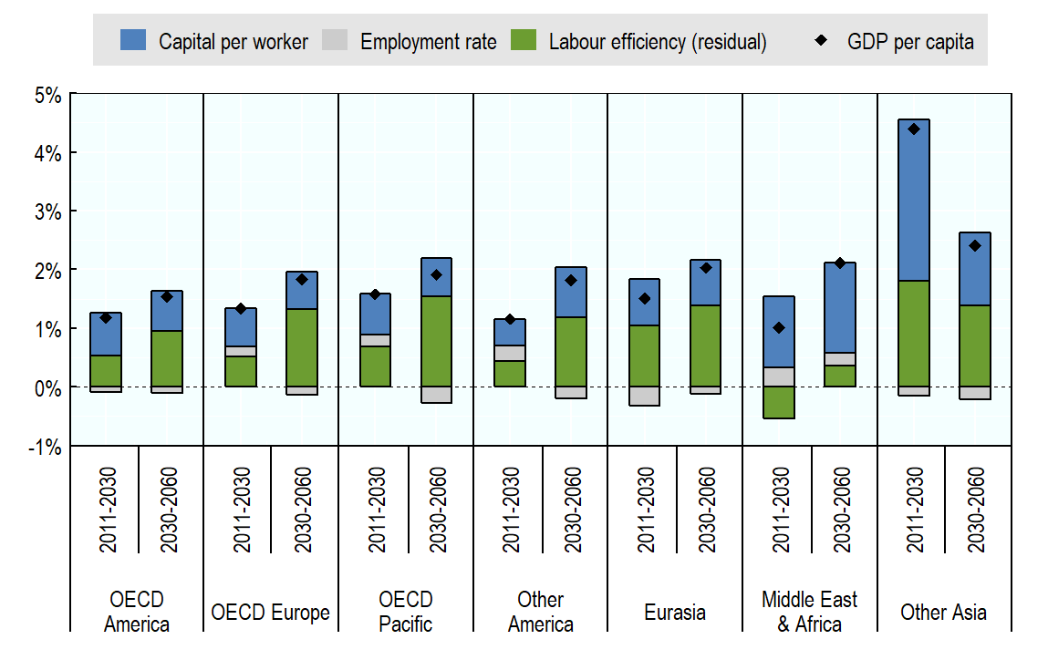
Note: The changes in the GDP per capita in market exchange rates (y) are decomposed in three components: (i) the change in employment rate (ER), (ii) the change in capital per worker (where capital is defined in a broad way including land and natural resources) (k), and, as a residual factor, (iii) the change in labour efficiency (A). Changes in GDP (in market exchange rates) can be decomposed as in the following formula:
, where α is the share of labour income in GDP. The GDP per capita growth rate in market exchange rates differs from the one in PPP exchange rates as the weights of different countries in regional aggregates differ.
Source: OECD ENV-Growth model (OECD Environment Directorate) and OECD Economics Department (Guillemette and Turner, 2018_{[14]}).
Economic growth is thus characterised by changes in production technologies, which drive changes in the input structure (e.g. substitution of production inputs, labour or capital)., Such shifts in the input structure of production are not new – during the industrial revolution, for example, machines used to automate production reduced the need for labour. More recently, the increasing efficiency of cars has led to a lower use of fuel to travel the same distance, as well as a substitution between different types of fuels (e.g. ethanol instead of gasoline).
The production of manufacturing goods is an interesting example of these production changes. Table B.1 illustrates changes over time in the cost structure of aggregate manufacturing good production, for OECD and non-OECD countries. Inputs of services increase, reflecting the servitisation phenomenon described above, while other inputs of goods and services –including extracted materials – decrease. Labour costs also increase, due to wage increases relative to the marginal cost of production (not shown here).
In both OECD and non-OECD countries, unit production costs are projected to decline, reflecting higher productivity resulting from technical progress. However, this effect is stronger in non-OECD countries, where a higher rate of convergence also leads to more marked changes in productivity over time. In all regions, production costs shift away from industrial inputs towards more services.
Table B.1. Input composition for the production of manufacturing goods
Share of components in production costs of manufacturing goods
 |  | OECD |  |  | Non-OECD
 |  | 2011 | 2030 | 2060 | 2011 | 2030 | 2060
Price evolution (index 2011 = 1) |  | 1.00 | 1.00 | 0.99 | 1.00 | 0.91 | 0.84
Input Composition  of production | Capital and resources | 12% | 11% | 12% | 12% | 9% | 10%
Input Composition  of production | Labour | 18% | 19% | 17% | 11% | 14% | 14%
Input Composition  of production | Agricultural inputs | 3% | 4% | 3% | 7% | 7% | 8%
Input Composition  of production | Industrial inputs | 48% | 46% | 40% | 56% | 54% | 49%
Input Composition  of production | Services inputs | 19% | 21% | 27% | 14% | 15% | 21%
Source: OECD ENV-Linkages model.
As new technologies emerge, are adopted and become cheaper, they will be more widely used for the production of goods. An example is electricity generation as electricity can be produced with different technologies. Over time renewable technologies are projected to become cheaper and easier to access so that they will be more widely used to produce electricity. In the central baseline scenario, which projects a gradual shift towards renewables, the percentage of electricity produced with renewable technologies is projected to increase at the global level from 24% in 2016 to 31% in 2040, while fossil fuel electricity is projected to decline from 65% in 2016 to 61% in 2040 (IEA, 2017_{[15]}).

Trade in energy is excluded from this reduction, but are still subjected to import tariffs and benefit from the domestic support to capital and labour.
The results presented in this Section are also presernted in a dedicated OECD Covid Brief (OECD, 2021 forthcoming_{[27]}). The Covid Brief also investigates the effects of a slower than forecast recovery of the economy.
OECD (2020_{[16]}) provides a more detailed discussion of the macroeconomic implications of the pandemic.
The forecasts for India of OECD and IMF are aligned to the Reserve Bank of India forecasts for the fiscal year running from April to April. The sharp contraction is followed by a significant rebound, with Indian GDP growth in 2021 forecast to be above 10%.
The pharmaceuticals sector comprises around 0.7% of total output of the global economy, and above 1% in the European OECD countries (on average).
The sector that according to the simulations is projected to perform best in the longer run is the health sector.
Such shifts depend crucially on the modelling framework and assumptions regarding e.g. the speed of recovery. Small perturbations of regional and sectoral impacts can have significant effects on relative competitiveness and thus lead to significantly different results for shifts in trade patterns. The results presented here are therefore merely a snapshot of a possible projection, and are surrounded by significant uncertainties.
Emissions of PM2.5 reflect primary emissions and exclude secondary particles that are formed in the atmosphere.
See also the discussion on Covid and biodiversity in (OECD, 2020_{[28]}).
Of course, this positive effect is not the result of a cost-effective policy measure. The economic costs associated with this environmental benefit are huge, and the result of an external shock, not a deliberate policy action.
The focus here is on the economy; other counties may be more severely affected in terms of mortality and other health impacts.
The result for India is despite the fact that it has a relatively closed economy and is driven by export considerations rather than import effects.
This result, but to a lesser extent also e.g. the results for GHG emissions, is influenced by the policy assumptions on trade in energy, which are subject to revision. As the effect is mostly related to shifting trade, rather than to world production levels, the effect on CO₂ emissions is much less pronounced.
Similarly, the policies induce some regions, such as Japan and Korea (the OECD Pacific region), to rely more on fossil fuels in their energy system, driving their materials use up.
Interactions with the Covid scenario will be added in a later version of the paper.
In the simulations, South Africa is separated from the rest of Sub-Saharan Africa, which is labelled “Other Africa”. In the text, the term Other Africa is replaced with Sub-Saharan Africa to improve readability.
Other EU includes the non-OECD EU countries (see Table A.2).
In the ENV-Linkages model, services are split into several sectors (see Annex A): business services, three transport service sectors (land, air, water), and other services (which include all government services, education, health, waste management).
To illustrate these trends, Miroudot and Cadestin Invalid source specified. showed that in 2015 in OECD countries between 25% and 60% of employment in manufacturing firms was in service support functions such as R&D, engineering, transport, logistics, distribution, marketing, sales, after-sale services, IT, management and back-office support.
Energy intensive industries include the sectors producing chemicals, iron & steel, pulp, paper publishing and mon-metallic minerals.
The methodology for projecting labour efficiency has been developed by the OECD Economics Department. Guillemette et al. Invalid source specified. describe this methodology as well as the projection for the underlying determinants of long run efficiency. For the remaining 180 countries, the OECD Environment Directorate adopts a similar methodology but with fewer determinants in the long run efficiency: indicators for institutional quality as well as rule of law are not included in ENV-Growth model due to lack of data.
For standard growth models (e.g. the Solow-Swan growth model), the capital-to-output ratio and the employment rate stabilise in the long run following the convergence towards a balanced growth path where capital supply growth matches labour efficiency growth.
These effects are driven by changes in relative costs and in factor productivity that affect the mix of inputs and technologies used to produce the final goods. The input substitution effect occurs as the price of one input changes relative to other inputs. In particular, if different inputs can serve as substitutes in the production of a specific commodity, then the mix of inputs that are used for the production of this commodity will depend on their relative prices. Further, if production inputs become more efficient through increases in total factor productivity, then more output can be generated with the same amount of inputs.
In the modelling framework, smooth production functions are used to represent the production choices of many individual firms. Individual production technologies are only specified for selected sectors, notably those related to energy production and materials processing.
The decline in capital costs in non-OECD countries mostly reflects an observed decline in the price of capital between 2011 and 2018; in real terms capital costs are projected to grow more rapidly than other primary production factors in the coming decades.

