25th Annual Conference on Global Economic Analysis
Accelerating Economic Transformation, Diversification and Job Creation

Investigating Poultry Interventions in Ghana and Senegal
Omid Zamani¹, Craig Chibanda², Janine Pelikan¹
- Thünen Institute of Market Analysis, Bundesallee 63, 38116, Braunschweig, Germany
- Thünen Institute of Farm Economics, Bundesallee 63, 38116, Braunschweig, Germany

PRELEMINARY DRAFT – PLEASE DO NOT CITE OR QUOTE

8-10 June, 2022, Virtual Conference

Introduction
Poultry meat continues to be an important source of animal protein in sub-Saharan African countries including Ghana. Increasing urbanization and income combined with rapid population growth has led to a growing demand for animal products in many African countries (Mottet and Tempio 2017). In 2020, per capita consumption reached about 11.4 kg, and it is forecast to reach 409,000 mt in 2022, which is a 29% increase over the 2019 estimates (318,000 mt) (USDA database, 2022). To meet growing demand, poultry imports by some African countries are rapidly increasing and are much higher than the local production (FAOSTAT, 2020). Improving the competitiveness of local industries is viewed as a promising way to increase domestic poultry production. In this line, the Ghanaian policymakers have been keen to formulate various supporting policies to reverse the country’s dependency on imports. For poultry production, existing literature highlights lowering feed costs as a key factor for an increase in competitiveness in Ghanaian poultry production (Andam et al. 2017). Additionally, the outbreak of production costs implies that the high feed costs are caused by various drivers at different levels (e.g. Sumberg et al., 2017; Netherlands Enterprise Agency, 2019). The present paper primarily aims to compare different key factors behind the high cost of production in the Ghanaian poultry value chain and investigate the possible scenarios to reduce it. In the case of Senegal, the poultry ban is the major policy intervention in the poultry market. Since 2005, the Senegalese poultry sector has been experiencing a trade ban on poultry imports to prevent the Avian Influenzas outbreak. We evaluate the potential effects of the ban policy on the performance of poultry farms using a comparative analysis between Senegal and Ghana.
Firstly, we classify the high feed cost drivers into three main levels, farm-level, national-level, and macro-level factors. 99 Since the tariff rate of feed ingredients is around 5%, the reduction of border protection for feed has little effect on agricultural trade and costs (Zamani et al. 2022). Here, the improvement of the feed processing capacity and efficiency may help producers to reduce the cost of production. Besides, trade restriction including a complete ban on poultry product imports is the major policy intervention in the Senegalese poultry sector.
Given the scope of our analysis and data availabilities, we use different methods to evaluate the policies of interest. To begin with, we develop a spatial partial equilibrium model including different stages to assess spillover effects of feed costs on the poultry meat market. Figure 1 presents the input and product flow in a typical poultry value chain in Ghana from farm to home. The model is based on a spatial partial equilibrium model developed by Samuelson (1952) and extended by Takayama, and Judge (1964). The final calibrated model is applied to investigate the impact of feed processing capacity and efficiency on poultry meat production. In our analysis, the main advantage of using a partial equilibrium approach compared to general equilibrium is that it permits analysis within the value chain context including feed conversion ratio and processing details. Additionally, it allows us to assess the effects of policies at price levels.
The rest of paper is organized as follow. Next section reviews the literature to draw a general picture of problem and elaborate on the possible solutions. Section 3 presents the framework to evaluate the scenarios.

Literature review

Exchange rate and prices
A critical objective of most central banks in developing economies including Ghana is to maintain low and stable inflation (Amoah and Aziakpono 2018). A key instrument to attain this objective is the exchange rate. The empirical literature highlights the significant pass-through of exchange rate changes to consumer prices in Ghana (e.g. Amoah and Aziakpono 2018). This may result in increased uncertainty levels which can negatively affect household and firm budget planning in Ghana. As mentioned above, the Ghanaian poultry sector is a significant subsector in terms of food security. However, this sector is highly dependent on imports (Zamani et al., 2021).
Exchange rate policies have a direct effect on food prices and an indirect effect by raising the cost of production. A rising exchange rate means higher prices for imports. In our case, exchange depreciation can increase the prices of poultry meat and therefore reduce its imports, especially if the domestic consumption is significantly met by imports. Moreover, an increase in exchange rate affects production through its effects on input prices. Devaluation indirectly might be correlated with the cost of food production if it encourages substitution between foods and cash crops (Alderman and Shively, 1996). In this regard, Weissman (1990) reports that Ghana’s drastic devaluation in the mid- 1980s had overall negative effects on food-producing regions over the country. It should be kept in mind that the final effects on product prices depend on the share of imported products and production inputs as well as the interaction between different stages along the value chain. For instance, suppose half of the production inputs are imported in foreign currency. According to the basic economic theories, a 20% depreciation of the exchange rate of foreign currency may lead to an increase in its production cost by 10%. Given increasing imports of poultry meat, we may expect that the direct effect of the exchange rate on import reduction is dominant. In this regard, van Horn (2018) reports that the reduction of the exchange rate leads to a lower offer price of poultry meat by decreasing the cost of production. Additionally, Enu and Attah-Obneg (2013) highlight a positive relationship between the real exchange rate and agricultural production in Ghana.

Trade restrictions and infant-industries
This section attempts to explain the effects of trade restriction using infant industry argument. An import restriction including a partial or complete trade ban is prohibited for member countries according to the World Trade Organization (WTO). Exceptions are taken into account under defined conditions such as safeguarding mechanisms, and human, livestock, and plant health-related issues (see GATT 1994 article XI). Aiming at increasing self-sufficiency -through protecting domestic producers- and preventing animal diseases outbreak, import restriction has drawn particular attention among West African policymakers (Akunzule et al., 2009; Johnson, 2011; Naggujja et al., 2020). The contemporary trade policies in poultry sectors of West African countries have been characterized by different import ban policies (Zamani et al. 2021; Zamani et al. 2022). Existing literature shows that the trade ban policy effect varies from country to country. For instance, Ghana’s government recently imposed an import ban on poultry products from four European countries in 2021 (Zamani et al. 2022). Nevertheless, this is not the first time that Ghana has experienced a partial ban. During the 2006-2007 Avian Influenza outbreak, Ghana applied a partial ban on imports from less important trading partners (Akunzule et al., 2009; Johnson, 2011). Despite this ban, imports to Ghana continued to increase over the corresponding period. However, local production was protected from a large outbreak of avian influenza (Akunzule et al., 2009).
Apart from the aforementioned effects, there are other externalities of the trade restrictions. Andriamananjara et al. (2009) and Golub (2012) highlight the impact of poultry trade restrictions on increased tendency to smuggle (illegal trade) of frozen meat. Furthermore, an import ban on inputs of poultry production leads to an increase in maize prices. Maize prices tripled from 2007 to 2008 and left many poultry producers unable to provide sufficient feed quantities (Killebrew et al., 2010). Zamani et a (2022) simulate the effects of the 2021 partial import ban on poultry products in Ghana. Due to a “cushioning” effect, the total imports of corresponding products do not change following the partial ban. However, a complete ban has larger effects on the value chain and causes domestic production to increase substantially. In Nigeria, the complete ban has led to a reduction in the per capita consumption of chicken meat from an annual average of 1.32 kg/person in 1995-to 1999 to an annual average of 0.85kg/person in 2011–2015 (Andam et al. 2017).
As mentioned already, since 2006, Senegal has been experiencing a ban on the import of live poultry, edible poultry meat and offal, and poultry products to prevent Avian Influenza from entering the country and supporting local producers. This public intervention has stimulated domestic production in the years following the import ban. The poultry sector is now able to meet almost 100% of the Senegalese poultry demand. In contrast to Nigeria, the inspection of time-series data implies that consumption has increased following the import ban (FAO-STAT, 2021). According to Arnoldus et al. (2020), the per capita consumption of chicken meat increased from 3.1 kg/person in 2007 to around 5 kg/person in 2019.
According to the above explanations, the difference in the impact of poultry import bans implies that the policy implications of a ban policy cannot be generalized based on the effects on other countries but should instead be investigated based on the specific local context. As mentioned above, the protectionism policies in the poultry sector of Senegal and Ghana can be explained by the infant industry argument. The theory is first proposed by Alexander Hamilton and Friedrich List at the beginning of the 19th Century which justify the protection of domestic production from international trade. In the case of West African countries, the domestic poultry productions are high cost relative to the imported products (Sumberg et al., 2017). According to the infant industry argument, “the sector requires a temporary period of protection or assistance during which its costs will fall enough to permit it to survive international competition without assistance” (Krueger ad Tuncer, 1982; pp 1143). Given WTO restrictions, the public sector can protect the infant industry using different policy instruments like trade protections or subsidies to insure later economics efficiency. In other words, the public protections aim to support the infant industry at the early stages to create a reasonable rate of return when it is developed. Nevertheless, it raises the question of whether the long-run benefits can compensate the short-run costs of infant industry protections.

Method
Given the scope of our analysis and data availabilities, we use different methods to evaluate different drivers of feed costs in the poultry market of Senegal and Ghana. To begin with, we develop a spatial partial equilibrium model including different stages to assess the spillover effects of feed costs on the poultry meat market. Figure 1 presents the input and product flow in a typical poultry value chain in Ghana from farm to home. The model is based on a spatial partial equilibrium model developed by Samuelson (1952) and extended by Takayama, and Judge (1964).

Figure 1. Framework of policy analysis
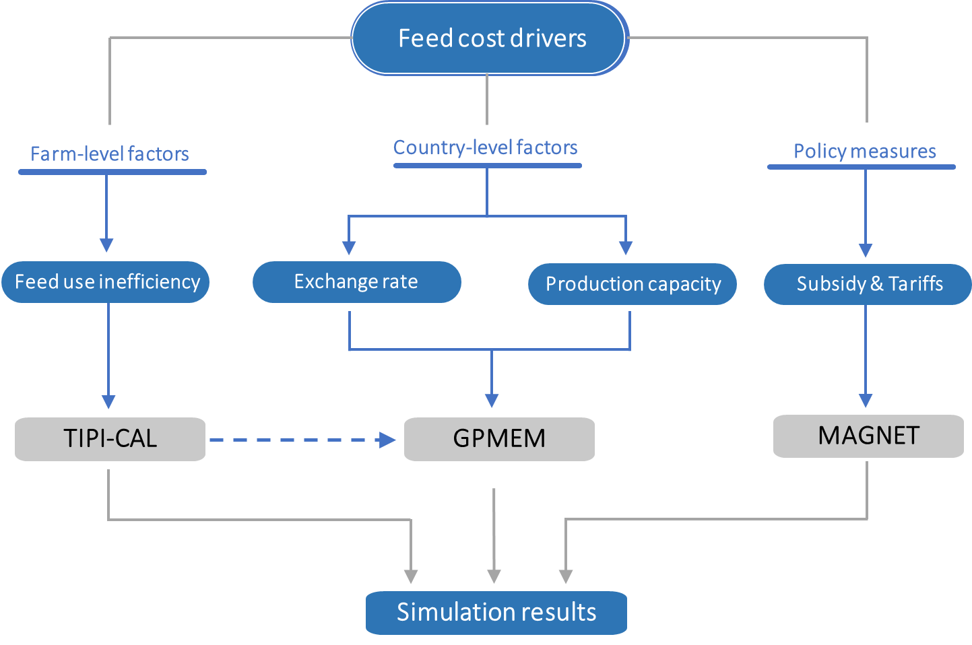
Source: Own presentation.

Typical farm approach
The typical farm approach was used to analyse the costs of production and the feed-use efficiency of different broiler farm-types in Ghana and Senegal. The approach employs qualitative methods (semi-structured interviews or/and focus groups) to construct empirically grounded farm data sets that represent the most common farm types in a specific region (Chibanda et al., 2020; Lasner, 2020). In case of Ghana, this study expands on the farm economic analysis conducted by Chibanda et al. (2020). Chibanda et al. (2022) provides a detailed step-by-step explanation of how typical farms are constructed and analysed. These steps are summarized below.
Step 1: Identification of the most prevalent conventional broiler production systems and most important production regions
The most common broiler production systems in Ghana and Senegal were identified through a literature review and consulting local experts (researchers and extension officers). While the most important production regions “hot spots” were identified through reviewing national statistics. Three conventional broiler production systems that are common in both countries were identified: small scale, medium scale and large-scale integrated production systems. The hot spots for broiler production in Ghana that were identified are Accra, Kumasi and Dormaa. While for Senegal they were Dakar and Thiès.
Step 2: Farm visits
A farm that represents each production system was then identified in consultation with extension officers. Semi-structured interviews were then used to collect farm data from the selected broiler farms. This means farm data was collected from three farms in Ghana and three farms in Senegal.
Step 3: Typification of farm data
According to Chibanda et al. (2020), the typification of farm data (i.e. construction of typical broiler farms) can be done through the use of either focus groups or consulting local poultry expert. In the case of Ghana, focus groups were used to typify the individual farm data collected from the three farms. This was done through the focus group participants discussing each value collected from the farms until they reached a consensus that each figure reflects the most common situation for the specific production system. A total of three focus groups were held, one for each farm-type. Each focus group discussion was composed of ten participants who included five broiler producers, three extension officers and two local researchers. In the case of Senegal, the individual farm data was ‘typified’ by replacing the farm particularities with typical information that was provided by poultry experts (agricultural officers and researchers) knowledgeable of the production systems and regions. The typical farms that were constructed for Ghana and Senegal were then named according to country code (GH for Ghana and SN for Senegal) and the number of broilers they produce annually (GH_3k, GH_12k, GH_27k, SN_9k, SN_36k and SN_38k).
Step 4: Data analysis
The Technology Impact Policy Impact Calculations (TIPI-CAL) model was used to analyse the typical farm data. TIPI-CAL is a computer-based policy impact assessment tool used in farm economic analysis as it allows a detailed analysis of farm-level variables (Kress and Verhaagh, 2019). More specifically, TIPICAL was used to calculate the production costs, feed consumption and feed conversion ratio (FCR). The FCR was calculated using the following formula:
$$FCR=\frac{Cumulative feed intake (kg) }{Total weight gain (kg)}$$

Spatial Equilibrium Model of Poultry Value Chain
Following Andam et al. (2017), we apply a modified form of equilibrium problem to model the poultry value chain of Ghana. Figure 1 presents different markets and their relationship along the Ghanaian Poultry Multi-market Equilibrium Model (GPMEM). The model is designed based on the poultry value chain structure incorporating maize, soybean, poultry feed, and chicken meat market for 8 provinces in Ghana. The spatial equilibrium models are typically solved as a nonlinear optimization problem that maximizes net social welfare subject to transportation costs, a world price for imports, and local supply and demand constraints. The net quasi welfare function is measured as the integrals of the inverse demand and supply functions. To investigate the effects of scenarios at meso-level e.g. different stages of the poultry value chain, the partial equilibrium model is required to be adopted. Moreover, this model allows us to assess the effects of exchange rate and feed conversion ratio on price levels, production, consumption, trade, and social welfare.

Figure 2. Product flows in the Ghanaian broiler value chain
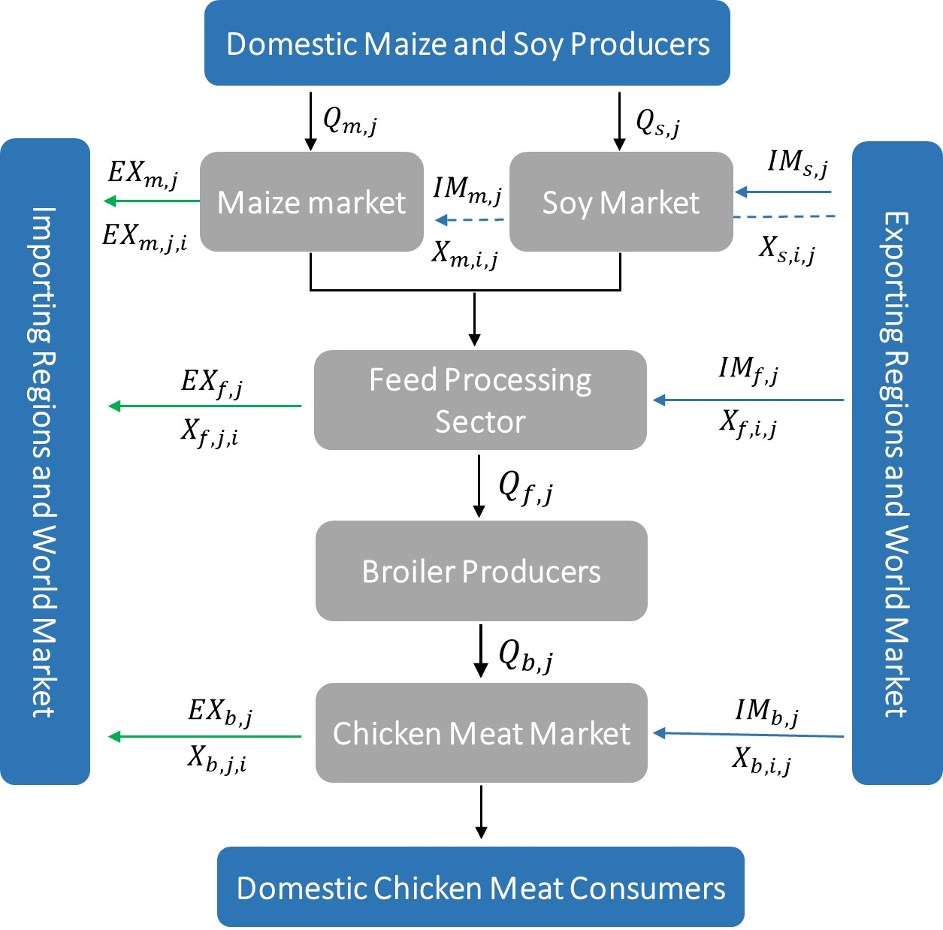
Note: m = maize, s = soy, f = feed, b = chicken meat, i = regions
Note that the subscripts m, s, f, b, and i (alias j) refer to maize, soybean, poultry feed, and regions, respectively throughout the paper. The model is generally based on a spatial equilibrium model developed by Samuelson, Takayama, and Judge (Samuelson, 1952; Takayama and Judge, 1964) and extended by Takayama and Judge (1964). Firstly, we assume the functions of supply and demand are linear in each region (Bouët and Metivier, 2016). Thus, the soybeans ($S_{s,j}$) and maize ($S_{m,j}$) domestic productions at region j are a function of commodity prices are given by,
Eq(1) $S_{m,j}=f(P_{h,j}), ⊥ S_{m,j}≥0 ∀j∈N$
Eq(2) $S_{s,j}=f(P_{h,j}), ⊥ S_{s,j}≥0 ∀j∈N$
Where $P_{h,i}$ denote prices of commodity h (h= m, s, f, b, and i). Private traders are assumed to import all commodities (maize, soybean, broiler feed, and poultry meat) at CIF price while we restrict export only to chicken meat, broiler feed, and maize. The price parity equations for export and import are defined as,
Eq(3) $P_{h}^{w}\left(1+τ\right)ϵ+{CM}_{h,j}≥P_{h,j}, ⊥ {IM}_{h,j}≥0 ∀j∈N$
Eq(4) $P_{h,j}+{CX}_{h,j}≥P_{h}^{w}\left(1-ρ\right)ϵ, ⊥ {EX}_{h,j}≥0 ∀j=m,f,b$
Where $P_{h}^{w}$, $τ$, $ρ,$ and $ϵ$ show world price for commodity h, import tariff, export tariff, and exchange rate respectively. ${CM}_{h,j}$ and ${CX}_{h,j}$ are non-tariff trade costs. In the next stage, the composition of domestic and imported soybean and maize are transported to the milling sector to produce poultry feed. According to the soybean production in Ghana, we assume feed is exclusively used to produce poultry meat (IFPRI, 2020). Hence, the derived demand for feed ($D_{f,j}$) at region j is specified as,
Eq(5) $D_{f,j}=0.4(S_{b,j}), ⊥ D_{f,j}≥0 ∀j∈N$
The domestic demand for maize includes maize demand for poultry feed and household (final consumption). According to the market structure and poultry feed ingriendet in Ghana, we assume that 60% of broiler feed consists of maize. Thus, the function of maize is given by,
Eq(6) $D_{m,j}=f(P_{h,j})+0.6(S_{f,j}), ⊥ D_{m,j}≥0 ∀j∈N; ∀h$
Additionally, demand for beef is a derived demand from chicken meat given the regional feed conversion ratio, i.e.${FCR}_{j}$,
Eq(7) $D_{f,j}= {FCR}_{j}×S_{b,j}, ⊥ D_{f,j}≥0 ∀j∈N$
Next, we can define the inter-regional trade flows ($X_{h,j,i}$) according to transportation costs ($C_{j,i}$) between regions,
Eq(8) $P_{h,j}=P_{h,i}+C_{j,i}, ⊥ X_{h,j,i}≥0$
Based on the Karush–Kuhn–Tucker (KKT) optimality condition and previous equations, the model closure is identified as follow,
Eq(9) $D_{m,i}=S_{m,i}+{IM}_{m,i}-{EX}_{m,i}+\sum_{j}{\sum_{i}{(X_{h,i,j}-X_{h,j,i})}}, ⊥ P_{m,i}≥0 ∀i∈N; ∀h$
Eq(10) $D_{f,i}=S_{f,i}+{IM}_{f,i}-{EX}_{f,i}+\sum_{j}{\sum_{i}{(X_{h,i,j}-X_{h,j,i})}}, ⊥ P_{f,i}≥0 ∀i∈N; ∀h$
Eq(11) $D_{b,i}=S_{b,i}+{IM}_{b,i}-{EX}_{b,i}+\sum_{j}{\sum_{i}{(X_{h,i,j}-X_{h,j,i})}}, ⊥ P_{b,i}≥0 ∀i∈N; ∀h$
Eq(12) $D_{s,i}=S_{s,i}+{IM}_{s,i}+\sum_{j}{\sum_{i}{(X_{h,i,j}-X_{h,j,i})}}, ⊥ P_{s,i}≥0 ∀i∈N; ∀h$
Finally, all model variables including quantity produced, demand, bilateral trade flows (regional and international trade), and prices should be positive or zero. Given this assumption, the complementarity inequalities in equations (1) through (12) are solved together to run the model. We use the Mixed Complementarity Problem (MCP) to solve the problem, as it incorporates both dual and primal variables. Moreover, the MCP provides better performance in presence of an ad valorem tariff (Devadoss 2012). Further, we calibrate the model according to constant terms of supply and demand functions. The final calibrated model is applied to investigate the impact of feed processing capacity and the performance of poultry meat production. The base model should reproduce the baseline data. In our analysis, the main advantage of using a partial equilibrium approach compared to general equilibrium is that it permits analysis within the value chain context including feed conversion ratio and processing details.

MAGNET model
We apply a global general equilibrium model to assess policy measures to reduce feed costs. Providing more obvious intersectoral and interregional linkages, general equilibrium models have been the workhorse for assessing the economy-wide effects of policy interventions (Hertel 2013). MAGNET stands for the Modular Applied GeNeral Equilibrium Tool, which is based on the Global Trade Analysis Project (GTAP) database with a particular focus on the global agricultural sectors. More specifically, MAGNET is used to investigate import tax revenue shift to subsidy on intermediate products of the poultry value chain. MAGNET has several advantages over standard GTAP models. In our analysis, MAGNET allows us to endogenously determines the subsidies on the poultry production input. Besides, a noted advantage is that the MAGNET model accounts for the imperfect mobility of the return to capital (i.e., wage) and land (i.e., rent) between agricultural and non-agricultural sectors. Thus, the factor transfer over agricultural and non-agricultural sectors is made sluggish (Sartori et al. 2019). In contrast to the standard GTAP models, land supply is assumed endogenous in the MAGNET model. This feature allows describing a supply curve between average real agricultural land rent and the land area in a region that is used for agriculture (Woltjer et al., 2014). In contrast to most of the general equilibrium models, MAGNET assumes differences in technological change across sectors (Woltjer et al., 2014). Moreover, for this analysis, the latest version of MAGNET is applied that disaggregates the poultry sector from other livestock products. Given these advantages, this model has been widely applied by researchers and public institutes to assess the economic implications of agri-food trade policy scenarios (e.g. Boulanger and Philippidis, 2015; Helming and Tabeau, 2018).

Comparative analysis: Synthetic Control Method

To analyze the effects of complete ban on poultry imports in Senegal, we first need to project the trend of poultry production and imports in the absence of receiving the complete import ban. As a tool for policy evaluation, we use the synthetic control method (SCM) to investigate the effect of treatment in comparative case studies. Over the last decade, SCM has been widely used for estimating the effects of interventions in different contexts (see e.g. Mohan,2017; Cole et al., 2020; Abadie, 2021). The SCM provides several advantages over other similar methods, e.g. propensity score matching (PSM) and difference-in-difference (DID). First, it can control endogenous problems due to selection bias and other factors associated with control group selection and relaxes the parallel trend assumption of the DID method (Olper et al., 2018; Li et al., 2020). Secondly, SCM does not calculate weights without using the post-intervention data (Cole et al., 2020).
Following Abadie et al. (2010), we split our sample into two periods, a pre-intervention period, $T_{0}$, and the post-intervention period, $T_{1}$, where $T=T_{0}+T_{1}$. We assumed there are K +1 countries, among which the first country (i.e. treated unit) was affected by the imports ban over the pre-intervention period $T_{0}+1,…,T$, and the other K countries (so-called “donor pool”) is considered as the control samples. The idea of SCM is to estimate the pre-intervention characteristics of the treated unit using a weighted average of control units in the donor pool, known as the synthetic control, that approximate the pre-treatment outcomes for the treated unit (Abadie et al., 2015; Ben-Michale et al., 2021).
For each country j and time t, let $Y_{j,t}^{I}$ be the outcome variable observed for the countries that did not experience a complete import ban in post-intervention period, and $Y_{j,t}^{N}$ be the outcome for the treated unit (i.e. Senegal) after it had adopted the complete ban. Accordingly, the net effect of the ban ($ρ_{j,t}$) for the treated unit is defined by the gap between $Y_{j,t}^{N}$ and $Y_{j,t}^{I}$, as follows,
Eq (1) $ρ_{j,t}=Y_{j,t}^{N}-Y_{j,t}^{I}$
Following Abadie et al. (2015), it is assumed that the imports ban has no impact on outcome variable in the pre-intervention period, i.e. $Y_{j,t}^{N}=Y_{j,t}^{I}$ so for $t<T_{0}$ and all units. We define $D_{j,t}$ as an indicator that takes the value 1 if the country j is exposed to the ban policy at time t, and zero otherwise. Accordingly, the observed outcome for country j at time t is,
Eq (2) $Y_{j,t}=Y_{j,t}^{N}+ρ_{j,t}D_{j,t}$
Following Abadie et al. (2010), the potential effect of the intervention for the affected unit on our study (Senegal) in period $t>T_{0}$ is measured by Abadie et al. (2010),
Eq (3) $ρ_{j,t}=Y_{1,t}^{I}-Y_{1,t}^{N}=Y_{j,t}-Y_{1,t}^{N}$
Since $Y_{1,t}^{I}$ is known, one can estimate the post-intervention trend of the variable of interest by estimating $Y_{1,t}^{N}$ which is the outcome variable of Senegal where no intervention occurred. Abadie et al. (2010) applies the following linear factor model to estimate $Y_{j,t}^{N}$.
Eq (4) $Y_{j,t}^{N}=β_{t}+θ_{t}X_{j}+δ_{t}Z_{j}+ε_{j,t}$
Where $β_{t}$ denote the time-variant fixed effect, $X_{j}$ are the observed variables, and $Z_{j}$ is the unobserved variable affecting the variable of interest. $ε_{j,t}$ is the random error term with zero means. According to Abadie (2021), a weighted average of units in the donor pool may approximate the characteristics of the treated unit much better than any untreated unit alone. Given a set of weights for each untreated unit $W=\left(w_{2},…, w_{J+1}\right)'$, a synthetic control estimate of $Y_{1,t}^{N}$ is:
Eq (5) ${\hat{Y}}_{1,t}^{N}=\sum_{j=2}^{J+1}{w_{j}Y_{j,t}}$
Where ${\hat{Y}}_{1,t}^{N}$ stands for the counterfactual domestic production. In Equation (5), the weights are assumed to be nonnegative and sum up to one, i.e. $\sum_{j=2}^{J+1}{w_{j}}=1$. Following Abadie and Gardeazabal (2003), an optimization algorithm is applied to determine the optimal weights ($w_{j}$) by minimizing the deviation of the outcome variable path of the synthetic treatment country for the pre-intervention period.

Results

Costs of broiler production in Ghana and Senegal
The total production costs for typical broiler farms in Ghana and Senegal where calculated using the typical farm approach. However, since the data was collected in different years, the costs of production for the two countries cannot be compared. Consequently, in this section we present the production costs for each individual country.
Broiler production costs in Ghana (in 2020)
Figure X shows that, for all typical broiler farm-types in Ghana, feed costs represent the highest cost item. More specifically, the farm economic analysis reveals that feed costs represent 56% of the total production costs for typical small-scale broiler farms; 62% for typical medium-scale broiler farms, and 42% for typical large-scale integrated broiler farms. The proportion of feed costs is lower for the large-scale integrated farm-type because the other cost items (i.e., labour costs and veterinary costs) are significantly high in comparison to the other farm-types.
Figure 3. Production costs of the typical broiler farms in Ghana in 2020 (€ /100 kg live weight)

Source: Own survey and calculations
Broiler production costs in Senegal (in 2022)
Figure X shows that the most important cost items for the three typical farms in Senegal are feed costs and DOC costs. Feed costs represent 54% of the total cash costs for SN_36k; 58% for SN_9k and 60% for SN_38k.

Figure 4. Production costs of the typical broiler farms in Senegal (EUR /100 kg live weight).
Source: Own survey and calculations
The findings show that feed costs are the most important cost component for typical broiler farms in both countries. However, it is important to note that although there is an almost similar pattern in terms of farm cost structure, the typical farms are operating in very different environments. The typical farms in Ghana are operating in relatively open poultry trade market which results in the massive importation of low-cost frozen chicken meat imports. While the Senegalese farms are operating in a sector where there is a ban on uncooked poultry meat imports.

Farm level drivers: Feed use inefficiency
The Feed Conversion Ratio (FCR) is the most commonly used indicator to measure feed-use efficiency in poultry production (Zampiga et al. 2021). According to Chibanda et al (2022), the FCR is an indicator that measures the amount of feed used to produce a kilogram of meat. Therefore, a low FCR value implies that a chicken is more efficient in converting feed into weight gain. Hence, analysing the FCR is important for understanding feed costs because it provides insights on whether the optimum amount of feed is being used in production. According to Smith (2001), fast-growing broiler genotypes such as Ross 308 and Cobb 500 typically achieve an ideal selling live weight of around 2 to 2.5 kg after 35 to 42 days when reared in the tropics. Of which, the Ross 308 breed of broilers can attain an optimum FCR of 1,61 after 42 days (Aviagen, 2019). While the Cobb 500 breed can attain an optimum FCR of 1.68 after a feeding period of 42 days (Cobb, 2015).
Table 1 shows that all the typical broiler farms from Ghana (GH_3k, GH_12k and GH_27k) have FCRs values that are significantly higher than the recommended optimum values. This implies that broiler farms in Ghana are feeding their broilers more feed than they are supposed to and, therefore, spending more money on feed than necessary. The feed use inefficiency (high FCR values) of the typical broiler farms in Ghana can be attributed to various factors which differ from one production system to another. For small-scale farms, represented by GH_3k, the high FCR can be attributed to long feeding periods and poor feed quality. Table 1 shows that small-scale farms have a significantly longer feeding period of 63 days. This< implies that small-scale producers are often rearing their chickens for 21 days longer than what they are ideally supposed to. Small-scale producers who participated in th focus group held in Accra explained that they have to rear their chickens for a longer period because they do not have a reliable market to sell all their chickens soon after the production cycle (42 days). These findings are consistent with the results from a study conducted by Amanor-Boadu et al. (2016) on 1.508 broiler farms in Ghana which indicates that the average selling age of live birds for small farms is around 9.6 weeks (67 days). Additionally, the producers explained that they often do not purchase ready-made feed sold by commercial feed mills. Instead, they buy their own feed ingredients and take them to “informal” feed millers who then produce customized feed mixes for the producers. Andam et al. (2017) calls these informal feed mills “service feed mills” and explains that they typically serve small-scale produces and only produce feed based on the ingredients supplied by the producers. Andam et al. (2017) further explain that the quality of feed produced by such mills cannot be guaranteed because they usually do not conduct any quality control of feed ingredients (i.e. tests for aflatoxin, moisture content, toxicity). Consequently, some of the feed used by small-scale producers is poor quality because it is produced from feed ingredients such as maize and soya beans which are either mouldy, have high levels of aflatoxins or have a high moisture content. Of which, the negative effect of toxins such is aflatoxins on the FCR has long been established (Johnson et al. 2020). In the case of medium scale farms, represented by GH_12k, extension officers who participated in a focus group held in Dormaa explained that the main cause of feed inefficiency among producers in the region were poor animal husbandry practices. The extension officers highlighted that farm workers who are predominantly responsible for giving feed to the chickens often did not do this properly. The officers explained that based on their observations, workers often put too much feed in the feeding trays which often resulted in feed wastage as some of the feed would be thrown out when it is wet. However, this feed is usually accounted by the farm owners as feed given to the chickens while in reality it is feed wasted. In the case of large-scale farms, represented by GH_27k, producers and extension officers attributed the feed inefficiency to the use of poor quality locally hatched DOCs. The extension officers explained that they observed that locally hatched chicks are often characterized by poor growth and high mortalities. These observations are supported by experiments conducted by Yeboah et al. (2019) which show that locally hatched DOCs in Ghana have lower weight gains and higher mortalities in comparison to imported DOCs. FAO (2014) explains that local hatcheries often produce inferior quality chicks because Ghana does not have laws that ensure the regulation and monitoring of hatchery activities.
In the case of Senegal, SN_38k has an FCR (1,61) that is lower than the recommended value and SN_36k has an FCR (1,78) that is just slightly above the recommended value. While SN_9k has an FCR (2.06) which is much higher than the recommended FCR. Poultry experts attributed the significantly high FCR for the small-scale farm (SN_9k) is attributed to poor poultry husbandry practices. More specifically, the feed use inefficiency is largely attributed to feed waste during feeding due to the use of poorly designed home-made feeders.
Table 1. Feeding period, Feed consumption and Feed conversion ratio (FCR)
 | GH_3k | GH_12k | GH_27k | SN_9k | SN_36k | SN_38k
Feeding period (days) | 63.00 | 45.50 | 42.00 | 38.00 | 40.00 | 35.00
Final live weight (g) | 3.00 | 2.00 | 2.20 | 2.00 | 2.00 | 2.00
Feed conversion ratio (FCR) | 2.43 | 2.08 | 2.33 | 2.06 | 1.78 | 1.61
Source: Own survey and calculations

National-level drivers
To investigate the potential drivers of poultry feed costs at meso level, we first identify five scenarios regarding optimal feed conversion ratio, exchange rate and feed capacity in Ghana. As Table 2 presents, two scenarios are defined to evaluate exchange rate depreciation. These two scenarios (Sim 1 and 2) evaluates the effects of exchange rate depreciation of Cedi over US dollar by 10% and 50% respectively. Moreover, the third and fourth scenarios (Sim 3 and 4) targets reducing feed conversion ratio (i.e. improving poultry meat production) and doubling feed capacity in Ghana. In the last scenario (Sim 5), we evaluate a combination of increasing feed industry capacity by 50% and feed market liberalization.
Table 2. Descriptive of scenarios
Scenario | Description
Base | Calibrated model at observed values of demand and supply
Sim1 | Increase exchange rate by 10%
Sim2 | Increase exchange rate by 50%
Sim3 | Optimal feed conversion ratio, i.e. 1.65
Sim4 | Doubling national level of broiler feed production
Sim5 | Increasing feed capacity by 50% and feed market liberalization
Figure 5 presents the simulation results for domestic production, consumption, import and market prices in the poultry value chain of Ghana. As shown, exchange rate depreciation increases market prices for all products within the poultry value chain. However, the price changes are more obvious when exchange rate rise by 50%. Exchange rate depreciation make the imported products more expensive relative to the domestic ones which in turn promotes the domestic producers to increase supply. Our findings show increases for all products supply as exchange rate increases. This drives demand for production inputs including maize, soy and feed. As our results show however the consumption for maize drops, which is explained by the larger effects of household consumption on the maize demand. The higher price of domestic products will lead to drop the consumption of final products including poultry and maize. The changes in supply and derived demand for inputs finally determines the demand for imports. In this line, the demand for imports of soybean will increases following exchange rate depreciation. Higher derived demand for soybean by feed industry leads to higher imports volume of this product. In a similar fashion, doubling feed industry capacity drives higher demand for soybean and maize. However, domestic supply of soybean is not enough to cover increased demand by feed industry, which in turn increases import demand.
Figure 5. Simulation results for all five scenarios
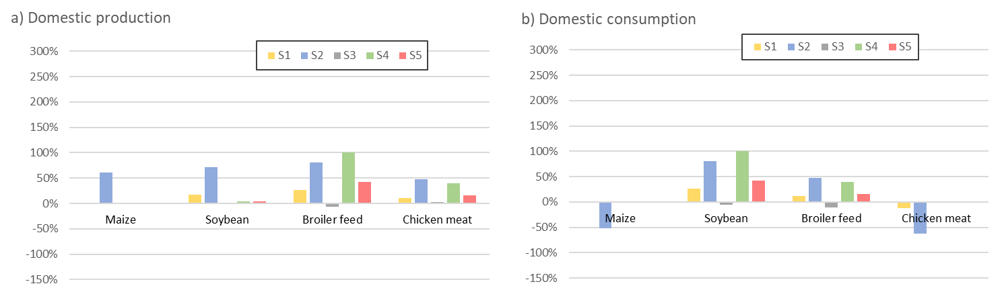
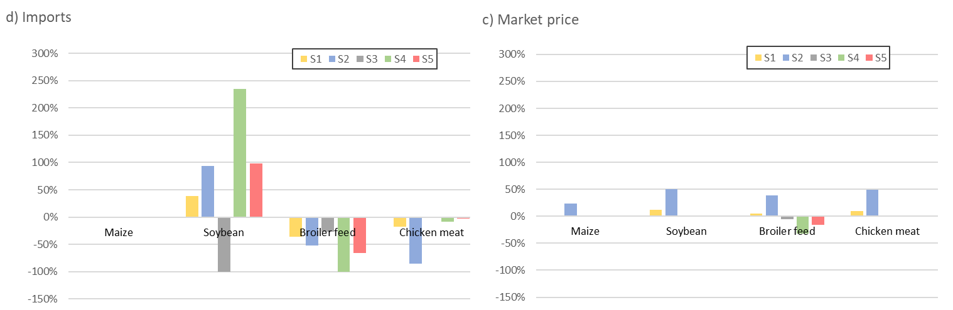
Source: Own calculations.

Figure 6. Net welfare changes in the Ghanaian poultry value chain
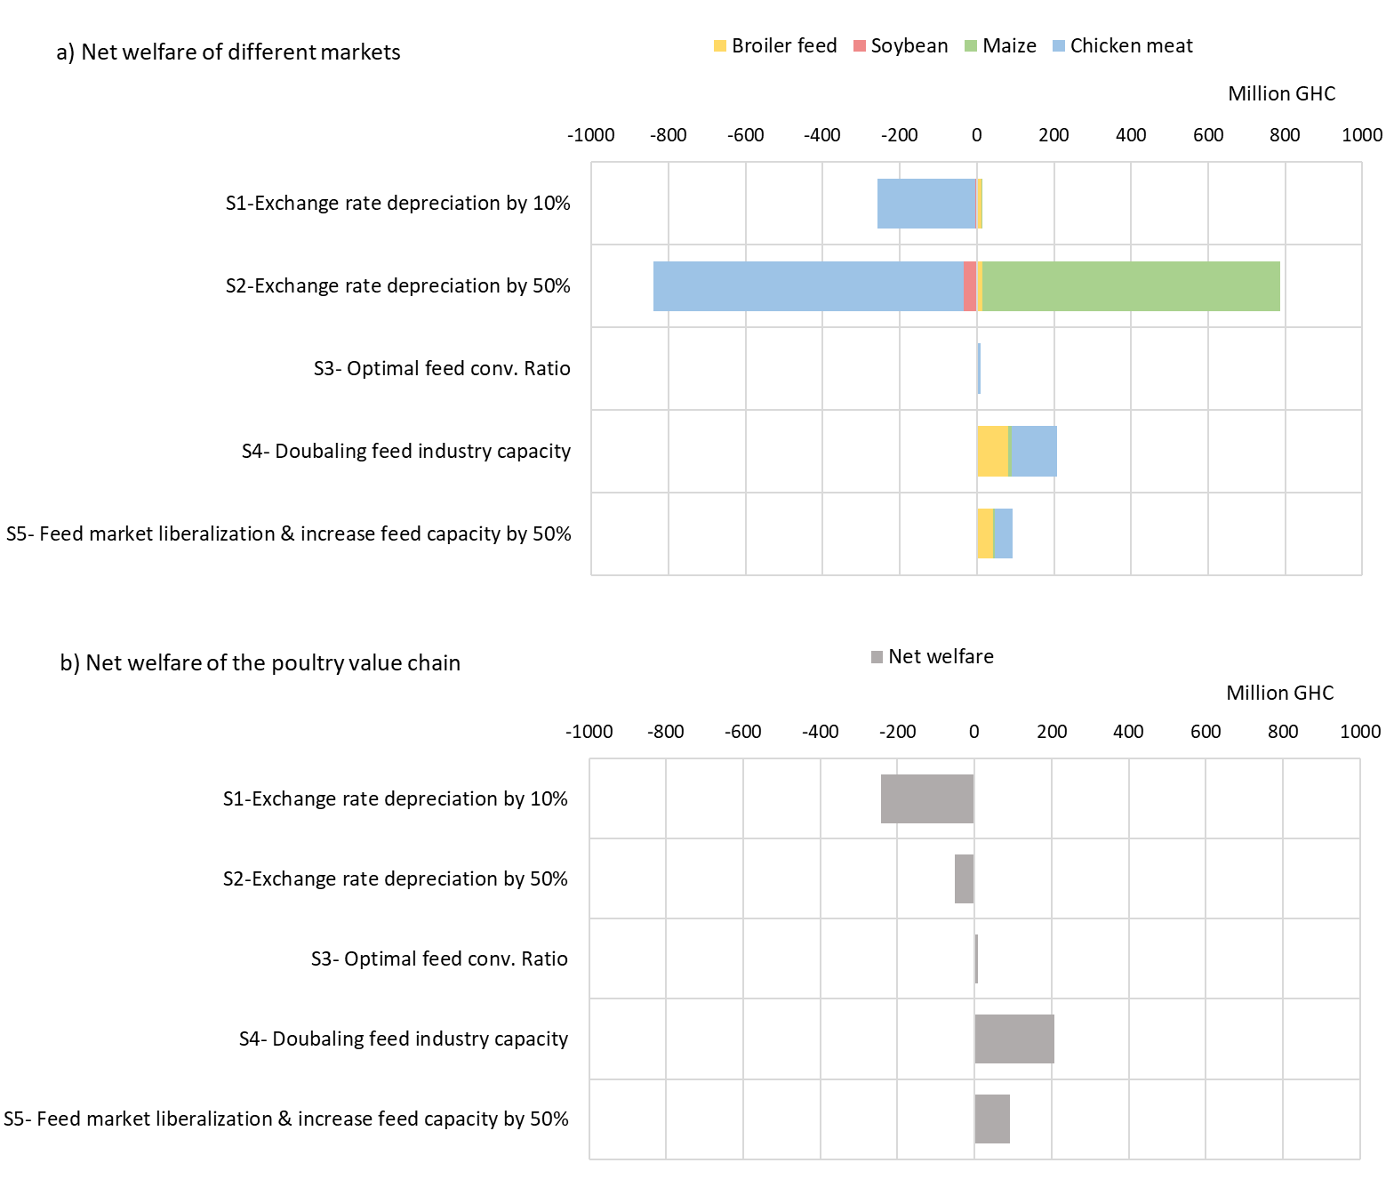
Source: Own calculations.

Policy Measures
In the previous chapters, we have identified feed costs as a significant factor for the competitiveness of the poultry sector in Ghana. This raises the questions: What policy measures can be implemented to reduce feed costs and increase production? What other effects do these measures have? Zamani et al., (2022) shows that the abolishment of tariffs for feed ingredients that are around 5% has almost no effect on agricultural trade or production costs and thus on the domestic production level (compare Table 3). Rather the improvement of the feed processing capacity and efficiency may help producers to reduce the costs of production. Here, we develop a policy scenario in which we subsidize feed for poultry production. The amount of the subsidy is equal to the tariff revenue generated by imported poultry meat. Currently, Ghana levies a 35% tariff on poultry meat imports and generates tariff revenue that could be used to support the domestic poultry industry. If the tariff revenue is used entirely as a feed subsidy the domestic production could increase up to a level of 221% (compare Table 3). It is not only the producers that benefit from this subsidy. Prices for consumers decrease by 24% and they increase their consumption of poultry meat by 14%. Our results indicate that the consumers are not substituting poultry meat with other products. In sum they seem to consume more food as a result of the decline in the price for poultry meat. However, they substitute imported poultry meat with domestic poultry meat.
Table 3. Impact of a subsidy on feed in 2030
Domestic production of poultry meat | 221%
Consumer price for poultry meat (domestic & imported) | -24%
Private consumption volume of poultry meat | 14%
Import value of poultry meat | -52.2%
GDP | -0.125
Source: Zamani et al. (2022); Own calculation
Table 4 shows which imports from which countries decrease due to a subsidy. Imports from the US and the EU decrease most. In total, poultry meat with a value of 62.2 thousand US$ less is imported from the US and 62.51 thousand US$ from the EU. Although the imports from Brazil decrease significantly by 18.37 thousand US$. Trade with other regions of the world including the intra African trade is only slightly influenced by the subsidy.
Table 4. Impact of a subsidy on feed on imports in 2030 (1000 US$)
EU15 | -59.58
CEEC13 | -2.93
USA | -62.2
Canada | -1.23
Mexico | -2.49
Brazil | -18.37
Rest Africa | -0.97
Rest of the World | -3.88
Source: Zamani et al. (2022); Own calculation

Complete ban and farm performance
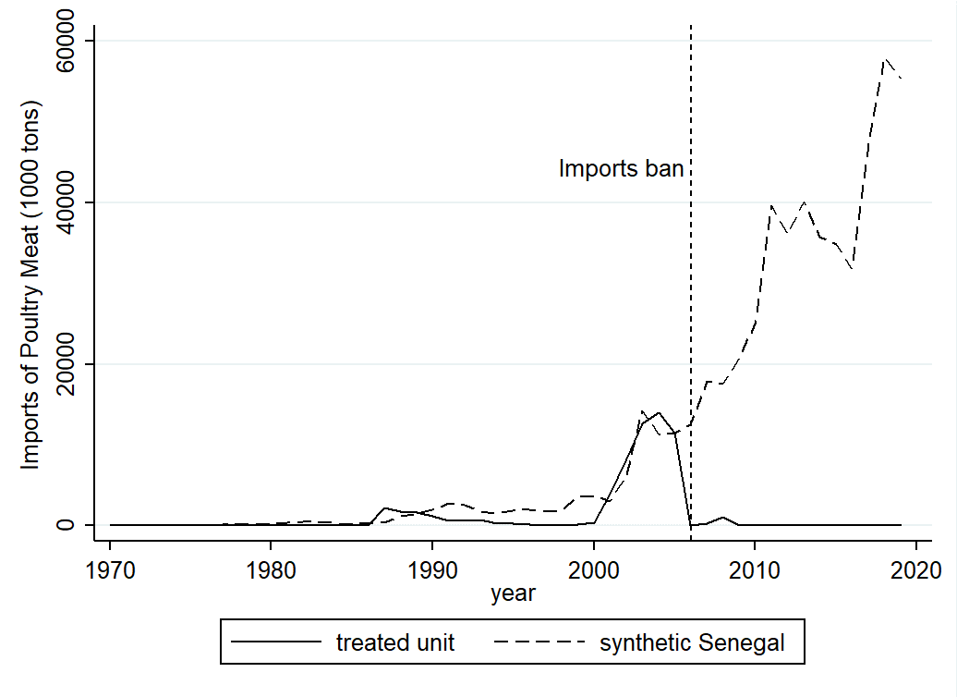
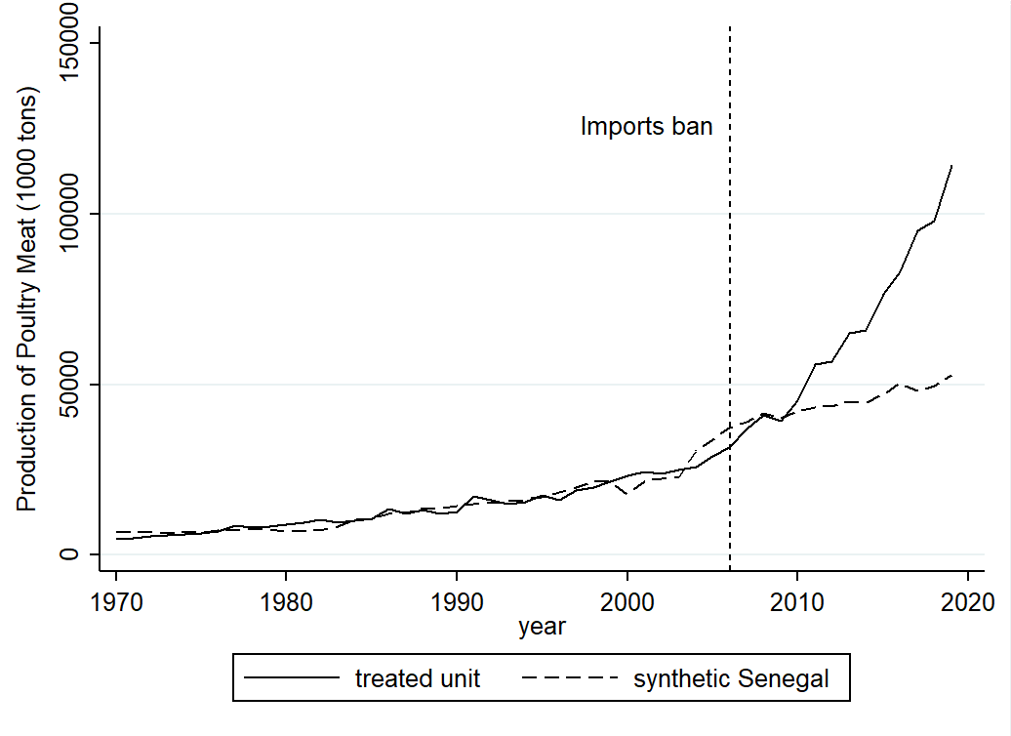
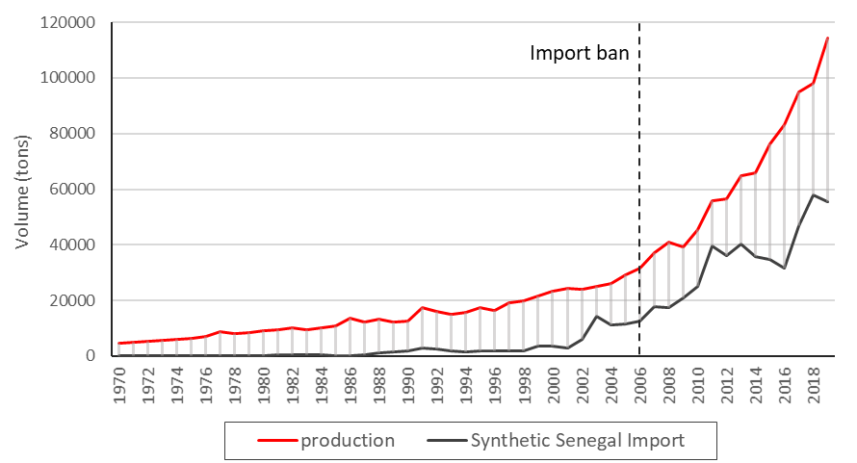

References
FAOSTAT, R. (2020). FAOSTAT database. Food Agric. Organ. UN.
Andam, K. S., Johnson, M. E., Ragasa, C., Kufoalor, D. S., & Das Gupta, S. (2017). A chicken and maize situation: the poultry feed sector in Ghana (Vol. 1601). Intl Food Policy Res Inst.
Sumberg, J., Awo, M., & Kwadzo, G. T. M. (2017). Poultry and policy in Ghana: Lessons from the periphery of an agricultural policy system. Development Policy Review, 35(3), 419-438.
Netherlands Enterprise Agency (2019): Analysis poultry sector Ghana. An update on the opportunities and Challenges. Netherlands Enterprise Agency (RVO.nl).
Zamani, O., Chibanda, C., & Pelikan, J. (2022). Impacts of Import Restrictions on Poultry Producers in Ghana. Q Open.
Takayama, T., & Judge, G. G. (1964). Equilibrium among spatially separated markets: A reformulation. Econometrica: Journal of the Econometric Society, 510-524.
Samuelson, P. A. (1952). Spatial price equilibrium and linear programming. The American economic review, 42(3), 283-303.
Amoah, L., & Aziakpono, M. J. (2018). Exchange rate pass-through to consumer prices in Ghana: is there asymmetry?. International Journal of Emerging Markets.
Zamani, O., Pelikan, J., & Schott, J. (2021). EU exports of livestock products to West Africa: An analysis of dairy and poultry trade data (No. 162). Thünen Working Paper.
Enu, P., & Attah-Obeng, P. (2013). Which macro factors influence agricultural production in Ghana?. Academic Research International, 4(5), 333.
Andriamananjara, S., Brenton, P., Von Uexkull, J. E., & Walkenhorst, P. (2009). Assessing the economic impacts of an economic partnership agreement on Nigeria. World Bank Policy Research Working Paper, (4920).
Akunzule, A. N., Koney, E. B. M., & Tiongco, M. (2009). Economic impact assessment of highly pathogenic avian influenza on the poultry industry in Ghana. World's Poultry Science Journal, 65(3), 517-528.
Johnson, M. C. (2011). Lobbying for trade barriers: a comparison of poultry producers' success in Cameroon, Senegal and Ghana. The Journal of Modern African Studies, 49(4), 575-599.
Krueger, A. O., & Tuncer, B. (1982). An empirical test of the infant industry argument. The American Economic Review, 72(5), 1142-1152.

Since the ECOWAS CET was implemented after Senegal’s poultry ban, for 115 tariff lines, including poultry products, Senegal applies custom duties exceeding the WTO-bound tariff (WTO, 2017). Senegal’s bound tariff must stand within the range of 15% to 30%, but the rate of ECOWAS for poultry meat is 35%. The ECOWAS member states are negotiating to find solutions for these inconsistencies (WTO, 2017).
We base our empirical model on Andam et al. (2017). However, our model majorly focuses on broiler sub-sector including domestic soy production and regional feed conversion rates. Our model also includes the national production of soybean in Ghana.
Woltjer et al. (2014) provide a detailed description and assumptions of MAGNET.

