Estimating labor-market transition matrices and their determinants in low- and middle-income countries: The case of Mexico
Abstract
[To be added at the end]

Introduction
This research aims to investigate the relationship between international trade and labor market dynamics in Mexico, specifically focusing on the formal and informal sectors, labor force participation, occupations, and industries. Although international trade has the potential to foster economic development by facilitating labor reallocation from less productive to more productive sectors, assessing its impact on labor market dynamics is often challenging due to data limitations, which hinders accurate measurements of transitions.00000 Recent labor-market models incorporate switching costs for workers who wish to move across sectors due to trade, with structural estimates suggesting that these costs can represent several months or years of a worker's earnings. Labor-market frictions can also arise from search costs for firms, which link worker outcomes to changes in foreign competition in the initial firm, industry, or region of employment. However, until recently, there has been insufficient evidence on how individual workers adapt to trade shocks (see Autor, Dorn and Hanson 2016, Artuc¸ et al. 2010, Dix-Carneiro 2014, Pessoa 2016, Ashournia 2015). While existing literature has explored the impact of trade on labor market outcomes in developing countries, most of these studies have been confined to formal employment or urban areas (Goldberg and Pavcnik 2007, and Harrison, McLaren, and McMillan 2011, provide surveys on this topic).
To contribute to the existing literature, this study uses a novel database for Mexico that provides more recent and granular data on labor market performance and trade at the city level, constructed from the National Occupation and Employment Survey (ENOE) and Panjiva Global Trade Database. Using this data, we investigate the relationship between exports and labor market transitions while controlling for various factors, including worker characteristics, time, and region.
Furthermore, the study presents a methodology for assessing the impact of changes in local export orientation on labor-market dynamics using microeconomic panel data for low- and middle-income countries. The use of a high-dimensional fixed effects model used to control for export-exposure, economic controls at the metropolitan area, and unique individual characteristics provides a robust analysis.
The methodology is showcased for the case of Mexico, given the heterogenous trade-exposure of its local labor markets, publicly available microdata, and export statistics at the municipality level. We estimate different types of labor market transitions across four different labor market categories: labor force and informality status, occupations, and industries.
Moreover, this study examines the relationship between exports and worker transitions, while controlling for worker’s characteristics, time, and regions, at the city level. The results indicate a positive effect of exports on worker transitions, albeit only at the regional level and not across the entire country. The estimation of different types of labor market transitions across four different labor market categories (labor force and informality status, occupations, and industries) further enhances the study’s significance.
This study’s findings offer critical insights into the complex dynamics between trade and labor markets, underscoring the need for tailored policy interventions to address the varied regional impacts of trade. These insights may be particularly relevant for policymakers and researchers interested in understanding how economic shocks, such as tariff reductions, impact labor markets the city level.
The paper is organized in four sections that cover a review of the recent literature on estimation of labor transition matrices, data and methodology, estimation results and a discussion on how these estimates could be used to inform and calibrate ex-ante simulations, such as those in dynamic computable general equilibrium (CGE) models.

Literature Review

Labor market transitions in LMI countries
Labor market dynamics in low-and-middle-income (LMI) countries have received significant attention in recent years, particularly with regards to the movement of workers from formal to informal employment, and the dynamics of job loss and hiring. A variety of studies have focused on transitions between different types of employment, workers’ characteristics, and sectors in developing economies. Studies examining transitions between different types of employment have been conducted by Bosch and Maloney (2021), Conover, Khamis and Pearlman (2022), Samaniego and Viegelahn (2021), and Gutierrez et al. (2019), among others. The impact of workers’ characteristics such as age, gender, education, and income on transition probabilities has been identified in several studies, including Herrera and Rosas Shady (2003), Tansel and Ozdemir (2019), Theodossiou and Zangelidis (2009), and Cuesta and Bohorquez (2014).
However, there is a gap in the understanding of how trade policy and shocks impact the transitions of workers into and out of the labor force, across industries and occupations, and between formal and informal jobs. Bosch and Maloney (2021) investigated the cyclical properties of unemployment and informality in Mexico and Brazil by employing a Markov process and constructing a transition matrix that reflects the probability of transitioning from one employment state to another. Their findings provide insight into the mobility process of workers between different types of employment and the available "spaces" in each state (Bosch and Maloney 2007).
Conover, Khamis and Pearlman (2022) used multinomial logit and transition matrices to explore the relationship between education and labor market outcomes among young, male, urban workers in Mexico. Their research showed that education is strongly correlated with formal and higher quality employment. Similarly, Tansel and Ozdemir (2019) used Markov chain models to estimate transition probabilities in Egypt from 2006 to 2012 by gender, considering eight different labor market states. They found that workers’ characteristics, particularly education, were associated with transition probabilities across several labor market states.
Herrera and Rosas Shady (2003) also used a multinomial logit to study the odds of moving from one state to another given workers’ characteristics, using the Peruvian National Household Survey (ENAHO) for the period 1997-1999 to estimate labor market transitions among the employed, unemployed, and those exiting or entering employment. They concluded that most labor transitions occur between unemployment and inactivity (and vice versa), particularly in urban areas.
Cuesta and Bohorquez (2014) investigate how personal characteristics and circumstances affect labor transitions. They also find age, gender, education, and income to be important factors on transitions, whereas marital status did not seem to affect the likelihood of transitions.
Additional research of transition matrices was done for Bangladesh. Gutierrez et al. (2019) study the transitions between different types of formal and informal employment. They gather data of workers transitions between different types of employment in Bangladesh and find substantial amounts of transitions between employment types.
Samaniego and Viegelahn (2021) estimate transition rates for the case of Vietnam. They look at worker transitions and transition probabilities for the period 2011-19 using micro-level data on individual’s employment status and job type. Similar to the type of data we have for the Mexican case, Vietnam’s data is a rotating panel, with individuals that can be tracked for a period of time. They estimate 4 categories of transitions (labor force status; formal job; industry; and occupation). An advantage of Samaniego and Viegelahn (2021) research is that it considers also transitions among different industry sectors and occupations, as well as considering the different biases that could appear when estimating the transition matrices if they are not taken into consideration.
In the case of Mexico, transition matrices can be constructed using similar methodologies as those employed by Samaniego and Viegelahn (2021). Additionally, the inclusion of worker and job characteristics, as done by Tansel and Ozdemir (2019) in their study of Egypt, and Conover, Khamis and Pearlman (2022) for Mexico, which can improve the accuracy of the estimated transition probabilities. Understanding the dynamics of labor market transitions is crucial for policymakers to develop policies that promote formal and higher quality employment opportunities for workers in LMI countries.

Labor mobility and trade
Trade can exert a substantial influence on labor market transitions, whereby the export of commodities and services may generate fresh employment prospects in expanding industries. This, in turn, can give rise to labor market transitions, as workers shift from declining sectors to flourishing ones. Nonetheless, the ramifications of trade on such transitions are intricate and contingent upon the unique conditions of each nation. There are only a few studies that can track individual workers through time to see what happens to them in the short-term.
Arias et al. (2018) have constructed a model for Mexico that accounts for the friction costs associated with the transition between formal and informal employment and the impact of trade liberalization. Using a sectoral mobility framework that incorporates the endogenous switching of workers between sectors and employment statuses based on expected employment prospects, the study reveals that inter-industry labor mobility costs are significant. However, the cost of entry into informal employment is markedly lower than that of entry into formal employment. The authors' study contributes to the existing literature by assessing how labor market frictions engender dissimilar effects of trade shocks on various categories of workers, particularly skilled versus unskilled and formal versus informal employees.
A recent World Bank study (see Vazquez and Winkler 2023), found that trade liberalization in Mexico has had a positive impact on employment conditions by creating formal employment opportunities that provide workers with pensions and job security. The study revealed that export-oriented trade has led to reductions in informality and an influx of domestic migrants. Municipalities with high exports per worker have lower informality rates and less employees without pension or retirement benefits. Research on this paper complements the results found by Vazquez and Winkler (2023) by analyzing how trade can also affect workers transitions among different sectors, informality, and occupations.
McCaig and Pavcnick's (2018) research analyzes the effects of a positive export shock on labor allocation between the informal, microenterprise sector and the formal firm sector in Vietnam. The authors utilize data from the United States-Vietnam Bilateral Trade Agreement, which resulted in significant reductions in US tariffs on Vietnamese exports, to examine the impact of this shock on labor allocation. Their study shows that in response to the US tariff reductions, the share of manufacturing workers in the formal sector increased by 5 percentage points. The shift was greater for workers in more internationally integrated provinces and younger age groups.
Menezes-Filho and Muendler (2007) conducted a study that combined the Melitz (2003) model with worker heterogeneity to assess the impact of trade liberalization on jobs in Brazil during the 1990s. They used a rich dataset that linked worker-level panel data with firm-level and industry-level data to test the most advanced trade models. Their results showed that trade liberalization led to net employment losses in exporting firms and firms with a comparative advantage. They also found that tariff reductions and increased import penetration increased the likelihood of workers transitioning into informality and unemployment, with a lower probability of transitioning back to formal employment. In addition, they observed longer reallocation times for workers moving from one formal-sector job to another. The study's results were robust to different levels of exposure to trade, firm-level productivity, worker heterogeneity, and general trends in the country during the period studied.
The article of Artuc, Lederman and Rojas (2015) discuss the impact of China's export and import growth on Latin American producers. The shift in aggregate demand faced by exporters varied across countries and sectors. Latin American manufacturing exporters faced lower prices and increased competition, while the increase in Chinese raw material imports contributed to the recent increase in commodity prices. The effect on wages and employment varied across countries and sectors. The article developed vulnerability and opportunity indices for manufacturing, mining, and agriculture to quantify the impact of China on each sector's trade balance in a large sample of Latin American economies. The article estimated a neoclassical small open economy model with labor market adjustment costs using Argentine, Brazilian, and Mexican data. It simulated the effect of changes in labor demand across sectors to study labor-market adjustments caused by the growth of Chinese exports in global markets. The report found that the positive shocks in agriculture and mining offset the negative shock in manufacturing, leaving the total level of employment and real wages almost at the same level in Argentina and Brazil. In Mexico, the larger shock in manufacturing provokes a reduction of employment in the long run. The highest mobility cost is found for workers moving out of informality into formality while changing sector towards agriculture or mining, limiting the movement of workers to these sectors positively affected by China.
For developed economies, Caliendo and Parro (2015, 2019) present a comprehensive framework that enables large-scale quantitative analyses while preserving key economic insights that yield meaningful results. The model also facilitates the assessment of effects that are typically challenging to quantify or identify in reduced-form empirical research. By leveraging the growth of Chinese import competition, (Caliendo and Parro 2015) estimate the overall and disaggregated employment and welfare effects on the U.S. economy. In contrast Caliendo and Parro (2019) examine the general equilibrium effects of a surge in China's productivity, which led to increased penetration into the U.S. market. Their model takes into account labor mobility frictions, goods mobility frictions, geographic factors, input-output linkages, and international trade in shaping the effects of shocks across various labor markets.
Asquith et al. (2019) investigate the impact of the China shock on U.S. job flows by analyzing employment data for establishments in different industries and commuting zones. They estimate the effects of the shock on each component of job flows at both industry and commuting-zone levels. While (Bernard et al. 2003), and Melitz (2003) have also examined the impact of trade liberalization on gross job creation and destruction, their studies relied on establishment data and did not account for the movement of workers from one industry to another.
Davidson et al. (2014) investigate the influence of globalization on the correlation between firm and worker quality by the comparative advantage of different industries. Using worker-firm data from Sweden, the authors examined the effect of trade openness on the matching between workers and firms across industries with varying degrees of comparative advantage. Their findings reveal that openness to trade positively affects the matching between workers and firms in industries with greater comparative advantage, indicating that globalization can lead to a more efficient allocation of labor. However, the authors note that the impact of globalization on the correlation between worker and firm quality is limited in industries with lower comparative advantage.

Mexico trade performance since 2005
Our research uses data available for Mexico for the period from 2005 to 2019. During this period, Mexico’s trade liberalization policy has had a significant impact on the country's economic development, especially in international trade. Since 1994, when Mexico joined the North American Free Trade Agreement (NAFTA), the proportion of goods and services exported as a share of GDP has increased from 20.3% to 41% in 2021. This has led to a fourfold increase in the total value of Mexico's exports to US$465 billion, putting it in a favorable position compared to countries like Thailand and Malaysia (Vazquez and Winkler 2023). NAFTA eliminated most tariffs on traded goods between Canada, Mexico, and the United States and removed barriers to cross-border investment, which led to Mexico's trade boom. The United States-Mexico-Canada Agreement (USMCA) implemented in 2018 is expected to maintain Mexico's robust trade relationships with its northern neighbors.

Data

The National Survey of Occupation and Employment
The National Survey of Occupation and Employment (ENOE) is a household survey that aims to gather detailed information on labor force status, occupation, industry, wages, and demographic characteristics. It covers all 32 states and 39 cities in Mexico, with a focus on urban areas, and is representative at both national state levels and city level.
The ENOE employs a rotating panel structure, wherein the same households are interviewed for five consecutive quarters every year from 2005 to 2020, with one-fifth of the sample being replaced each quarter. Data from the survey is harmonized for the period spanning from the first quarter of 2005 to the fourth quarter of 2019. This yields a dataset comprising 60 time periods, with over 12 million observations obtained from more than 2 million individuals and approximately 120,000 households in each quarter. The initial sample size of 2,443,993 individuals was derived after filtering for those within the working age range of 16 to 64 years old and that had the first interview and subsequent interview with an interval of no more than 3 months apart..
The average annual sample size for Mexico is around 420,000 for females and 368,000 for males, with approximately 39% of all formal workers being female. Meanwhile, around 41% of informal workers are females and 77% are not employed.
The use of individual panels spanning a two-year period comprising five quarters provides a unique opportunity to closely monitor labor market transitions at the individual level. This is made possible by employment data obtained from household surveys that cover all sectors of the workforce, including agriculture, manufacturing, and services, as well as formal and informal sectors and occupations, and worker characteristics.
The available data allows for the creation of employment transition matrices that reflect transitions between sectors, workers' characteristics, and formality status. These matrices can be constructed quarterly and annually, using the first and fifth interviews of each individual to obtain yearly transitions. As a result, a total of fourteen year-on-year transition matrices can be obtained, with the first matrix reflecting transitions between 2005 and 2006 and the most recent matrix capturing transitions between 2018 and 2019.
The ENOE dataset is an invaluable resource for researchers and policymakers who seek to understand the dynamics of the labor market in Mexico. Its comprehensive coverage, rotating panel structure, large sample size, and consistent measurement of informality make it a reliable source of information for conducting rigorous analyses. Moreover, the ENOE dataset measures informality in a consistent manner that is in compliance with International Labor Organization (ILO) standards. This ensures that the data is comparable across countries and over time.
Figure 1 shows the proportion of individuals who were employed in each quarter of the survey period. The figure indicates that, on average, around 64% of the sample was employed during each quarter. This suggests that the labor market in the surveyed areas remained relatively stable throughout the survey period.

Figure 1 Percentage of workers employed through the years has remained stable
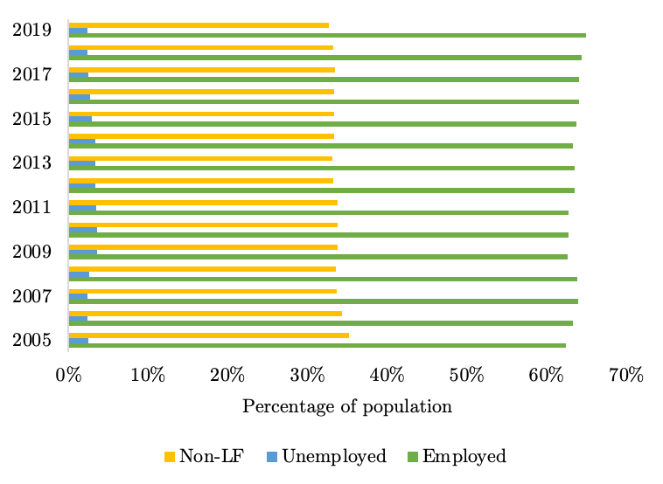
Source: World Bank Staff elaboration based on ENOE.

Our research, enabled by the ENOE microdataset, has allowed us to generate insights into the gender disparities in educational attainment at a granular level. The dataset has also enabled us to construct representative indicators at the city level that are statistically significant and contribute to a more nuanced understanding of labor market trends.
The analysis has revealed that the largest disparities between the shares of women and men with years of education occur in the range of 17 to 21 years of education. Within this range, we have found that women aged 25-34 and 35-44 tend to have a positive gap over their male counterparts, suggesting that they are more likely to have obtained higher levels of education than men in the same age groups (Figure 2).
Figure 2 Gender gap in education by age groups
Source: World Bank staff calculations using data from ENOE

Table 2 provides a summary of the data used in this study, presenting employment shares disaggregated by gender, occupation, and formality status. The results indicate that the formal sector is dominated by men in professional, service and market sales, and machine operator occupations, accounting for 15.6%, 18.5%, and 16.6% of the male workforce, respectively. In contrast, the informal sector employs the largest share of male workers in elementary occupations, craft workers, and skilled agricultural occupations, representing 24.3%, 22.3%, and 17.4% of male workers, respectively.
For females, the results reveal that the largest share of formal workers is concentrated in professional occupations, representing 24% of the female workforce, followed by service and market sales (19.4%) and technicians (15.3%). In contrast, women in the informal sector tend to be employed in service and market sales (38.8%), elementary occupations (30.7%), and craft workers (10.8%).
Overall, the findings suggest gender differences in occupational segregation across the formal and informal sectors. While men tend to dominate in skilled and technical occupations in the formal sector, they are more likely to work in manual and low-skilled occupations in the informal sector. On the other hand, women are concentrated in service-oriented occupations in both formal and informal sectors, but are more likely to be employed in low-paid and insecure jobs in the informal sector.

Table 2 Employment shares by gender and formality status
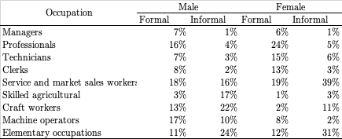
Source: World Bank Staff elaboration based on ENOE.

Exports at the sub-national level
We also utilize the Panjiva Global Trade Database, a comprehensive dataset of global shipping data that provides firm-level quarterly export shipment information. Our analysis focuses specifically on Mexico's export data, which has been collected by Panjiva since 2011. The dataset is derived from bills of landing collected from Mexican Customs and contains 918,953 records of firm-level quarterly export shipments between 2011.Q1 and 2022.Q1.
The sample consists of 77,678 unique firms, with SIC industry classification data available for approximately one-third of all registered firms (25,244 firms), accounting for 79% of the total export shipment values. We find that only 12.17% of the total number of firms (9,453 firms) are responsible for 99% of the total export shipment values. Furthermore, SIC information is available for 6,296 of the top 99% firms by export value, constituting two-thirds of this group.
Analyzing the data across the entire period, we find that the median shipment value for all firms is $0.17m, while the mean shipment value is $73.28m. For the top 12.17% of firms, the median shipment value is $56.56, and the mean shipment value is $596.2m. In contrast, for the bottom 1% of firms, the median export value is $0.10m, and the mean export value is $0.83m.
These findings indicate significant heterogeneity in the distribution of export shipments across firms, with a small number of firms accounting for a large share of the total export shipment values. Such insights can provide valuable guidance for policymakers and researchers looking to understand the factors that influence firms' export performance and identify strategies for promoting trade growth and competitiveness.
Figure 2 presents the export per worker in Mexico at the municipal level. The map shows that the northeast and northwest regions have the highest export per worker, which can be attributed to their proximity to the United States of America border, a major trading partner for Mexico. In contrast, the central region and the Pacific west have municipalities with both high and low levels of exports per worker.
The South and Southeast regions exhibit the lowest levels of exports per worker, which is not surprising given their distance from the border and other characteristics such as lower income levels. These results highlight the importance of geographic location as a factor influencing firms' export performance. Municipalities closer to major trading partners may have an advantage in terms of access to markets, while those farther away may face additional barriers to trade.
These findings can have implications for policymakers and businesses seeking to promote trade and economic growth in Mexico. Understanding the geographic distribution of exports and the factors that contribute to it can inform targeted policy interventions aimed at addressing regional disparities and promoting trade competitiveness.
In addition to their implications for trade and economic growth, the results of Figure 3 can also have implications for labor transitions among different regions in Mexico. The regional disparities in exports per worker suggest that workers in municipalities with low levels of exports may face challenges in finding employment opportunities that offer higher wages and greater job security.
Conversely, workers in municipalities with high levels of exports may have better job prospects and opportunities for upward mobility. These dynamics can affect patterns of labor migration and the distribution of human capital across regions in Mexico.
Overall, these results highlight the complex interplay between regional economic performance, trade, and labor markets. Understanding these dynamics is essential for developing effective policies and strategies to promote inclusive economic growth and development across Mexico's regions.

Figure 3 Exports per worker at the municipal level
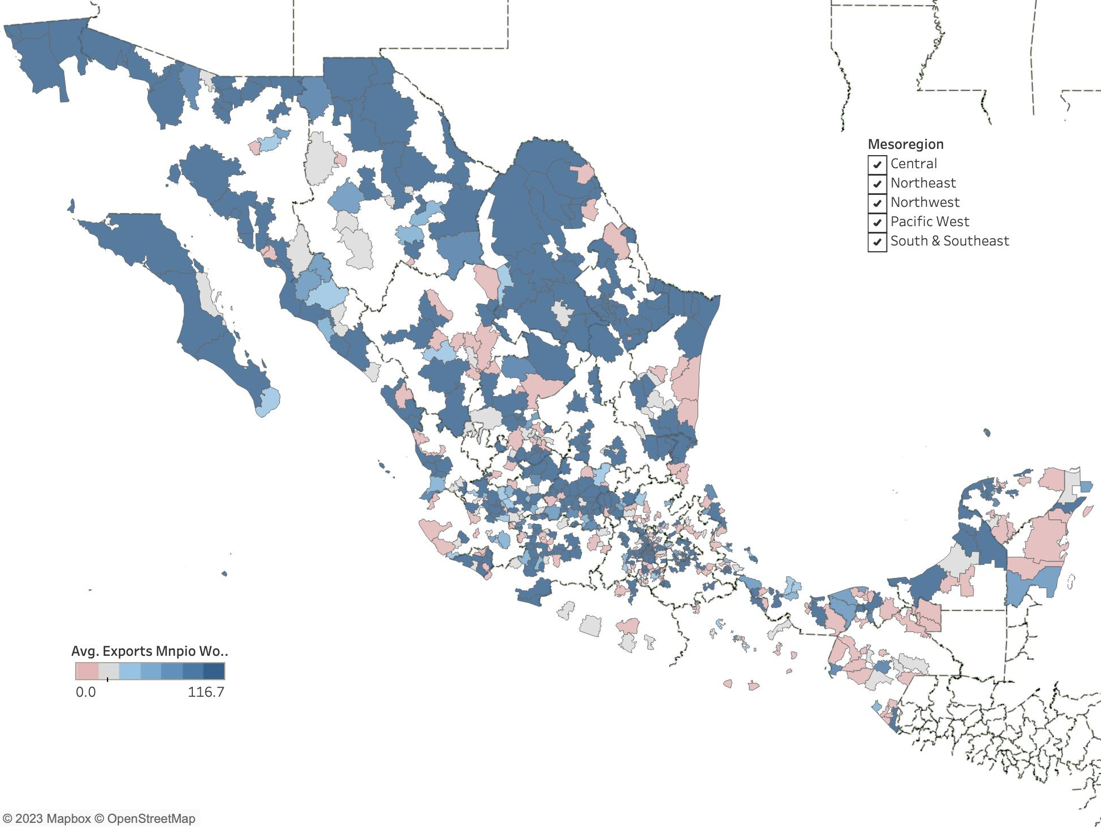
Source: World Bank Staff elaboration based on Panjiva Global Database and ENOE.

Methodology
The paper begins by examining job market transitions across four distinct labor market categories, namely labor force and informality status, occupations, and industries. To estimate these transitions, the study employs the ENOE database and builds on the methodology developed by Samaniego and Viegelahn (2021)
The approach used by Samaniego and Viegelahn (2021) is based on the flows of workers and jobs, which are influenced by labor demand, matching between workers and firms, and wage determination. This approach recognizes the dynamic nature of labor markets and considers the probabilities of individuals moving into and out of different labor market states.

By understanding how socio-demographic transitions can impact the share of individuals in each labor market state, the study provides valuable insights into the distribution of labor market opportunities and outcomes across different groups (See also Blanchard and Diamond (1992)).

Labor force status (LFS): employed, unemployed, out of the labor force.
Formal job (FNJ): employed with a formal job, employed with an informal job, not employed.
Industry (IND): 4-digit ISIC code of primary job
Occupation (OCCU): 1-digit occupational classification for primary job
Let C ∈ {LFS, FNJ, IND, OCCU} be the set of these 4 categories, labelled as c.

Each c is composed of $s_{c}$ mutually exclusive statuses. For each pair of statuses (j,k) in category c, we estimate transitions from state j in quarter t to state k in quarter t+1 as the weighted sum of all individuals who transition between these two states

${N(j,k)}_{t}=\sum_{i}{\left(c{ \atop i,t}=j, c_{i,t+1}=k\right){w_{i}}^{}}$ 1
The transition probabilities out of state j into state k in period t are obtained by dividing the weighted flows by the weighted sum of all individuals in state j in period t.
We consider two possible weights: sampling weights and attrition revised weights. Sampling weights are provided by Mexico’s National Institute of Statistics and Geography (INEGI) as frequency weights, without any further adjustment. These weights are meant to reflect the occurrence of each observation in the general population of Mexico.
For the attrition revised weights, the paper follows Fallick and Fleischman (2001) and (Samaniego and Viegelahn 2021) using the inverse probability weights. It estimates the attrition probability for different groups in the sample, and then uses the inverse estimated match rate to reweight the observation in the sample.
The first step in the analysis involved estimating probit models of attrition for each quarter using equation $2$ where ${attrit}_{i,t}$ is an indicator variable that takes a value of 1 if individual $i$, who is in the survey’s sample in quarter t, cannot be matched to with an observation in the subsequent period $t+1$, and takes a value of zero otherwise. The model also includes a set of fixed effects, represented by $g,t$, which capture the interaction between the individual’s gender, civil state, literacy, and age groups (grouped in 10-year age bins).

${attrit}_{i,t}=\sum_{g}{γ_{g}^{t}+∈_{i,t}}$ $SEQ Equation \backslash * ARABIC$$2$
The predicted attrition probability for each group $g$ is used to estimate a relative attrition probability and scale the sampling weights using the relative attrition probability.

$ω_{i}^{att}=ω_{i}×\frac{\hat{{attrit}_{i,t}}}{{attrit}_{t}}$ 3
The individual sampling weight, denoted as $ω_{i}$ is calculated using the individual’s $i's$ sampling weight and ${attrit}_{t}$, which is equal to 1 minus the share of matched observations in quarter t. The reweighting process involves using the inverse of the match rate for each group to adjust the weights. This means that transitions by individuals in groups that are more likely to drop out of the sample are given more weight, thereby compensating for their higher attrition rate.
It is important to note that this paper does not account for the presence of classification errors and does not make any corrections to address this issue.
The transition probabilities presented in this report were estimated using a linear probability model, which takes into account a diverse set of variables designed to control for workers' characteristics. These variables encompass age category, education level, literacy, gender, firm size, and urban location, along with a series of time fixed effects. Notably, the regression analyses also account for attrition weights, which are utilized to improve the accuracy of the estimations. To calculate the attrition weights used in this study, a probit model of attrition was estimated for each quarter of the sample, following the methodology proposed by Samaniego and Viegelhan (2021). The authors provide a detailed explanation of the procedure, which involves estimating a model of attrition using data from previous quarters and using the predicted probabilities from the model to create weights for the current quarter. These weights are then applied to adjust the sample to account for attrition bias.
The second section of our study focuses on investigating the effect of trade on labor market transitions using a multilevel fixed effect linear model that incorporates multiple levels of fixed effects. This model considers various factors such as individual-level characteristics, occupation, industry, and geographical location that may impact labor market transitions. Our research reveals that unobserved worker characteristics are significant determinants of transitions and can obscure the estimated impact of trade on labor market transitions if not controlled for. The examination of the relationship between trade and labor market transitions provides valuable insights into how international trade patterns can influence employment opportunities and outcomes for various groups of workers. The findings of this analysis have important implications for policymakers seeking to promote equitable and sustainable economic growth within the context of globalization.

Results

Transitions across industry sectors
The presented data in Table 2 indicate a notable shift in labor allocation across sectors in the economy, with the services sector becoming the largest employer during the period between 2005 and 2020. This suggests that the demand for services has risen in comparison to primary sectors such as agriculture, fishing, extractive industries, and mining. This transformation may signify a structural change in the economy, with a shift towards service-oriented industries characterized by specialized skills in fields such as finance, healthcare, and information technology. The decline in employment opportunities in primary industries may be due to several factors, including globalization, automation, and changes in consumer preferences. The decline in employment opportunities in primary industries could stem from various factors, including globalization, automation, and shifts in consumer preferences.

Table 2. Difference in the share of workers between 2005-2020 by sector for Mesoregions in Mexico
Source: World Bank Staff elaboration based on ENOE.

This section presents an analysis of labor market transitions across economic sectors at the 2-digit level. Our study findings suggest that workers employed in the agriculture sector are more likely to transition towards the construction, manufacturing, and commerce sectors in comparison to other economic sectors.
The analysis reveals that workers in the agriculture sector are more likely to transition to the construction, manufacturing, and commerce sectors compared to other economic sectors. This finding is based on an examination of the socio-demographic characteristics of these workers, which suggests that specific factors may influence their decisions to switch sectors. For instance, agricultural workers are highly likely to remain in their current sector, while the likelihood of transitioning to the manufacturing sector is much lower at 0.2%. Consequently, workers in the agriculture sector tend to move to related sectors such as construction.
The agriculture, commerce, and manufacturing sectors demonstrate the lowest probabilities of transitioning to other economic sectors, while the mining, public utilities, transport, and financial and business services sector exhibit the highest frequency of workers transitioning to different sectors. These results contrast with those of Samaniego and Viegelahn (2021), who found that financial service activities, education, and human health activities had the lowest probabilities of transitioning to another economic sector in Vietnam. This indicates that specific sectors may be more dynamic and offer more opportunities for workers to explore different career paths.
Several factors contribute to differences in the likelihood of transitioning to different economic sectors, such as skill requirements, wage disparities, informality rates, and other job quality and worker characteristics indicators. Nevertheless, workers tend to remain in their current industry in most economic sector categories. This suggests that industry-specific factors play a significant role in determining employment decisions and transitions. The analysis also indicates that the probability of remaining in the same economic sector decreases more rapidly for yearly transitions compared to quarterly transitions, which suggests that workers are more likely to switch to a different sector of economic activity over the long term, as opposed to short-term transitions.
This finding has important implications for businesses and policymakers, as they need to anticipate changes in the labor market and adjust their strategies accordingly. For example, businesses may need to invest in training programs to adapt to changing demands in the labor market, while policymakers may need to implement policies that support workers in transitioning to new sectors of economic activity.

Table 5. Transition probabilities by industry
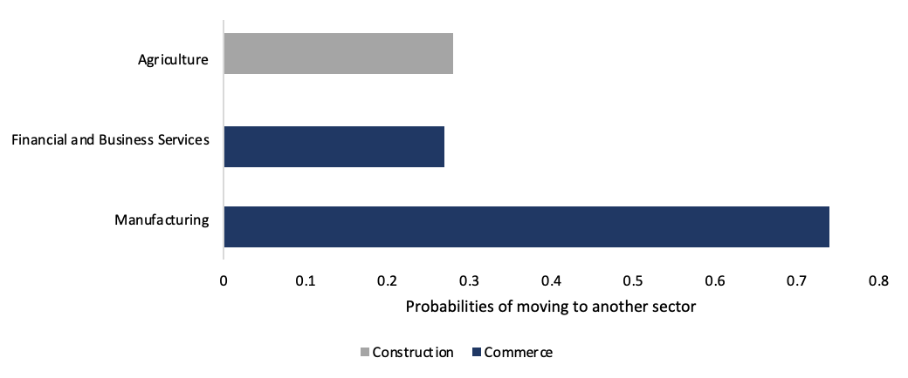
Source: World Bank Staff elaboration based on ENOE.

Our study indicates that the probability of remaining in the same sector of economic activity decreases more rapidly for yearly transitions, particularly in certain industry sectors such as Financial and Business Services, Commerce, Transport and Communications, and Mining.
The findings of our analysis suggest that workers in these sectors are more likely to switch to different economic sectors over the long term. For instance, the probability of a worker remaining in the same sector of economic activity decreases faster on a yearly basis than on a quarterly basis, indicating that the longer the time horizon, the greater the likelihood of a worker transitioning to a different sector.
This trend is particularly evident in sectors such as Financial and Business Services, Commerce, Transport and Communications, and Mining. These industries are characterized by a high degree of dynamism and are often subject to changes in demand and technological innovation. As a result, workers in these sectors may need to adapt to new opportunities and challenges by acquiring new skills and knowledge.

Table 7. Differences in yearly and quarterly transitions
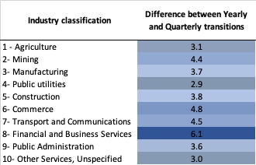
Source: World Bank Staff elaboration based on ENOE.

5.2 Occupation

Our study also analyzed the transition probabilities by occupation, and the results indicate that professionals and service and market sales workers are the most likely to remain in the same occupational sector. In contrast, managers are more likely to transition to different occupational sectors, such as professionals and service and market sales workers.
The findings suggest that professionals and service and market sales workers have a strong attachment to their occupational sector, and are less likely to switch to a different one. This may be due to the nature of their work, which often requires a specific set of skills and knowledge that are closely tied to their occupational sector.
In contrast, managers are more likely to transition to different occupational sectors, such as professionals and service and market sales workers. This may be due to the fact that managers often have transferable skills and knowledge that can be applied across different sectors, making it easier for them to transition to new occupational roles. Moreover, the high frequency of movement among managers may reflect the fact that they are often seeking new challenges and opportunities to advance their careers.
The implications of these findings for businesses and policymakers are important. For example, businesses may need to invest in training and development programs that enable professionals and service and market sales workers to acquire new skills and knowledge. Similarly, policymakers may need to develop policies that support managers in transitioning to new occupational roles, such as providing education and training programs, job matching services, and incentives for businesses to create new jobs.

Table 8. Transition probabilities by occupation (yearly transitions)
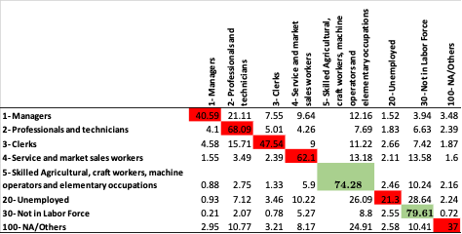
Source: World Bank Staff elaboration based on ENOE.

Informality
Mexico's labor market faces a significant challenge in the form of high rates of informal employment, which accounts for a substantial portion of the country's workforce. These workers are typically not protected by labor regulations and are not entitled to social benefits such as healthcare and pensions. Our analysis suggests that most formal workers tend to remain in formal employment, with a transition rate of around 13% into the informal sector. Conversely, informal workers are more likely to transition into unemployment than formal employment. Samaniego and Viegelahn (2021) have also identified two potential drivers of increased formal employment: low rates of exit from formal employment or high rates of entry from informal employment or inactivity. The implications of these factors for policy makers seeking to boost formal employment differ significantly.
Furthermore, we found that unemployed workers are more likely to transition into the informal sector rather than the formal sector, perpetuating a cycle of unemployment and informal employment rather than facilitating a move towards formal work. These results suggest that policies aimed at promoting formal employment opportunities, particularly for those in the informal sector and the unemployed, could potentially alleviate the challenges posed by informal employment and promote more sustainable and equitable economic growth.
Figure 3 depicts a visual representation of the quarterly labor market transitions, with sampling weights used to ensure the representativeness of the data. The transitions are divided into two panels: Panel a) focuses on the movements between formal and informal employment, while Panel b) displays the transitions between non-employment and employment. The figure reveals that the increase in the share of workers in formal employment is primarily driven by an increase in inflows to formal jobs from informal employment. This suggests that workers are more likely to transition from informal employment to formal employment, which has contributed to the overall rise in the proportion of workers in formal employment. However, the figure does not consider the probability of workers transitioning to the unemployed sector, which is found to be higher than the probability of transitioning to formal sector jobs. The use of sampling weights ensures that the data is representative of the larger population, providing a more accurate understanding of the labor market transitions.

Figure 4 Quarterly Labor Market Transitions: Movements Between Formal/Informal and Employment/Non-Employment
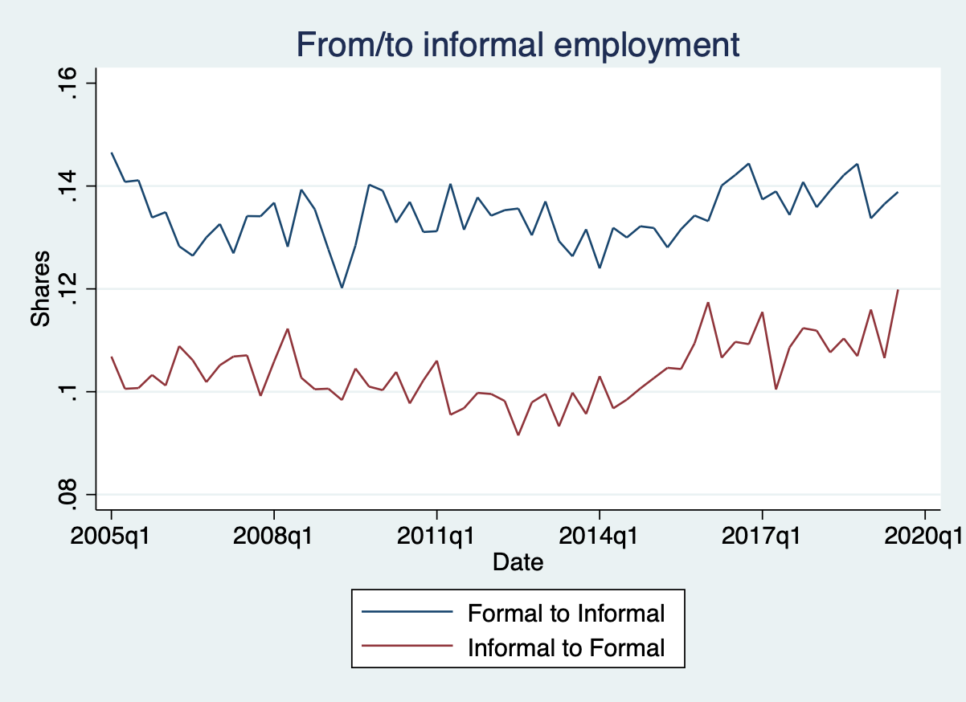 | 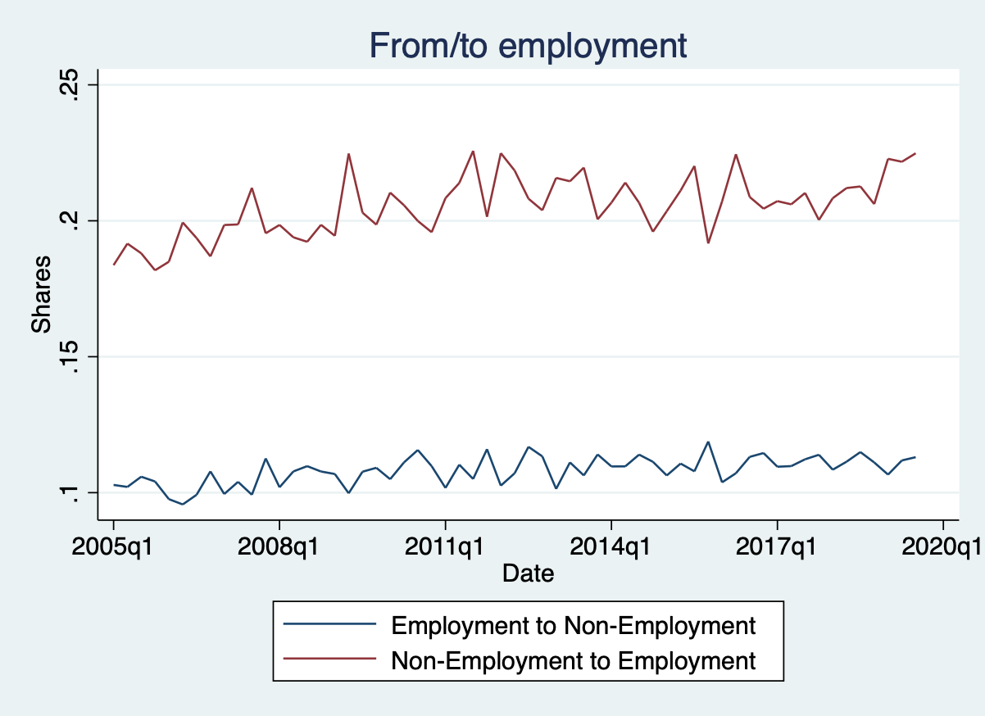
Source: World Bank Staff elaboration based on ENOE.

Table 10 presents the results of transitions between formal employment, informal employment, and non-employment in Mexico. The table indicates that informal workers have a higher likelihood of moving to the non-employment sector compared to the informal sector. Conversely, formal workers have a higher probability of remaining in formal employment in the subsequent period, regardless of whether the transitions are yearly or quarterly. This finding is consistent with the study conducted by Conover, Khamis, and Pearlman (2022), which reported that workers who enter the formal sector are more likely to remain in that sector.

Table 10. Informality transitions (yearly)
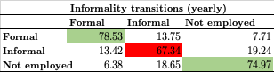
Source: World Bank Staff elaboration based on ENOE.

Moreover, Table 11 further reinforces the robustness of the results by analyzing quarterly frequency transitions. The probability of remaining employed is higher for workers who are already employed compared to those who are unemployed. Specifically, the likelihood of employed workers remaining employed is approximately 88% for quarterly transitions. This could be due to various factors, including job security, skills, experience, and performance. Moreover, their skills and experience may be better aligned with the requirements of their current jobs, making them valuable assets to their employers.
On the other hand, the largest probability for unemployed individuals is to transition into employment. This could be attributed to the fact that they are actively seeking employment opportunities and may be more flexible in terms of job requirements and salary expectations. Unemployed individuals may also be motivated to quickly find work in order to support themselves and their families, which could increase their likelihood of accepting any available job offers.

Table 11. Informality transitions (quarterly)​
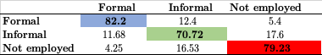
Source: World Bank Staff elaboration based on ENOE.

The results presented in Table 13 shed light on the frequency of transitions among different labor statuses, including employed, unemployed, and individuals not in the labor force. The table reveals that the frequency of employed workers remaining employed in the following year is high, at 86.3. Interestingly, the frequency of workers transitioning from employed to not in the labor force is higher than the frequency of workers transitioning from employed to unemployed. This finding is consistent across both yearly and quarterly data.

Table 13. Labor status transitions (yearly)
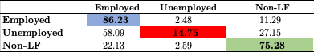
Source: World Bank Staff elaboration based on ENOE.

For unemployed individuals, the results suggest that there is a higher probability of finding a job than transitioning to not in the labor force. This trend is more pronounced in yearly data than in quarterly data (Table 14). Finally, for individuals who are not in the labor force, there is a high probability of staying in the same sector. However, those who do transition are more likely to move into the employed sector rather than the unemployed sector. These results have important implications for policymakers and researchers seeking to understand the dynamics of labor market transitions and design effective interventions to support individuals moving between different labor statuses.

Table 14. Labor status transitions​ (quarterly)
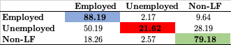
Source: World Bank Staff elaboration based on ENOE.

Need to show results from regressions.

Exports
We utilized the Panjiva database to incorporate the Mexican exports value in USD. The dataset encompasses all exports from Mexico between 2011 and 2022, with quarterly observations. This database consists of postal codes obtained from the exporting companies, which were then matched with the ENOE database containing representative data at the metropolitan area level. Out of the 986,909 total observations, 122,986 were deleted due to a lack of postal code information.
We were able to recover the postal code for 22,000 observations using a program that utilized firm addresses. Additionally, we identified and corrected erroneous postal codes for roughly 350 observations. Ultimately, we were able to retain data for 863,923 observations. However, we encountered 275 postal codes that were not present in Mexico’s postal code database.
Table 12 depicts the evolution of exports in Mexico, both at the national level and in selected states, highlighting a rapid recovery following the onset of the COVID-19 pandemic. This observation is consistent with recent research in international trade, which has shown that many countries experienced a strong rebound in trade activity after the initial shock of the pandemic.
According to recent studies, the pandemic had a severe impact on international trade in the first half of 2020, causing a sharp decline in trade volumes and significant disruptions to global supply chains. However, many countries, including Mexico, have seen a relatively rapid recovery in trade activity in the latter half of 2020 and into 2021. This recovery has been supported by a range of factors, including government policies aimed at stimulating economic activity, the rollout of vaccines, and the gradual easing of restrictions on trade and travel.
In the case of Mexico, the data presented in Table 12 suggests that the recovery in exports has been particularly strong, both at the national level and in selected states. These figures suggest that Mexican exporters have been able to adapt quickly to changing market conditions and have been successful in finding new export opportunities despite the challenges posed by the pandemic. Moreover, the recovery in Mexican exports has been broad-based, with multiple states experiencing significant growth in their export sectors.
Overall, the data presented in Table 12 is consistent with recent academic research on the impact of the COVID-19 pandemic on international trade, which suggests that while the pandemic initially caused significant disruptions to global supply chains, many countries have been able to recover relatively quickly. The strong recovery in Mexican exports highlights the resilience of the country's export sector and its ability to adapt to changing market conditions.

Table 15. Exports increase using Panjiva and INEGI data
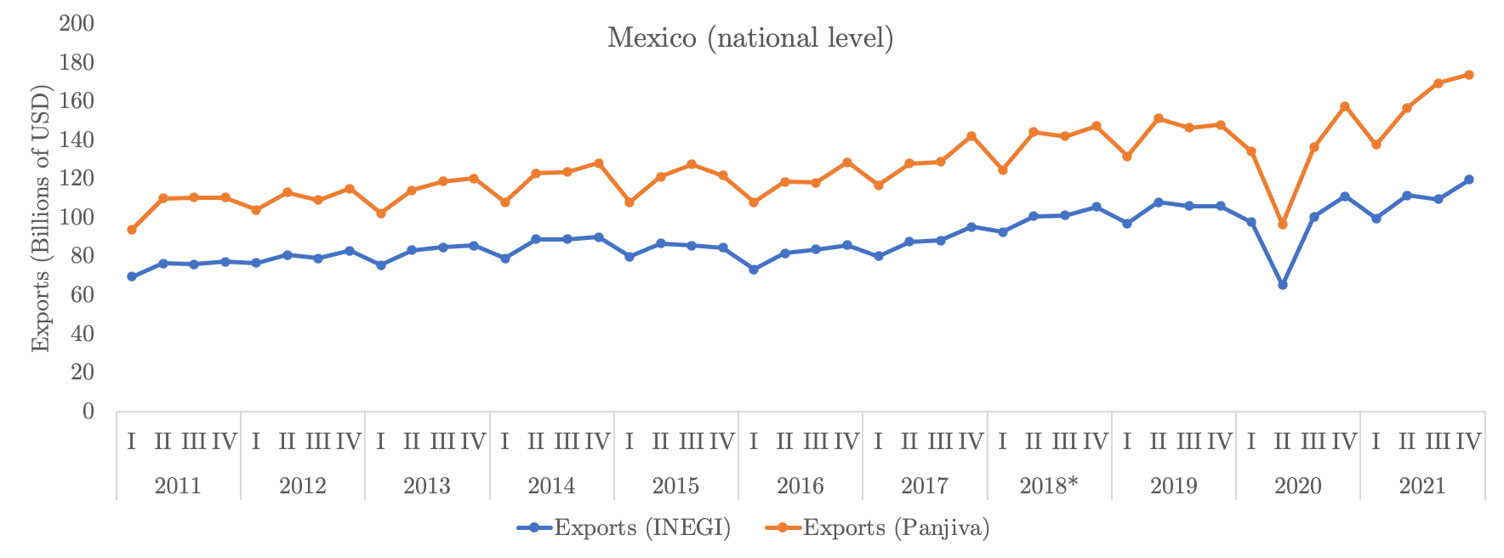
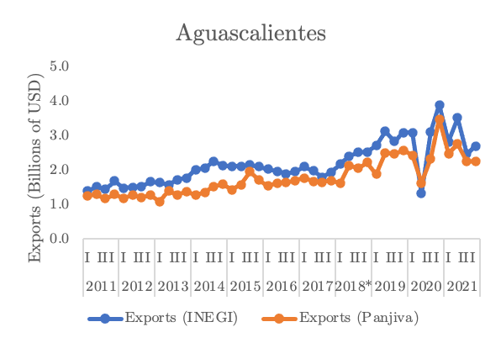 | 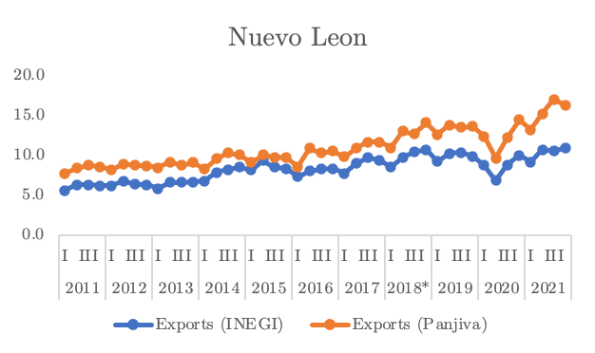 | 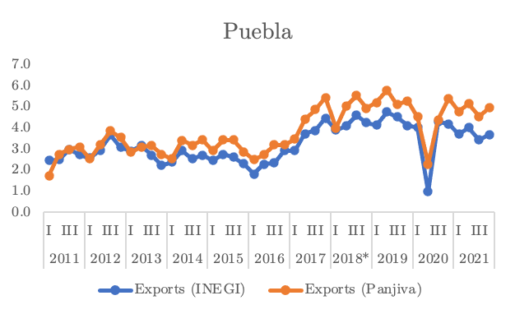
Source: World Bank Staff elaboration based on Panjiva and INEGI.
* Data from INEGI is estimated starting in 2018

Results summary
This research examines the labor market transitions in Mexico, focusing on the factors that influence workers' decisions to remain in the same sector or transition to a different one. Using transition matrices and a database that combines data from the National Occupation and Employment Survey and the Panjiva Global Trade Database, this study provides valuable insights into labor market dynamics in Mexico and the impact of trade and exports on worker transitions.
The study finds that there are no significant differences between quarterly and annual transitions and that most workers tend to stay in their sector. However, there are variations across sectors, with agriculture, commerce, and public administration having the lowest probabilities of transition to another economic sector, while financial and business services having the highest. Additionally, the study highlights the cyclical nature of unemployment and informality, with workers having a larger probability of moving to the informal sector rather than the formal one.
The impact of trade and exports on labor market transitions in Mexico depends on the specific industries involved, with some industries being a major driver of employment growth but highly concentrated in certain regions. The study makes several contributions to the literature on labor market performance and trade in Mexico, including introducing a new database that enables more recent statistics analysis and examining the relationship between exports and worker transitions at the regional level.
The analysis emphasizes the importance of understanding the dynamics of the labor market and the factors that influence workers' decisions to transition to different economic sectors or occupational sectors. The findings of this study can inform policies and interventions aimed at promoting sustainable economic growth and employment opportunities for workers in different sectors, supporting both employed and unemployed individuals, and promoting job security, stability, and opportunities for career advancement.

References

Arias, Javier, Erhan Artuc, Daniel Lederman, and Diego Rojas. 2018. “Trade, Informal Employment and Labor Adjustment Costs.” Journal of Development Economics 133 (July): 396–414. https://doi.org/10.1016/j.jdeveco.2018.03.006.
Asquith, Brian, Sanjana Goswami, David Neumark, and Antonio Rodriguez-Lopez. 2019. “U.S. Job Flows and the China Shock.” Journal of International Economics 118 (May): 123–37. https://doi.org/10.1016/J.JINTECO.2019.02.002.
Bernard, Andrew B, Jonathan Eaton, J Bradford Jensen, and Samuel Kortum. 2003. “Plants and Productivity in International Trade.” Source: The American Economic Review 93 (4): 1268–90.
Blanchard, Olivier Jean, and Peter Diamond. 1992. “The Flow Approach to Labor Markets.” NBER WORKING PAPER SERIES.
Bosch, Mariano, and William Maloney. 2007. “Gross Worker Flows in the Presence of Informal Labor Markets: Evidence from Mexico, 1987-2002.”
Bosch, Mariano, and William F. Maloney. 2021. “Cyclical Movements in Unemployment and Informality in Developing Countries.” SSRN Electronic Journal. https://doi.org/10.2139/ssrn.1139904.
Caliendo, Lorenzo, and Fernando Parro. 2015. “Estimates of the Trade and Welfare Effects of NAFTA.” Review of Economic Studies 82: 1–44. https://doi.org/10.1093/restud/rdu035.
———. 2019. “Trade and Labor Market Dynamics: General Equilibrium Analysis of the China Trade Shock.” Econometrica 87 (3): 741–835. https://doi.org/10.3982/ECTA13758.
Cuesta, Jose, and Camilo Bohorquez. 2014. “Labor Market Transitions and Social Security in Colombia.” The Journal of Developing Areas 48 (3): 149–74. https://doi.org/10.1353/jda.2014.0052.
Davidson, Carl, Fredrik Heyman, Steven Matusz, Fredrik Sjöholm, and Susan Chun Zhu. 2014. “Globalization and Imperfect Labor Market Sorting.” Journal of International Economics 94 (2): 177–94. https://doi.org/10.1016/J.JINTECO.2014.08.001.
Flinn, C., and J. Heckman. 1982. “New Methods for Analyzing Structural Models of Labor Force Dynamics.” Journal of Econometrics 18 (1): 115–68. https://doi.org/10.1016/0304-4076(82)90097-5.
Gutierrez, Italo A, Krishna B Kumar, Minhaj Mahmud, Farzana Munshi, and Shanthi Nataraj. 2019. “Transitions between Informal and Formal Employment: Results from a Worker Survey in Bangladesh.” Journal of Development and Migration 9 (3). https://doi.org/10.1186/s40176-019-0141-2.
Hanson, Gordon H. 2010. “Why Isn’t Mexico Rich?” Source: Journal of Economic Literature 48 (4): 987–1004.
Herrera, Javier, and Gerardo David Rosas Shady. 2003. “Labor Market Transitions in Peru.” https://www.researchgate.net/publication/4874679.
Kehoe, Timothy J, and Kim J Ruhl. 2010. “Why Have Economic Reforms in Mexico Not Generated Growth?” Source: Journal of Economic Literature 48 (4): 1005–27. https://doi.org/10.1257/jel.48.4.1005.
Melitz, Marc J. 2003. “The Impact of Trade on Intra-Industry Reallocations and Aggregate Industry Productivity.” Econometrica 71 (6): 1695–1725. https://doi.org/10.1111/1468-0262.00467.
Samaniego, Brenda, and Christian Viegelahn. 2021. Estimating Labour Market Transitions from Labour Force Surveys The Case of Viet Nam. www.ilo.org/global/publications/working-papers.
Tansel, Aysit, and Zeynel Abidin Ozdemir. 2019. “Transitions across Labor Market States Including Formal/Informal Division in Egypt.” Review of Development Economics 23 (4): 1674–95. https://doi.org/10.1111/RODE.12620.
Theodossiou, I, and A Zangelidis. 2009. “Should I Stay or Should I Go? The Effect of Gender, Education and Unemployment on Labour Market Transitions ☆.” Labour Economics 16 (10): 566–77. https://doi.org/10.1016/j.labeco.2009.01.006.

The Markov process X_{t} is defined over a discrete space where there are K number of possible states (job sectors) a worker could be found in. If the worker is observed at different points in time, then a discrete transition matrix can be built. See also (Bosch and Maloney 2007; Flinn and Heckman 1982)
A study by Theodossiou and Zangelidis (2009) also identified workers’ characteristics such as gender differences in job transitions in six European countries (United Kingdom, France, Germany, Spain and Greece), with men being more mobile across jobs and women having higher exiting to non-employment. They also found education to be an important factor in transition probabilities, especially for women. Although this research is not for a developing economy, the results are similar to other research for developing economies.
However, it is worth highlighting that estimates of labor market transitions that involve more disaggregated labor market categories, such as 4-digit industry or occupation classifications, are likely to be more affected by this type of bias. Nevertheless, there is no evidence of an unusual increase in gross flows between categories at different levels of disaggregation, which somewhat alleviates concerns about potential misclassification bias.
The transitions frequencies calculated on this part of the report are unconditional to workers’ personal characteristics.

