Economic and environmental impacts of policies promoting a circular food system with a specific role for livestock in the EU.

Abstract
Feeding animals with low-cost-opportunity feed (LCF) such agricultural residues and by-products, and through a better use of local resources are two policies under discussion in the move towards circular food systems. In this study, we incorporated technical aspects of livestock production into a global economic model to investigate the economic and environmental effects of circular food system policies in the European Union (EU27). Our findings indicate that these policies lead to an increased use of LCF, which lowers greenhouse gas emissions in agriculture and promotes domestic sourcing of feed. However, a higher demand for LCF increases crop production, leading to higher land use and prices, reduced agricultural wages, and greater agricultural imports. Additionally, an increased use of by-products as feed results in higher production of primary commodities, such as biofuels, lowering economy-wide emissions, but putting additional pressure on land, and increasing biomass imports. To address the drawbacks of circular agri-food policies additional measures may be required.

Feeding animals with low-cost-opportunity feed (LCF) such agricultural residues and by-products, and through a better use of local resources are two policies under discussion in the move towards circular food systems. In this study, we incorporated technical aspects of livestock production into a global economic model to investigate the economic and environmental effects of circular food system policies in the European Union (EU27). Our findings indicate that these policies lead to an increased use of LCF, which lowers greenhouse gas emissions in agriculture and promotes domestic sourcing of feed. However, a higher demand for LCF increases crop production, leading to higher land use and prices, reduced agricultural wages, and greater agricultural imports. Additionally, an increased use of by-products as feed results in higher production of primary commodities, such as biofuels which lower economy-wide emissions, but further appreciate land, increasing biomass imports. To tackle the drawbacks of circular agri-food policies additional complementary policy measures may be required.

Introduction
Animal-sourced foods (ASF) largely contribute to the environmental impacts of our food system (ASF) (Hilborn et al., 2018; Herrero et al., 2015; Poore & Nemecek, 2018; Steinfeld et al., 2006). Animal feed plays a major role (Salami et al., 2019), accounting for 45% of greenhouse gas (GHG) emissions from the livestock sector (Gerber et al., 2013), occupying 70% of the global agricultural land (Steinfeld et al., 2006) and utilising 30-40% of human-edible feed crops (Erb et al., 2012). As historically ASF demand increases with rising incomes (Cole & McCoskey, 2013; OECD/FAO, 2020; Schader et al., 2015), expected global population and prosperity growth cause serious environmental concerns. To tackle this challenge, current studies (Röös et al., 2017; van Hal et al., 2019; Van Zanten et al., 2019; De Boer & van Ittersum, 2018) identify solutions in more circular agri-food systems with a particular role for livestock. Low-opportunity-cost feed (LCF) such as discarded biomass, plant residues, by-products, and food loss and waste, typically compete less for land or natural resources and represent an important human-inedible feed resource for livestock production (Salami et al., 2019). Upcycling LCF to replace human-edible feed crops in animal diets represents a strategy for transitioning towards a more circular food system as it may mitigate food-feed competition and reduce the environmental impacts of global livestock production (van Hal et al., 2019). On top of this, an additional strategy for circularity consists in feeding livestock through a better use of local resources (De Schutter, 2017; Stephens et al., 2020; European Commission, 2020). Decreasing imports of compound feed and feeding crops in EU27 can reduce the negative environmental externalities associated to feed production and trade (Wessler, 2022; IPES-Food, 2019; 2020), simultaneously increasing the availability and reuse of domestic LCF (Van Zanten et al., 2019a).
Despite the recognized environmental benefits of circular agri-food systems (Röös et al., 2017; van Hal et al., 2019; Van Zanten et al., 2019; De Boer & van Ittersum, 2018), limited knowledge exists on their operational aspects and the economic implications of policy interventions that foster this transition (Ominski et al., 2021). Increasing the reuse of livestock by-products (LCF) while simultaneously decreasing feed imports can affect demand for biomass, influencing agricultural production, and associated economic, environmental, and resource-related challenges. The substitution of compound feed and feeding crops with LCF presents a potential risk to the economic welfare of key stakeholders in the agricultural sector, including animal feed producers. Additionally, a higher demand for domestic resources and agricultural residues may drive up crop production, which may intensify the demand for land, as well as greenhouse gas emissions and chemical fertilizers use. The effective design of policy interventions aimed at promoting circular food systems requires a thorough assessment of the consequences of the proposed strategies.
The EU27 stands actively as global promoter of circular policies (European Commission, 2020; 2021), but no official policy has been established to achieve circularity within agri-food systems. Policies such as tax incentives for reused products, environmentally-motivated subsidies on loss/waste reuse, and recycled content requirements can promote resource efficiency (European Commission, 2020), incentivizing more sustainable material reuse (OECD-G20, 2021). Given the absence of a consensus on adequate policy instruments, adopting such measures to promote a circular food system for livestock could constitute a promising policy arena. However, devising policies for circular food systems transitions requires an interdisciplinary understanding of the technical and socioeconomic consequences of measures. Technical studies (van Hal et al., 2019; van Selm et al., 2022; Van Zanten et al., 2019a) outline the possibilities of using LCF as feed and closing nutrient cycles (Wiel et al., 2019), but ignore opportunity costs, price changes, and market behaviour, crucial for measuring the effectiveness of circular policies. On the other hand, economic studies address market-related issues but generally overlook the biophysical and technical constraints of circularity, providing only partial solutions.
Global general equilibrium (GE) models are useful for analysing circular economy policies that involve multiple agents, countries, and integrated sectors within a market environment (McCarthy et al., 2018; Winning et al., 2017). GE models depict interactions among producers along global supply chains and consumer responses to changing prices and incomes, analysing endogenous economic-wide price effects and socioeconomic and environmental impacts crucial for assessing the consequences of circularity measures. However, GE models do not fully account for biophysical balances and livestock feeding restrictions necessary for quantifying the implications of circular policies. As economic models often violate biophysical balances, circular solutions may result unfeasible, impeding the connection to technical studies required to foster circular systems with new technologies. While previous studies (Britz & van der Mensbrugghe, 2018; Chepeliev, 2022) have integrated physical data into GE models, none have investigated circular solutions for livestock systems.
In this study, we combine economic and technical modelling circularity in livestock production to evaluate the impact of circular agri-food policies in the EU27, focusing on three research questions that progressively broaden the scope of analysis to consider direct and indirect effects. First, we pose a preliminary research question investigating which combination of instruments and magnitude of intervention allows to promote a circular agri-food system while containing potential negative economic and environmental spillover effects. The answer to this question will define two reference policies that the following research questions will investigate. First, to what extent circular agri-food system policies reduce the environmental footprint of livestock and feed production, as well as changing feed composition and sourcing in the EU27? Second, what are the impacts of circular policies on agricultural production and wages, and do they decrease the environmental footprint of agriculture in the EU27? Third, what are the impacts of circular agri-food policies on non-agricultural sectors and how they influence biomass allocation, trade, and total greenhouse gas emissions in the EU27? To answer these questions, we enhance a global general equilibrium model by integrating physical biomass tracing throughout global supply chains. Our study attempts to link the technicalities of livestock production and feeding into a monetary value-based GE model, which is one of the novelties of this research. We consistently account for livestock diets and incorporate physical biomass data to capture the behavioural responses of economic actors along global supply chains when policies promoting LCF use as feed are implemented. In substituting primary feed with LCF, we aim to respect feed conversion ratios and energy supply in animal diets, describing and contextualising the cases where energy supply and livestock dietary requirements are imbalanced. We acknowledge that the integration of biophysical balances and livestock feeding constraints into GE models is crucial for evaluating circular agrifood system policies, and we recognize the need for a critical reflection on potential shortcomings and recommendations for further improvement.
From our preliminary analysis we identify two reference scenarios that exhibit the most optimal trade-offs between economic welfare and environmental sustainability. We select a “weak circular economy” (WCE) policy scenario where a low subsidy on LCF reuse is provided and compare it against “strong circular economy” (SCE) policy scenario where higher subsidies on LCF reuse and a feed import tariff are imposed in EU27. Our findings indicate that these policies lead to an increased use of LCF, which lowers greenhouse gas emissions in agriculture and promotes domestic sourcing of feed. However, a higher demand for LCF increases crop production, leading to higher land use and prices, reduced agricultural wages, and greater agricultural imports. Additionally, an increased use of by-products as feed results in higher production of primary commodities, such as biofuels, lowering economy-wide emissions, but putting additional pressure on land, and increasing biomass imports. To address the drawbacks of circular agri-food policies additional measures may be required.
The reminder of this paper is organized as follows. Firstly, the methodology section outlines our contributions in incorporating technical livestock features and circular economy principles into a global economic model. Secondly, the results section showcases the effects of various policy combinations and includes an in-depth analysis over the two selected reference scenarios, addressing our research questions. Finally, the discussion section contextualizes our findings and draws policy implications.

Methods
Global economic model.
To investigate the impact of policies towards more circular livestock systems in EU27, we use a global general equilibrium (GE) model. Global GE models provide an economy-wide coverage including agricultural sectors, industries, and services. Their detailed representation of value flows from primary and intermediate production to final consumption allows an in-depth understanding of economic adjustments between biomass-demanding sectors along global supply chains when policies favouring the reuse of LCF are implemented. In this, GE models capture substitution effects between biomass flows when global trade and actors’ demand change in response to policies, illustrating economy-wide synergies and trade-offs of interventions.
For this study we use the global GE model MAGNET (Modular Applied GeNeral Equilibrium Tool), an advanced recursive dynamic variant of the well-known Global Trade Analysis Project (GTAP) model (Corong et al. 2017), with a specific focus on agri-food sectors and the rest of the bioeconomy (Van Meijl et al. 2006, Woltjer et al. 2014). MAGNET has been widely used for simulating global policies on agriculture, trade, and the bioeconomy (Francois et al. 2005, Van Meijl et al. 2018), assessing impacts on a wide range of indicators including agricultural markets, food security (Van Meijl et al. 2020) and sustainability (Perez-Dominguez, 2021; Leclere et al., 2020). Its detailed representation of biobased materials, including by-products and residues from agricultural and forestry sectors, enables modelling circular flows in agriculture, investigating the replacement of primary agricultural inputs with secondary biobased alternatives. In this MAGNET version we preserve full sectoral details for biomass sectors to capture in detail responses to changing biomass flows when LCF is upcycled as animal feed. We model other non-biomass sectors in a more aggregate way, capturing their competing demand for endowments without overburdening the model in terms of sector detail. We aggregate MAGNET to eight global regions complemented by three single countries i.e. United States, China, and Brazil, kept disaggregated given their relevance in global feed and livestock markets. Additional model details are available in the Supplementary Information.
Modelling circular flows in livestock production systems.
Value-based GE models often misrepresent biophysical flows during simulations (Delzeit et al., 2020), providing economic solutions without proficiently enquiring underlying biophysical material flows. Improving the representation of physical material cycles in GE models enables to model more realistically the effects of an efficient use of biophysical resources in circular practices (Pauliuk et al., 2017), increasing the policy relevance of models. Modelling circularity in livestock production requires an explicit representation of physical biomass flows necessary for accounting the biophysical balances and constraints of upcycling LCF as production input. Moreover, as dietary constraints vary by livestock type, defining livestock-specific feed composition and LCF in physical units allows to quantify nutritional contents of feed inputs, consistently respecting the nutritional balance of livestock diets when primary feed is replaced by LCF. Usually, value-based economic models including GE models do not comprehend livestock technical features and disregard dietary constrains of animals when analysing changes in livestock dietary composition. The MAGNET model comprises seven livestock sectors including beef cattle, dairy cattle, other ruminants, swine, poultry, wool (sheep), and aquaculture. Based on the dietary characteristics of each livestock, the novelty of our approach consists in the inclusion of four different feed sectors supplying animal-specific feed in line with the dietary constrains of each livestock type. This is generally glossed-over by available GE models and allows to measure the nutritional balance of livestock, effectively defining feed-conversion-ratios (FCR) when primary feed is substituted with LCF. Detailed sectoral information and model changes are available in the Supplementary information. To implement circular flows we focus on partly replacing primary feed (i.e. cereals, horticulture, other crops, and processed compound feed) supply with LCF derived from different agricultural and non-agricultural sectors in our model. LCF in MAGNET consists of by-products and agricultural residues. By-products comprise oilcakes, molasses, distiller’s dried grains (DDGS) and fishmeal, with the latter already largely used as animal feed. Agricultural residues are instead obtained from agricultural production of several cereals and horticulture commodities. Detailed information on source and type of by-products and residues included in MAGNET is available in the Supplementary information.

Model Data.
The version of MAGNET utilised for this study is based on the GTAP 10 database (Aguiar et al., 2019). For tracing physical flows in MAGNET we follow the approach of (Kuiper et al., 2023) manipulating the standard GTAP 10 database to obtain a close representation of material flows. We subtract monetary components (taxes, subsidies, payments for international transport) from value-based flows and define a physical proxy reported in “dollar-based quantities” for all material flows throughout the global economy.
For commodities where physical production data is available, we convert dollar-based quantities to physical unites (Mtons), allowing a complete tracing of physical flows through the global economy. Physical biomass data (Mtons) for livestock and crops production is obtained from FAOSTAT. Aquaculture production data is obtained from (World Bank, 2014), while feed production is obtained from the FAO-Food-Balance-Sheets. To quantify by-products generated from non-agricultural products, we obtain physical primary production data from different sources (available in the Supplementary Information) and successively derive amounts of by-products by applying technical conversion factors (TCF) derived from FAO. For agricultural residues, we use shares of losses generated at agricultural production and post-harvest handling & storage reported by (Gatto et. al 2023) and apply them to the physical production of cereals and horticulture, quantifying residues supply. A complete overview of our data and further details are provided in the Supplementary Information.
In the integration of physical quantities, we preserve the consistency of a GE framework, accurately representing biophysical balances and technical input substitutions often violated by constant-elasticity-of-supply/constant-elasticity-of-transformation (CES/CET) functions typical of GE models. With this “physically-extended” version of MAGNET we provide an overview of policy impacts towards circularity from a multidisciplinary perspective, integrating a biophysical assessment of the circular economy within a global economic model. To address nutritional balances in livestock diets we rely on feed-conversion-ratios available from literature and reported in the Supplementary Information. First, we quantify the production output (Mtons) of livestock sectors in MAGNET, defining the nutritional supply required to produce the given output of live animals. Following, we specify the nutritional composition of total feed supply to each livestock sector, indicating the nutritional contents of primary feed and LCF. Accordingly, we verify that in the processes of substituting primary feed with LCF the overall nutritional supply required to healthily feed livestock remains preserved across model simulations. As we do not fully represent livestock diets omitting grass, hey, and other types of animal-based by-products and residues, feed-conversion-ratios for certain livestock have been adjusted based on literature. Data sources, nutritional balances, and detailed composition of animals’ diets are available in the Supplementary information.

Towards a more circular livestock system scenario.
We use MAGNET to investigate the impact of policies promoting a circular food system in EU27 in 2030. We use 2020 as base year and define our business-as-usual (BAU) scenario from the IMF-World Economic Outlook projections for GDP and population (IMF, 2022), to project the global economy in 2030. We compare our BAU scenario with two scenarios where circular policies are implanted on a different extent. Taxation/tariffs on resource-intensive commodities coupled with subsidies on more sustainable alternatives are among the most promising options for discouraging negative externalities and encouraging positive ones (Pretty et al. 2001, EC, 2016 - Accelerating clean energy innovation). As market instruments are widely used to enhance the transition to a circular economy (OECD, 2021), “hard” measures (i.e. tariffs, legislations or permits), are most effective when supported by “soft regulation” measures such as subsidies, public procurement, or campaigns (SAPEA, 2020).
In our model LCF makes up 5.2% of the total feed supply, while 80% of the feed supply is sourced domestically within the EU27 in the base year. To increase domestic sourcing of feed use and promote higher use of LCF in 2030, we propose various policies such as subsidies on LCF use, import tariffs on primary feed (compound feed and feeding crops), or a combination of both. Subsidies can be budget-neutral or non-budget-neutral. Budget-neutral subsidies are financed through ad-valorem taxes on domestic animal feed use by livestock sectors in EU27, while non-budget-neutral subsidies are funded directly from the government budget. Figure 1 illustrates the relationship between subsidies and LCF use in our model. A budget-neutral subsidy is preferable to a non-budget-neutral subsidy as it achieves a higher share of LCF within the feed supply for a given subsidy level.
To address our preliminary research question we investigate different subsidy-tariff combinations outlining which type of intervention provide the most optimal trade-offs between economic welfare and environmental impacts. From this, we select two policy scenarios: a “weak circular economy” (WCE) scenario, where a 20% budget-neutral subsidy on LCF use as feed is given to livestock sectors, and a “strong circular economy” (SCE) scenario where a 40% budget-neutral subsidy on LCF use as feed and an 20% import tariff on compound feed and feeding crops imports is imposed in the EU27. An overview of our BAU scenario and selected circular policy scenarios is provided in the Table 1.

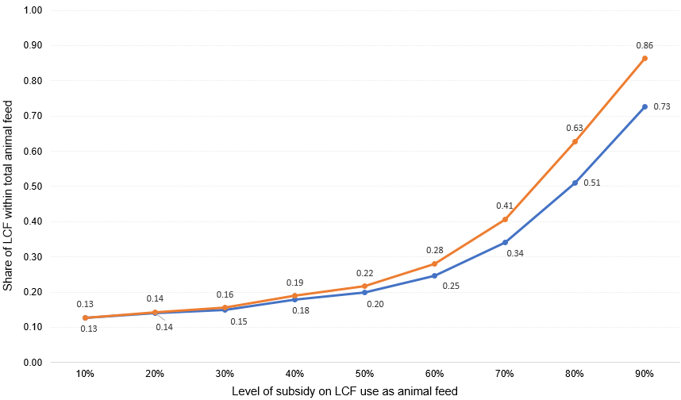
Figure 1. Relationship between subsidies on LCF use (x-axis) and shares of LCF within total feed supply (y-axis) in case of “budget-neutral” subsidies (orange) and “non-budget-neutral” subsidies (blue) in EU27 in 2020. Estimates refer to dollar-based units (USD) in 2020. The curve in blue illustrates how the application of different subsidy levels affects the shares of LCF within total feed supply in the case of a “non-budget-neutral” policy where the subsidy is fully financed by the government. Differently, the orange curve illustrates the effects of different subsidy levels on the shares of LCF within total feed supply in the case of a “budget-neutral policy” where the subsidy is fully financed by a tax levied on domestic primary animal feed use by livestock sectors in EU27. The slope of the orange response curve results steeper after a 30% subsidy, providing a higher share of LCF within total feed supply at a given subsidy level. This is principally due to the tax levied to finance the subsidy which directly increases prices of primary animal feed, resulting in a more severe substitution effect between LCF and primary feed.

REGION SPECIFIC SHOCK (% change in driver or size of policy intervention)
 |  |  |  | Population growth |  |  | GDP growth
Macro drivers in  BAU, WCE, and  SCE scenario⁺ | EU27 |  |  | 0.6 |  |  | 39.1
Macro drivers in  BAU, WCE, and  SCE scenario⁺ | BRA |  |  | 4.8 |  |  | 60.8
Macro drivers in  BAU, WCE, and  SCE scenario⁺ | CHN |  |  | -0.5 |  |  | 82.8
Macro drivers in  BAU, WCE, and  SCE scenario⁺ | USA |  |  | 3.1 |  |  | 42.9
Macro drivers in  BAU, WCE, and  SCE scenario⁺ | SEA |  |  | 7.2 |  |  | 77.6
Macro drivers in  BAU, WCE, and  SCE scenario⁺ | INDA |  |  | -2.1 |  |  | 29.0
Macro drivers in  BAU, WCE, and  SCE scenario⁺ | NAMO |  |  | 8.3 |  |  | 58.6
Macro drivers in  BAU, WCE, and  SCE scenario⁺ | LAC |  |  | 7.5 |  |  | 52.4
Macro drivers in  BAU, WCE, and  SCE scenario⁺ | REUCA |  |  | 3.2 |  |  | 48.3
Macro drivers in  BAU, WCE, and  SCE scenario⁺ | MENA |  |  | 11.6 |  |  | 72.5
Macro drivers in  BAU, WCE, and  SCE scenario⁺ | SSA |  |  | 19.4 |  |  | 76.0
Policy interventions promoting a circular agri-food system in EU27⁺⁺
Source of input | Feed inputs demanded  by livestock sectors |  | Weak Circular Economy  scenario (WCE) |  |  |  | Strong Circular Economy scenario (SCE)
Source of input |  |  | TAX (%) |  | SUBSIDY (%)  (budget-neutral) |  | TAX (%) | SUBSIDY (%)  (budget-neutral)
domestic | CEREALS | 2.65* |  |  |  |  | 6.56*
domestic | HORTICULTURE | 2.65* |  |  |  |  | 6.56*
domestic | COMPOUND FEED | 2.65* |  |  |  |  | 6.56*
domestic | AGRICULTURAL RESIDUES |  |  |  |  | 20.0 |  |  | 40.0
domestic | BY-PRODUCTS |  |  |  |  | 20.0 |  |  | 40.0
imported | CEREALS |  |  |  |  |  | 20.0**
imported | HORTICULTURE |  |  |  |  |  | 20.0**
imported | COMPOUND FEED |  |  |  |  |  | 20.0**
imported | AGRICULTURAL RESIDUES
imported | BY-PRODUCTS
Notes: ⁺Population and GDP projections from IMF (2022) covering the period between 2020-2030. EU27 = European Union-27; BRA = Brazil; CHN = China; USA = United States of America; SEA = Southeast Asia; INDA=Industrialised Asia; NAMO = North America & Oceania; LAC = Latin America & Caribbean; REUCA = Rest of Europe & Central Asia; MENA = Middle East & North Africa; SSA = Sub-Saharan Africa.
⁺⁺ The illustrated policy interventions have been selected from different policy levels and combinations based on trade-offs between environmental benefits and economic welfare (see Results section).
*Size of the ad-valorem tax levied to finance the subsidy.
**Import tariff levied to crops and horticultural products demanded by livestock sectors. Import tariffs do not apply to imported crops and horticultural products demanded by other sectors in the economy.
Table 1. Overview of regional macro drivers and magnitude of selected policy interventions to promote a circular agri-food system in the in EU27 in 2030.

Results
An overview of the impact of different policy interventions promoting a circular agri-food system with a specific role for livestock.
The effectiveness of interventions designed to promote a circular agri-food system depends on the size and combination of policy instruments. We test different policy combinations to evaluate impacts on variables key to our research questions. An overview of tested interventions and associated impacts is provided in figure 2 below.
When subsidies are financed through taxes on primary feed (i.e. compound feed and feeding crops) livestock feed demand decreases, reducing feed supply in 2030 (Panel A – figure 2). Differently, when subsidies are financed through government spending (non-budget neutral), the absence of taxes does not affect livestock feed demand and results in a higher feed supply. Combining an import tariff with a budget-neutral subsidy partly redirects feed import demand to domestic markets. In case of a budget-neutral subsidy, the rise in production costs of livestock sectors generated by the tax controls the rise in domestic demand generated by the tariff, maintaining total feed use below baseline (BAU) levels. On the other hand, when the import tariff is combined with non-budget-neutral subsidies domestic feed demand further increases as the tariff enlarges the observed impact of non-budget-neutral subsidies. With a stand-alone tariff, the shift in demand towards domestic feed increases total feed supply, as the decrease in imports is compensated by stronger increase in domestic feed production. This is proportional with the size of the import tariff, as a higher tariff exerts a more significant increase in domestic demand and total feed production in 2030.
Providing budget-neutral subsidies increases shares of low-cost opportunity feeds (LCF) within total feed supply (Panel B - figure 2). The tax supporting budget-neutral subsidies appreciates primary feed inputs, encouraging their replacement with cheaper subsidized LCF. When subsidies are non-budget neutral, the substitution effects are weaker. The absence of a tax does not increase the value of primary feed inputs, which remain widely used by the livestock sectors. Supporting both types of subsidies with an import tariff further increases the use of LCF, as LCF replace decreasing amounts of imported feed.
In line with the observed trends of feed demand, budget-neutral policies lead to a decrease in livestock production across the analysed policies (Panel C - figure 2). Increasing subsidy levels have a more direct effect on decreasing livestock compared to rising import tariffs. This is because budget-neutral subsidies target domestic primary feed, which represents the highest share of feed sources across livestock sectors. On the other hand, import tariffs alone redirect feed demand towards domestic markets, resulting in less severe effects on livestock production. The shift towards domestic animal feed generated by the tariff can be seen as a positive contribution towards a circular food system, as it promotes higher sourcing of feed from domestic resources. Under non-budget neutral policies, livestock sectors profit from subsidies, increasing demand for feed hence overall production in 2030.
Crop production increases across our policy scenarios (Panel D – figure 2) as subsidies on LCF use indirectly increase the production of primary crops generating agricultural residues. In the case of budget neutral subsidies, the increase in feeding crops production is more contained as the tax contains primary feeding crops demand from livestock and compound feed sectors. Differently, providing non-budget neutral subsidies expands livestock feed demand, exerting more severe effects on feeding crops production (Panel D - figure 2). This directly relates to the lower substitution effects observed in panel B of figure 2. Under both types of subsidies, an import tariff generates an additional increase in feeding crops production, given the higher increase in domestic feeding crops demand.
Finally, the increase in crop production observed across policy scenarios result in a higher use of chemical fertilisers. This is observable under both typologies of subsidies and is more remarked under non-budget neutral policies as average crop production expand relatively more compared to budget neutral policies.
Observed trends of crops and livestock production have direct effects on land use (Panel E – figure 2), with livestock being the main driver of total land use change. Non-budget neutral subsidies lead to a greater expansion of livestock production, resulting in a relatively higher increase in land demand. On the other hand, although livestock production decreases under budget-neutral subsidies, the use of land from livestock sectors decreases proportionally less. This is because financing subsidies through taxes on primary feed indirectly stimulates the use of pastureland by livestock (ruminants) sectors, maintaining land into production. Across policies, the expanding production of crops additionally result in a higher land use. This is more severe when an import tariff is imposed in addition to subsidies as shifting demand towards domestic markets further increases domestic crop production and pastureland use.
Changing trends of livestock production directly affect greenhouse gas (GHG) emissions (Panel F – figure 2). Decreasing livestock production through budget-neutral subsidies helps reduce GHG emissions in the EU27 agricultural sector by 2030. On the other hand, increasing livestock production through non-budget neutral subsidies leads to higher GHG emissions. Although budget-neutral policies increase emissions from crop production and fertiliser use, the overall decrease in emissions from livestock production outweighs these effects resulting in lower GHG from agriculture. In comparison with tariffs, budget-neutral subsidies exert an overall stronger effect on reducing emissions as livestock production is more affected by the direct tax levied to finance the subsidy.
Based on our analysis, we select two reference policy scenarios: a stand-alone 20% budget neutral subsidy identified as our “weak circular economy” (WCE) scenario, and a 40% budget neutral subsidy coupled with a 20% import tariff on primary feed identified as “strong circular economy” (SCE) scenario. Our policy selection is based on the potential to reduce the environmental impact of food production in the EU27 by 2030 without unduly burdening livestock, crop, and feed producers. The following sections will focus on these two policy scenarios further examining key variables relevant to our research questions.

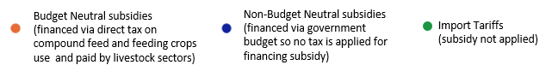

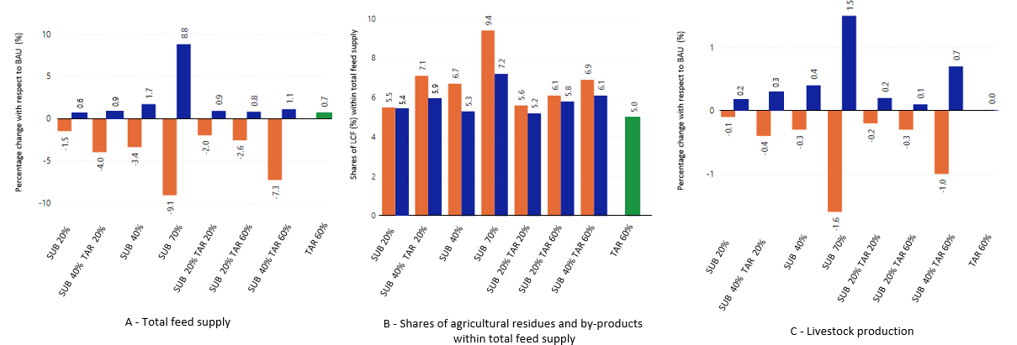
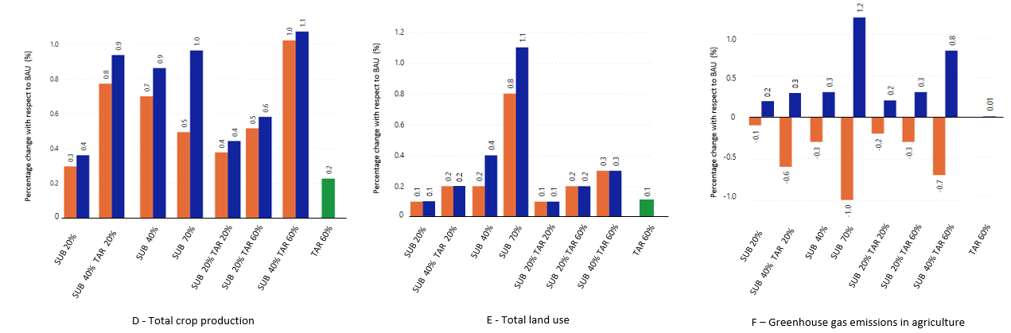
Figure 2. Overview of the impact of policy instruments promoting a circular livestock system. Estimates illustrated in the figure report changes (%) with respect to our business-as-usual (BAU) scenario in 2030. The only exception concerns Panel B, where estimates refer to shares of low-cost-opportunity feeds (LCF) i.e. agricultural residues and by-products, within total feed supply (domestic and imported) in EU27. Panel A illustrates how different policies affect total feed supply (domestic and imported) in the EU27. Panel B reports the shares of LCF within total feed supply, illustrating the degree of circularity achievable under each policy combination. Panel C reports changes of livestock production under different policy combinations. Panel D illustrates changes in crop production under different policy combinations. Panel E illustrates the changes in total agricultural land use (from crops and livestock sectors) under different policy combinations. Finally, Panel F reports changes in total greenhouse-gas emissions in agriculture (from crops and livestock sectors) associated with different policy combinations.

The impact of policies promoting a circular agri-food system on livestock sectors and feed production
The impact of policies on livestock production varies depending on the type of livestock (Panel A - figure 3). Other ruminants (small ruminants and sheep) are particularly affected by policies due to their relatively higher shares of domestic compound feed and imported feeding crops within total feed consumption. In the “weak circular economy” scenario (WCE), these sectors experience a 0.3% decrease in production, which further decreases by 1.4% in the “strong circular economy” scenario (SCE) due to the import tariff. Conversely, dairy cattle and swine production are more affected in absolute terms, given their higher consumption of primary feed. In the WCE scenario, dairy cattle production decreases by 0.1% (0.11 million Mtons), further decreasing by 0.3% (0.41 million Mtons) in the SCE scenario. Swine production also decreases by 0.2% (0.04 million Mtons) in the WCE scenario and by 0.8% (0.15 million Mtons) in the SCE scenario. Finally, aquaculture sectors are the least affected due to lower amounts of imported feeds and higher reliance on LCF such as fishmeal. These sectors benefit from the policies, increasing production by 2.7% and 5.7% in the WCE and SCE scenarios, respectively.
Both policy scenarios lead to a decrease in feed production, but the changes in feed composition vary across livestock sectors (Panel B - Figure 2). The implementation of a low subsidy on livestock compound feed (LCF) use in the EU27 leads to an increase in the share of LCF in the total feed supply, from 4.9% to 5.7%. This increase is due to the partial replacement of primary feed, which decreases (-2.2% or 6.8 million Mtons) across livestock sectors (Panel B - Figure 2). The subsidy lowers domestic prices of by-products (-25.6%) and residues (-20.4%), appreciating compound feed and feeding crops (average +2.4%), due to the tax imposed to finance the subsidy. Compound feed appreciates relatively more than feeding crops, leading to a decrease in its share (-1.5% or 6.54 million Mtons) in favor of feeding crops (+0.8% or 0.65 million Mtons). In absolute terms, substitution effects are more severe for dairy cattle and swine, as such sectors are the largest consumers of primary feed and are more incentivized to replace it with LCF when primary feed prices increase. These sectors experience an average 1.4% increase (or 1.16 million Mtons) in the share of LCF within the total feed supply. Poultry and cattle (respectively 0.8% or 0.39 million Mtons and 0.7% or 0.21 million Mtons) also experience an increase in the share of LCF, while aquaculture is relatively less affected (0.5% or 0.08 million Mtons) due to a higher use of LCF in the business-as-usual (BAU) scenario which results in a less pronounced substitution of primary feed.
Increasing subsidies on LCF while imposing an import tariff on primary feed leads to a further increase in the use of LCF within total feed consumption, reaching up to 7.1% of total feed. (Panel B – figure 3). The import tariff reduces primary feed imports by an average of 14.5% compared to BAU, resulting in a lower feed supply compared to BAU. The higher price of imported feed incentivizes an increase in LCF use, especially for dairy cattle (+3.1% or 1.6 million Mtons) and swine (+2.4% or 1.65 million Mtons), which rely more on imported feed and are more sensitive to price changes. The import tariff also diverts import demand towards domestic markets, creating additional demand for domestic feed biomass. However, the higher taxes levied to finance higher subsidies reduce feeding crops demand from livestock and compound feed sectors, resulting in an average decrease in total feed demand of 6.0% (15.7 million Mtons).
In a circular food system, the sourcing of feed is a critical component, and increasing the dependence of livestock sectors on domestic feed sources is an effective way to close material loops. In 2030, approximately 85.5% of the total feed consumed in the Business-As-Usual (BAU) scenario is domestically sourced. In the WCE scenario, a subsidy on domestic LCF, increases the share of domestic feed use by an average 1.6% (Panel C – figure 3). This effect is more pronounced in the SCE scenario, where the imposition of the import tariff and higher subsidies drives a substantial increase in the use of domestic feed biomass (average +5.3%) reaching 90.8% of domestic feed sourcing over total feed use. The increasing reliance on domestic feed sources in the EU27 has significant implications for feed-exporting regions. Most affected regions are Latin America and the Caribbean (LAC) and Rest of Europe & Central Asia (REUCA) where feed exports to the EU27 decrease by an average 0.2% in the WCE scenario and by an average 1.8% in the SCE scenario. Brazil is parallelly affected as feed exports to the EU27 decrease by 0.1% in the WCE scenario and by 1.0% in the SCE scenario.
The decrease in ruminant production results in a lower land use in both the WCE (-0.03%) and SCE (-0.05%) scenarios (Panel C - figure 4) but the reduction in land use is not proportional to the decrease in ruminant production. This is because in both scenarios the taxes imposed on domestic feed inputs appreciate compound feed and feeding crops, generating a substitution effect between feed and pastureland which drives a less steep decrease of total land demand. Regarding greenhouse gas (GHG) emissions, a lower livestock production reduces total emissions from livestock sectors by -0.3% in the WCE scenario and -1.1% in the SCE scenario (Panel D - figure 4), with most reductions observed for ruminants and swine.
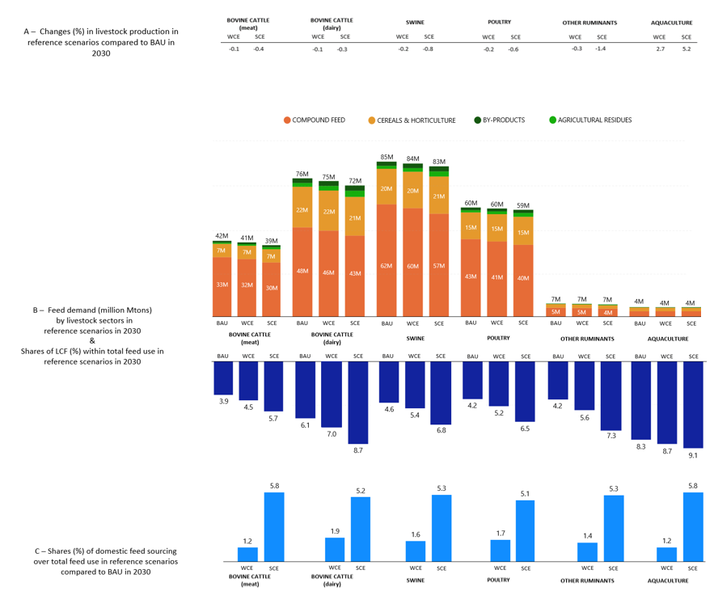
Figure 3. Changes in livestock production, feed supply, composition, and sourcing in EU27 in 2030 (by scenario). BAU refers to our business-as-usual (baseline) scenario, while WCE and SCE respectively represent the “weak circular economy” and the “strong circular economy” scenario. “Other ruminants” refers to the sum of feed supplied to other cattle (goats, sheep, and other types of small ruminants raised for meat and dairy products) and sheep (raised for wool production). Panel A illustrates changes (%) in total livestock production under different policies compared to our baseline scenario in 2030. Panel B reports total feed demand (million Mtons) by each livestock sector in baseline and under different policies in 2030, illustrating the composition of total feed use. Panel B reports the changing shares of low-cost-feedstuff (LCF) such as agricultural residues and by-products in our reference scenarios in 2030.Finally, Panel C illustrates the changing shares (%) of domestic feed use over total feed use by each livestock type compared to BAU by reference scenario in 2030.
Agriculture-wide impacts of policies promoting a circular agri-food system.
The increasing use of low-cost-opportunity feeds (LCF) indirectly results in an increase in production of the main commodities from which agricultural residues and by-products are derived (Panel A – figure 4 and Panel A – figure 5). The increasing demand for agricultural residues leads to a corresponding increase in the production of primary crops (Panel A - figure 4). In the WCE scenario, the rising demand for agricultural residues causes an average increase of 0.3% in the production of cereal and horticulture crops. The extent of the increase in production is partially contained by the reduced demand for feeding crops from the compound feed and livestock sectors, due to a tax imposed to finance the subsidies. Nonetheless, a higher crop production intensifies land use (Panel B – figure 4), leading to an average 1.1% increase in land prices and a consequent appreciation of domestic cereals and horticulture crops (average +0.4%). This additionally prompts a 1.3% average increase in imports of agricultural products in the EU27, primarily from China (average 1.4%) and Brazil (average 1.2%).
While stronger subsidies and import tariffs severely push domestic crop production, the higher taxation required to finance increasing subsidies plays a key role in limiting feed and crops demand, containing the increase in crop production. Nonetheless, the impact on crop production is more pronounced in the SCE scenario, as the higher subsidy coupled with import tariffs results in a greater increase in domestic crop production (0.8%). The increase in crop production leads to a stronger appreciation of land (+3.3%) and, consequently, of agricultural products (0.9%). This is additionally due to the import tariff which contributes to rising land prices as it decreases imports of feeding crops by an average of 23.6%, redirecting demand towards domestic markets. The tariff has a negative impact on the main feed-exporting regions, such as Latin America and the Caribbean (LAC) and the Rest of Europe and Central Asia (REUCA). However, due to the increased demand for agricultural imports in the EU27 resulting from higher domestic land prices, an increase in exports of non-feeding crops to the EU27 (average +2.3%) counterbalances the negative effects of the tariff. EU27 imports primarily increase for sugar-beet (average 12.4%) and horticultural products (average 1.7%) mainly from China, LAC, REUCA, and Sub-Saharan Africa (SSA).
Changes in agricultural production and trade have negative effects on labour demand and wages in the agricultural sector of the EU27 (Panel B – figure 4). Compared to our business-as-usual scenario (BAU), the appreciation of land increases average agricultural imports, reducing domestic demand for agrifood products and average agricultural unskilled wages in the EU27. Moreover, the average unskilled wages in agriculture decrease as workers transition from relatively more labour-intensive livestock sectors to the crop sectors, which on average rely more on land. In the WCE scenario, average wages for unskilled agricultural workers decline by a 0.07%, while in further decreasing in the SCE scenario (-0.3%). Outside the EU27, the rise in imports of non-feeding crops by the EU27 has a positive impact on agricultural welfare, increasing unskilled agricultural wages. The REUCA and SSA regions benefit the most as they experience a more significant increase in unskilled agricultural wages of 0.2% and 0.5% in the WCE and SCE scenarios, respectively. This is additionally due to the fact that regions exporting feed to the EU27, such as Brazil, Latin America & Caribbean (LAC), and Rest of Europe and Central Asia (REUCA), redirect their exports to China and Southeast Asia, avoiding the negative impact of the feed import tariff in the EU27.
The increase in primary crop production generates an average increase in land use from crop sectors (Panel C – Figure 4). In the WCE scenario, total land use in agriculture increases by 0.1%, driven primarily by expanding crop sectors. However, as ruminant sectors partially substitute taxed primary feed with pastureland, land use decreases proportionally less than livestock production, contributing to a higher agricultural land use in the EU27. The stronger increase in crop production observed in the SCE scenario leads to a further increase in land use from crop sectors resulting in a higher use of total agricultural land (0.2%). As a result, the use of chemical fertilizers increases in both policy scenarios, specifically by a 0.2% in the WCE scenario and by a 0.4% in the SCE scenario.
In the WCE scenario, greenhouse gas (GHG) emissions from livestock production decrease, but this benefit is partially offset by expanding emissions from crop sectors (0.1%). Here, the additional use of chemical fertilizers further increases GHG emissions by a 0.3%. Despite this, total emissions from agriculture in the EU27 decrease by 0.1%. In the SCE scenario, crop-related GHG emissions increase by an average of 0.6%, with the additional use of chemical fertilizers accounting for a further emissions increase of 1.0%. Nonetheless, the stronger decrease in emissions from livestock sectors results in a decrease in total emissions from agriculture (-0.6%) compared to the baseline (BAU) scenario in 2030.

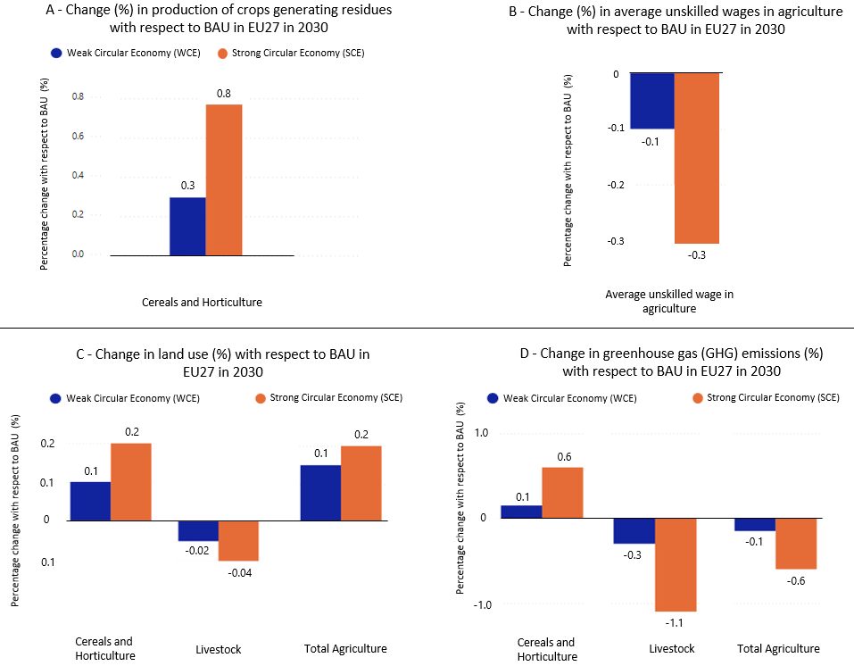

Figure 4. Economic and environmental impacts on agricultural sectors in the EU27 in 2030 (by scenario). Estimates refer to percentage change (%) in our reference scenarios with respect to our business-as-usual (BAU) scenario in 2030. The upper part of the figure (i.e. panels A and B) illustrate economic impacts while the lower part of the figure (i.e. panels C and D) report the environmental impacts of investigated policies. Panel A illustrates the average change (%) in cereals and horticulture production under our policy scenarios in 2030. Panel B illustrates the impact of our policy scenarios on average unskilled agricultural wagers in the EU27 in 2030. Panel C reports changes (%) in land use (by sectors and in total) under our policy scenarios in 2030. Finally, Panel D illustrates changes (%) in greenhouse gas (GHG) emissions (by sectors and in total) under our policy scenarios in 2030.

Economy-wide impacts of policies promoting a circular agri-food system.
Similarly to crop production, the increase in demand for by-products generated by our policies indirectly leads to an increase in the production of the main commodities that generate these by-products (Panel A - figure 4). In the WCE scenario, production primarily increases for biofuels (generating dried distillers' grains (DDGS)) (15.5%), and processed fish (generating fishmeal) (1.1%). The production of molasses obtained refined sugars increases relatively less (0.4%) due to the high use of molasses in other production processes (i.e., processed foods) which limits its use as animal feed. In the SCE scenario, higher subsidies combined with an import tariff result in a more significant increase in the production of DDGS (45.2%), fishmeal (2.6%), and oilcakes (1.1%) with a relatively minor impact on the production of molasses (0.7%).
The heterogenous impacts of policies affect the allocation of biomass across non-agricultural sectors (Panel B – figure 4). In the WCE scenario, the demand for domestic and imported energy crops increases by 30.1%, rising to 46.5% in the SCE scenario, and further contributing to the increase in crop-related land use. As a result, domestic biomass is redirected towards energy use, thereby reducing its availability for food and feed production. In comparison to the business-as-usual scenario, the WCE scenario results in a slight increase in domestic biomass allocation towards other industrial uses (0.1%), but a decrease in biomass allocation for feed (-0.2%) and food (-0.02%) uses. The SCE scenario leads to even more significant changes, with the energy use of biomass increasing by 0.4%, while decreasing for feed (-0.4%) and food (-0.03%) purposes.
Trends of biomass demand directly influence trade of primary biomass and biobased products (Panel C – figure 4). The increasing production of biofuels in the EU27 has a direct impact on exports of such products, with both our policy scenarios resulting in higher biofuel exports. In the WCE scenario, exports of biofuels increase by an average of 7.2%, primarily towards Brazil, Industrialized Asia (INDA), and the United States. The SCE scenario leads to an even sharper increase in biofuel production, resulting in a larger average increase in exports of 21.5%. Similarly, the increasing production of aquaculture and processed fish enlarges exports in both scenarios (WCE 11.1%; SCE 21.6%), mainly towards Southeast Asia (SEA), Sub-Saharan Africa (SSA), and Brazil. Total EU27 food exports decrease in the WCE scenario (-1.0%) as well as in the SCE scenario (-2.0%) due to a lower allocation of domestic biomass towards food which in turn increases food imports (WCE 1.1%; SCE 2.3%). On the import side, the higher production of biofuels leads to an increase in imports of energy crops (average 2.5% in the WCE scenario and 4.1% in the SCE scenario), mainly from SSA and Latin America & the Caribbean. The increased availability of biofuels generates a substitution effect within the domestic use of energy sources, leading to a decrease in demand for refined petroleum products from domestic (WCE -0.3%; SCE -0.5%) and imported (WCE -0.02%; SCE -0.05%) sources.
Finally, we find policies indirectly promote a substitution effect between refined petroleum products and biofuels , particularly in the transportation and chemical sectors. This leads to a reduction in economy-wide greenhouse gas (GHG) emissions (Panel D – figure 4) which further contributes to the GHG emission reduction achieved in agriculture. In the WCE scenario emissions from non-agricultural sectors decrease by a 0.1%, further decreasing in the SCE scenario (-0.4%). This, combined with the decrease in GHG emissions from agriculture, leads to a reduction of total GHG emissions (WCE 0.2%; SCE 1.1%) in the EU27 in 2030.

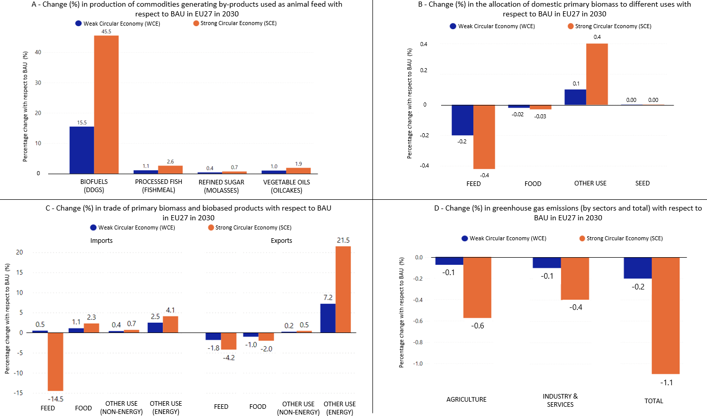
Figure 5. Changes in production of by-products, biomass allocation, trade, and greenhouse gas emissions in the EU27 in 2030 (by scenario). Estimates refer to percentage change (%) in our reference scenarios with respect to our business-as-usual (BAU) scenario in 2030. Panel A illustrates change (%) in production of commodities generating by-products under our policy scenarios in 2030. Panel B illustrates change (%) in the allocation of domestically produced primary biomass in the EU27 to different uses (feed, food, other uses, and seed) under our policy scenarios in 2030. Here “other uses” refers to the use of biomass in industrial non-food sectors such as textile, chemical, and bioenergy sectors. Panel C reports changes in trade of primary biomass and biobased products under our policy scenarios in 2030. Here the “feed” category refers to feeding crops as well as processed compound feed. Similarly, the “food” category refers to trade of primary fresh agri-food products as well as processed foods. The “other use (non-energy)” category refers to trade of biomass products (fresh and processed) used in industrial non-food non-energy sectors such as textile or chemical sectors. Differently, the “other use (energy)” category refers to trade of biomass products used to produce bioenergy, including trade of energy crops as well as biofuels. Finally, Panel D illustrates changing greenhouse gas emissions by sectors and in total under our policy scenarios in 2030.

Discussion
In this paper we investigate economic and environmental impacts of policies promoting the transition towards a more circular food system with a specific role for livestock. We explore different policy instruments aiming to replace primary animal feed with low-cost-opportunity feeds (LCF) and increase the domestic sourcing of animal feed in the EU27 in 2030. The use of a global general equilibrium (GE) model allows to investigate the impact of subsidies and import tariffs targeting agricultural and non-agricultural products, depicting interactions across sectors, global trade dynamics, and economy-wide effects. The inclusion of endogenous price responses to policies is critical to identify substitution effects and understand how changing prices of subsidized agricultural residues and industrial by-products affect their reuse in a circular economic framework. Additionally, the endogenous representation of labour markets modelled as segmented between agricultural and non-agriculture markets for two types of labour (skilled and unskilled), consents to capture wage developments when policies targeting specific sectors are implemented. Finally, a global modelling framework enables to identify how policies in the EU27 affect other regions, outlining world-wide trade-offs between sustainability targets and socioeconomic welfare. These features render a GE framework preferred over a partial-equilibrium (PE) framework where labour markets and non-agricultural sectors are often omitted.
The novelty of our study revolves around improved modelling of livestock systems and the circular economy in monetary CGE models, addressing a key limitation of these models (Pyka et al. 2022; Pauliuk et al., 2017). We improve existing economic models by incorporating physical biomass flows and dietary features of livestock, often overlooked in standard value-based GE frameworks but crucial for evaluating the technical aspects of livestock production in a circular agri-food system. We introduce four animal-specific feed sectors and ad-hoc production structures for each livestock sector to enhance the technical representation of livestock systems. The expansion of our economic model in the field of livestock sciences provides an understanding of the economic feasibility of various strategies suggested to improve circularity in agri-food systems. In this regard, a core finding of our study shows that promoting a higher use of low-cost-opportunity feeds (LCF) can lead to an increase in crop production, creating additional pressures on agricultural land. An increase in land use and prices rises agricultural imports, lowering unskilled agricultural wages in the EU27. In the absence of direct taxation on livestock sectors (non-budget neutral subsidies) a higher use of LCF can increase livestock production and related greenhouse gas (GHG) emissions, compromising the benefits of a circular food system.
These drawbacks become especially relevant when envisioning a livestock sector heavily reliant on LCF (van Zanten et al., 2018; Wiel et al., 2019, van Hal et al., 2019, Sandström et al., 2022). From a nutritional perspective, a higher reliance on domestic feed sources helps closing material loops (FAO, 2015; Schipper et al., 2018), although changing livestock diets with higher contents of LCF may affect the nutritional balance of livestock. Across our investigated scenarios, feed-conversion-ratios (FCR) for each livestock sector result close to reference estimates observed in literature (see Table S11 - Supplementary Information). The only exception is represented by bovine cattle which presents a relatively lower FCR compared to literature as several feed products (i.e. hay, pasture grass) are not integrated in our model and are omitted from nutritional calculations. Nonetheless, as the average diet across livestock sectors in our model is mainly composed by grains (around 60-65%), with LCF ranging from an average 5% to 7% in the SCE scenario, the high energy content of livestock diets allows to remain consistent with gross energy (MJ/kg DM) and crude protein (% DM) requirements observed in literature (see Tables S10a - S10g – Supplementary Information). Here, an entry point for improvement could consist of restructuring the GTAP database (on which our economic model is built) to provide a data version that better represents the current composition of livestock diets across countries. From a system-wide perspective, we find that achieving a truly circular agri-food system requires significant efforts beyond simply implementing policies promoting a high use of LCF and a more domestic sourcing of feed. Stronger policies for circularity exert negative externalities on wages and the environment while do not significantly increase the shares of LCF within total feed use. These drawbacks raise doubts about the feasibility and benefits of circular agri-food systems and highlight the need for comprehensive multidisciplinary analyses.
Across the analysed policies, we test the impact of subsidising LCF as animal feed and imposing import tariffs on compound feed and feeding crops in the EU27. We find budget-neutral policies, where subsidies promoting the use of LCF are funded by taxing livestock sectors, effectively decrease total feed demand, lowering livestock production and GHG emissions in 2030. These policies effectively increase the reuse of LCF in replacement of primary feed, promoting the domestic sourcing of feed, although shares of LCF are relatively low. Contrarily, we find non-budget neutral subsidies funded through government budget increase shares of LCF but rise total feed demand, expanding livestock production and related GHG emissions. Imposing an import tariff on feed increases the domestic sourcing of feed but results in a higher use of cropland and pastureland in 2030.
Budget-neutral policies should be preferred for promoting circularity, although the size of the interventions is crucial. While the 20% subsidy tested in our weak circular economy (WCE) scenario reduces GHG emissions without significantly affecting livestock and feed producers, a stronger subsidy (e.g. 40% or 70%) risks to strain producers, threatening their welfare. Moreover, stronger subsidies stimulate demand for agricultural residues, generating a more severe increase in crop production. This, coupled with a severe shift in livestock demand from feed to pastureland due to higher taxes required for financing stronger subsidies, increases land use and prices, rising agricultural imports while lowering agricultural wages.
Among our policies, we find that a viable option for encouraging the use of LCF and promote a higher domestic sourcing of feed lies in combining a 40% subsidy with a 20% import tariff on compound feed and feeding crops (strong circular economy - SCE scenario). Compared to a stand-alone subsidy, this policy further reduces GHG emissions, leading however to a larger increase in land use and lower agricultural wages. As negative effects on wages are rather contained, this policy presents the best trade-offs for favouring a circular food system, also in comparison to other investigated subsidy-tariff combinations. As current debates on circular economy in the EU27 (European Commissions, 2020; 2021) lack clarity on effective instruments favouring this transition, our findings may serve as a starting point to identify potential policy interventions. In this, we offer a quantification of potential policy drawbacks illustrating the link between subsidies and the increase in crop production, confirming prior studies on negative externalities of subsidies (Font Vivanco et al., 2018, 2021; Li et al., 2017).
Policies promoting a circular agri-food system may reduce the environmental footprint of livestock sectors but require a decrease in production. We aligns with previous findings in the field of livestock sciences (Van Selm et al., 2022; Van Zanten et al., 2019; De Boer and Van Ittersum, 2018), providing a physical quantification of the reduction in production output required to achieve a specific degree of circularity. We find a lower livestock production decreases GHG emissions and land use in both our WCE and SCE scenario. Despite so, the decrease in GHG emissions is relatively contained (-0.3% in the WCE scenario and -1.1% in the SCE scenario) and stronger policies seem to not provide a significant contribution to achieve the EU27 targets on GHG emissions reduction in 2030 (EC, 2020). Our results show that the reduction in land use from ruminant sectors is not proportional to the decrease in their production. This is due to an increase in pastureland use related to the appreciation of primary feed generated by the imposed tax. As the size of this substitution can have detrimental effect on land, increasing prices while threatening biodiversity (Leclere et al. 2020), introducing a tax on primary feed may require additional policies. Viable options could entail setting targets for sustainable pasture management (AHDB, 2017) or providing incentives for sustainable land use practices (IPCC, 2014).
Changes in land use further relate to expanding crops production. In both our scenarios, a higher use of agricultural residues drives an increase in primary crop production, rising land use and domestic land prices. In the EU27, the appreciation of agricultural land rises imports of agricultural products, increasing food dependency on international markets. Higher land prices and agricultural imports result in a decline in agricultural wages, particularly for low-skilled workers. This confirms previous studies linking land prices and agricultural wages (Sumner et al., 2017; Swinton and Young, 2001; Rau et al., 2017; EC, 2018; European Parliament, 2017) and underscores the importance of accounting for potential trade-offs on welfare and income security when policies aiming for sustainable production are designed in the EU27. In addition, the intensification of primary crop production increases use of chemical fertilizers, rising crop-related GHG emissions. Nonetheless, as such increase is outweighed by the reduction of emissions from livestock sectors, total emissions form agriculture in the EU27 remain below baseline levels in both scenarios in 2030. Based on this we may conclude that promoting a circular agri-food system contributes to climate mitigation strategies but risks to have spillover effects into land, threatening low-income low-skilled workers in agriculture. To avoid this, complementary policies for decreasing primary biomass demand or increasing the availability of lost or discarded biomass should be implemented. Taxation on animal-sourced foods (currently applied or debated in several countries) or changes in regulations to favour the reuse of additional types of discarded biomass as animal feed, including the reuse of food waste (Zu Ermgassen et al., 2016), constitute viable solutions for decreasing pressures on land in the EU27 food system in 2030. Relaxing regulations for upcycling secondary biomass as animal feed can increase LCF supply, reducing the high increase in crops production linked to the higher demand for agricultural residues. This could additionally avoid the increase in land use and prices, limiting the rise in agricultural imports and the negative spillovers to agricultural wages.
Outside agriculture, we find both scenarios promote the use of by-products as animal feed, but production of main commodities increase. A higher biofuel production (generating distillers dried grains) pushes demand for energy crops, stimulating land demand while redirecting domestic biomass towards energy use. A lower allocation of domestic biomass for food and feed, increases food imports lowering food sovereignty in the EU27 in 2030. Nonetheless, a higher production of biofuels promotes a substitution effect within the domestic energy consumption bundle, decreasing domestic and imported demand for refined petroleum products in favour of more sustainable biobased alternatives. In both our scenarios this indirect effect reduces total GHG in the EU27 in 2030, further contributing to the climate mitigation debate.
As always, our findings are subject to several limitations. Main methodological limitations lie in the lack of a detailed representation of feed components and livestock categories. A distinction between cattle (sheep, horses, others), poultry (broilers, hen, etc) or aquaculture (marine fish, freshwater fish, molluscs, etc) may provide a clearer picture of how circular policy measures may mitigate environmental impacts of more specific livestock productions in 2030. Similarly, the inclusion of additional feed types such as pasture grass, hay, animal by-products, minerals, and additional plants, currently omitted in our modelling framework, would have enhanced the calculation of nutritional balances, increasing the technical details of our analysis. This limitations become apparent in the substitution between primary feed and LCF. As we do not include different productivity levels for livestock and feed, the size of substitution effects may differ based on the productivity level of a specific animal or feed type. Further research could improve our economic framework by differentiating livestock by productivity level, investigating if higher shares of LCF compromise the productivity and nutrition of different livestock production systems. For this, it may be necessary to combine a GE framework with more detailed partial-equilibrium models or biophysical models, including higher details for livestock and agricultural sectors while still accounting for income- and economy-wide effects, crucial for devising the effectiveness of polices towards a more circular food system.
While the importance of transitioning to a more circular and sustainable livestock production has been widely investigated, very little is today available on the consequences of economic policies promoting a circular agri-food system with a specific role for livestock. The novelty of our analysis consists of clarifying the impact of circular policies for livestock production from an economic and technical perspective, addressing knowledge gaps around the broadly debated circular economy transition in EU27. Our findings highlight the significance of implementing a collaborative multidisciplinary approach towards food system strategies. This serves as a foundation for connecting economic and technical models, facilitating future research on circularity. Policymakers must consider the potential trade-offs of circular policies on social welfare and other environmental challenges, taking a holistic approach that accounts for economic, social, and environmental dimensions of sustainability. In conclusion, while circularity proves to be the right step for mitigating the environmental impact of livestock production in EU27, future research may contribute to understand how parallel policies can complement benefits and contain drawbacks of circular solutions, enhancing the sustainability of our food system in 2030.

References (to be finished)

Garnett, E. (2011). The impact of livestock production on climate change: A review of the literature. Environmental Science & Policy, 15(4), 357-369.

Wirsenius, S., Hedenus, F., & Mohlin, K. (2011). Greenhouse gas emissions from the EU livestock sector: A life cycle assessment. Journal of Cleaner Production, 19(6-7), 641-648.
FAO and UNEP. 2021. Global assessment of soil pollution: Report. Rome. https://doi.org/10.4060/cb4894en
Food and Agriculture Organization of the United Nations. (2014). Reducing greenhouse gas emissions from livestock: Best practice and emerging options. Retrieved from http://www.fao.org/3/a-i3437e.pdf

International Livestock Research Institute. (2014). The livestock sector and climate change: The role of the United Nations Framework Convention on Climate Change. Retrieved from https://cgspace.cgiar.org/bitstream/handle/10568/43720/CCAFS-Report-Livestock-Sector-and-Climate-Change.pdf?sequence=1&isAllowed=y

European Environment Agency. (2017). Reducing greenhouse gas emissions from livestock: Opportunities and challenges. Retrieved from https://www.eea.europa.eu/publications/reducing-greenhouse-gas-emissions-from-livestock

Schipper, R., van der Vorst, J. G. A. J., & Tukker, A. (2018). Towards a circular agro-food industry: An analysis of the agro-food system in the Netherlands. Journal of Cleaner Production, 172, 3715-3729. https://doi.org/10.1016/j.jclepro.2017.04.154

Food and Agriculture Organization of the United Nations. (2015). Domestic feed production: Opportunities and challenges for sustainable livestock development. http://www.fao.org/3/a-i4350e.pdf

Agriculture and Horticulture Development Board. (2017). Sustainable grazing management for livestock farmers.

Intergovernmental Panel on Climate Change. (2014). Agriculture and climate change: Part 1 - Mitigation potential and challenges.
Sumner, D. A., & Matthews, W. A. (2017). The Impact of Land Prices on the Incomes of Farmers and Farm Workers in the United States. Agricultural and Resource Economics Review, 46(2), 249-268. https://doi.org/10.1017/age.2017.7
Swinton, S. A., & Young, D. L. (2001). The Effects of Land Prices on the Wages of Farm and Nonfarm Labor in the United States. American Journal of Agricultural Economics, 83(3), 618-633. https://doi.org/10.1111/0002-9092.00183

Rau, M.-L., Gocht, A., & Britz, W. (2018). The Effect of Land Prices on Agricultural Wages in Europe. Journal of Agricultural Economics, 69(3), 736-756. doi: 10.1111/1477-9552.12271
European Commission. (2018). Land Prices and Farm Incomes in the EU: Analytical Insights and Policy Options. Retrieved from https://ec.europa.eu/agriculture/sites/agriculture/files/land-prices-farm-incomes-2018_en.pdf
European Parliament. (2017). Land Prices and Rents in EU Agriculture. Retrieved from https://www.europarl.europa.eu/RegData/etudes/STUD/2017/583124/IPOL_STU(2017)583124_EN.pdf
Francois, J., van Meijl, H. and van Tongeren, F. (2005), 'Trade liberalisation in the DOHA Development Round’ Economic Policy , pp. 351-391. https://doi.org/10.1111/j.1468-0327.2005.00141.x
van Meijl, H., Y. Tsiropoulos, H. Barteling, R. Hoefnagels, E. Smeets, A. Tabeau, A Faaij, (2018) On the macro-economic impact of bioenergy and biochemicals – Introducing advanced bioeconomy sectors into an economic modelling framework with a case study for the Netherlands, Biomass and Bioenergy, 108 . - p. 381 - 397 (Impact factor 3.1). https://doi.org/10.1016/j.biombioe.2017.10.040.

European Commission, 2020; 2021
https://op.europa.eu/en/publication-detail/-/publication/762414e8-ee81-11eb-a71c-01aa75ed71a1/language-en
https://op.europa.eu/en/publication-detail/-/publication/45cc30f6-cd57-11ea-adf7-01aa75ed71a1/language-en/format-PDF/source-170854112

Britz, W., & van der Mensbrugghe, D. (2018). CGEBox: A Flexible, Modular and Extendable Framework for CGE Analysis in GAMS. Journal of Global Economic Analysis, 3(2), 106–177. https://doi.org/10.21642/JGEA.030203AF
Chepeliev, M. (2022). Incorporating Nutritional Accounts to the GTAP Data Base. Journal of Global Economic Analysis, 7(1), Article 1. https://doi.org/10.21642/JGEA.070101AF
Cole, J. R., & McCoskey, S. (2013). Does global meat consumption follow an environmental Kuznets curve? 9(2), 12.
De Schutter, O. (2017). The political economy of food systems reform. European Review of Agricultural Economics, 44(4), 705–731. https://doi.org/10.1093/erae/jbx009
Delzeit, R., Beach, R., Bibas, R., Britz, W., Chateau, J., Freund, F., Lefevre, J., Schuenemann, F., Sulser, T., Ruijven, B. V., Weitzel, M., & Willenbockel, D. (2020). Linking Global CGE models with Sectoral Models to Generate Baseline Scenarios: Approaches, Challenges, and Opportunities. Journal of Global Economic Analysis, 5(1), 34.
Erb, K.-H., Mayer, A., Kastner, T., Sallet, K.-E., & Haberl, H. (2012). The Impact of Industrial Grain Fed Livestock Production on Food Security: An extended literature review. 83.
Font Vivanco, D., Kemp, R., & van der Voet, E. (2016). How to deal with the rebound effect? A policy-oriented approach. Energy Policy, 94, 114–125. https://doi.org/10.1016/j.enpol.2016.03.054
Font Vivanco, D., Nechifor, V., Freire-González, J., & Calzadilla, A. (2021). Economy-wide rebound makes UK’s electric car subsidy fall short of expectations. Applied Energy, 297, 117138. https://doi.org/10.1016/j.apenergy.2021.117138
Font Vivanco, D., Sala, S., & McDowall, W. (2018). Roadmap to Rebound: How to Address Rebound Effects from Resource Efficiency Policy. Sustainability, 10(6), Article 6. https://doi.org/10.3390/su10062009
Gerber, P. J., & Food and Agriculture Organization of the United Nations (Eds.). (2013). Tackling climate change through livestock: A global assessment of emissions and mitigation opportunities. Food and Agriculture Organization of the United Nations.
Hilborn, R., Banobi, J., Hall, S. J., Pucylowski, T., & Walsworth, T. E. (2018). The environmental cost of animal source foods. Frontiers in Ecology and the Environment, 16(6), 329–335. https://doi.org/10.1002/fee.1822
Li, H., Ren, J., Bao, Q., Ren, X., Yang, Y., & Xie, Y. (2017). Reducing rebound effect through fossil subsidies reform: A comprehensive evaluation in China. Journal of Cleaner Production. http://dx.doi.org/10.1016/j.jclepro.2016.09.108
McCarthy, A., Dellink, R., & Bibas, R. (2018). The Macroeconomics of the Circular Economy Transition: A critical review of modelling approaches. 53.
Ominski, K., McAllister, T., Stanford, K., Mengistu, G., Kebebe, E. G., Omonijo, F., Cordeiro, M., Legesse, G., & Wittenberg, K. (2021). Utilization of by-products and food waste in livestock production systems: A Canadian perspective. Animal Frontiers, 11(2), 55–63. https://doi.org/10.1093/af/vfab004
Pauliuk, S., Arvesen, A., Stadler, K., & Hertwich, E. G. (2017). Industrial ecology in integrated assessment models. Nature Climate Change, 7(1), 13–20. https://doi.org/10.1038/nclimate3148
Poore, J., & Nemecek, T. (2018). Reducing food’s environmental impacts through producers and consumers. Science, 360(6392), 987–992. https://doi.org/10.1126/science.aaq0216
Röös, E., Bajželj, B., Smith, P., Patel, M., Little, D., & Garnett, T. (2017). Greedy or needy? Land use and climate impacts of food in 2050 under different livestock futures. Global Environmental Change, 47, 1–12. https://doi.org/10.1016/j.gloenvcha.2017.09.001
Salami, S. A., Luciano, G., O’Grady, M. N., Biondi, L., Newbold, C. J., Kerry, J. P., & Priolo, A. (2019). Sustainability of feeding plant by-products: A review of the implications for ruminant meat production. Animal Feed Science and Technology, 251, 37–55. https://doi.org/10.1016/j.anifeedsci.2019.02.006
Schader, C., Muller, A., Scialabba, N. E.-H., Hecht, J., Isensee, A., Erb, K.-H., Smith, P., Makkar, H. P. S., Klocke, P., Leiber, F., Schwegler, P., Stolze, M., & Niggli, U. (2015). Impacts of feeding less food-competing feedstuffs to livestock on global food system sustainability. Journal of The Royal Society Interface, 12(113), 20150891. https://doi.org/10.1098/rsif.2015.0891
Spiegal, S., Kleinman, P. J. A., Endale, D. M., Bryant, R. B., Dell, C., Goslee, S., Meinen, R. J., Flynn, K. C., Baker, J. M., Browning, D. M., McCarty, G., Bittman, S., Carter, J., Cavigelli, M., Duncan, E., Gowda, P., Li, X., Ponce-Campos, G. E., Cibin, R., … Yang, Q. (2020). Manuresheds: Advancing nutrient recycling in US agriculture. Agricultural Systems, 182, 102813. https://doi.org/10.1016/j.agsy.2020.102813
Stephens, E. C., Martin, G., van Wijk, M., Timsina, J., & Snow, V. (2020). Editorial: Impacts of COVID-19 on agricultural and food systems worldwide and on progress to the sustainable development goals. Agricultural Systems, 183, 102873. https://doi.org/10.1016/j.agsy.2020.102873
Uwizeye, A., Gerber, P. J., Schulte, R. P. O., & de Boer, I. J. M. (2016). A comprehensive framework to assess the sustainability of nutrient use in global livestock supply chains. Journal of Cleaner Production, 129, 647–658. https://doi.org/10.1016/j.jclepro.2016.03.108
van Hal, O., de Boer, I. J. M., Muller, A., de Vries, S., Erb, K.-H., Schader, C., Gerrits, W. J. J., & van Zanten, H. H. E. (2019). Upcycling food leftovers and grass resources through livestock: Impact of livestock system and productivity. Journal of Cleaner Production, 219, 485–496. https://doi.org/10.1016/j.jclepro.2019.01.329
van Selm, B., Frehner, A., de Boer, I. J. M., van Hal, O., Hijbeek, R., van Ittersum, M. K., Talsma, E. F., Lesschen, J. P., Hendriks, C. M. J., Herrero, M., & van Zanten, H. H. E. (2022). Circularity in animal production requires a change in the EAT-Lancet diet in Europe. Nature Food, 3(1), Article 1. https://doi.org/10.1038/s43016-021-00425-3
Van Zanten, H. H. E., Van Ittersum, M. K., & De Boer, I. J. M. (2019a). The role of farm animals in a circular food system. Global Food Security, 21, 18–22. https://doi.org/10.1016/j.gfs.2019.06.003
Van Zanten, H. H. E., Van Ittersum, M. K., & De Boer, I. J. M. (2019b). The role of farm animals in a circular food system. Global Food Security, 21, 18–22. https://doi.org/10.1016/j.gfs.2019.06.003
Winning, M., Calzadilla, A., Bleischwitz, R., & Nechifor, V. (2017). Towards a circular economy: Insights based on the development of the global ENGAGE-materials model and evidence for the iron and steel industry. International Economics and Economic Policy, 14(3), 383–407. https://doi.org/10.1007/s10368-017-0385-3

For more detailed information visit www.magnet-model.eu

