Evaluating the economic and employment implications of GHG emission reductions using a CGE and a Macro-Econometric model: The role of macro closures and finance

Fragkiadakis Dimitrisª and Paroussos Leonidas^{b}

  - Abstract
In many studies Macro-econometric – Keynesian type models and neoclassical CGE models provide mixed insights regarding the performance of climate and energy policies. This study is concerned in assessing the mechanisms through which this takes place for different ETS allocation modes and a Carbon Border Adjustment Mechanism, using two large scale applied models representing the two different modelling methodologies: the CGE model GEM-E3 and the macro econometric model GINFORS-E. Both models have been used to simulate the economic implications of an EU increase of GHG emission reduction targets from 40% in 2030 to 55% and from 80% to 95% in 2050. The two models (when in GEM-E3 the option of crowding out is activated) show different (in direction) impacts on GDP and employment. In GEM-E3, the GDP effect in 2030 is negative for the EU. GINFORS-E shows a positive GDP effect in in all countries except Russia. Regarding the carbon leakage rate which is calculated over the 2020-2050 period the GEM-E3 model calculates carbon leakage rates that are in the range of (0-24.4%) which are higher from GINFORS (which are in the range of 5.4-13.6%). Leakage is driven by the basic metals sector followed by chemicals. In overall the key factors driving the differences of the model results are: i) the source of financing of the additional investments required to reduce GHG emissions and ii) the rate of resource utilization that the two models assume.

  - Keywords
Computable general equilibrium, macro-econometric, climate policy, macroeconomic impacts

ª E3-Modelling SA, Panormou 70-72, Athens , Greece; E-mail: dfragkiadakis@e3modelling.com
^{b}E3-Modelling SA, Panormou 70-72, Athens , Greece; E-mail: paroussos@e3modelling.com

Introduction
The clean energy transition is a capital-intensive process through which low value-added products (fuels) are substituted by investments in high value-added products (wind turbines, PV panels, Energy efficient appliances and machines). This process takes place in a dynamic energy system where prices, technology costs, production structures, consumer preferences and habits are all constantly evolving and where different and new types of labour skills, infrastructure and materials are needed. At the same time, the international perspective in terms of trade flows is expected to change as countries that are net exporters of fossil fuels will face low demand and countries that produce the clean energy technologies will increase their share in global trade flows. The pace of FDI is expected to accelerate in relevant to the transition sectors as firms will aim to gain comparative advantages and established knowledge capacity. The pace at which is country will decarbonise its energy system will be different providing costs and opportunities: early adopters may bear production costs due to more expensive energy (this may drive to relocation – carbon leakage) but also benefit from first mover advantages – from investing first in the production and adoption of clean energy technologies.
At the early stages of the transition, financing requirements are high while the technologies and skills required to make the transition may not have yet reached full learning potential – these are important potential bottlenecks. Competitiveness impacts are not static, whilst needing to contend with potentially higher energy prices and costs, industry will also transform to produce the novel value-added products and materials. As for all technology-driven growth, first-mover advantages may drive competitiveness gains and export-driven growth. Timely coordination of all changes in the system is essential, including the mobilisation of adequate financing to support the large-scale deployment of new technologies. All these elements show that the quantification and assessment of the economic implications of energy and climate policies – especially in an open economy - is a quite complex task as the uncertainties and the inter-dependencies and dynamics of multiple systems must be taken into account.
A lot of studies have been contacted in assessing the macroeconomic impacts of reducing GHG emissions. The findings are diverse and largely depend on the following factors: i) Methodology used and system dynamic properties, ii) Granularity of abatement options representation, iii) Accounting for full system effects (e.g. avoided climate related damages), iv) Assumptions on elasticities, technology costs, policies and measures already in the Reference scenario.
In this study we focus on the methodological features of a Neo-Classical CGE and a Neo-Keynesian model that lead to different economic results.

Models Used: An Overview of GEM-E3 and GINFORS-E
In this section an overview of the two models (GEM-E3 and GINFORS-E) is provided focusing on the key mechanisms regarding carbon pricing the economic/energy system adjustments. Detailed description of the two models is available at Capros et al (2017) and Lutz et al (2013).

  - GEM-E3
The GEM-E3 model is a multi-regional, multi-sectoral, recursive dynamic computable general equilibrium (CGE) model which provides details on the macro-economy and its interaction with the environment and the energy system. It is an empirical, large scale model, written entirely in structural form. GEM-E3 allows for a consistent comparative analysis of policy scenarios since it ensures that in all scenarios, the economic system remains in general equilibrium. In addition, it incorporates micro-economic mechanisms and institutional features within a consistent macro-economic framework and avoids the representation of behaviour in reduced form. Particularly valuable are the insights the model provides regarding the distributional aspects of long-term structural adjustments. The GEM-E3 model is extensively used as a tool of policy analysis and impact assessment.
The GEM-E3 model has been used to quantify a series of climate policy scenarios with different GHG emission reduction targets and configurations regarding the participation of countries, sectors, supply rule of emission allowances, targeted trade mechanisms and trade elasticities. In all cases the key mechanism driving the results of the model is the introduction of a carbon price. The carbon price is internalized in economic agents’ choices (firms and households) and drives investments, fuel substitution, adoption of new production processes and consumption patterns. Carbon prices on one hand increase production costs of firms (as they need to engage in more expensive but less carbon intensive production processes) and reduce households disposable income (as firms price higher their products) but on the other hand they create a demand stimulus effect (the business model changes from low capital expenses (CAPEX) and high operational expenses (OPEX) to high CAPEΧ and low OPEX), drive shifts to economic activities with high output and employment multiplier effects and directs production and R&D to new technologies – lowering eventually their production costs. The net economic and employment result of this adjustment is uncertain and depends on the country, sector and time. The figure below depicts the key mechanisms through which the adjustment process of the economic system takes place in the GEM-E3 model once a carbon price is introduced.
Figure 1: Key mechanisms in GEM-E3 regarding carbon pricing
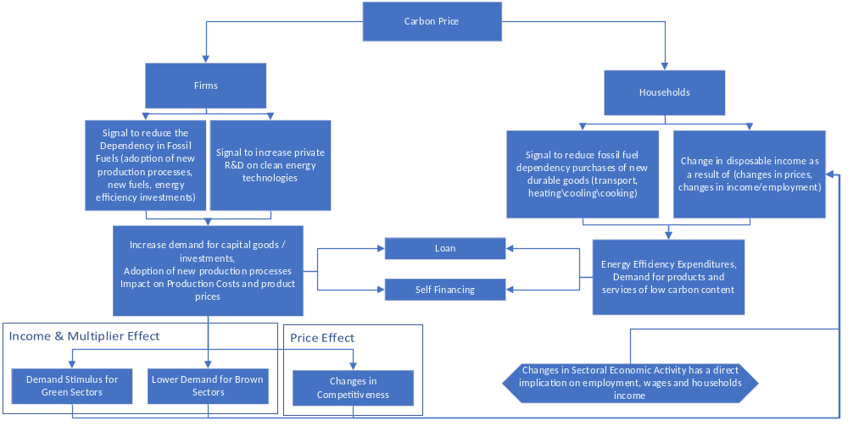

GINFORS-E
GINFORS-E is a global model that it is designed for assessments of economic, energy, climate and environmental policies up to the year 2050. It is a bilateral world trade model based on OECD data, which consistently and coherently models exports and imports of 25 goods groups for 64 countries and one ‘rest of the world' region. All EU-27 countries, additional European economies and international major trade partners are explicitly modelled. It incorporates a macro-model, consisting of exports and imports, other core components of final demand (private and public sector consumption and investment), markets for goods and the labour market, for each country. The country models are also divided into 36 goods categories in accordance with the OECD internationally harmonised input-output (IO) tables. For every country OECD bilateral trade data on industry level is linked to the IO tables. Each national model is linked to an energy model, which determines energy conversion, energy generation and final demand for energy for 19 energy sources disaggregated by economic sector based on IEA energy balances. Energy-related CO2 emissions are linked to energy use. The model considers technological trends and price dependencies.
GINFORS-E can be used to analyse the socioeconomic impacts of a variety of price changes and policies in individual countries in a global context. It is a macro econometric model built on post-Keynesian theory. The parameters used in the model equations are estimated econometrically based on time series data from OECD, UN, IMF, and IEA from 1990 to 2019. Actors have myopic expectations and follow past behavioural routines. Markets are not assumed to be cleared. The model resolves annually. The following figure shows key mechanisms of an increase in carbon prices in GINFORS-E. Investment in clean energy technologies (CET), their trade structure, reduction of fossil fuels, and general changes in investment and consumption drive GDP impacts.
Figure 2: Key mechanisms in GINFORS-E regarding carbon pricing
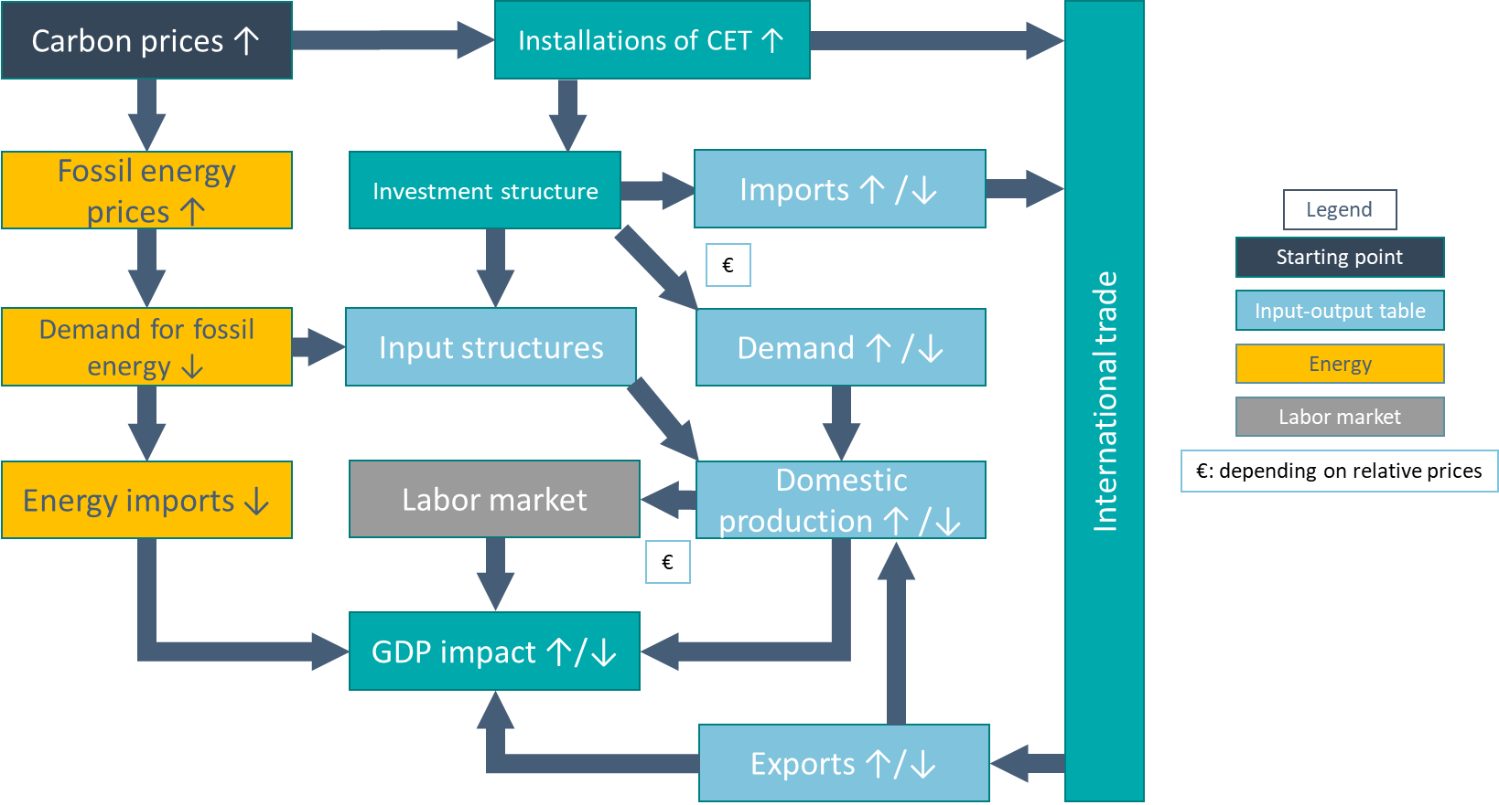

Key model Features
The two models share many common features but also have fundamental differences. Both models are using similar datasets comprising of input-output tables, bilateral trade matrices, energy balances and household budget surveys. Both models are calibrated on a single base year but the GINFORS-E factor demand and consumption functions are empirically estimated on long time series data whereas the GEM-E3 production and consumption functions are dynamically calibrated over time starting from their base year values following normative assumptions. The key model difference are presented in the table below.

Feature | GEM-E3 | GINFORS-E
Economic agents’ behaviour | Optimisation | Non-Optimisation – empirically estimated
Price formation | Cost minimization, market clearing | Mark-up pricing
Growth / Dynamics | Technical progress, capital accumulation, Output Multiplier | Demand driven through increasing investments and or consumption, output multiplier, price increases on markets reduce growth
Macro Economic Closure | Savings equal Investment on national or regional level | Investments can surpass savings on national level
Labour Market | Involuntary unemployment through a labour supply curve. Endogenous unemployment though labour supply function. | Endogenous Unemployment
Elasticities | Nested CES, CET Armington function, LES Consumption functions | Factor demand functions, international trade adjusted to reproduce an Armington function: lower elasticities in GINFORS-E (especially for non-energy inputs and trade elasticities)
Investment | Based on Tobins Q (firms profitability compared to cost of capital replacement) | Follows past relations (no optimization, capital partly substitutes energy)
Financing | Additional to the Reference scenario financing has to become available from agent’s savings or cancelling of investment projects | Indefinite financing is available at a given capital cost
Capital Stock / Capacity utlisation rate | Full utilization rate | Less than 1 utilization rate

Scenarios
The GEM-E3 and GINFORS-E models were used to quantify the following four climate scenarios:
Sc6.NDCs_Ref: In this scenario the EU reduces GHG emissions by 40% below their 1990 level until 2030. For 2050, the EU targets a reduction of 80% compared to 1990 ( EU-27 plus the United Kingdom). Sector separation into ETS and non-ETS is maintained in the EU until 2030. After that, a single carbon price applies. In all other countries, a uniform country-specific carbon price applies, growing with GDP after 2030. In the EU-ETS, free allocation for industry and full auctioning for the energy sector is assumed.
Sc7.EU_FA: differs from REF in that the EU (and the UK and other countries that apply the EU-ETS such as Switzerland and Norway) tighten their reduction targets to 55% in 2030 and 95% in 2050. In this, CCS is excluded from a potential mitigation portfolio in industry and power generation alike, due to unproven environmental integrity and very limited practical experience so far. For nuclear energy, no new installations are considered beyond those already under construction are assumed. As in scenario NDCs_Ref, free allocation for industry and full auctioning for the energy sector in the EU-ETS is assumed. All other countries do not pursue more advanced mitigation targets compared to scenario 6 (NDCs_Ref),
Sc8.EU_AU: The reduction targets remain unchanged compared to scenario EU_FA. However, the allocation of emission allowances changes, which are now auctioned in full in all sectors in the EU. Compensation for increased electricity costs due to the ETS is also eliminated throughout.
Sc9.EU_ff55: In this scenario the emission targets (EU and non-EU) are as in EU_FA and EU_AU. From 2026, a carbon border adjustment mechanism (CBAM) is gradually introduced until 2035, and at the same time the free allocation is reduced and phased-out until 2034. The choice of sectors for the CBAM is based on the European Commission’ s proposal (EU 2021b).

Results
In the reference Scenario 6 (NDCs_Ref), the carbon prices in both models are similar. In 2030, quite low prices of 52.6 USD2010/t CO₂ in GINFORS-E and 39.9 USD2014/t CO₂ in GEM-E3 are sufficient to achieve the target of a 40% GHG reduction compared to 1990. In the following years, prices rise sharply in both models and reach a level of 300 USD to achieve a GHG reduction of 80% compared to 1990. In the target scenarios 7 to 9, the differences in CO₂ prices are significantly larger. While GINFORS-E requires a price of 226 USD/t in 2030, GEM-E3 requires a much lower price of around 76 USD. By 2050, the prices then converge again strongly and are at 524 USD2014 in GEM-E3 and 577 USD2010 in GINFORS-E. This difference in carbon prices indicates the following:
- In the short term the GEM-E3 is more flexible regarding the representation of abatement options (hence the lower carbon price).
- In the long-term remaining GHG emissions are harder to abate and both models have a similar and steeper “implied” marginal abatement cost curve.
Before proceeding to further analysing the results we need to underline that already in the reference, high carbon prices are necessary in 2050 and emissions decrease strongly after 2030. The scenario comparison only measures the delta between a 95% to an 80% GHG reduction in 2050. The following results do not describe the overall effects of climate protection in Germany and the EU, but only the effects of this difference.
Figure 3: EU carbon prices in Scenarios 6 to 9
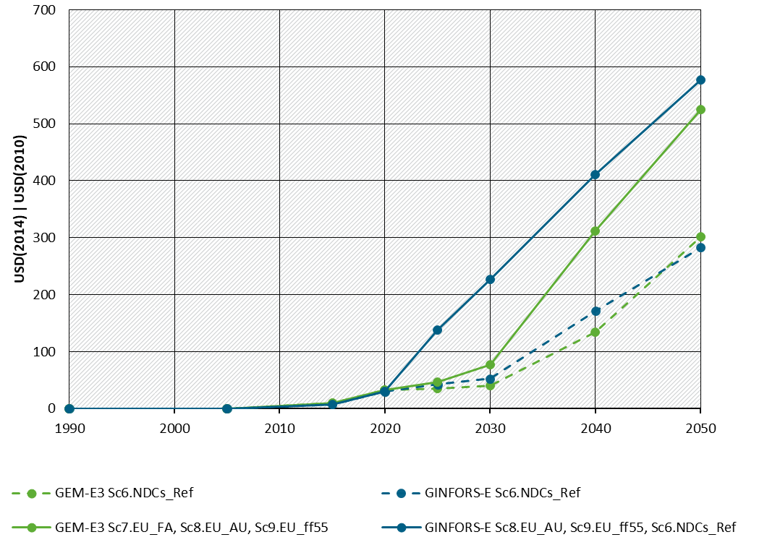
Source: GEM-E3 and GINFORS-E.
In the short term the EU escalating carbon prices increase production costs for EU located firms deteriorating competitiveness on the internal and international markets. However, changes in costs are relatively low and both models report relatively low leakage rates (0-24.4%).

The two models show different adoption of the technological choices to reduce GHG emissions. GINFORS decarbonises the energy system mainly by substituting fossil fuels and RES deployment. GEM-E3 ranks first RES deployment and energy efficiency improvements. Changes in activity are marginal in both models.
Figure 4: EU emission reduction Kaya decomposition for 2030 – compared to Sc6.NDCs_Ref in 2030 (left – GINFORS-E, right – GEM-E3)
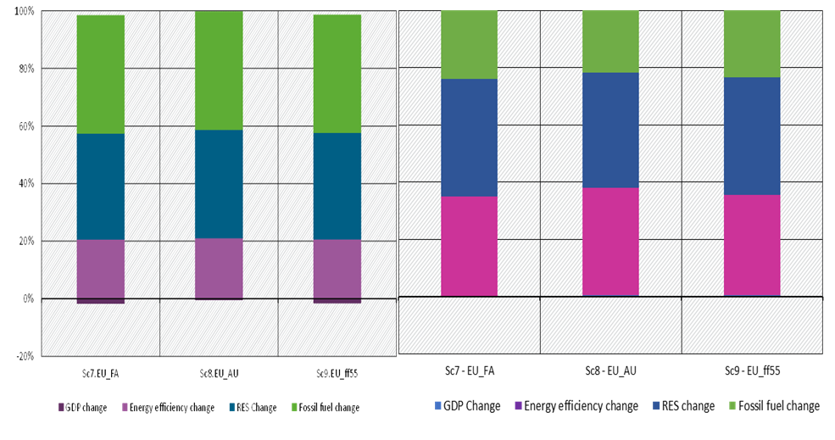
Source: GEM-E3 and GINFORS-E.
Both models find positive carbon leakage rates with GEM-E3 having significantly larger rates (despite the lower carbon prices that the CGE model produces). This results is mainly driven by the higher trade (Armington) elasticities in GEM-E3 allowing for easier substitution between domestic – imported products. In GEM-E3 the introduction of CBAM is quite effective hence in scenario 9 the carbon leakage rate virtually goes to zero.
Table 1: Carbon leakage rates in ETS sectors for 2020 to 2050
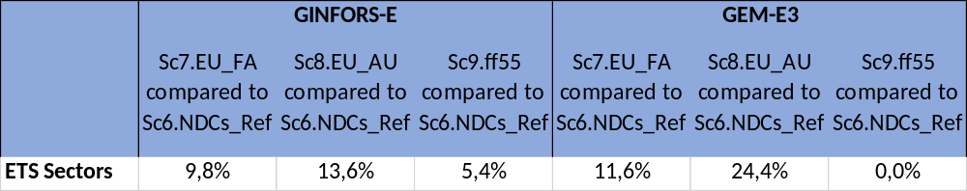
Source: GEM-E3 and GINFORS-E.
At a sectoral level the leakage takes place in the carbon intensive and trade exposed sectors. Both models present that basic metals is the most vulnerable sector regarding carbon leakage. GEM-E3 considers chemicals together with non-metallic minerals as sectors quite exposed. Both models present significant carbon leakage rates in Scenario 8.
Table 2: Carbon leakage rates by sector for 2020 to 2050
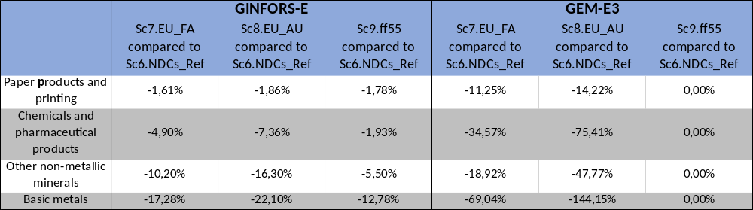
Source: GEM-E3 and GINFORS-E.

In scenarios 7 to 9, the country GDP effects are predominantly slightly negative in GEM-E3, and positive in GINFORS-E, except for Russia where the negative effects are much more pronounced in GINFORS-E than in GEM-E3 (Figure 4). It is also interesting to note that the more positive GDP results in GINFORS-E apply both for countries with ambitious climate goals in scenarios 7-9 (EU as a whole, Germany, UK) and in general also for countries without such goals (such as USA, India, Japan and Turkey). The difference in GDP in both models is driven by the crowding out effect and lower constraints in GINFORS-E: in GEM-E3 additional investments in clean energy have to be financed by cancelling investments of equal value elsewhere in the economy whereas in GINFORS-E the additional investments are financed from idle financial deposits. Additional investment has positive short-term demand effects but will increase capital costs in the long-term. So GINFORS-E allows for some temporal shift of investments. In addition, the GEM-E3 model assumes full (100% utilisation rate) operation of equipment (factories), hence additional demand for goods may create inflationary effects (which lessen in the long term once investments increase the production capacity of the economy). On the other hand, GINFORS-E assumes utilization rates of below 1, i.e. availability of idle production capital, and it is possible for factories to meet the additional demand without the (full) inflationary effects.
As noted above, for the EU, the two models show different signs for the effects in 2030. In GEM-E3, the negative effects for the EU-28, Germany and the United Kingdom are between 0.3 and 0.6% compared to the reference. In the CGE model, higher CO₂ prices without any type of caron revenues recycling leads to a deceleration of the growth rate in GDP. The effects are strongest with full auctioning and smallest with free allocation of emission allowances. Other countries are hardly affected in GEM-E3. One exception is Russia, which can export less fossil fuels to the EU.
In GINFORS-E, on the other hand, the GDP effects in 2030 are positive for the EU, with the design of the EU ETS playing a significantly larger role. In this macroeconometric model, the direction of the macroeconomic effects is basically open, as the economy has unused resources in the reference. The increased CO₂ reduction in the “target” scenarios 7, 8 and 9 is associated with certain changes in production and consumption structures towards sectors with low carbon emissions and lower fossil fuel imports. Energy efficiency increases and clean energy technology costs are lower. While industrial production is slightly lower than in the reference, as prices increase, production in the construction and service sectors increases a bit. As these sectors account for most of the European production and value added, this change is sufficient for the slightly positive EU GDP effect.
Figure 5: GDP deviations from Sc6.NDCs_Ref for GEM-E3 and GINFORS-E in 2030
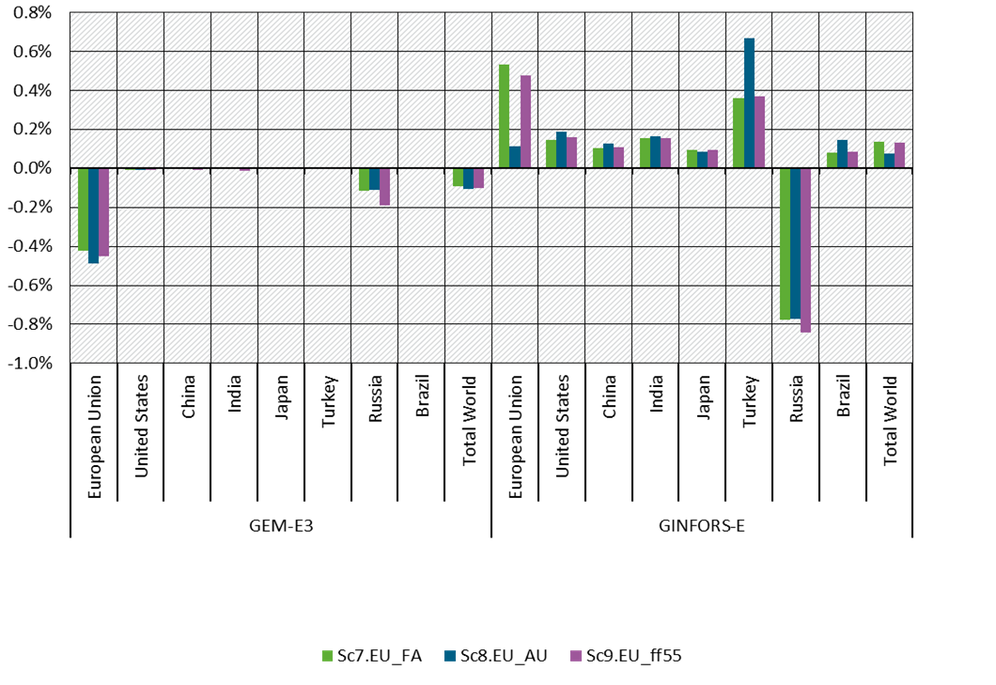
Source: GEM-E3 and GINFORS-E.
In this respect, Figure 6 should be interpreted with caution, because the effects are relatively large in sectors with low shares in total production, while they are hardly visible in the bigger sectors. For GINFORS-E, the design of the EU ETS plays a significantly larger role for the EU. However, the order of the different design options in scenarios 7 to 9 are the same as in GEM-E3.
Russia is also negatively affected in GINFORS-E because less energy can be exported to Europe. This effect is stronger than in GEM-E3. The (slightly) largest effect is in scenario 9 with a CBAM in the EU, which might be partly explained by a relatively high share of exports to the EU in the reference scenario 6 - not least in the basic metals industry. Other countries benefit from the somewhat stronger economic growth in the EU. On the one hand, as in the case of Turkey, they are more competitive in carbon-intensive sectors in all three scenarios 7-9, but also benefit overall from the higher GDP in the EU.
For the average annual growth rates, however, this means only very small differences between the results of the two models. When considering the differences in the sign of the GDP effects, it should always be taken into account that the long-term growth dynamics in both models are hardly changed by the climate protection measures.
The scenarios do not include the costs of climate change. According to various studies, the effects of climate change on the long-term growth path can be significant, so that the costs of climate protection will in any case be much lower than the costs of climate change.

The following figure shows the sectoral production effects in the carbon-intensive sectors. As can be seen, the predicted impacts of more ambitious climate policy in the EU are, by and large, negative in both models (apart from CBAM for the directly affected sectors in GEM-E3, see below). The degree of the production drop in the Basic metals and the “Other energy intensive sectors” (mainly non-metallic minerals such as cement) is somewhat larger in GINFORS-E, whereas for Chemicals the cross-model differences are diverging.
In GEM-E3 and in GINFORS-E, in line with our expectations the introduction of the CBAM leads to positive effects compared to auctioning in all three EITE sectors where it is applied – Chemicals, Basic metals, and Other energy intensive sectors. In GEM-E3 and in GINFORS-E the CBAM protects the energy intensive industries in the domestic market – hence the reduction in imports compared to scenario EU_AU. However, the CBAM increases the production costs of downstream sectors (that are now purchasing more expensive imported materials) – this increase is having a negative impact on competitiveness and production. In non-energy-intensive sectors, the effects in GINFORS-E are slightly more positive. Production of the energy sector is reduced in GINFORS-E compared to the reference, because the energy savings due to efficiency increase are greater than the additional energy required from renewable sources..
Figure 6: EU Sectoral Production – deviations from Sc6.NDCs_Ref for GEM-E3 and GINFORS-E in 2030
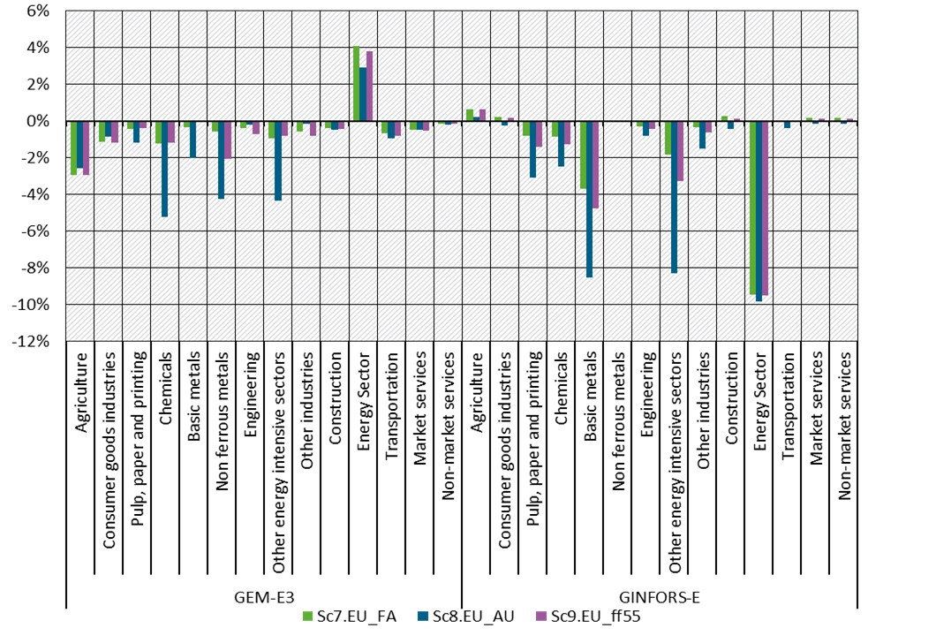
Source: GEM-E3 and GINFORS-E.

Conclusions
This paper discusses the mechanisms through which a neoclassical and a post-Keynesian economic model provide different insights to the same policy question. The study focusses on the structural differences of the two approaches (as they are reflected in the applied economic models). Focus is on the different insights the two models provide when they are used in assessing the impact of GHG mitigation policies. It is in many studies that Macro-econometric – Keynesian type models present positive impacts on GDP as the ambition to reduce emissions increases, whereas neoclassical models present negative effects. This study assesses the mechanisms through which this takes place using a set of policy relevant scenarios on the EU-ETS and a CBAM.

The policy scenarios regard the EU increasing its GHG emission reduction target from 40% in 2030 to 55% and from 80% in 2050 to 95%, whereas the non-EU countries follow their (unconditional) NDC targets (partly converted to 2030 emissions) and afterwards do not change their policies. We examine different industrial competitiveness measures (free allowances, border adjustment mechanisms). The scenario setup allows the measurement of carbon leakage (by country and sector) and the overall effectiveness of different measures to mitigate it – next to carbon leakage, also in terms of affected sector production.

The two models (in particular when in GEM-E3 the option of crowding out is selected) show different impacts on GDP, sectoral production, and carbon leakage. In GEM-E3, the GDP effect in 2030 is slightly negative whereas GINFORS-E shows a positive GDP effect in in all countries except Russia. Employment follows the GDP effect for both models. A Kaya decomposition analysis show that in GEM-E3 the deployment of RES technologies drives the GHG emission reduction in EU, followed by energy efficiency measures while GINFORS-E shows that RES technologies and the substitution within fossil fuels are the main contributors.

The carbon leakage is calculated over the 2020-2050 period by sector and country. The GEM-E3 model found the highest leakage rate in the ferrous metals sector followed by non-ferrous metals and chemicals with an overall leakage rate of -11.6% in ETS sectors, the leakage rate is almost doubled when full auctioning is assumed. In GINFORS-E it is found that basic metals have the highest leakage rate followed by non-metallic minerals, chemicals and rubber and plastic products. Leakage rates are significantly lower than in GEM-E3, as Armington elasticities are also lower. Full auctioning increases leakage rates. On a macro level, there is no carbon leakage in GINFORS-E, as emission reductions outside the EU in electricity are higher in absolute terms than emission increases in the ETS sectors.

The key factors driving the differences of the model results are: i) the source of financing of the additional investments, ii) the rate of resource utilization, iii) trade and substitution elasticities. In the default simulation of the GEM-E3 model the resources to finance the additional investments required to decarbonise the energy system are made available after cancelling part of the investment projects that were planned in the reference case (crowding out). In GINFORS-E the additional financing is available as idle resources are assumed, hence the economy is benefited from a Keynesian demand boost effect.

References
Capros, P. & Karadeloglou, P. & Mentzas, G., 1990. "An empirical assessment of macroeconometric and CGE approaches in policy modeling," Journal of Policy Modeling, Elsevier, vol. 12(3), pages 557-585.

Capros P., P. Georgakopoulos et al. (1997). “Coordinated versus uncoordinated European carbon tax solutions analysed with GEM-E3 linking the EU-12 countries”, in S. Proost (editor) “Economic Aspects of Environmental Policy”, Kluwer Academic Publishers, 1997.
Lutz, C. & Meyer, B. (2009b): Environmental and Economic Effects of Post-Kyoto Carbon Regimes. Results of Simulations with the Global Model GINFORS. Energy Policy, 37, 1758-1766.
Meyer, B. (2011): Macroeconomic Modelling of Sustainable Development and the Links between the Economy and the Environment. ENV.F.1/ETU/2010/0033. Final Report to the EU Commission, GWS Research Report 2012/1, Osnabrück.
Proposal for a DIRECTIVE OF THE EUROPEAN PARLIAMENT AND OF THE COUNCIL amending Directive 2003/87/EC establishing a system for greenhouse gas emission allowance trading within the Union, Decision (EU) 2015/1814 concerning the establishment and operation of a market stability reserve for the Union greenhouse gas emission trading scheme and Regulation (EU) 2015/757

Available at https://e3modelling.com/wp-content/uploads/2018/10/GEM-E3_manual_2017.pdf
Available at https://web.jrc.ec.europa.eu/modinv/discovery/midas/explore/models/model-ginfors-e/
https://web.jrc.ec.europa.eu/modinv/discovery/midas/explore/models/model-ginfors-e/
Detailed description of the scenarios is available at “Unilateral EU climate action, carbon leakage and CBAM – scenario description and results from the GINFORS-E model” - Christian Lutz, Maximilian Banning

