Estimating Economy-Wide Climate Change Impacts on the U.S. Economy: Implications from FrEDI-USREP

Mei Yuan¹, Tony Gardella², Jonathon Becker³, Corinne Hartin³, Ken Strzepek^{1,2}, Erin McDuffie³, Marcus Sarofim³, Jim Neumann², James McFarland³, Mustafa Babiker¹, Sergey Paltsev¹

¹ Massachusetts Institute of Technology, Cambridge, MA, USA
² Industrial Economics, Cambridge, MA, USA
³ US Environmental Protection Agency, Washington DC, USA

Abstract
Climate models often assess impacts on specific sectors and regions in isolation, neglecting the interactions across sectors, regions and time, as well as the ripple effects through goods and factor markets. As a result, aggregated partial impacts may fail to represent the full economy-wide effects of climate damages. To address this limitation, we incorporate single-sector damage estimates derived from the EPA Framework for Evaluating Damages and Impacts (FrEDI) into MIT U.S. Regional Energy Policy (USREP) model, a multi-sector multi-region computable general equilibrium model, to trace sectoral and regional dynamics. The FrEDI-USREP model includes six contiguous U.S. regions, accounts for demographic group differences, and focuses on the three most significant climate damage categories: health, infrastructure and labor productivity. The heterogenous climate impacts reshape regional comparative advantages, inducing factor movement that may exacerbate regional disparity and factor price changes that drive distributional impacts. We find general equilibrium effects up to twice single-sector partial impacts. Northern regions gain GDP in building damage scenarios and lose minimally in the lost labor scenario, but all regions, including northern, face GDP losses when impacts on transportation increase cost of consumption that leads to a reduction in investment.

Keywords: computable general equilibrium, climate change impacts, factor reallocation, distributional impacts

Introduction
Climate change poses significant physical and economic risks, requiring comprehensive tools for evaluating its impacts and informing policy decisions. The U.S. Environmental Protection Agency’s (EPA) Framework for Evaluating Damages and Impact (FrEDI) plays a crucial role in this process by estimating sector impacts of climate change. However, FrEDI’s partial equilibrium (PE) approach limits its ability to capture the broader economic dynamics and interactions across sectors. On the other hand, typical analyses of emission abatement policies using a computable general equilibrium (CGE) model such as the U.S. Regional Energy Policy (USREP) model often focus solely on the economic costs of policies without considering the potential benefits from climate impact mitigation, such as improved health, enhanced infrastructure resilience, and increased labor productivity.
To address these limitations, this study integrates FrEDI with USREP, creating a unified framework that combines FrEDI’s projections of emission-temperature-damage climate impacts with USREP’s economy-wide dynamic modeling. The FrEDI-USREP integration overcomes the limitations of FrEDI’s PE approach by incorporating intersectoral interactions and feedback loops that are core characteristics of general equilibrium (GE) approach. For instance, this integrated approach captures impacts through feedback mechanisms, such as how changes in mortality risk affect labor supply and investment decisions; or how market would respond to transportation disruptions due to infrastructure damages, dynamics that are not presented in a PE analysis.
The integrated of FrEDI with USREP provides several advantages: (1) ensuring consistent economic accounting across all sectors; (2) capturing consumer and producer responses to climate impacts; (3) capturing the interactions across sectors and regions through domestic and national markets; and (4) enabling the assessment of both costs and benefits associated with emissions reductions. In summary, the FrEDI-USREP approach evaluates the full economic implications of climate change and related mitigation strategies. By combining FrEDI's sector impact assessments with USREP's economy-wide modeling capabilities, the integrated framework offers policymakers a more comprehensive and consistent framework for cost-benefit analysis of climate policies.

Model Description
The FrEDI framework is a reduced-complexity model developed by EPA to assess the physical and economic impacts of climate change across various sectors within the United States (Hartin et al., 2023; Sarofim et al., 2021). By integrating over 30 climate change impact models and peer-reviewed studies, FrEDI quantifies relationships between mean surface temperature changes and climate-driven impacts in 20 different sectors, enabling detailed projections through 2300. FrEDI utilizes a temperature-binning approach to model impacts based on future temperature projections, allowing for the use of any custom warming scenario. It also incorporates socio-economic projections like GDP and population data to estimate future damages.
An ensemble of U.S emission trajectories are passed as inputs into the simple climate model FaIR to calculate global mean surface temperature. This temperature output, along with GDP and population, is then fed into FrEDI to estimate sectoral climate impacts in the U.S. The transportation impacts from high-tide flooding and damages to coastal properties are estimated based on the projections of global mean sea level rise using a semi-empirical approach from existing literature (Kopp et al., 2016) which are directly linked to changes in global mean surface temperature.
The USREP model is a recursive dynamic computable general equilibrium model of the U.S. economy designed to analyze economic impacts of energy and environmental policies (Yuan et al., 2019). It has the capability to assess impacts on regions, sectors and industries, and different household income classes. The equilibrium conditions for producers, consumers and markets in USREP are represented in complementarity format. Profit-maximizing firms produce goods and services using intermediate inputs from other sectors and primary factors of production owned by households. Utility-maximizing households receive income from the supply of labor, capital, and resources and government transfers. Household income is exhausted by consumption and savings for investment.

Methodology
The technical approach to evaluating the climate change impact on the U.S. economy using FrEDI-USREP includes two main steps in the first phase of the study: Firstly, establish the USREP baseline with projections for GDP growth, population, emissions, assuming that the climate impacts remain constant at base year level through the end of the century. Secondly, update the climate impacts projected by FrEDI based on USREP’s GDP growth and emissions trajectories, and compare the resulting economic impacts with the baseline.
Our analysis using FrEDI-USREP focuses on three primary impact categories: health, infrastructure, and labor. Following methods outlined in the FrEDI Technical Documentation (EPA, 2021), we convert FrEDI’s estimated impact into economic instruments that can be implemented in USREP.

Health impacts
Health impacts in terms of mortality risks due to air quality, extreme temperatures, and suicide, are measured using the Value of a Statistical Life (VSL) and translated into changes in the value of survival for economic agents. To incorporate these impacts into the economic model, we augment the welfare function to include the value of survival, calibrate the benchmark equilibrium value of survival, and estimate the elasticity of substitution between wealth and the value of survival.

Infrastructure impacts
Infrastructure impacts such as damages to roads, bridges, and transmission lines, are measured by the repair costs and the associated delays (e.g., construction, service disruption). These impacts are translated into changes in the efficiency of transportation services. In addition, infrastructure impacts such as building damages due to wind and coastal impact in terms of economic loss are translated into loss of annuity income in the subsequent periods.

Transportation delay
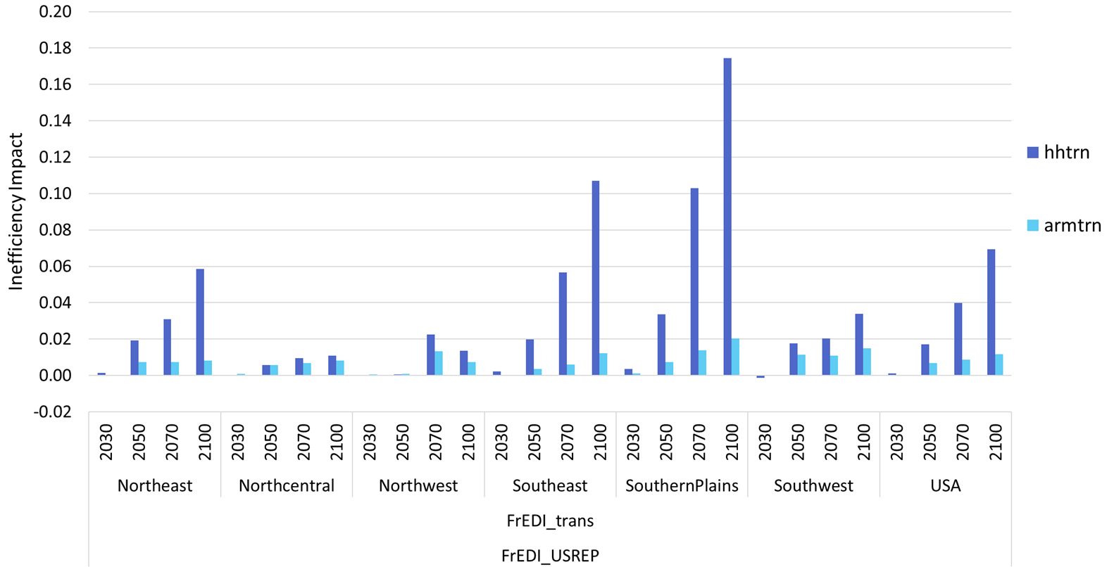

Road and rail repair
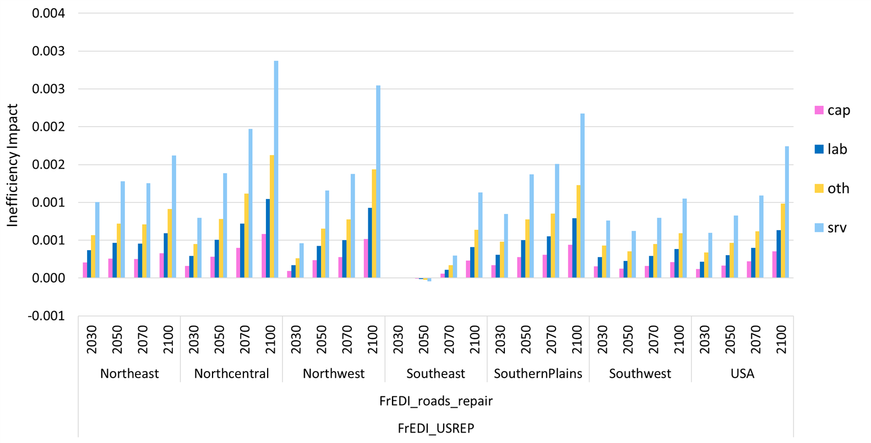

Building damage
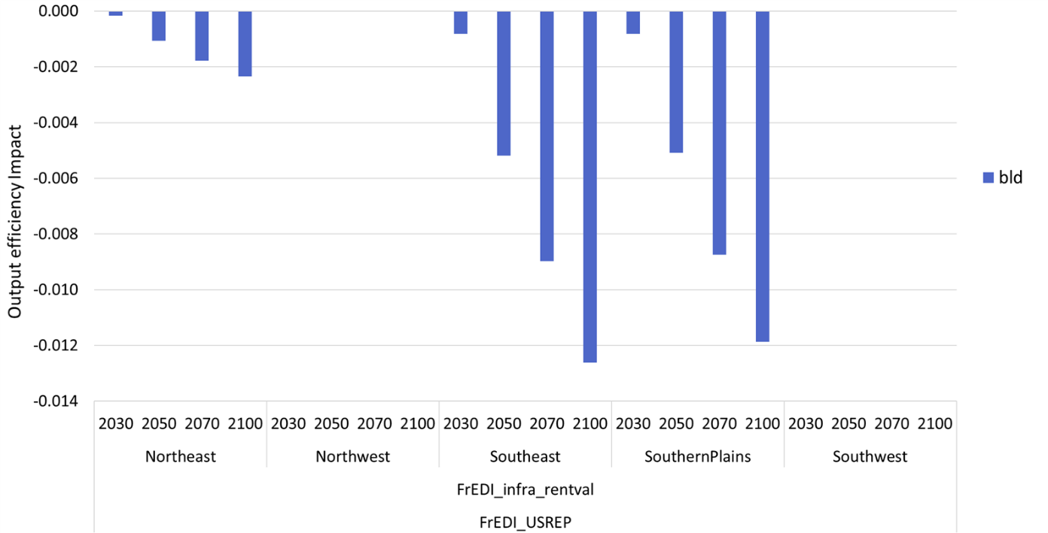

Labor impacts
Labor impacts, expressed as lost labor hours, are translated into changes in labor demand required to produce the same level of output, and these impacts are implemented as changes in the efficiency units of labor supply. This process involves imputing base year average wage rates by sector based on employment data from the Bureau of Labor Statistics (BLS) by industry. We then calculate the lost labor as a percentage change from the baseline sectoral labor demand and implement this lost labor as a productivity change in the scenario.
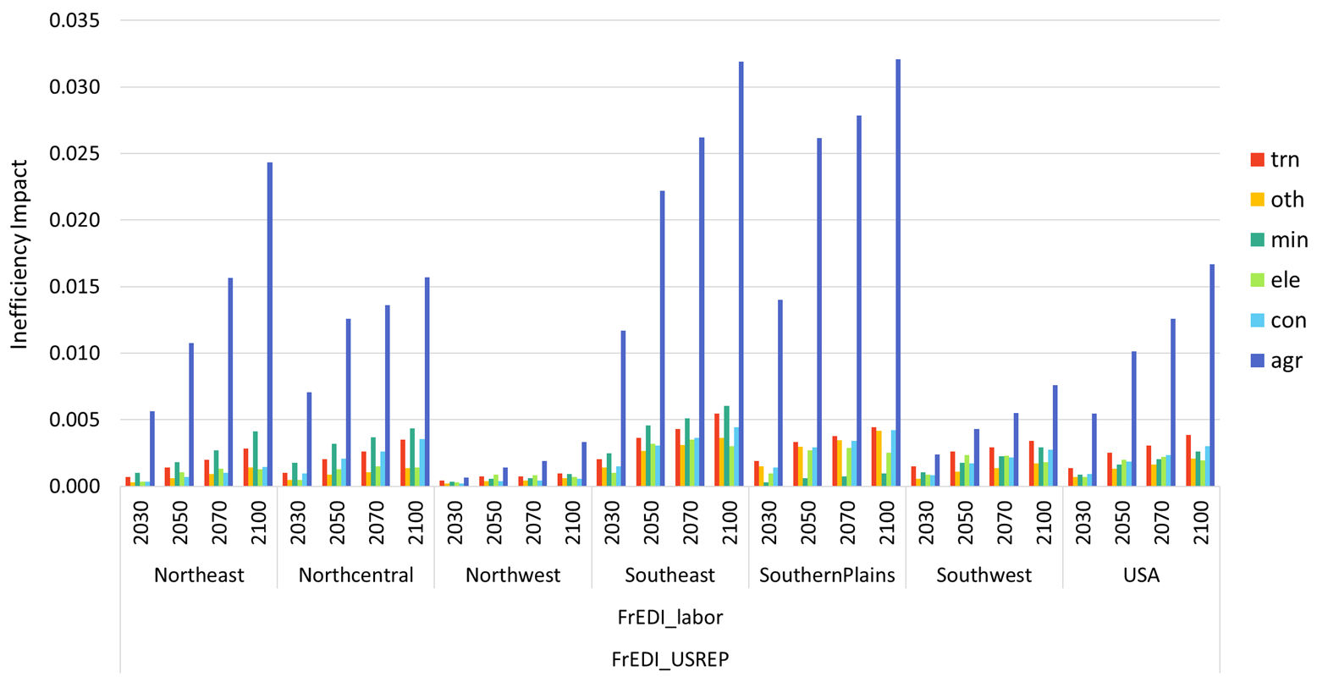

Results Discussion
This study aims to address FrEDI's limitations in capturing economic dynamics and interactions. By comparing the GE impacts on GDP as measured by USREP with the PE sectoral impacts estimated by FrEDI, we quantify the additional economic effects not captured by FrEDI alone.
In this section, we illustrate the mechanism by which impacts ripple through the economy and identify the key impact channels. Sectoral or factor productivity shifts comparative advantage between regions, inducing factor reallocation within and across regions. Sectors not directly impacted by climate change receive indirect impacts through factor reallocation. Factor mobility can exacerbate regional disparities. Trade in goods are amplified by trade in factors. Factor returns drive distributional impacts.
The comparison improves our understanding of the economy-wide implications of climate impacts on individual sectors, providing insights for designing policy measures to strengthen economic resilience to climate change.

Building damages
The U.S. Bureau of Economic Analysis (BEA) input-output table define the building sector (real estate) as capital intensive, with output measured by rental values rather than total property values. This distinction is important when assessing climate change impacts, as building damage reduces rental income over a structure’s remaining life. The sector involves in significant amount of trade, with cross-region rental payments recorded as exports and imports of building services. For example, a property rent paid by a resident from other regions represents an export of building services from the region where the property resides, and an import by regions where the rent payer resides.
Given this understanding of the economic accounts, we translate FrEDI estimates of building damages into rental value losses based on assumed interest rates and remaining lifespan, and apply the losses as a Hicks neutral technical change. That is, building damages are represented as reductions in building sector’s productivity, lowering building service output produced from a given supply of inputs from capital, labor, and intermediate materials. Hence the building damage is expected to reduce building service supply, raising building sector’s output price if demand for remains stable. FrEDI estimates project more severe impacts on building structures in Southeast and Southern Plains, milder impacts in Northeast, and the rest of the U.S. faces small to no impacts.
As high-impact regions incur larger reduction in productivity relative to less-impacted regions, this differential productivity impacts shift comparative advantage to favor less-impacted regions in building services. On the flip side, the high-impact regions gain comparative advantage in all other sectors. In each region, factors are reallocated toward the sectors with comparative advantage.
Capital, being mobile across regions, flows from high-impact to less-impact regions, supporting the building sector’s expansion in the latter. Labor, mobile within regions but limited in mobility across regions, shifts in less-impact regions from other sectors to the expanding building sector, while in high-impact regions, labor moves out of the building sector into other local industries. Labor immobility across regions prevents wage equalization, deepening disparities as less-impact regions favor capital-intensive production and high-impacted regions shift toward labor-intensive activities.
Other sectors not directly impacted by climate change receive indirect impacts through factor reallocation. In less-impact regions, the building sector’s growth draws factors from other sectors that are relatively labor-intensive (e.g. the service and manufacturing sectors). Because building sector is more capital intensive than all other sectors, its expansion requires proportionally more capital than labor from other sectors, leading to excess supply of labor and lower wages in less-impact region. In high-impact regions, the building sector shrinks and releases factors to other sectors, lowering their cost of production and potentially boosting their output.
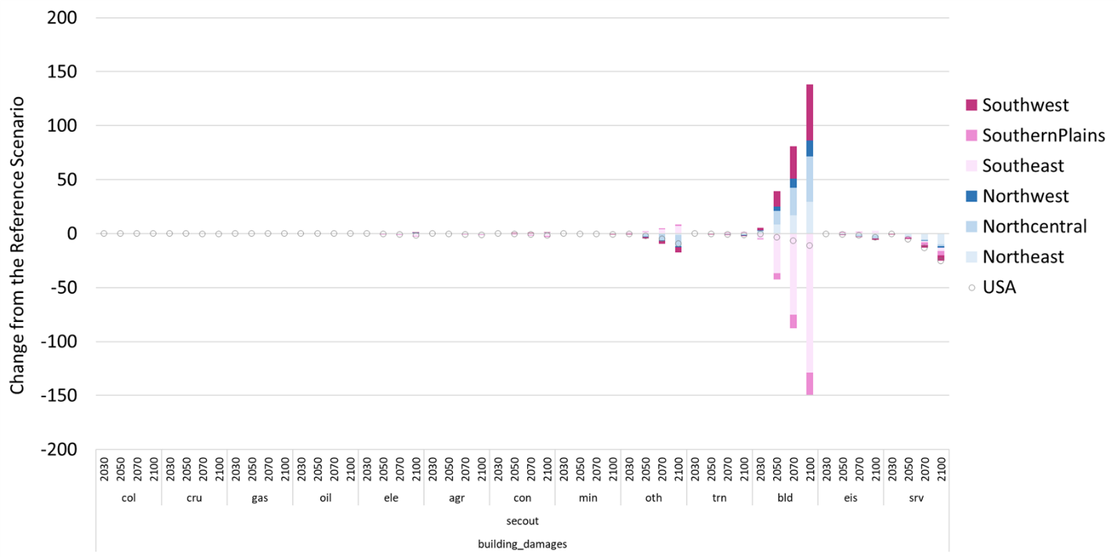
Figure 1: Sectoral output by region in the Building Damage scenario (change from the Reference scenario, Billion$)
These shifts in sectoral output and factor allocation follow trade theory. According to Stolper-Samuelson theorem that links price changes to factor returns, rising building prices, driven by sectoral productivity impacts, leads to a more than proportional increase in returns to capital, the factor used intensively in building, while depressing wages due to excess labor supply as a result of a mismatch in factor intensity between the building and other sectors. Capital mobility relaxes Stolper-Samuelson’s fixed factor endowment assumption, allowing capital to flow to less-impact regions for higher returns. According to Rybczynski theorem that connects factor endowments to outputs, capital inflows in less-impact regions leads to a more than proportional increase in the output of the building sector that uses capital intensively, and a decrease in the output of labor-intensive sectors. Increased capital supply mitigates the increase in returns to capital, driving a greater cost reduction for the capital-intensive building sector and encouraging its expansion. Building sectoral expansion draws more labor from other sectors, further contracting other sectors.
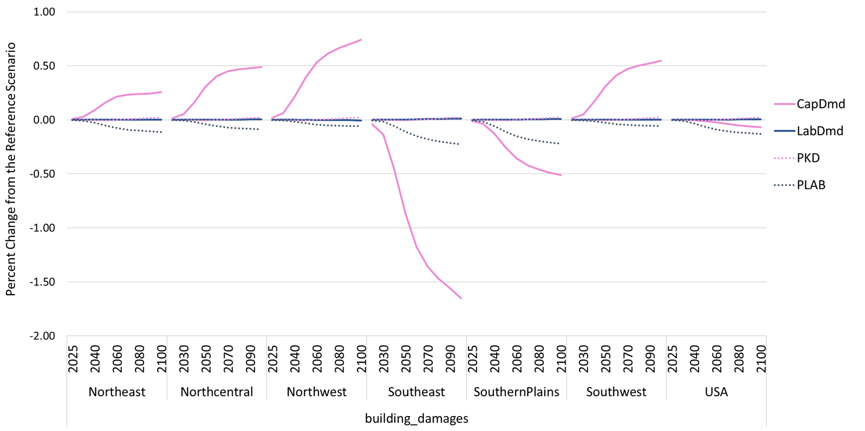
Figure 2: Factor demand and prices by region in the Building Damage scenario (change from the Reference scenario, Billion$)

Lost labor
National-level changes in sectoral output due to climate-driven labor obscure considerable regional disparities. High-impacted regions (Southeast and Southern Plains) with sectors heavily exposed to climate risks, face larger output reductions, while less-impacted regions (Northwest, Northcentral, and Northeast) often expand output, partially offsetting national losses. These divergent outcomes stem from factor mobility assumptions. Labor endowed in one region has limited opportunity to supply to other regions, whereas non-vintage capital, fully mobile, can flow to sectors and regions for higher returns.
For each climate-impacted sectors (electricity, agriculture, mining, construction, transportation and manufacturing), uneven labor productivity declines driven by different regional climate exposure shift comparative advantages. High-impacted regions suffer greater productivity losses, weakening their competitiveness relative to less-impact regions. Firms in these hard-hit regions may substitute capital for costlier labor, but rising input costs and their comparative disadvantage compared to firms in less-impact regions force them to reduce output. As production contracts, both labor and capital are released. Labor remains bound to its region, but the released capital is able to move to less-impact regions to support expanding sectors that gain comparative advantage. This capital reallocation helps offset the losses in high-impacted regions, mitigating overall output reductions by shifting production geographically.
The service sector, though not directly harmed by climate effects, faces indirect effects through factor reallocation. In high-impacted regions, as climate-affected sectors shrink and release labor which the service sector absorbs and expands. However, income effects due to falling wages from productivity declines and reduced economic activity reduce demand for service sectoral output, limiting its growth or causing its contraction. In less-impacted regions, however, capital inflows enable other sectors to grow and compete for the same regional labor pool, drawing labor away from the service sector. The results show that the latter effect dominates, leading to an overall contraction in service sector output nationwide.
The capital-intensive building sector contracts in every region due to two key impacts: service sector demand for commercial building services and household income affecting spending on residential building. In less-impact regions, service sector contraction curbs demand for commercial building, while in high-impacted regions, service sector expansion increases demand. At the same time, lower household incomes, reflecting lower wage income from productivity losses, dampen demand for residential building services. Northcentral does receive a gain in income that increases residential building demand, but the negative effects from service sector contraction outweigh the positive income effect. In net, these forces result in reduced building sector output in all regions.
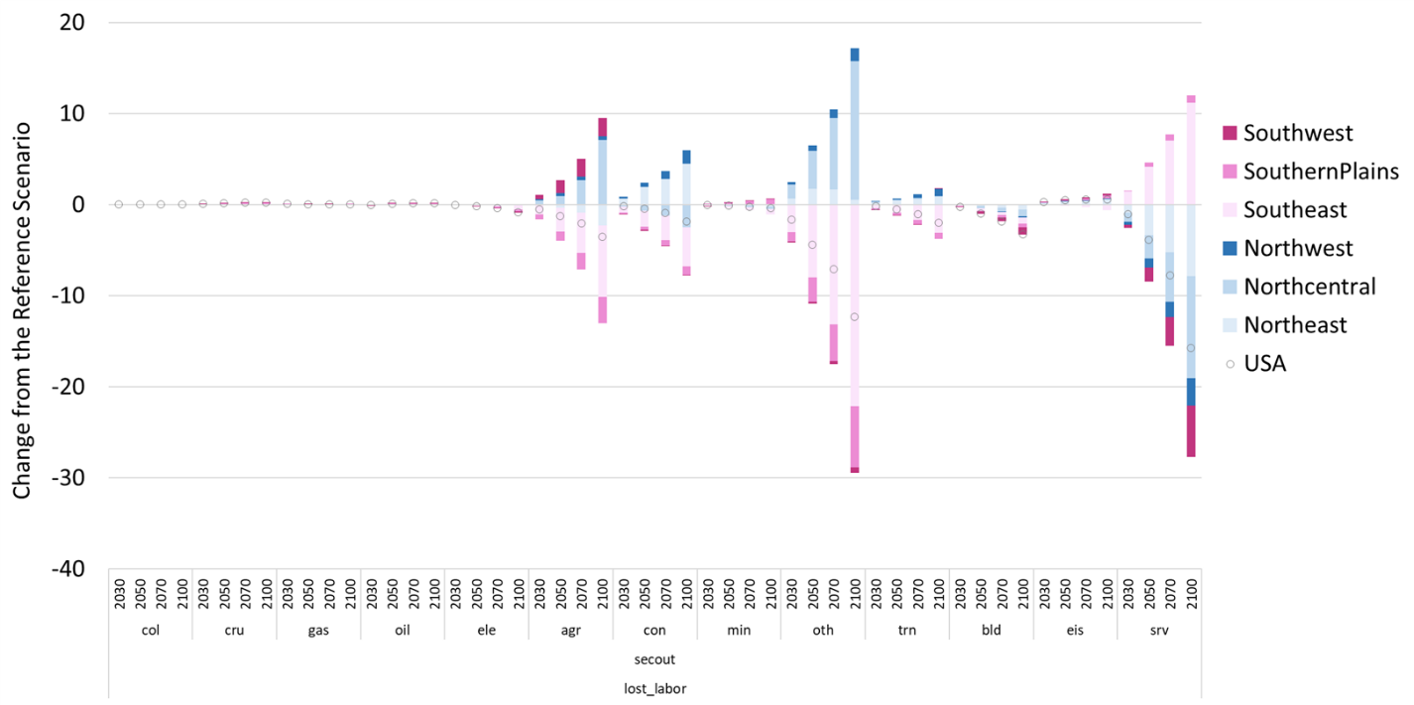
Figure 3: Sectoral output by region in the Lost Labor scenario (change from the Reference scenario, Billion$)
Capital mobility allows production to shift to less-impacted regions, mitigating the overall reduction in output while attracting labor demand for the expanding sectors and regions. Labor’s interregional immobility traps workers in more-impacted regions, creating inequality in wage rate and income across regions. Capital flight exacerbates the regions’ decline.
Climate-driven lost labor primarily affects labor-intensive sectors, causing these sectors to reduce output and release proportionately more labor than capital. As capital is mobile, it flows to the less-impacted regions to support expansion of the same sector, which are relatively more competitive due to smaller labor impact. However, these less-impact regions often see their service sectors contract as growing sectors compete for a limited labor pool. Although some of the released labor pairs with incoming capital in expanding industries, a portion of capital from the contracting service sector remains underutilized.
In high-impact regions, the service sector can expand by absorbing labor and capital from declining industries. Because the service sector is more labor-intensive relative to the sectors that release labor and capital, it absorbs disproportionately more labor than capital, resulting in excess supply of capital. Under the assumptions of diminishing returns in production, the marginal product of capital falls when capital becomes relatively more abundant than labor. This drives down the rental price of capital, lowers returns to capital owners, and contributes to broader income losses.
When labor productivity declines, more labor hours are needed to produce the same output. Even if the hourly wage stays fixed, the cost per unit of effective labor rises, leading to a divergence between the wage rate for effective labor and hourly wage rate (see Figure 4), with the gap growing in proportion to the size of the productivity decline.
Sectors directly affected by the negative labor productivity impact see higher production costs, with agriculture, transportation, and construction incurring the largest increases proportional to the labor impact. Meanwhile, sectors less impacted, such as the building and service sectors, benefit from factor reallocation and incur a moderate decline in production costs.
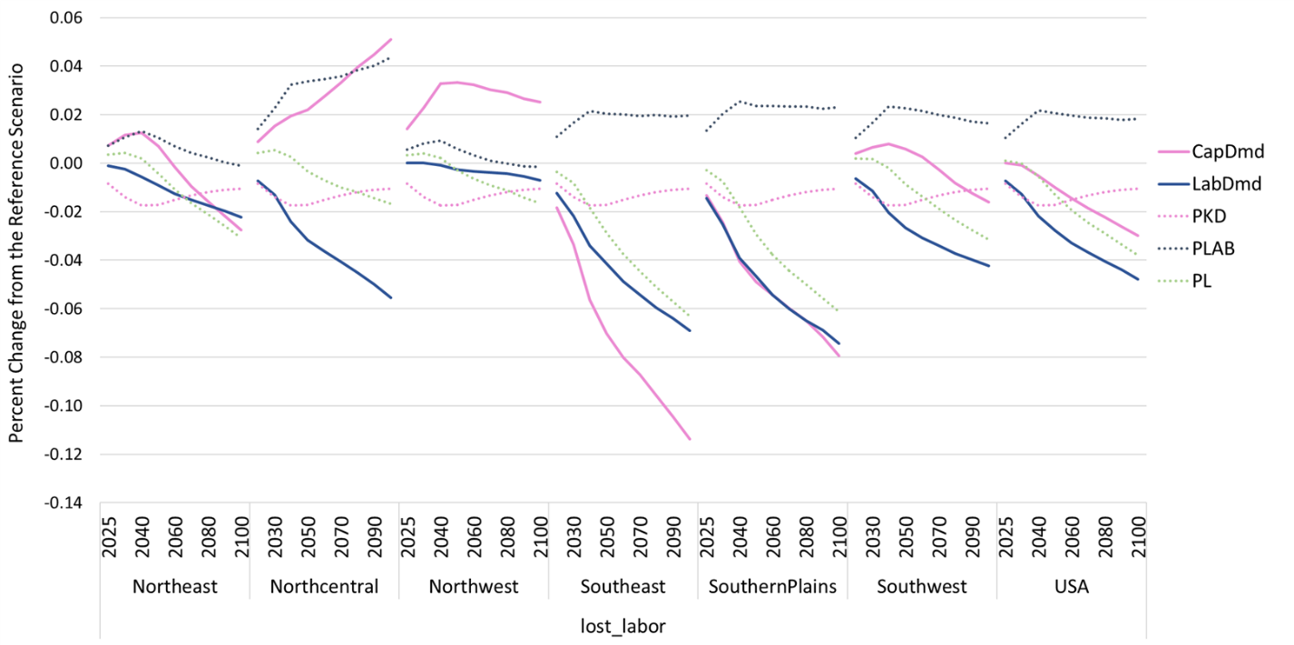
Figure 4: Factor demand and prices by region in the Lost Labor scenario (change from the Reference scenario, Billion$)

Reference
EPA. 2021. Technical Documentation for the Framework for Evaluating Damages and Impacts (Updated). U.S. Environmental Protection Agency, EPA 430-R-21-004. www.epa.gov/cira/FrEDI
Kopp, R. E., Kemp, A. C., Bittermann, K., Horton, B. P., Donnelly, J. P., Gehrels, W. R., Hay, C. C., Mitrovica, J. X., Morrow, E. D., and Rahmstorf, S.: Temperature-driven global sea-level variability in the Common Era, P. Natl. Acad. Sci. USA, 113, 1434–1441, https://doi.org/10.1073/pnas.1517056113, 2016.
Hartin, C., McDuffie, E. E., Noiva, K., Sarofim, M., Parthum, B., Martinich, J., Barr, S., Neumann, J., Willwerth, J., and Fawcett, A.: Advancing the estimation of future climate impacts within the United States, Earth Syst. Dynam., 14, 1015–1037, https://doi.org/10.5194/esd-14-1015-2023, 2023.
Sarofim, M. C., Martinich, J., Neumann, J. E., Willwerth, J., Kerrich, Z., Kolian, M., Fant, C., and Hartin, C.: A temperature binning approach for multi-sector climate impact analysis, Clim. Change, 165, 22, https://doi.org/10.1007/s10584-021-03048-6, 2021.
Yuan, M., Rausch, S., Caron, J., Paltsev, S., and Reilly J.: The MIT U.S. Regional Energy Policy (USREP) Model: The Base Model and Revisions. Joint Program Technical Note TN #18, August, 24 p. http://globalchange.mit.edu/publication/17331, 2019.

