The Impact of Digitalization on Global Manufacturing Value Chains: Regional Dynamics in the Age of Industry 4.0

Abstract

This paper investigates the impact of Industry 4.0 on global manufacturing value chains (GVCs), focusing on how different regions with varying levels of technological advancement integrate digitalization into their manufacturing sectors. By utilizing an economy-wide model and multi-regional input-output (MRIO) framework, the study examines both the economic impacts and sector-specific changes in GVC participation due to Industry 4.0. The results reveal that digitalization improves regions’ welfare, increases GDP, and boosts international trade, and enhances share of foreign content in countries’ exports, facilitating greater integration in GVCs. However, its effects on countries’ exports for re-exports are more nuanced. The results also indicate that intermediate goods imported for domestic final goods production with only one cross-border transaction benefit from greater efficiency, while those involved in at least two cross-border transactions face challenges. Overall, the results show that digitalization is reshaping the structure of GVCs, promoting regionalization, and altering the dynamics of global production. The results provide insights into the future of manufacturing GVCs, particularly in the context of uneven digital technological adoption across regions.
Keywords: Industry 4.0, Global Value Chains, GTAP
JEL Classification: F10, F13, F14

- Introduction
The growth of global value chains (GVCs) has significantly shaped international trade over recent decades. GVCs have altered the foundation of international trade by fragmenting production activities across countries based on comparative advantages (Baldwin, 2018). The allocation of labor across countries has progressively transitioned from inter-industry and intra-industry specialization to division within products and 'task' specialization. Products are increasingly “made in the world”. After the explosive growth during the early 2000s, GVCs have gradually become the backbone of the global economy. The large flows of goods, services, capital and technology moving across borders within GVCs have resulted in a growing interconnectedness between countries (WTO, 2018).
Since the 1980s, global value chains (GVCs) have expanded in length and complexity. Production processes for a growing range of goods, including traditional products like textiles and more technology-intensive items like electronics, as well as services, are increasingly distributed across multiple locations worldwide. This has led to a rise in trade and transportation flows over time. Organizing production within long and intricate GVCs allows firms to capitalize on the most advantageous location-specific factors for different production stages, resulting in benefits such as increased productivity, efficiency, and economies of scale (OECD, 2017).
To accurately discern a nation's contribution to international trade division, Hummels et al. (2001) pioneered the concept of vertical specialization [(VS (vertical specialization), i.e., a country’s share of imports included in its exports or the share of exports produced by a country that is used as intermediates for exports by other countries (VS1)] and devised the Hummels, Ishii and Yi (HIY) model to quantify a country or region's participation in GVCs. HIY classified GVC involvement as either ‘forward participation’ or ‘backward participation’. Forward participation in GVC refers to the domestic value added by a country-sector that is exported and used by other countries, particularly as intermediate inputs that contribute to foreign goods for domestic consumption. Industries with high forward participation typically focus on activities like research and product design. Backward participation in GVC occurs when foreign value added is included in intermediate inputs. In this case, foreign suppliers contribute to the domestic production process. Industries with high backward participation generally engage in low value-added activities, such as processing and assembly.
Nevertheless, the seminal model of HIY overlooked instances where importing nations could employ a country's exports for subsequent processing rather than immediate final consumption, thereby biasing the evaluation for developing countries primarily engaged in intermediate processing trade. In response, Koopman et al. (2012) introduced the Koopman, Wang, and Wei (KWW) method. This novel export decomposition technique categorizes a nation's total GVC exports into four distinct value-added components, and those components could be further subdivided into nine parts according to the final destination of exports (Koopman et al., 2012). The framework precisely delineates the relationship between components of officially reported trade statistics (measured in gross terms) and GDP (in net terms).
Further, Wang, Wei, Yu, and Zhu (2017) (hence force WWYZ) track GDP component absorption through forward linkages and the origins of value-added in final goods production via backward linkages, allowing precise identification and measurement of GVC activities. Both forward and backward GVC participation can be decomposed into simple and complex activities. Simple value chains refer to intermediate goods that are used by the direct importing country to produce final goods for domestic consumption, involving only a single cross-border transaction. Complex value-added activities cross the border at least twice, and thus involve more production links and higher GVC positions than simple activities (Wang et al., 2017).
Technological advancements have historically been pivotal in influencing the organization of production, both domestically and internationally. Baldwin (2016) highlights how the emergence of specific technologies has transformed global production processes, leading to distinct waves of unbundling: the steam revolution facilitated the first unbundling, separating production from consumption, while information and communication technologies (ICTs), drove the second unbundling by enabling the fragmentation of production activities.
Moreover, some experts claim that globalization will continue to accelerate due to the development of digital technologies (Hofmann & Rusch, 2017; Lee et al., 2014). An example of this trend is the Fourth Industrial Revolution, also known as Smart Manufacturing or Industry 4.0 (Kagermann et al., 2013). Scholars tend to categorize Industry 4.0 technologies into groups according to their impacts and use. For example, advanced robotics and augmented reality are adopted to improve working-related activities (Frank et al., 2019). Additive manufacturing and flexible machinery can support digital manufacturing, improving firms' flexibility and allow for customization (Weller et al., 2015; Ardanza et al., 2019). Technologies such as cloud services, internet of things (IoT), big data analytics are directly linked to the concept of 'smart factory' (Strozzi et al., 2017). The most significant feature of Industry 4.0 is that machines and components exchange information independently, trigger actions, and control each other (UNCTAD, 2017; Brennan et al., 2015; OECD, 2017).
Although the concept of Industry 4.0 lacks a commonly agreed definition, it is recognized that it has resulted in a high level of automation in manufacturing (Stock & Seliger, 2016; Alexopoulos et al., 2016), and represents the development of the direction of the manufacturing industry (Xu et al., 2018). In manufacturing, Industry 4.0 concerns the integration and adaption of digital technologies, such as ICTs (Ghobakhloo & Fathi, 2019). Given that ICTs are the key elements of Industry 4.0, studies tend to use ICTs to capture the development of Industry 4.0 (Schwab, 2016; Nagy et al., 2018; Atik & Ünlü, 2019).
Significantly, digitalization in manufacturing industries could be a "double-edged" sword for developing manufacturing GVCs (Dollar, 2019). On the one hand, Industry 4.0, the automation of manufacturing processes reduces the reliance on low-cost labour, a key advantage for these economies, leading to the reshoring of production to developed countries and the loss of manufacturing jobs in labour-intensive sectors. Thus, the "reshoring effect" could potentially shorten the GVCs and shrink the GVC trade. On the other hand, Industry 4.0 can boost the development of GVCs by increasing efficiency and knowledge spill over effects, which motivates firms to expand their geographic scope and reduces coordination costs along the value chain (Chen & Kamal, 2016; Antràs,2020). As a result, Industry 4.0 can affect the distribution of value-added and the division of production within GVCs (Wu et al., 2021; Li & Yang, 2021). The impacts of Industry 4.0 on manufacturing GVC remains as an open question.
To this end, this paper investigates the questions through empirical research on the interplay between Industry 4.0 and manufacturing GVCs. This work contributes to the existing literature in following ways. First, it examines the sectoral and economy-wide impacts of Industry 4.0 (as captured by digitalization-induced productivity shocks). Second, considering the varying levels of economic development among countries, the degree of Industry 4.0 implementation is expected to differ, this research studies whether its effects on manufacturing GVCs vary accordingly. Particularly, this paper investigates the potential of Industry 4.0 to drive manufacturing upgrades within GVCs. Third, different manufacturing industries demonstrate distinct levels of digital intensity, which may affect their sensitivity to digitalization and consequently influence the overall impact of Industry 4.0 on manufacturing GVCs. To address this, the paper analyses the effects by categorizing manufacturing sectors according to their digital intensity. Fourth, the research classifies manufacturing GVC participation based on methods of involvement and complexity, distinguishing between forward and backward participation as well as simple and complex GVC participation. In light of the heterogeneous levels of digital development among countries and the varying digital intensity across manufacturing sectors, this study seeks to explore the effects of Industry 4.0 on different types of manufacturing GVCs.
This analysis is investigated using an economy-wide model, which provides insights into the overall economy, specific industries, and facilitates "what-if" analyses. The economy-wide model links sectors and industries involved in economic change, depicting the actual landscape of manufacturing GVC across countries.
Several studies have used the Global Trade Analysis Project (GTAP) database for multi-regional input-output (MRIO) analysis. For example, Peters & Hertwich (2008) utilizes GTAP database to establish MRIO for calculating embodied carbon dioxide in international trade for examining implications of emission on global climate policy. Davis & Caldeira (2010) employs data from the GTAP Database to conduct a MRIO analysis on CO2 emissions based on consumption across global nations in 2004. Antimiani et al. (2018) extend the GTAP model by incorporating a value-added trade accounting framework, enabling value chain analysis in counterfactual simulations to measure value-added content in total trade flows. These studies demonstrate the GTAP models' potential to analyze the complex dynamics of GVCs. Thus, this research develops an economy-wide model built on MRIO tables to estimate the impacts of digitalization on manufacturing GVCs.
Augmenting existing methodologies, this work utilizes the economy-wide model and GVC accounting approach to estimate impacts of digitalization on manufacturing GVCs across regions. Specifically, this research employs the GTAP model to conduct counterfactual analyses, simulating the effects of digitalization on manufacturing industries. In the simulation, productivity shocks induced by digitalization are positively correlated with sectoral digital intensity. Additionally, based on the GTAP database and existing methodology [i.e., Peters et al. (2011) & Wang et al. (2017)], this research constructs MRIO tables before and after the digitalization shock to estimate the corresponding GVC indices. Comparing changes in GVC development caused by digitalization, this paper can observe whether digitalization promotes or impedes countries’ involvement in manufacturing GVCs.
The analysis reveals several noteworthy results. First, digitalization boosts GDP, welfare, and international trade by increasing exports and reducing imports across regions. However, China is an exception, showing an increase in imports alongside a decline in exports. Second, digitalization in the manufacturing sector primarily enhances backward GVC participation while reducing forward GVC involvement across regions. Third, digitalization enhances simple GVC participation but constrains complex GVC participation. Results suggest that while impacts of digitalization vary across industries due to differences in sectoral digital intensity, the digital intensity alone is not the only determining factor. Each regions’ role within GVCs also significantly influences how digitalization affects its manufacturing GVC participation. Despite variations in each region's role within GVCs, digitalization has generally facilitated the upgrading of manufacturing value chains across regions. There is also evidence that digitalization tends to shorten manufacturing value chains and promote the development of regional value chains.
The rest of the paper proceeds as follows: Section 2 undertakes the literature review, Section 3 details the used methodology, Section 4 presents results. Concluding remarks are offered in Section 5.

- Literature Review
The links between Industry 4.and GVCs are multi-faceted and complex. Lichtblau et al. (2015) find that the goal of Industry 4.0 is to enable the manufacturing process to achieve high flexibility and high efficiency, allowing firms to manufacture individualized products in the economic condition of mass production. Strange & Zucchella (2017) express that the wide adoption of Industry 4.0 technologies can affect the spatial distribution of GVCs. Additionally, digital technologies, as upstream inputs, spread their effects through trade, with GVCs enhancing their role. Digitalization embedded in GVCs has reshaped the distribution of value-added (i.e., domestic value added in exports). This transformation alters the location of value chains and the production chains through GVCs (Gao et al., 2023).
However, Industry 4.0 could simultaneously be a driver and a barrier to GVCs. On the one hand, historical experience shows that new technologies favor the fragmentation of production across regions, and Industry 4.0 is no exception (Qin et al., 2024). Strange & Zucchella (2017) argue that Industry 4.0 (e.g., ICTs, an elementary part of Industry 4.0) increases GVC involvement by reducing trade costs and increasing efficiency. Firms improve production and logistical efficiency by using digital technologies to minimize transportation and inventory costs (World Bank, 2020). Accordingly, Backer & Flaig (2017) find that international fragmentation reduces transportation and coordination costs more than specialization and economies of scale. Further, Opazo-Basáez et al. (2022) indicate that Industry 4.0 reduces GVC production phase geographical restrictions, delays, and uncertainties. Firms can 'fine slice' value-adding activities and arrange them to the optimal location (Buckley, 2011). Therefore, Industry 4.0 promotes GVCs.
On the other hand, Industry 4.0 could "make the international fragmentation of production less attractive" and is "the biggest game-changer, reversing the importance and length of GVCs and reshoring global production and trade back towards OECD economies" (De Backer & Flaig, 2017, P.6). Kagermann et al. (2013) and Bauernhansl et al. (2014) show that Industry 4.0 technologies can increase a firm’s output by increasing productivity and capacity utilization and lowering production costs. Intensive usage of Industry 4.0 technologies may decrease labor input and change the capital-labor ratio (in favor of capital). Therefore, Industry 4.0 may diminish the appeal of labor arbitrage in low-wage countries and emphasize the significance of economies of scale in developed countries by compensating the locational advantages of low-wage countries. Similarly, according to De Backer & Flaig (2017), the international fragmentation of production is becoming less appealing due to the technologically feasible lower share of labor in production, high productivity potentials, and an increasing demand for customized products in developed countries. There is a trend toward the rebalancing of the world economy toward the developed economies.
Additionally, the digital integration of manufacturing processes has the potential to facilitate the development of more vital regional value chains. Strange & Zucchella (2018) advocate that the technology enhances human-machine and machine-machine interaction, enabling improved product adaptation and individualization. Consequently, firms will prioritize proximity to customers over production costs when making location decisions. This will accelerate the transition from centralized to decentralized supply chains, with greater emphasis on accessibility and localization. For example, while Kinkel (2014) points out that the 're-shore' effects are more significant in industries with high complexity and customization, Bornert & Musolino (2024) indicate that firms have a greater propensity to reshore in industries that have been investing more in contract manufacturing. As a result, Industry 4.0 may shorten GVCs and reduce GVC trade.
Furthermore, existing literature shows that digitalization can promote the upgrade of GVCs. Forster et al. (2018) assesses the impact of digital transformation on the enhancement of the value chain through qualitative lenses, such as through case analyses. A study by Oliveira et al. (2021) within the Brazilian digital gaming sector demonstrates that digitalization is instrumental in the value chain advancement of small and medium-sized enterprises (SMEs). Over time, researchers shift towards utilizing industry-level data to evaluate the implications of digitalization. He (2020) utilizes the World Input-Output Database (WIOD) to scrutinize the trade value added across various sectors within the manufacturing industry. Through empirical analysis, the study examined the transformative impact of digital technology on the restructuring and enhancement of the manufacturing sector. Yong et al. (2022) demonstrates that the digital economy plays a pivotal role in the structural advancement of the manufacturing sector. The research employs the mediation effect model, revealing that the digitalization significantly enhances the manufacturing structure. The study identifies that both innovation capacity and total factor productivity (TFP) serve as substantial partial mediator in this enhancement process. The findings underscore the significance of the digitalization in driving innovation and productivity, which are key in the structural upgrading of the manufacturing industry. Guo et al. (2023) used an inter-country input-output accounting model to measure the degree of industrial digitalization, finding that digitalization provides Chinese industries with a competitive advantage in the division of labor within GVCs.
Yet, these investigations have two limitations. First, these studies primarily focus on direct impacts of digital transformation on GVCs, failing to capture a comprehensive view of its economy-wide influence. Second, the analysis of digitalization’s effects on GVCs according to the sectoral digital intensity is under-researched. As a result, based on the sectoral digital intensity, this research employs an economy-wide model to analyze the interaction between digitalization and manufacturing GVCs, while also assessing its macro- and microeconomic impacts.

- Data and Methodology
This section presents the data and methodology used to analyze the impacts of Industry 4.0 on manufacturing GVCs, using digitalization as a proxy for Industry 4.0, consistent with existing literature. This work simulates the impact of digitalization effects in the GTAP model by introducing productivity gains in regional manufacturing sectors. The methodology consists of three primary components: measurement of digitalization in the manufacturing industry, calculation of GVC participation indices, and the construction of a MRIO database. First, this section introduces the estimation of manufacturing digital intensity across regions to capture Industry 4.0 progress (Section 3.1). Second, this section details the calculation of manufacturing GVC participation indices both before and after the digitalization simulation (Section 3.2). The changes present the impacts of digitalization. Third, given that MRIO tables are essential for calculating both digital intensity and GVC indices, this section introduces the construction of these tables using GTAP data for both baseline and simulated scenarios (Section 3.3). Finally, this section details the scenarios used in the simulations (Section 3.4).
3.1 | Measurement of Digitalization
Following the approach of Zhang & Yu (2020), this study estimates digital pervasiveness within sub-manufacturing sectors using MRIO tables. By considering sectoral linkages, this method provides an accurate reflection of digitalization in each sector. The digitalization index measures the presence of ICT devices and ICT-enabled services to transform the manufacturing sector into a digitalized state. This research categorizes four digital intermediate inputs based on the International Standard Industrial Classification of All Economic Activities (ISIC Rev.4), as outlined by Zhang & Yu (2020). These four digital sectors are manufacturing of computers, electronic, and optical products (C-26); telecommunications (J-61); computer programming, consultancy, and related activities (J-62); and information service activities (J-63). The index measures the extent to which digital technologies are used in each manufacturing sector, considering both direct and indirect digital inputs. Direct inputs refer to the inputs obtained from the four digital sectors that are directly used by each industry. Indirect digital inputs are included in the inputs used by each manufacturing industry. The digital intensity index quantifies the overall presence of digital technology in the manufacturing sector by including both direct and indirect digital inputs (Xie & Wang, 2022).
The digital index for the use of digital input j in sector g, $b_{gj},$ is:
$b_{gj}=a_{gj}+\sum_{m=1}^{N}{a_{gm}a_{mj}}+\sum_{n=1}^{N}{\sum_{m=1}^{N}{a_{gn}a_{nm}a_{mj}}}+…$ (1)
Where $a_{gj}$ refers to the direct consumption of digital output by sector g, as defined above. $\sum_{m=1}^{N}{a_{gm}a_{mj}}$ is the indirect digital sector j's output consumed by the manufacturing sector g via manufacturing sector m (e.g., machinery). $\sum_{n=1}^{N}{\sum_{m=1}^{N}{a_{gn}a_{nm}a_{mj}}}$ represents the additional indirect consumption of manufacturing sector g to digital sector j through manufacturing sectors m (e.g., machinery) and n (e.g., Rubber and Plastics) (and so on) until it covers indirect digital inputs in all relevant sub-manufacturing sectors.

3.2 | Global Value Chain Participation Indices
This study follows the production activity decomposition framework proposed by Wang et al. (2017) to measure GVC participation indices. In Wang et al. (2017), the country-sector level production activities are decomposed into GVC and non-GVC components. The approach traces the sources and destinations of value added from both producer and user perspectives, differentiating forward and backward linkages. GVC participation measures the extent to which a country or sector is integrated into the global production system, with higher values indicating a greater degree of involvement in GVCs.
Wang et al. (2017) categorizes a country’s total production activities into four distinct segments: purely domestic production, conventional international trade, simple GVC activities, and complex GVC activities. Specifically,
$\hat{V}B\hat{Y}=\hat{V}L\hat{Y^{D}}+\hat{V}L\hat{Y^{F}}+\hat{V}LA^{F}B\hat{Y}=\hat{V}L\hat{Y^{D}}+\hat{V}L\hat{Y^{F}}+\hat{V}LA^{F}L\hat{Y^{D}}+\hat{V}LA^{F}(B\hat{Y}-L\hat{Y^{D}})$ (2)
Where each element in the $\hat{V}B\hat{Y}$ matrix represents the value added from a source country-sector directly or indirectly used in the production of final goods and services in a particular country/sector. $\hat{V}$ represents diagonal matrix with elements of $V$ at the diagonal, and $V$ is the value-added coefficient vector. While $Y$ is the final goods and services production vectors, $\hat{Y}$ is the diagonal matrix of final production of each country/sector. $Y^{D}$ and $Y^{F}$ are for domestic and foreign final goods and services production vectors, $\hat{Y^{D}}$ and $\hat{Y^{F}}$ are the diagonal matrixes accordingly. $B$ is the global Leontief inverse，reflecting the industrial linkages among all countries; $L={(I-A^{L})}^{-1}$, is the local Leontief inverse, reflecting linkages among various industries within each individual country. $A^{F}$ refers to foreign or imported input coefficient matrix.
Summing up Equation (2) along row direction, the work can decompose country-sector final goods production in terms of where the value added comes from:
$va^{'}=\hat{V}BY= \underset{V_D}{\underbrace{\hat{V}LY^{D}}}+ \underset{V_RT}{\underbrace{\hat{V}LY^{F}}}+\underset{V_GVC_S}{\underbrace{\hat{V}LA^{F}LY^{D}}}+\underset{V_GVC_C}{\underbrace{\hat{V}LA^{F}(BY-LY^{D})}}$ (3)
Summing up Equation (2) along column direction, the work can decompose country-sector final goods production in terms of where the value added comes from:
$Y^{'}=VB\hat{Y}=\underset{Y_D}{\underbrace{VL\hat{Y^{D}}}}+\underset{Y_RT}{\underbrace{VL\hat{Y^{F}}}}+\underset{Y_GVC_S}{\underbrace{VLA^{F}L\hat{Y^{D}}}}+\underset{Y_GVC_C}{\underbrace{VLA^{F}(B\hat{Y}-L\hat{Y^{D})}}}$ (4)
The first terms in both equations (3) and (4) represent value-added produced at home and absorbed by domestic final demand without involving international trade; it is labelled as $V_D$ and $Y_D$, respectively. The second terms are domestic value-added embodied in final product exports, and are labelled as $V_RT$ and $Y_RT$, respectively. Both of them are domestic production activities, but $V_D$ and $V_RT$ from are the sum of value added from a country-sector used in all downstream sectors. $Y_D$ and $Y_RT$ are the value added in a country sector that sums up the value added from all upstream sectors.
Thus, a country’s forward and backward GVC participation can be expressed as follows:
${GVCPt}_{f}=\frac{V_GVC_{-}S}{Va^{'}}+\frac{V_GVC_{-}C}{Va^{'}}=\frac{\overset{^}{V}LA^{F}BY}{Va^{'}}$ (5)
${GVCPt}_{b}=\frac{Y_{-}GVC_{-}S}{Y^{'}}+\frac{Y_GVC_{-}C}{Y^{'}}=\frac{VLA^{F}B\hat{Y}}{Y^{'}}$ (6)
Forward GVC participation is measured by the share of a sector's value added that is part of GVC activities, reflecting a country's ability to provide intermediate goods for global production. Backward GVC participation, on the other hand, is measured by the contribution of both domestic and foreign production factors to the value added of a country’s final products, indicating the extent of involvement in globally segmented production activities.
3.3 | GTAP Model and MRIO Conversion
This research employs the latest version of the GTAP model (Corong et al., 2017) and the GTAP 11 Data Base (Aguiar et al., 2023), which uses 2017 as the reference year and distinguishes 65 sectors in each of 141 countries and 19 aggregated regions.
The GTAP model is a multi-country, multi-sector general equilibrium model. The GTAP model explicitly models sectoral production, household and government consumption, and investment, in each country/region. The standard GTAP model assumes perfect competition and constant returns to scale. Each country in the model is interconnected via bilateral trade in each commodity. bilateral trade among regions using the Armington assumption (i.e., good produced in different regions are imperfect substitutes). The study utilizes the GTAP model to simulate and analyze the effects of Industry 4.0 on the economies of 11 regions and the dynamics within manufacturing GVCs.
The GTAP database is a consistent global database that contains harmonized input-output tables and bilateral trade data (Narayanan & Walmsley, 2008; Aguiar et al., 2023). Since the GTAP database is already balanced, the MRIO analyst can manipulate the GTAP data into an MRIO without the need to perform additional balancing (Peters, 2008). Therefore, the database can be used for many MRIO applications (Su et al., 2010). For example, Daudin et al. (2011) examined cross-country input-output data from GTAP and found that China’s forward participation is lower than its backward participation. Wen et al. (2021) utilizes the GTAP database to construct MRIO and GTAP model to assess the impact of RCEP tariff reductions on GVCs and find that RCEP strengthens the GVC position and participation of signatories. This research constructs a MRIO database based on the GTAP database, and analyze the impact of Industry 4.0 on development of manufacturing GVCs.
Following Peters et al. (2011), this paper converts the GTAP database into a MRIO database based on the following equation:
$X_{i}^{r}=Z_{i}^{rr}+Y_{i}^{rr}+t_{k}^{r}+\sum_{s}{e_{i}^{rs}}$ = $Z_{i}^{rr}+Y_{i}^{rr}+t_{k}^{r}+\sum_{s}{Z_{i}^{rs}+Y_{i}^{rs}})$ (7)
Where $X_{i}^{r}$is the total output of industry i in region r, $Z_{i}^{rr}$ is domestic firm purchases in industry i within region r, $Y_{i}^{rr}$ is domestic consumer purchases of final goods in industry i within region r, $t_{k}^{r}$is the export of international transport service k from region r. $e_{i}^{rs}$ is total export of industry i from region r to region s, the sum of exported intermediates and final goods. $Z_{i}^{rs}$ is the exports of intermediates in industry i from region r to region s, and $Y_{i}^{rs}$ refers to exports of final goods in industry i from region r to region s (Appendix 2 shows details)
3.4 | Model aggregation and scenarios
This research aggregates the GTAP database into 7 sectors (Table 1) and 11 regions (Table 2). The regional aggregation includes China, Japan, Korea, U.S., EU, New Zealand, Australia, Singapore, ASEAN, India and Rest of the World (RoW). The 65 industrial sectors are grouped into Agriculture, Mining, Services, and four manufacturing industries, which differ with respect to digital intensity. Industry digital intensity classification follow Calvino et al., (2018) and are based on various factors, including ICT industry investment, procurement of ICT intermediate products, robotics utilization, ICT specialists, and online sales. The four manufacturing industries are: low-digital-intensity manufacturing sectors (LDIS), medium-low-digital-intensity manufacturing sectors (MLDIS), medium-high-digital-intensity manufacturing sectors (MHDIS), and high-digital-intensity manufacturing sectors (HDIS). Note that although the classification of manufacturing digitalization is based on Calvino et al., (2018), sectoral digital intensities for each sector are calculated using the GTAP Database and the methods of calculations Zhang & Yu (2020) (as described in Section 3.1).
Table 1 and Table 2 are to be here
Digitalization is expected to increase productivity in sectors that it is used. Because digitalization's impacts are broad and could be disruptive, detailed estimates are not widely available. In order to model the impacts of digitalization in manufacturing across countries, this study measures the digital intensity to represent the digitalization of each sector. These digital inputs are derived from four key digital industries (as mentioned in section 3.1). Moreover, the estimated digital intensities serves as a proxy for the productivity gain in each sector due to digitalization. (i.e., digitalization-induced productivity improvement will be large in sectors with higher digital intensity that sectors with lower digital intensity).
This analysis implements digitalization as technical change in the manufacturing sectors of each region. The technical progress is simulated as an increase in manufacturing productivity (i.e., a positive shock would be applied to the GTAP variable aoall), and it implies that more output will be produced for the same quantities of inputs (Appendix 1 presents the details). Furthermore, for the EU, ASEAN, and RoW, this study calculates productivity multipliers at both the sectoral and regional levels, accounting for each country's contribution to the region's total manufacturing output and the impact of its digitalization, with variations based on digital intensity. Specifically, a weighted average approach is employed, where each country's share of manufacturing value added, relative to the regional total, determines its influence on the region's overall digitalization level.
Table 3 presents the digitalization productivity shocks simulated in the model. The estimates range from 0.02% - 0.27%. On one hand, it demonstrates the existence of a digital divide, with varying paces and levels of digitalization in manufacturing across regions. On the other hand, it reveals that some developed regions could have relatively low digital levels, for example, the digitalization level in the United States is lower than that in Korea and China. Additionally, it shows that some MHDIS have a higher digital intensity than HDIS, as in Singapore and ASEAN, where the MHDIS digital intensity exceeds that of HDIS. This is because, as noted above, the classification of sectors and the calculation of digital intensity uses different methodologies.
Table 3 is to be here
In the next section, the results from the digitalization shock are presented, and GVC participation indexes before (i.e., baseline scenario) and after this shock (i.e., simulated scenario) are calculated and compared to measure the impact of digitalization on manufacturing GVCs.

4. Results
This section presents changes in GDP, welfare, and gross trade due to digitalisation (relative to the baseline scenario), and explores how digitalization has impacted GVCs.
4.1 | Economy-wide change and gross trade
The impact of digitalization on GDP in each region in the Industry 4.0 scenario is shown in column (1) of Table 4. The productivity improvement in manufacturing industries induced by digitalization increased GDP by varying degrees across regions. Interestingly, higher productivity shocks do not necessarily translate into higher GDP changes. For example, the productive shocks for Australia are, on average, larger than those for the EU and USA; however, the proportional increase in GDP in Australia is lower than in those countries. This can be attributed to the smaller scale and specialized nature of Australia’s manufacturing sector, which is concentrated in high-tech and resource-intensive industries. In contrast, the United States and Europe have larger and more diverse manufacturing sectors, encompassing industries such as automotive, aerospace, and electronics, enabling digitalization to have a greater impact on economic growth.
Table 4 is to be here
Change in welfare due to digitization are reported in column (3) of Table 4. Welfare changes are quantified using equivalent variation (EV) in income. Changes in welfare as a proportion of GDP are displayed in column (4), highlighting the combined impact of digital technologies on economic growth and social welfare. The welfare-to-GDP change ratio (W/G ratio) quantifies the extent to which GDP growth translates into welfare gains, providing a measure of the efficiency of economic growth in enhancing societal well-being, particularly in the context of digital technology adoption.
The results indicate that regions with a welfare-to-GDP change ratio exceeding 1% include New Zealand (2.188%), Singapore (1.506%), China (1.277%), and Australia (1.063%). In contrast, India exhibits a ratio below 0.5% (i.e., 0.241%), while all other regions fall within the range of 0.5% to 1%. Regional variations in this ratio are likely influenced by factors such as the quality of digital infrastructure, policy frameworks, social welfare systems, and stages of economic development (Oloyede et al., 2023). For example, according to the New Zealand's Strategic Intentions 2023-2028, the country aims to harness digitalization to drive economic growth and social well-being. This strategy emphasizes advancements in key areas such as cloud computing, cybersecurity, and artificial intelligence, while promoting R&D funding for start-ups and small-and-midsize enterprises (SMEs) to foster projects with substantial social and economic impact (Ministry of Business, Innovation and Employment, 2023).
Following Huff & Hertel (2001) and Hanslow (2001), this study conducts a welfare decomposition of the aggregate welfare changes due to digitalization. The sources of welfare change in the decomposition are changes in allocative efficiency, technology productivity, terms of trade, and investment/savings. Figure 1 displays the contribution of each category to the overall welfare change. The technical change effect is the dominated source of welfare gains for all regions, contributing around 91% of total welfare gains (i.e., $52.395 billion net welfare gains out of $57.434 billion). Changes in welfare in other categories are not uniform across regions. For instance, the resource allocation effect results in a welfare gain for China, whereas it leads to welfare losses for the EU and the RoW. Similarly, terms of trade leads to welfare gains for China, New Zealand, and Singapore, but caused welfare losses in other regions. Nevertheless, these effects are relatively minor compared to the impact of technical change.
Figure 1 is to be here
Figure 2 presents aggregated changes in exports and imports for sectors of interest in the simulated scenario across regions. In all regions except China, manufactured exports increase (ranging from 0.02% to 1.08%) and imports decrease (ranging from -0.02% to -0.61%) across regions. China’s manufactured exports decline by between 1.95% to 2.52%, and its imports increase by between 0.69% to 1.48%.
Figure 2 is to be here
Figure 3 illustrates the changes in imports from China and exports to China for each region. The most significant change occurs in exports of Australia (high digital-intensive sectors), USA (low digital-intensive sectors), and India (low digital-intensive sectors). Substitution from domestic to foreign goods in China could drive the increase in exports to China. The digitalization shocks cause an increase in the market price (pms) for Chinese manufactured goods relative to those produced in other countries. In other words, the digitalization shock reduces China’s comparative advantage.
Figure 3 is to be here
Due to the Armington assumption in the GTAP model, which differentiates products by their country of origin, the impact of digitization on terms of trade varies across regions, as shown in Column (3) of Appendix 3.
Conversely, China, Singapore, and New Zealand have seen improvements in their terms of trade due to digitalization. China experiences the largest positive gains across all manufacturing sectors, while New Zealand benefits specifically from medium-high to high digital-intensive sectors. Singapore sees gains in most sectors except those with medium-high digital intensity.
Despite digital advancements, many countries face increased global competition, leading to faster declines in export prices relative to import prices, resulting in modest terms of trade losses. Nonetheless, these regions achieve overall net welfare gains as terms of trade loss are relatively modest.
4.2 | Global Value Chains Changes
4.2.1 | Impacts on Forward Participation and Backward Participation
Upgrading within GVCs is driven by firms' adoption of digitalization in manufacturing. Following Wang et al. (2017), this analysis estimates and compares forward and backward GVC participation rates before and after the incorporation of Industry 4.0, capturing its direct impact on GVC participation. Notably, this analysis assumes that digitalization does not influence other factors, such as technologies or governance structures, which could further shape manufacturing GVCs. Figure 4 and Figure 5 illustrate the impacts of digitalization on backward participation and forward participation, respectively.
Figure 4 and Figure 5 are to be here
These results are discussed separately for two different groups of economies. This enables a more detailed analysis of the factors influencing the impact of digitalization on the manufacturing value chain, while considering the specific developmental contexts of the regions involved.
The first group of economies are so-called latecomer countries. These countries learn from the experiences of developed nations, gradually accumulating capabilities within GVCs to achieve industrial upgrading and technological advancement, thereby enhancing their global competitiveness (Andreoni et al., 2021). As noted by Mehta (2022), productivity growth leads to GVC upgrading. This means that the degree of forward and backward GVC participation is influenced by a country’s productivity level. Specifically, the GVC upgrading process consists of four stages. In the initial stage, low backward and forward linkages limit productivity growth. In stage two, as firms advance, backward linkages increase while forward linkages remain low, risking a low-value-added trap. In stage three, with the accumulation of technological capabilities, forward linkages rise and backward linkages decline, enabling a transition to high-value-added production. Finally, in the stage four (the advanced stage), both linkages decrease further, allowing firms to achieve high productivity through effective management of globally distributed production processes within the GVC (Mehta, 2022).
Latecomer countries/regions in the model are China, Korea, ASEAN, India, and Singapore. Latecomer countries tend to leverage their comparative advantages for specialized production and processing in manufacturing GVCs. The second group includes developed regions/nations such as the U.S., EU, Japan, Australia, and New Zealand. These countries hold a leading position in GVCs, with established industries and relatively advanced technologies.
Figures 4 and 5 illustrate the changes in backward and forward GVC participation due to digitalization, respectively. Positive values indicate an increase, while negative values indicate a decrease in participation. For instance, India's forward participation in medium-low digital-intensive sectors decreases by 0.001 (i.e., 0.2%), while backward participation increases by 0.007 (i.e., 3.5%). This suggests that, relative to the baseline, India's forward participation has decreased and backward participation has increased due to digitalization. Meanwhile, for reference, Appendix BF1 and Appendix BB1 provide the forward and backward GVC participation indices in baseline scenario, respectively.
For latecomer countries, digital technologies primarily enhance backward value chain participation while reducing forward value chain participation. These findings align with the stages of value chain upgrading discussed by Mehta (2022), demonstrating that digitalization facilitates status improvement within GVCs, even though countries are at different stages of GVC integration.
Specifically, the industrial structures of ASEAN, and India remain relatively traditional, dominated by less advanced manufacturing industries. In the presence of digitalization, these regions are increasingly involved in backward manufacturing GVCs and less involved forward manufacturing GVCs (i.e., stage two: backward linkages increase while forward linkages remain low).
The results in Figure 4 show that the index for backward participation increased by less than 0.02 for these regions, and results in Figure 5 indicate that index for forward participation is reduced by around 0.001. These results indicate digitalization facilitates the transition of these regions from simple assembly and manufacturing to the production of more complex products and the accumulation of technological capabilities. Firms in these regions increasingly rely on external suppliers for components or intermediate goods. Thus, the backward linkages are increased. However, digitalization reduces forward linkages, indicating that easier access to and reliance on external technologies and components can lead firms to remain entrenched in certain production stages, stifling their capacity for independent innovation and hindering their ability to transition to higher-value-added activities (e.g., R&D and design). Consequently, this dependence may inhibit their development of forward participation (Araújo et al., 2021).
China and Korea stand out as exception. Backward GVC participation in China decreases while forward participation increases (i.e., stages three: forward linkages rise and backward linkages decline), whereas both types of GVC participation decline in Korea (i.e., stage four: both backward and forward linkages decrease further). This suggests that digitalization promotes manufacturing upgrade within GVCs for both China and Korea. For China, digital technologies allow firms to accumulate technological capabilities and resources to upgrade from low-value to high-value production processes. The patterns are consistent with stage three of upgrading within GVCs, that is, a reduction in reliance on external suppliers (i.e., decreased backward linkages) and an increase in influence over downstream markets (i.e., increased forward linkages).
In the case of Korea, productivity gains from digitalization result in a decline in both forward and backward linkages, aligning with the advanced stage described by Metha (2022). In Stage Four, Korean firms transition to high-value-added activities, creating advanced global production networks. Dependence on external suppliers and customers declines as firms restructure value chains to optimize resources and internalize key operations, enhancing control and efficiency. By focusing on core competencies and outsourcing non-core functions, firms reduce the quantity of forward and backward linkages while improving their quality. Long-term partnerships with high-calibre collaborators emerge, ensuring that these streamlined linkages are more aligned and value-driven, reinforcing the resilience and efficiency of the network (Mehta, 2022; Andreoni et al., 2021).
For the group of developed countries, results show that the impacts of digitalization on manufacturing GVC participation vary across regions and sectors. Overall, digitalization tends to reduce forward participation and increase backward participation, except in the U.S. (i.e., U.S. has seen an increase in both forward and backward linkages). The possible underlying reason for this phenomenon could be attributed to the distinct industrial development strategies and technological foundations of the regions in question.
For example, Europe and Japan have accumulated significant expertise in advanced manufacturing sectors. Europe excels in industries such as automotive and aerospace (i.e., HDIS) (De Concini & Toth, 2019), while Japan specializes in the manufacturing of computers, electronics, and optical products (i.e., MHDIS) (Intralink Limited, 2024). This technological and industrial prowess may explain why digitalization has the most pronounced positive impact on backward value chain participation in Europe’s HDIS and Japan’s MHDIS. As for Australia and New Zealand, these regions may place greater emphasis on leveraging their natural resources endowment. Firms in these areas may rely on the adoption and assimilation of advanced international technologies and base their economic development on resource-driven industries. For example, New Zealand's comparative advantage in agricultural commodities explains why backward participation in its LDIS have seen the most significant increase.
The United States and Singapore represent notable exceptions, as their manufacturing industries are characterized by a strong orientation toward service-oriented manufacturing. Firms in these countries increasingly provide value-added services, such as product design and customized solutions, which are deeply reliant on advanced digital technologies. The digital transformation of manufacturing has reenforced the competitive advantage of these nations in these areas.
Additionally, digital technologies may enhance backward linkages by improving supply chain management, allowing manufacturers to efficiently source resources on a global scale. The results also suggest that digitalization enhances the role of U.S. and Singapore in the high-value segments of the value chain, such as knowledge-intensive products and services. This could be due to the reason that as the center for technological innovation and the production of high-value-added products, their manufacturing uses digital tools to enhance connections with downstream customers, offering customized products that enhance forward linkages.
4.2.2 Disaggregated Analysis on Impacts of Digitalization on Simple and Complex Participation
This paper further examines the impacts of digitalization on forward and backward GVC participation by analysing simple and complex components of this participation. Simple forward participation in GVCs refers to goods or services crossing borders once during production, such as raw materials exports with minimal processing. Complex forward participation involves multiple border crossings, with intermediate goods being processed in several countries before final assembly or export, as seen in high-tech electronics production. Digitalization affects these differently: in simple GVCs, it enhances efficiency through automation, optimizing single-stage processes. In contrast, complex value chains benefit from digital technologies, which improve coordination across multiple production stages, facilitating real-time data sharing, logistics management, and collaboration across global firms (Institute of World Economics and Politics, CASS, & Research Center for Hongqiao International Economic Forum, 2023).
Consistent with changes in overall forward and backward GVC participation, South Korea shows simultaneous declines in both simple forward (Appendix F2) and simple backward GVC participation (Appendix B2). In other regions, while digitalization impacts vary due to industry-specific characteristics, its influence generally leads to positive growth in GVCs. Appendices F3 and B3 provide further insights into complex GVC participation. With digitalization, regions tend to reduce their involvement in both complex forward and complex backward GVC participation. Notably, only the results for the United States and South Korea align closely with those in F1 and B1: the United States exhibits sustained positive growth, while South Korea shows negative growth. This confirms that digital technologies are strengthening the United States' influence within GVCs, while driving significant changes in South Korea’s role in manufacturing value chains.
Moreover, the results indicate that, in general, digitalization tends to boost simple GVC participation and impede complex GVC participation. This indicates that, in the presence of digitalization, GVCs are increasingly exhibiting patterns of regionalization and the formation of shorter supply chains (Lundquist & Kang, 2021).
There are several potential reasons for this result. First, the advancement of digital technology reshapes the relative importance of traditional production factors within GVC activities. For instance, the deep integration of digital technologies across manufacturing industries has reduced the relative significance of labor, making labor costs less decisive in the structuring of complex GVCs
Second, while digitalization has generally improved overall production efficiency, its impact on participation in complex value chains appears to be more intricate. Complex value chains demand deeper technological innovation and closer partnerships, which may not be fully realized in the current stages of digitalization adoption. Thus, participation in these more intricate value chains could be constrained, as firms may struggle to meet the higher demands for innovation and collaboration that these chains require.
Overall, the results are consistent with Baldwin & Okubo (2019) who conclude that digitalization will lead to the development of production hubs, e.g., factory Asia and factory Europe.
5. Conclusion
This study explored the impact of Industry 4.0, particularly digitalization in manufacturing GVCs, highlighting both the opportunities and challenges associated with digital transformation across regions. In contrast to existing literature, this research 1) used sectoral digital intensity across regions as a proxy for manufacturing productivity improvements, 2) examined the economy-wide effects of digital technology adoption in manufacturing industries, and 3) investigated the simultaneous adoption of digitalization across regions at different stages of progress, considering their varying sectoral digital sensitivities and role within GVCs, thus providing a more nuanced and realistic perspective.
The results revealed that digitalization generates broad economic benefits, including enhanced welfare, economic growth, and increased cross-border trade. By influencing forward and backward GVC participation, digitalization has also facilitated the upgrading of manufacturing sectors within GVCs. However, its impacts varied across regions, depending on levels of development, sectoral digital intensity, and industrial capabilities. Additionally, the effects differ between simple and complex GVCs: while simple GVCs with fewer cross-border production stages gain from efficiency improvements, complex GVCs—characterized by multiple production stages and extensive international collaboration—become less prevalent. This trend reflected a regionalization and shortening of manufacturing GVCs.
Overall, results underscored the transformative role of digitalization in reshaping manufacturing GVCs and offered several important policy implications for governments aiming to harness the benefits of digitalization in manufacturing GVCs. First, as digitalization fostered greater backward GVC participation, policymakers in those regions should focus on improving access to digital technologies and strengthening their digital infrastructure. This will facilitate their integration into manufacturing GVCs and support their transition from low-value-added manufacturing to more technologically advanced production processes. However, the dependence on external suppliers for intermediate goods highlights the need for policies that encourage domestic innovation and reduce reliance on foreign technologies.
Second, policies should continue to support digitalization, particularly in regions where digitalization enhances both forward and backward GVC participation. This could include further investment in digital infrastructure, workforce upskilling in digital technologies, and incentives for firms to adopt advanced manufacturing technologies that can enhance competitiveness in global markets.
Third, while digitalization promotes regionalization and shorter supply chains, it also increases global competition. Policymakers should consider strategies to mitigate the risks associated with reshoring, such as enhancing the resilience of domestic manufacturing ecosystems through robust industrial policies and strategic investments in digital capabilities.
This analysis, however, is subject to certain limitations that could inform future research. For instance, the measurement of Industry 4.0 remains challenging, as the concept continues to evolve. Future studies could expand on this by incorporating broader dimensions of Industry 4.0, such as the adoption of artificial intelligence (AI). Additionally, this study uses the GTAP database with 2017 as the reference year; future research could benefit from using a more updated version of the GTAP database once it becomes available. At last, this analysis employs a static GTAP model, offering a comparative static assessment of Industry 4.0 but without capturing dynamic adjustments over time. As a result, firms are unable to adapt to new technologies in response to digitalization in manufacturing within this framework. Future research could overcome this limitation by utilizing a dynamic GTAP model to better account for technological adaptation and long-term effects.

Reference List
- Aguiar, A., Chepeliev, M., Corong, E., & van der Mensbrugghe, D. (2023). The Global Trade Analysis Project (GTAP) Data Base: Version 11. Journal of Global Economic Analysis, 7(2). https://doi.org/10.21642/JGEA.070201AF (Original work published December 19, 2022).
- Andreoni, A., Lee, K., & Torreggiani, S. (2021). Global value chains,‘in-out-in’industrialization, and the global patterns of sectoral value addition. Oxford University Press.
- Antimiani, A., Fusacchia, I., & Salvatici, L. (2018). GTAP-VA: An integrated tool for global value chain analysis. Journal of Global Economic Analysis, 3(2), 69-105.
- Antràs, P. (2020). Conceptual aspects of global value chains. The World Bank Economic Review, 34(3), 551-574.
- Araújo, N., Pacheco, V., & Costa, L. (2021). Smart additive manufacturing: the path to the digital value chain. Technologies, 9(4), 88.
- Ardanza, A., Moreno, A., Segura, Á., de la Cruz, M., & Aguinaga, D. (2019). Sustainable and flexible industrial human machine interfaces to support adaptable applications in the Industry 4.0 paradigm. International Journal of Production Research, 57(12), 4045-4059.
- Atik, H., & Ünlü, F. (2019). The measurement of industry 4.0 performance through industry 4.0 index: an empirical investigation for Turkey and European countries. Procedia Computer Science, 158, 852-860.
- Baldwin, R. (2012). WTO 2.0: Global governance of supply chain trade, policy insight, 64. Centre for Economic Policy Research.
- Baldwin, R. (2016). The great convergence: Information technology and the new globalization. Harvard University Press.
- Baldwin, R., & Okubo, T. (2019). GVC journeys: Industrialisation and deindustrialisation in the age of the second unbundling. Journal of the Japanese and International Economies, 52, 53-67.
- Bauernhansl, T., Ten Hompel, M., & Vogel-Heuser, B. (2014). Industrie 4.0 in Produktion, Automatisierung und Logistik. Anwendung· Technologien· Migration.
- Bornert, X., & Musolino, D. (2024). The Manufacturing Reshoring Phenomenon: A Policy-Oriented Analysis of Factors Driving the Location Decision. Economies, 12(5), 100.
- Brennan, L., Ferdows, K., Godsell, J., Golini, R., Keegan, R., Kinkel, S., ... & Taylor, M. (2015). Manufacturing in the world: where next?. International Journal of Operations & Production Management, 35(9), 1253-1274.
- Buckley, P. J. (2011). International integration and coordination in the global factory. Management International Review, 51, 269-283.
- Calvino, F., Criscuolo, C., Marcolin, L., & Squicciarini, M. (2018). A taxonomy of digital intensive sectors. A taxonomy of digital intensive sectors. A Taxonomy of Digital Intensive Sectors | OECD Science, Technology and Industry Working Papers OECD iLibrary. Retrieved from https://doi.org/https://doi.org/10.1787/f404736a-en.
- Chen, W., & Kamal, F. (2016). The impact of information and communication technology adoption on multinational firm boundary decisions. Journal of International Business Studies, 47, 563-576.
- Corong, E. L., Hertel, T. W., McDougall, R., Tsigas, M. E., & Van Der Mensbrugghe, D. (2017). The standard GTAP model, version 7. Journal of Global Economic Analysis, 2(1), 1-119.
- Davis, S. J., & Caldeira, K. (2010). Consumption-based accounting of CO2 emissions. Proceedings of the national academy of sciences, 107(12), 5687-5692.
- De Backer, K., & Flaig, D. (2017). The future of global value chains: Business as usual or “a new normal”? Paris, OECD Science, Technology and Industry Policy Papers No.41.
- De Backer, K., Menon, C., Desnoyers-James, I., & Moussiegt, L. (2016). Reshoring: Myth or reality? OECD Science, Technology and Industry Policy Papers No. 27.
- De Concini, A., & Toth, J. (2019). The Future of the European Space Sector: How to Leverage Europe's Technological Leadership and Boos Investments for Space Ventures. European Investment Bank.
- Dollar, D., Khan, B., & Pei, J. (2019). Should high domestic value added in exports be an objective of policy?. GLOBAL VALUE CHAIN DEVELOPMENT REPORT 2019, 141.
- Frank, A. G., Dalenogare, L. S., & Ayala, N. F. (2019). Industry 4.0 technologies: Implementation patterns in manufacturing companies. International journal of production economics, 210, 15-26.
- Gao, Y., Li, M., Yu, A., & Pan, H. (2023). Digital global value chains: An analysis from the perspective of a value-added decomposition. Journal of Digital Economy, 2, 162-174.
- Ghobakhloo, M., & Fathi, M. (2019). Corporate survival in Industry 4.0 era: the enabling role of lean-digitized manufacturing. Journal of Manufacturing Technology Management, 31(1), 1-30.
- Hanslow, Kevin, 2000. "A General Welfare Decomposition For Cge Models," Technical Papers 28724, Purdue University, Center for Global Trade Analysis, Global Trade Analysis Project.
- He WB (2020). Analysis of effect of digital economy on upgrading and reconstruction of manufacturing industry from the perspective of global value chains. Asia-Pacific Economics,3,115–130.
- Hofmann, E., & Rüsch, M. (2017). Industry 4.0 and the current status as well as future prospects on logistics. Computers in industry, 89, 23-34.
- Huff, K., & Hertel, T. W. (2001). Decomposing welfare changes in GTAP (No. 308). Center for Global Trade Analysis, Department of Agricultural Economics, Purdue University.
- Hummels, D., Ishii, J., & Yi, K. M. (2001). The nature and growth of vertical specialization in world trade. Journal of international Economics, 54(1), 75-96.
- Institute of World Economics and Politics, CASS, & Research Center for Hongqiao International Economic Forum. (2023). World openness report 2023. Royal Collins Publishing Group.
- Intralink Limited (2024). Opportunities in Japan: FDI and trade report for the Ministry of Foreign Affairs of Republic of Estonia. Intralink Limited.
- Kagermann, H., Helbig, J., Hellinger, A., & Wahlster, W. (2013). Recommendations for implementing the strategic initiative INDUSTRIE 4.0: Securing the future of German manufacturing industry. Final report of the Industrie 4.0 Working Group. Acatech Deutsche Akademie der Technikwissenschaften e.V., Berlin.
- Kinkel, S. (2014). Future and impact of backshoring—Some conclusions from 15 years of research on German practices. Journal of purchasing and Supply Management, 20(1), 63-65.
- Koopman, R., Wang, Z., & Wei, S. J. (2012). Estimating domestic content in exports when processing trade is pervasive. Journal of development economics, 99(1), 178-189.
- Li, H., & Yang, C. (2021). Digital transformation of manufacturing enterprises. Procedia Computer Science, 187, 24-29.
- Lichtblau, K., Stich, V., Bertenrath, R., Blum, M., Bleider, M., & Millack, A. (2015). Industrie 4.0-Readiness. Aachen, Köln: IMPULS-Stiftung.
- Lundquist, K., & Kang, J. W. (2021). Digital platforms and global value chains. Global value chain development report, 179-201.
- Mehta, S. (2022). Upgrading within global value chains: backward linkages, forward linkages and technological capabilities. Asian Journal of Technology Innovation, 30(3), 581-600.
- Ministry of Business, Innovation and Employment. (2023). Strategic intentions 2023–2028. Retrieved January 13, 2025, from https://www.mbie.govt.nz/dmsdocument/28523-strategic-intentions-2023-2028.
- Nagy, J., Oláh, J., Erdei, E., Máté, D., & Popp, J. (2018). The role and impact of Industry 4.0 and the internet of things on the business strategy of the value chain—the case of Hungary. Sustainability, 10(10), 3491.
- Narayanan, B. and Walmsley, T.L., Editors (2008), ‘Global Trade, Assistance, and Production: The GTAP 7 Data Base’, Center for Global Trade Analysis, Purdue University.
- OECD (2017). Enabling the next production revolution: The future of manufacturing and services. Paris: Organization for Economic Co-operation and Development.
- Oliveira, L., Fleury, A., & Fleury, M. T. (2021). Digital power: Value chain upgrading in an age of digitization. International Business Review, 30(6), 101850.
- Oloyede, A. A., Faruk, N., Noma, N., Tebepah, E., & Nwaulune, A. K. (2023). Measuring the impact of the digital economy in developing countries: A systematic review and meta-analysis. Heliyon, 9(7).
- Opazo-Basáez, M., Vendrell-Herrero, F., Bustinza, O. F., & Marić, J. (2022). Global value chain breadth and firm productivity: the enhancing effect of Industry 4.0. Journal of Manufacturing Technology Management, 33(4), 785-804.
- Peters, G. P., Andrew, R., & Lennox, J. (2011). Constructing an environmentally-extended multi-regional input–output table using the GTAP database. Economic Systems Research, 23(2), 131-152.
- Peters, G. P., Minx, J. C., Weber, C. L., & Edenhofer, O. (2011). Growth in emission transfers via international trade from 1990 to 2008. Proceedings of the national academy of sciences, 108(21), 8903-8908.
- Peters, G.P. and E.G. Hertwich (2008a) CO2 Embodied in International Trade with Implications for Global Climate Policy. Environmental Science and Technology, 42, 1401–1407.
- Qin, L., Xie, W., & Jia, P. (2024). Value Chain Digitalization, Global Value Chain Embeddedness, and Distributed Innovation in Value Chains. Sustainability, 16(7), 2845.
- Schwab, K. (2016). The fourth industrial revolution. London, U.K: Penguin Random House.
- Stock, T., & Seliger, G. (2016). Opportunities of sustainable manufacturing in industry 4.0. procedia CIRP, 40, 536-541.
- Strange, R. and Zucchella, A. (2017), "Industry 4.0, global value chains and international business", Multinational Business Review, Vol. 25 No. 3, pp. 174-184. Retrieved from https://doi.org/10.1108/MBR-05-2017-0028.
- Strozzi, F., Colicchia, C., Creazza, A., & Noè, C. (2017). Literature review on the ‘Smart Factory’concept using bibliometric tools. International journal of production research, 55(22), 6572-6591.
- UNCTAD, U. (2017, January). World Investment Report 2017: investment and the digital economy. In United Nations Conference on Trade and Development, United Nations, Geneva (pp. 1-56).
- Wang, Z., Wei, S. J., & Zhu, K. (2013). Quantifying international production sharing at the bilateral and sector levels (No. w19677). National Bureau of Economic Research.
- Wang, Z., Wei, S. J., Yu, X., & Zhu, K. (2017). Characterizing global value chains: Production length and upstreamness (No. w23261). National Bureau of Economic Research.
- Weller, C., Kleer, R., & Piller, F. T. (2015). Economic implications of 3D printing: Market structure models in light of additive manufacturing revisited. International Journal of Production Economics, 164, 43-56.
- Wen, H., You, Y., & Zhang, Y. (2022). Effects of tariff reduction by regional comprehensive economic partnership (RCEP) on global value chains based on simulation. Applied Economics Letters, 29(20), 1906-1920.
- World Bank (2020). World Development Report: Trading for Development in the Age of Global Value Chains. Washington, DC: The World Bank.
- World Trade Organization (2018). World Trade Report 2018: The Future of World Trade: How Digital Technologies are Transforming Global Commerce. Retrieved from https://www.wto.org/english/res_e/publications_e/publications_e.htm.
- Wu, Y. Q., Lu, H. X., Liao, X. L., & Zhu, J. M. (2021). Research on the digitization of manufacturing will enhance the competitiveness of the value chain based on advantage comparison. Complexity, 2021, 1-15.
- Xie, J. & Wang, S.H. (2022). Export Quality Upgrading of Manufacturing Enterprises, WUHAN UNIVERSITY JOURNAL (Philosophy & Social Science), 75(1), 101-113, DOI：10.14086/j.cnki.wujss.2022.01.010.
- Xu, L. D., Xu, E. L., & Li, L. (2018). Industry 4.0: state of the art and future trends. International journal of production research, 56(8), 2941-2962.
- Yong Zhou, H. W., & Zhao’an Han. (2022). The impact of the digital economy on the transformation and upgrading of the manufacturing industry. Statistics & Decision, 38(20), 122–126. https://doi.org/10.13546/j.cnki.tjyjc.2022.20.024.

Table 1: Industry Aggregation and Concordance
INDUSTRY AGGREGATION | GTAP CLASSIFICATION | ISIC.REV4
AGRICULTURE | PDR, WHT,GRO,V_F, OCR, OSD, C_B, PFB, CTL, OAP, RMK, WOL, FRS, FSH
MINING | COA, OIL, GAS, OXT
MANUFACTURING INDUSTRY SEGMENTS
LOW DIGITAL INTENSIVE MANUFACTURING INDUSTRY | B_T, CMT, OMT, VOL, OFD, MIL, PCR, SGR, LEA | C10, C11,C12
MEDIUM LOW MANUFACTURING INDUSTRY | TEX, WAP, P_C, CHM, BPH, RPP, NMM, I_S, NFM, FMP, | C13,C14,C15, C19,C20,C21,C22,C23,C24,C25
MEDIUM HIGH DIGITAL INTENSIVE MANUFACTURING INDUSTRY | LUM, PPP, OME, EEQ, OMF | C16,C17,C18,C26,C27, C28
HIGH DIGITAL INTENSIVE MANUFACRTURING INDUSTRY | MVH, OTN | C29, C30
SERVICES | OTHERS

Table 2: Aggregation of Regions
Abbreviation | Region Name | Nations Included
USA | United States | United States
CHN | China | China
JPN | Japan | Japan
KOR | Korea | Korea
AUS | Australia | Australia
NZL | New Zealand | New Zealand
SGP | Singapore | Singapore
ASEAN | Association of Southeast Asian Nations | Indonesia, Philippines, Thailand, Cambodia, Laos, Myanmar, Viet Nam, Malaysia, Brunei
EU | European Union | The EU has 27 countries now
IND | India | India
RoW | Other regions or nations in the world | Remaining countries in GTAPAgg

Table 3: Simulated Settings: Productivity Shocks in Manufacturing Sectors Induced by Digitalization, Based on Digital Intensity
 | China | Japan | Korea | Australia | New Zealand | Singapore | India | EU | USA | ASEAN | RoW
Low digital-intensive sectors | 0.04 | 0.03 | 0.06 | 0.03 | 0.02 | 0.08 | 0.02 | 0.04 | 0.04 | 0.03 | 0.03
Medium-Low digital-intensive sectors | 0.09 | 0.05 | 0.09 | 0.04 | 0.02 | 0.07 | 0.03 | 0.05 | 0.05 | 0.05 | 0.06
Medium-High digital-intensive sectors | 0.27 | 0.14 | 0.24 | 0.24 | 0.04 | 0.25 | 0.11 | 0.14 | 0.09 | 0.18 | 0.21
High digital-intensive sectors | 0.25 | 0.14 | 0.26 | 0.26 | 0.05 | 0.16 | 0.12 | 0.13 | 0.13 | 0.13 | 0.16

Table 4 Simulated changes in GDP and welfare in Industry 4.0 scenario relative to the benchmark
 | (1) | (2) | (3) | (4)
 | GDP (U.S.$ billion) | GDP  (in %) | Social Welfare (U.S. $ billion) | Changes in Social Welfare Relative to Changes in GDP (in %)
China | 26.986 | 0.22 | 34.452 | 1.277
Japan | 2.889 | 0.06 | 1.780 | 0.616
Korea | 2.914 | 0.18 | 2.365 | 0.812
Australia | 0.127 | 0.01 | 0.135 | 1.063
New Zealand | 0.016 | 0.01 | 0.035 | 2.188
Singapore | 0.407 | 0.12 | 0.613 | 1.506
India | 0.854 | 0.03 | 0.206 | 0.241
EU | 7.447 | 0.05 | 5.513 | 0.740
USA | 5.054 | 0.03 | 2.657 | 0.526
ASEAN | 2.090 | 0.09 | 1.397 | 0.668
RoW | 8.650 | 0.04 | 8.282 | 0.957

Figure 1: Decomposition of Welfare Changes Induced by Digitalization
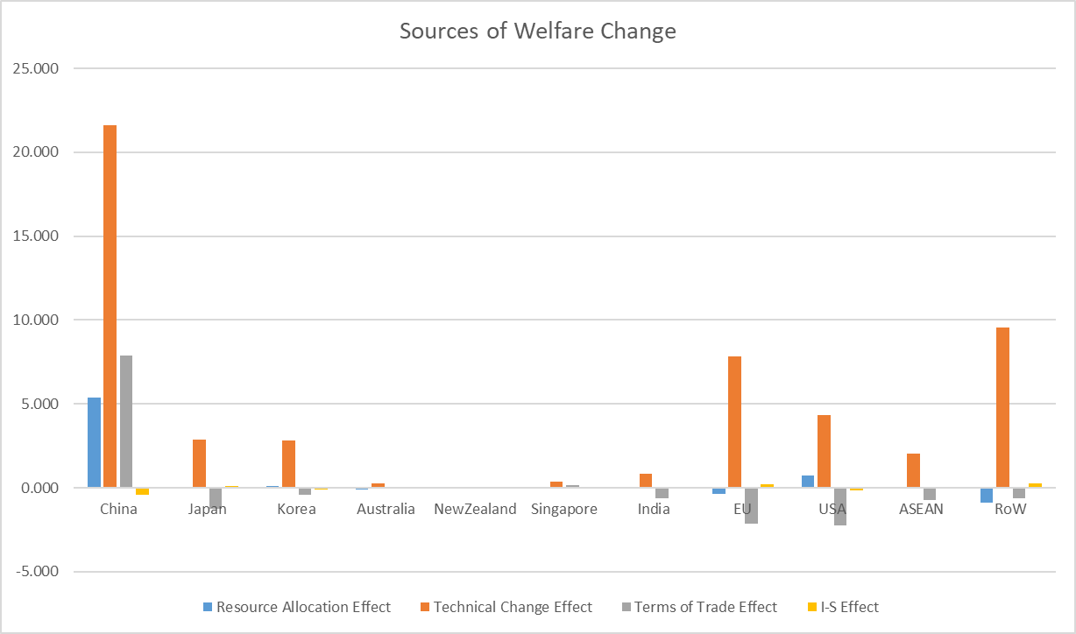

Figure 2 Change in Manufacturing Exports and Imports due to Digitalization (%)

Figure 3 Changes in Regions’ imports from and exports to China caused by Digitalization (%)

Figure 4：Changes in Backward Participation Index by country

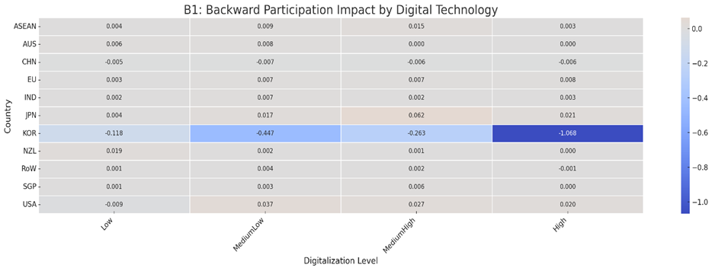

Figure 5: Changes in Backward Participation Index by country
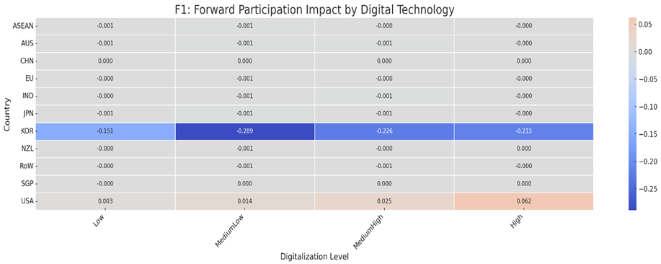

Appendix 1
This paper implements digitalization as Hicks-neutral technical change in the manufacturing sectors of each region. For example, if output, Q, is a function of two inputs, X1 and X2, exogenous technical change is modelled as :
$\frac{Q}{A_{0}}=f(X_{1}*A_{1}, X_{2}*A_{2})$ (1)
Parameters $A_{0}$, $A_{1}$, and $A_{2}$ model technical change. The output and inputs are measured in market units (i.e., $Q$, $X_{1}$, and $X_{2}$ ) or augmented unites (i.e., $\frac{Q}{A_{0}}$, $X_{1}*A_{1},X_{2}*A_{2}$). Hicks-neutral technical progress is simulated by an increase in parameter $A_{0}$ (i.e., a positive shock would be applied to the GTAP variable aoall), and it implies that more output will be produced for the same quantities of both inputs. Parameters $A_{1}$, and $A_{2}$ represents Hick-input augmenting technical change.
In the GTAP model, the sequence equations that connect percent change in output (qo) with aoall is as follows:
- Market clearing equation ensures output equals domestic consumption qds and exports qxs:

qo(i,r) = SHRDM(i,r)*qds(i,r)+sum(s, REG, SHRXMD(i,r,s)*qxs(i,r,s))+tradeslack(i,r); (2)
- Domestic consumption is a sum of consumption by firms (qfd), households (qpd), and government(qgd):

qds(i,r)=sum(j, PROD_COMM, SHRDRM(i,j,r)*qfd(i,j,r))+SHRDPM(i,r)*qpd(i,r)+SHRDGM(i,r)*qgd(i,r) (3)

- Each type of consumption above has a CES nest, with an elasticity of substitution between domestic and imports (Armington) dictating the extent of pass through from prices to demand for domestic consumption by each agent. The following is the example equation for domestic private consumption being a function of total private consumption(qp), and private consumption prices-domestic(ppd) and aggregated(pp).
qpd(i,s)=qp(i,s)+ESUBD(i)*[pp(i,s)-ppd(i,s)] (4)

- Each of the prices in the equations like the above are linked to the market prices (pm)-the following shows the example of the private domestic consumption price:
ppd(i,r)=atpd(i,r)+pm(i,r) (5)

- The following equation links the market price with the supply price, the only difference being the output tax (to), which remains unchanged in our simulations:
ps(i,r)=to(i,r)+pm(i,r) (6)

- The following equation links supply price with TFP, i.e., the variable ao, and other prices of intermediate inputs (pf), their associated productivity changes (af) as well as those of primary factors (pfe) and their associated productivity changes (afe and ava):
ps(j,r)+ao(j,r)=sum(i, ENDW_COMM,STC(i,jr)*[pfe(i,j,r)-afe(i,j,r)-ava(j,r)])+sum(i,TRADE_COMM, STC(i,j,r)*[pf(i,j,r)-af(i,j,r)])+profitslack(j,r) (7)

- At last, the equation below shows how the total change in TFP may come from the sector-specific TFP aosec, region-speicfic TFP aoreg and TFP that is specific to a sector and region aoall:
ao(j,r)=aosec(j)+aoreg(r)+aoall(j,r) (8)

Appendix 2
Following Peters et al. (2011), the total output of country r is calculated by:
$X_{i}^{r}=Z_{i}^{rr}+Y_{i}^{rr}+t_{k}^{r}+\sum_{s}{e_{i}^{rs}}$ (9)
$e_{i}^{rs}$= $Z_{i}^{rs}+Y_{i}^{rs}$ (10)
Where $X_{i}^{r}$is the total output of industry i in region r, $Z_{i}^{rr}$ is the domestic firm purchases of industry i in region r, $Y_{i}^{rr}$ is domestic purchases of final goods in industry i in region r, $t_{k}^{r}$is the export of international transport service k from region r, $e_{i}^{rs}$ is total export of i from region r to region s (valued in market prices of r ). Additionally, $e_{i}^{rs}$ is the sum of exported intermediates and final goods in industry i from region r to s.
Substituting equation (10) into equation (9):
$X_{i}^{r}=Z_{i}^{rr}+Y_{i}^{rr}+t_{k}^{r}+\sum_{s}{Z_{i}^{rs}+Y_{i}^{rs}})$ (11)
Where in equation (11),
$$Z_{i}^{rr}={vdfm}_{ij}^{r}$$
$$Y_{i}^{rr}={vdpm}_{i}^{r}+{vdgm}_{i}^{r}+{vdkm}_{i}^{r}$$
$$t_{k}^{r}={vst}_{k}^{r}$$

the exports of intermediates in industry i from region r to region s are obtained by (valued in the market price of region r) :
$Z_{ij}^{rs}=\frac{{\left(Z^{m}\right)}_{ij}^{s}}{{vim}_{i}^{s}}e_{i}^{rs}$ (12)
In addition, the exports of final goods from region r to region s in industry i are obtained by (valued in market price of region r):
$y_{i}^{rs}=\frac{{\left(y^{m}\right)}_{i}^{s}}{{vim}_{i}^{s}}e_{i}^{rs}$ (13)
In equation (12), ${\left(Z^{m}\right)}_{ij}^{s}$ is import firm purchase of i by j in region s (valued in price of region s), and ${\left(y^{m}\right)}_{i}^{s}$ is the import purchase of final goods of industry i in region s (valued in price of region s). $\frac{{\left(Z^{m}\right)}_{ij}^{s}}{{vim}_{i}^{s}}$ in equation (12) is import structure in importing countries (in prices of consuming countries) and provides the inter-industry shares, and $\frac{{\left(y^{m}\right)}_{i}^{s}}{{vim}_{i}^{s}}$ in equation (13) is for final consumption. ${vim}_{i}^{s}$ is the total import of i into region s.
For more information,
${vim}_{i}^{s}=\sum_{r}{{vims}_{i}^{rs}}=\sum_{j}{{vifm}_{ij}^{s}}+{vipm}_{i}^{s}+{vigm}_{i}^{s}+{vikm}_{i}^{s}$ (14)
$$e_{i}^{rs}={vxmd}_{i}^{rs}$$
$${\left(Z^{m}\right)}_{ij}^{s}=vifm$$
$${\left(y^{m}\right)}_{i}^{s}={vipm}_{i}^{s}+{vigm}_{i}^{s}+{vikm}_{i}^{s}$$
Where ${vim}_{i}^{s}$ is import of i from region r to region s, ${vifm}_{ij}^{s}$ is import firm purchase of i by j in region s, ${vipm}_{i}^{s}$ is import household purchase of i in region s, ${vigm}_{i}^{s}$ is import government purchase of i in region s, ${vikm}_{i}^{s}$ is import investment purchase of i in region s, ${vxmd}_{i}^{rs}$ is export of i from region r to region s.

Appendix 3
Sources of Welfare Changes (U.S. $ billion)
 | (1) | (2) | (3) | (4) | (5)
 | Resource Allocation Effect | Technical Change Effect | Terms of Trade Effect | I-S Effect | Total
China | 5.387 | 21.599 | 7.862 | -0.396 | 34.452
Japan | 0.035 | 2.854 | -1.234 | 0.125 | 1.780
Korea | 0.110 | 2.804 | -0.444 | -0.105 | 2.365
Australia | -0.108 | 0.235 | -0.023 | 0.031 | 0.135
New Zealand | -0.005 | 0.021 | 0.010 | 0.009 | 0.035
Singapore | 0.045 | 0.362 | 0.174 | 0.032 | 0.613
India | 0.039 | 0.816 | -0.619 | -0.030 | 0.206
EU | -0.357 | 7.804 | -2.130 | 0.196 | 5.513
USA | 0.734 | 4.320 | -2.220 | -0.177 | 2.657
ASEAN | 0.056 | 2.035 | -0.735 | 0.041 | 1.397
RoW | -0.895 | 9.545 | -0.641 | 0.273 | 8.282

Appendix BF1
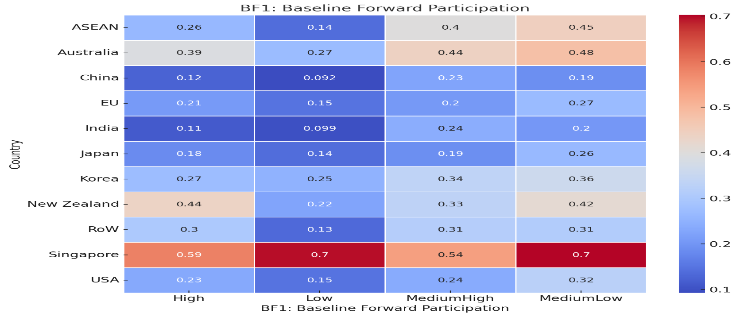

Appendix BB1
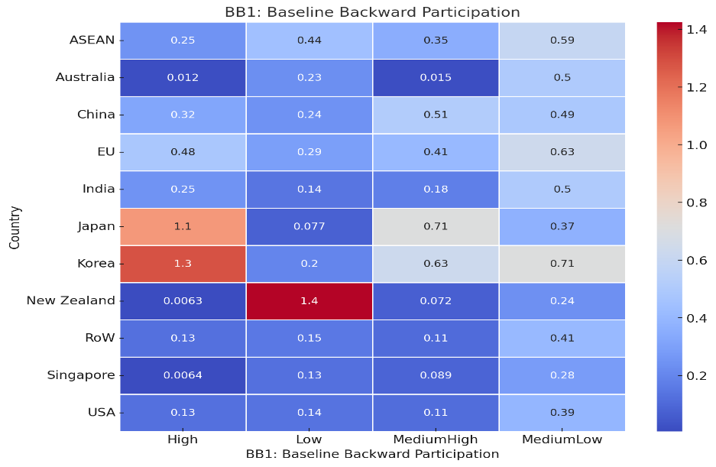

Appendix F2
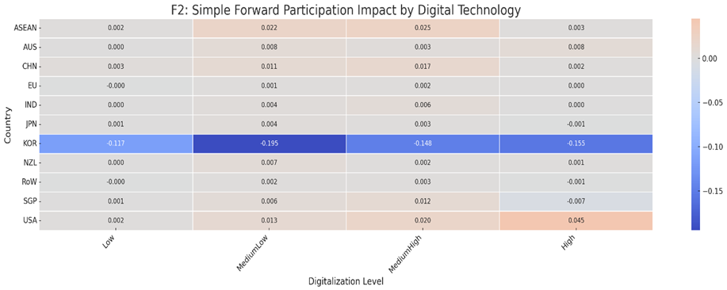

Appendix F3
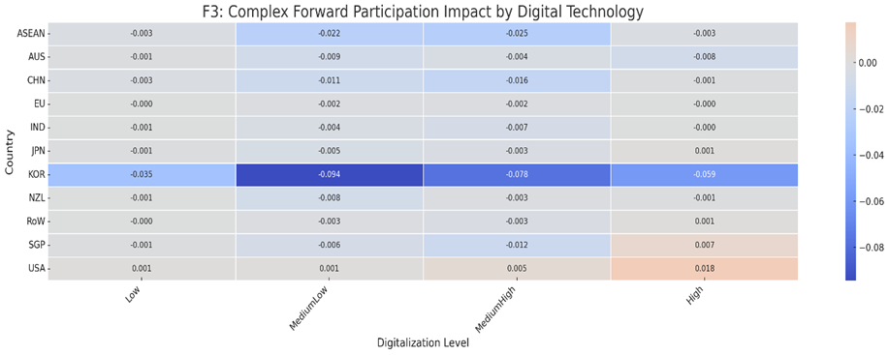

Appendix B2
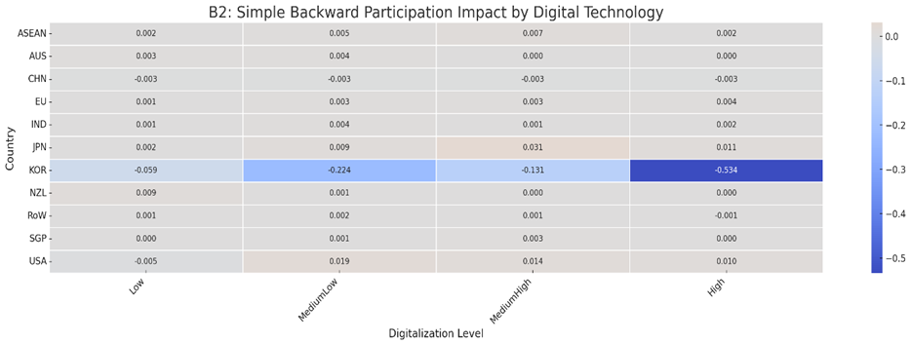

Appendix B3
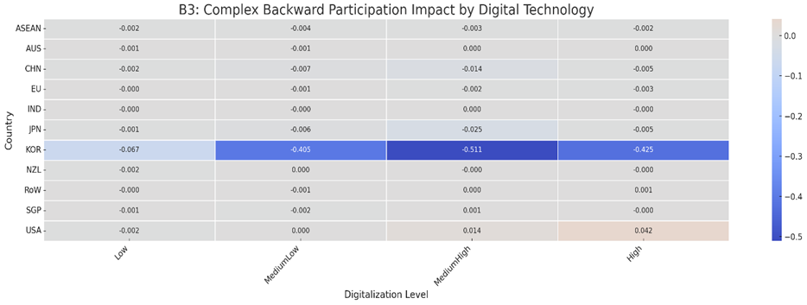

Digital technologies are reducing the worldwide work force. Nations with low wages lose their competitive advantage. In industrialized countries, production is moving closer to sales markets.
Manufacture of electronic components and boards, manufacture of computers and peripheral equipment, manufacture of communication equipment, and manufacture of consumer electronics (C-26).
Wired-, wireless-, satellite-, and other telecommunications activities (J-61).
Data processing, hosting and related activities (J-63).
This study examines only the direct impact of digitalization on manufacturing value chains, assuming that all other potential influencing factors remain fixed.

