Recursive-dynamic CGE modeling to assess systemic risks from nature degradation
Summary. Biodiversity loss and ecosystem-service degradation pose systemic risks to the global economy that remain largely absent from standard climate–economic scenarios. This paper develops a spatially explicit, recursive-dynamic Earth–economy modeling framework that links global general equilibrium analysis with gridded land-use and biodiversity dynamics. Building on GTAP-InVEST, we couple a dynamic CGE model with high-resolution land-use downscaling (SEALS) and ecosystem-service models to represent two-way feedbacks among climate change, land-use change, ecosystem services, and economic outcomes through 2050. Ecosystem services—including pollination, timber production, carbon sequestration, wild fisheries, water quality regulation, and erosion control—are modeled at fine spatial resolution and aggregated into region- and sector-specific productivity and capital shocks within the general equilibrium system. We integrate this framework with multiple Network for Greening the Financial System (NGFS) scenarios to compare climate-only projections with climate–nature pathways that account for biodiversity and ecosystem dynamics. Results show that ignoring nature systematically understates long-run GDP losses, obscures regional vulnerabilities, and fails to capture non-linear risks associated with ecosystem tipping points and collapse. Spatial heterogeneity is central: gridded analysis reveals concentrated dependencies on biodiversity in agriculture, forestry, fisheries, and coastal systems that drive macroeconomic and trade impacts. The framework provides a foundation for next-generation GTAP-based scenario analysis, enabling policymakers, central banks, and researchers to assess systemic economic and financial risks arising from land-use change and biodiversity loss.

Introduction
Biodiversity loss and ecosystem-service degradation are recognized as systemic risks to economic production, food security, and financial stability. Yet, these risks remain only weakly represented, or entirely absent, in global economic models. This omission causes biased economic analysis of the shocks and policies. Global biodiversity targets, such as the Kunming-Montreal Global Biodiversity Framework and the “30×30” land conservation goal, directly constrain land allocation, affect productivity, and interact with trade through changes in comparative advantage. These interactions are particularly important, as rapid economic growth, land scarcity, and integration into global markets amplify the consequences of ecological change.
This paper asks a fundamental question: How does explicitly accounting for spatially heterogeneous biodiversity and ecosystem services alter long-run economic and trade outcomes in dynamic global equilibrium analysis? To address this question, we develop a spatially explicit, recursive-dynamic Earth-economy modeling framework that couples a global general equilibrium model with gridded land-use and ecosystem-service models. By integrating biodiversity and ecosystem dynamics into economic projections to 2050, the framework aims to provide a next-generation platform for general equilibrium scenario analysis under climate-nature interactions.

Literature Review
The economic value of ecosystem services has been extensively documented (Costanza et al., 1997), and refined through ecosystem-service accounting frameworks such as the Millennium Ecosystem Assessment (MEA, 2005) and The Economics of Ecosystems and Biodiversity (Sukhdev et al., 2008, 2014). More recent literature emphasizes that ecosystem services contribute directly to economic production, particularly in agriculture, forestry, fisheries, and coastal protection (Dasgupta, 2021). Despite this recognition, macroeconomic modeling has lagged behind ecological science. Most integrated assessment models (IAMs) include climate damages but treat biodiversity loss as either implicit or qualitatively described (Nordhaus, 2017, 2019). Recent assessments argue that this omission leads to systematic underestimation of economic risks, especially under scenarios involving land-use change and ecological thresholds (Dasgupta, 2021).
In general equilibrium models, land use is typically represented through agro-ecological zones (AEZs) and nested constant elasticity of transformation (CET) structures. Extensions such as GTAP-AEZ and GTAP-BIO have improved representation of land heterogeneity and bioenergy competition, but land remains aggregated within regions and ecosystem services are not modeled explicitly (Hertel et al., 2009; Taheripour et al., 2010; Golub et al., 2013). Several studies have attempted to incorporate environmental constraints into CGE frameworks, including land protection or carbon pricing policies. However, these approaches generally impose policy shocks without modeling ecological feedbacks.
A growing body of work seeks to bridge this gap by coupling economic models with spatial ecosystem-service models such as GTAP-InVEST (Johnson et al., 2023, 2025), and GTAP-SIMPLE-G (Wang, 2024). Parallel efforts in land-use downscaling, such as SEALS (Johnson & Thakrar, 2024), enable translation of regional economic outcomes into gridded land-use patterns consistent with observed/simulated spatial dynamics.

Contributions
Most existing studies remain comparative-static or focus on single ecosystem services. Few frameworks integrate multiple ecosystem services dynamically over long-run horizons, and fewer still align with widely used scenario frameworks such as those developed by the Network for Greening the Financial System (NGFS). Three gaps remain in the literature. First, biodiversity and ecosystem services are rarely incorporated as endogenous, spatially explicit drivers of economic outcomes in global CGE analysis. Second, dynamic feedbacks between land-use change, ecosystem condition, and economic productivity are underexplored. Third, existing frameworks are not systematically aligned with policy-relevant scenario sets used by central banks and international institutions. This paper addresses these gaps by extending GTAP analysis into an Earth–economy framework that integrates land-use, biodiversity, and ecosystem services dynamically and spatially. For GTAP users, this framework offers three advances. First, it moves beyond aggregate land constraints to represent spatial heterogeneity in ecological dependence. Second, it translates ecosystem-service changes into sector- and region-specific productivity and capital shocks, consistent with general equilibrium logic. Third, it aligns the analysis with NGFS climate–nature scenarios, increasing relevance for policy and financial risk assessment.

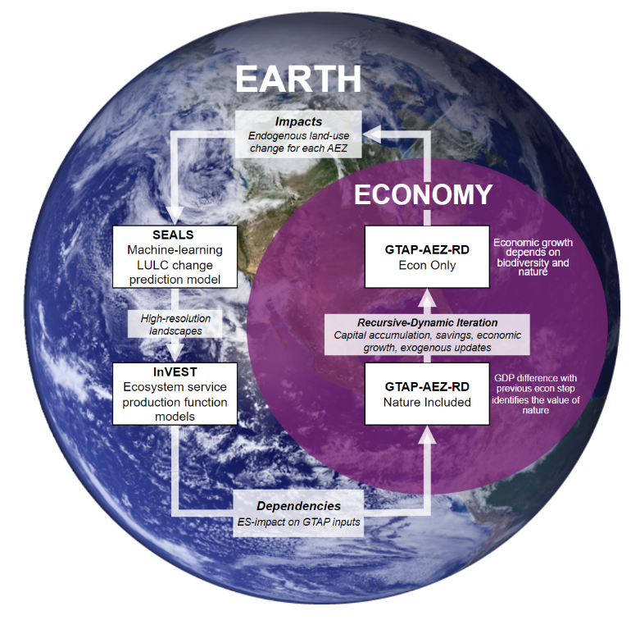
Methods
We combine GTAP-RD-AEZ, a recursive-dynamic CGE model calibrated to the GTAP-AEZ database, with spatial land-use and ecosystem-service modules of InVEST. Economic projections determine regional demands for land, agricultural output, forestry, and fisheries. These demands are downscaled to grid cells using SEALS, which allocates land-use change based on suitability, accessibility, and observed transition patterns. The modeling framework is illustrated in Figure 1. Ecosystem services (e.g., pollination, carbon sequestration, water quality regulation, erosion control, timber supply, wild fisheries, and coastal protection) are modeled using InVEST. Outputs are aggregated to the regional and sectoral level and mapped to productivity, capital stock, or damage parameters within the CGE model. The framework is implemented under multiple NGFS scenarios, allowing comparison between climate-only pathways and climate–nature pathways.
Figure 1. GTAP-InVEST Modeling framework.

Expected Results and Discussion
We expect that incorporating ecosystem services will amplify long-run costs of land-use change through multiple channels. Reduced pollination and soil retention lower agricultural productivity; degradation of fisheries and forests reduces natural capital returns; and loss of coastal protection increases capital damages. These effects interact with trade through substitution and reallocation across regions. We expect that climate-nature scenarios will show larger GDP losses than climate-only scenarios, with disproportionate impacts in biodiversity-dependent regions. Spatial heterogeneity is expected to generate nonlinear responses, as localized ecosystem degradation propagates through global markets. From a GE perspective, this framework demonstrates a pathway to incorporate spatial ecological realism without abandoning equilibrium consistency. It shows that conservation targets and land-use policies cannot be evaluated independently of trade and economic adjustment. As biodiversity loss accelerates, the credibility of global trade modeling increasingly depends on the ability to represent the economy-nature nexus.

References
Costanza, R., d’Arge, R., De Groot, R., Farber, S., Grasso, M., Hannon, B., Limburg, K., Naeem, S., O’Neill, R. V., Paruelo, J., Raskin, R. G., Sutton, P., & Van Den Belt, M. (1997). The value of the world’s ecosystem services and natural capital. Nature, 387(6630), 253–260. https://doi.org/10.1038/387253a0
Dasgupta, P. (2021). The economics of biodiversity: The Dasgupta review. Hm Treasury.
Golub, A. A., Henderson, B. B., Hertel, T. W., Gerber, P. J., Rose, S. K., & Sohngen, B. (2013). Global climate policy impacts on livestock, land use, livelihoods, and food security. Proceedings of the National Academy of Sciences, 110(52), 20894–20899. https://doi.org/10.1073/pnas.1108772109
Hertel, T. W., Rose, S., & RICHARD, S. (2009). Land use in computable general equilibrium models: An overview. Economic Analysis of Land Use in Global Climate Change Policy, 23–50.
Johnson, J. A., Baldos, U. L., Corong, E., Hertel, T., Polasky, S., Cervigni, R., Roxburgh, T., Ruta, G., Salemi, C., & Thakrar, S. (2023). Investing in nature can improve equity and economic returns. Proceedings of the National Academy of Sciences, 120(27), e2220401120. https://doi.org/10.1073/pnas.2220401120
Johnson, J. A., Chaplin-Kramer, R., Chapman, M., Polasky, S., & Williams, B. (2025). Earth-Economy Modeling: Advances in Linking Economic and Ecosystem Models. Annual Review of Resource Economics, 17(1), 209–239. https://doi.org/10.1146/annurev-resource-013024-033043
Johnson, J. A., & Thakrar, S. (2024). Projecting Global Changes in Land Use and Ecosystem Services Using SEALS (Spatial Economic Allocation Landscape Simulator). Environmental Indicators and Impact Assessment. https://doi.org/10.31223/X5GX36
MEA. (2005). Ecosystems and human well-being: Wetlands and water. Millennium Ecosystem Assessment, World resources institute.
Nordhaus, W. (2017). Revisiting the social cost of carbon. Proceedings of the National Academy of Sciences, 114(7), 1518–1523. https://doi.org/10.1073/pnas.1609244114
Nordhaus, W. (2019). Climate Change: The Ultimate Challenge for Economics. American Economic Review, 109(6), 1991–2014. https://doi.org/10.1257/aer.109.6.1991
Sukhdev, P., Wittmer, H., & Miller, D. (2014). The economics of ecosystems and biodiversity (TEEB): Challenges and responses. Nature in the Balance: The Economics of Biodiversity, 135–152.
Sukhdev, P., Wittmer, H., Schröter-Schlaack, C., Neßhöver, C., Bishop, J., Brink, P. T., Gundimeda, H., Kumar, P., & Simmons, B. (2008). The economics of ecosystems and biodiversity. na. https://www.cducsu.de/sites/default/files/benutzer/4/dateien/berlin101006-teebpavan.pdf
Taheripour, F., Hertel, T. W., Tyner, W. E., Beckman, J. F., & Birur, D. K. (2010). Biofuels and their by-products: Global economic and environmental implications. Biomass and Bioenergy, 34(3), 278–289. https://doi.org/10.1016/j.biombioe.2009.10.017
Wang, Z. (2024). GTAP-SIMPLE-G: Integrating Gridded Land Use, Crop Production and Environment Impacts into Global General Equilibrium Model of Trade. Journal of Global Economic Analysis, 9(2), 1–69. https://doi.org/10.21642/JGEA.090201AF

