Enhancing the Carbon Border Adjustment Mechanism through Endogenized Value-Added Inputs

Abstract
This study proposes an enhanced framework for the Carbon Border Adjustment Mechanism (CBAM) by internalizing value-added inputs—specifically capital, and government taxes—which are traditionally treated as exogenous in carbon accounting. Utilizing GTAP 12 2023 input-output tables and a closed input-output model, the research quantifies carbon emissions across three accounting scenarios, ranging from a standard intermediate consumption approach to a closed model with endogenized investment and government expenditure. Key findings indicate: Expanding the accounting scope significantly shifts the perceived flow of embodied carbon. Under a closed model with endogenous investment and government expenditure, the net transfer of CO2 from developing to industrialized regions increases from 2,148 MtCO2 under the standard consumption-based approach to 3,450 MtCO2, around 60% higher. While unilateral reduction by industrialized regions results in carbon leakage, implementing a CBAM that includes endogenized investment and government services reduces this leakage to near zero or below. Although a wider CBAM boundary increases environmental efficacy and drives higher emission reductions in developing regions, it leads to a greater global GDP loss and places a disproportionate economic burden on non-regulated developing nations. The paper concludes that while endogenizing value-added inputs provides a more comprehensive representation of global carbon flows, policymakers must balance these environmental gains against the escalating economic costs for developing regions.
Keywords: GHG mitigation, Consumption-based emission, Carbon tariff, Endogenized investment, Closed input-output model

Background and Methodology
Traditional carbon accounting often treats investment as an exogenous final demand, failing to account for capital goods as emission-intensive production inputs. This study utilizes GTAP12 2023 input-output tables to quantify carbon emissions by internalizing investment flows and endogenizing value-added inputs—specifically capital and taxes.
By building upon the equations developed by Bohringer et al. (2018), we construct the following system of equations:
$cc_{gr}^{Y}Y_{gr}=\sum_{j}{(cc_{jr}^{M}+c{o2}_{jgr}^{M})Z_{jgr}^{M}}+\sum_{g'}{(cc_{g'r}^{Y}+c{o2}_{g'gr}^{D})Z_{g'gr}^{D}}$ (1)
$cc_{ir}^{M}M_{ir}=\sum_{s∈R}{\left(cc_{is}^{Y}X_{isr}+\sum_{u∈U}{cc_{u}^{T}T_{uisr}}\right)}$ (2)
$cc_{u}^{T}\sum_{r∈R}{T_{ur}}=\sum_{r∈R}{cc_{ur}^{Y}T_{ur}}$ (3)
$$i∈I=\{1,2,...n\}, g∈G=I∪\{C,G,I\}$$
$c{o2}_{g'gr}^{*}$: Direct CO2 emission coefficient for input g’ used in sector g in region r
${cc}_{gr}^{Y}$: Carbon content of production activities
$Z_{Igr}^{D}=K_{gr}$: capital payment in sector g, $Z_{Ggr}^{D}=T_{gr}$: Tax payment in sector g

These define three nested accounting scopes beyond production-based emissions:
(1) CBM: Standard Approach; Includes all intermediate consumption.
(2) CBMeK: Endogenized Capital; Captures indirect emissions embodied in investment and capital accumulation.
(3) CBMeKG: Endogenized Capital & Tax; Corresponds to government expenditure.

Key Findings
Carbon Transfers
The 65 Industry sectors in the GTAP 12 database are aggregated into 21 aggregate sectors and the 163 original regions are aggregated into 6 regions following the IPCC AR6 WG3 classification, AFR = Africa; APC = Asia-Pacific; DEV = Developed economies; EEU = Eastern Europe; LAC = Latin America & Caribbean; MEA = Middle East & Africa. Among the 6 aggregated regions, ‘DEV’ are considered the industrialized region (‘IC’) and all the other regions are grouped as the developing region (‘DC’).
The scope of accounting significantly alters the perceived flow of embodied carbon between regions. When moving from the standard consumption-based approach to the comprehensive framework (including investment and government expenditure), the net transfer of CO2 (Consumption-based emission minus production-based emission) from DC to IC increases from 2,148 MtCO2 to 3,450 MtCO2, which is around 60% higher than the conventional approach.

<Figure 1> Regional CO2 Emissions by Various Accounting Approaches (2023, MtCO2)
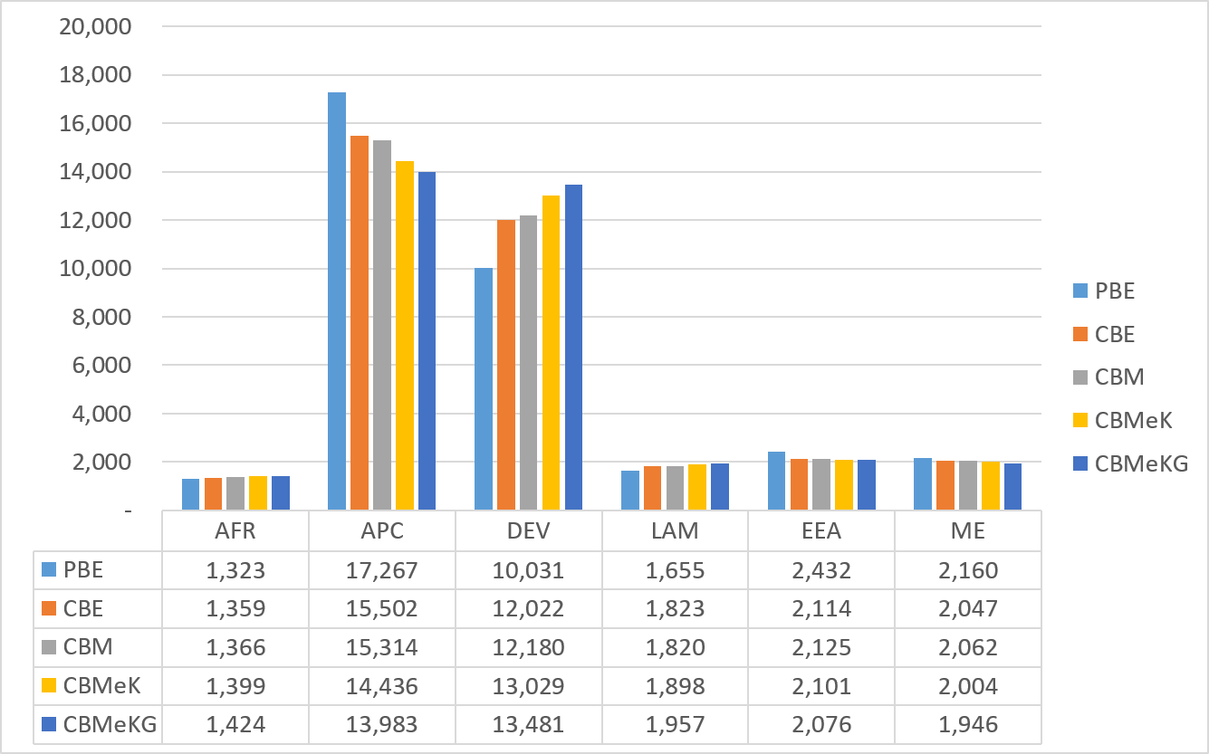
PBE: Production-based Emission; CBE: Consumption-Based Emission based on embodied emission in bilateral trades; CBM: Consumption-Based Emission based on MRIO; CBMeK: CBM with endogenous investment; CBMeKG: CBM with endogenous investment and government expenditure;

Endogenizing investment and government (CBMeK, CBMeKG) shifts emissions further toward household final demand sectors; emissions shrink in production-heavy sectors, and increase in consumption-linked sectors. For instance, emissions in the Power, Transport, and Metal sectors whose outputs are embodied further downstream, recede under consumption-based accounting scopes. Emissions for sectors such as Service, Food, and Health rise sharply as investment and government demand is folded into consumption.

<Figure 2> Sectoral CO2 Emissions by Various Accounting Approaches (2023, MtCO2)
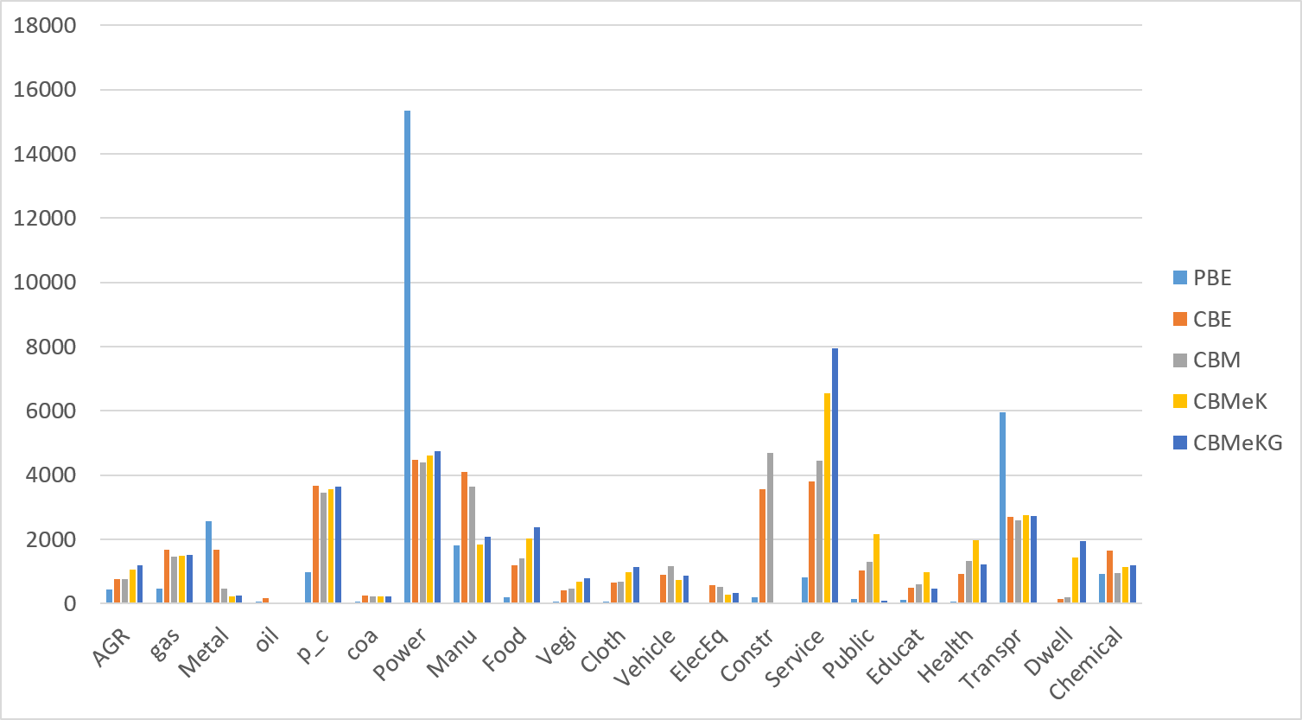

Embodied Carbon Price Approach
The study evaluates these expanded scopes within the context of Carbon Border Adjustment Mechanisms (CBAM) applied by industrialized regions (IC).
Equations (1)~(3) define the carbon intensities as consumption-based emissions for final demands encompassing the global supply chain. It is not clear if these are the right metric for a carbon tariff intended to fill the carbon price gap between importing and exporting regions, since intermediate consumption for the global supply chain includes infinite chains of supply for intermediate goods – including not only those produced in the exporting regions, but also those produced in other regions, including the importing regions. The global CGE intensities, therefore, include emissions originating from all regions, including importing regions that already have carbon prices in place at higher levels. This ensures a comprehensive accounting of embodied emissions in trade but causes double counting of emissions and duplication of carbon pricing on the traded commodities. Koopman’s double counting applies here as it applies to value added in trade.
Let ${cp}_{r}$ be the carbon price on direct emission in region r. Embodied carbon price on Y_gr, which is a derived, supply-chain-propagated, embodied price, is denoted by ${ecp}_{gr}^{Y}$ and is determined by the following system of equations.
${ecp}_{gr}^{Y}cc_{gr}^{Y}Y_{gr}=\sum_{j}{({ecp}_{jr}^{M}cc_{jr}^{M}+{cp}_{r}c{o2}_{jgr}^{M})Z_{jgr}^{M}}+\sum_{g'}{({ecp}_{g'r}^{Y}cc_{g'r}^{Y}+{cp}_{r}c{o2}_{g'gr}^{D})Z_{g'gr}^{D}}$ (1’)
${ecp}_{ir}^{M}cc_{ir}^{M}M_{ir}=\sum_{s∈R}{\left({ecp}_{is}^{Y}cc_{is}^{Y}X_{isr}+\sum_{u∈U}{{ecp}_{u}^{T}cc_{u}^{T}T_{uisr}}\right)}$ (2’)
${ecp}_{u}^{T}cc_{u}^{T}\sum_{r∈R}{T_{ur}}=\sum_{r∈R}{{ecp}_{ur}^{Y}cc_{ur}^{Y}T_{ur}}$ (3’)
The correct carbon tariff levied by region r on region s for the trade flow, $X_{isr}$, should be [${ecp}_{ir}^{Y}-{ecp}_{is}^{Y}]cc_{is}^{Y}$, not [${cp}_{r}-{cp}_{s}$]$cc_{is}^{Y}$. The effective carbon rate for the output i in region s, ${ecp}_{is}^{Y}$, may not be zero, even when the carbon price in the region is zero, if the region consumes intermediate inputs imported from other regions with positive carbon prices.

Impact on Carbon Leakage and GDP
We construct 10 scenarios:
- BAU: baseline BAU
- Ctax: Carbon tax by DEV for 20% reduction of CO2
- Cbam0: CBAM by DEV to all the other regions based on direct emission
- Cbam: CBAM by DEV to all the other regions based on embodied carbon content
- CbamK: CBAM by DEV to all the other regions based on embodied carbon content with endogenized investment
- CbamKG: CBAM by DEV to all the other regions based on embodied carbon content with endogenized investment and government expenditure
- CbamEcp: CBAM by DEV to all the other regions based on embodied carbon price for embodied carbon content
- CbamEcpK: CBAM by DEV to all the other regions based on embodied carbon price for embodied carbon content with endogenized investment
- CbamEcpKG: CBAM by DEV to all the other regions based on embodied carbon price for embodied carbon content with endogenized investment and government expenditure
- CbamEcp2w: (Two-way) CBAM by DEV to all the other regions based on embodied carbon price for embodied carbon content with export subsidy

The carbon price for the 9 mitigation scenarios ranges over 32.45 ~ 32.92 USD/tCO2, highest in CbamEcpK and lowest in the Ctax Scenario. In the Cbam scenarios, the CBAM is analyzed as being levied by the industrialized region (DEV) on imports from all other regions. Cbam scenarios slightly increases the carbon price required to meet the 20% target in the DEV region.
Carbon Leakage: While unilateral CO2 reduction by Industrialized Regions (IC) leads to a leakage rate of 2.26%, the implementation of a standard CBAM0 reduces this leakage to almost 0 and the CBAM based on endogenized investment and government expenditures leads to minus leakages, i.e., emission reductions in non-regulated regions rather than increase. Even a direct-emission (Scope-1) CBAM may therefore be sufficient to prevent leakage. Expanding the CBAM boundary to include capital and taxes leads to higher emission reductions in Developing Regions (DC).
Economic Cost: This increased environmental efficacy comes at an economic price. Broader embodied emission coverage results in a higher global GDP loss, with particularly significant impacts on the GDP of non-regulated (developing) regions (DC). As the tariff base widens, DC GDP falls from −0.04% (Cbam0) to −0.32% (CbamKG), while the industrialized region's own loss shrinks.

<Table 2> The Impact of CO2 Regulation and CBAM for Various Accounting Frameworks (2023)
 |  | Ctax | Cbam0 | Cbam | CbamK | CbamKG | CbamEcp | CbamEcpK | CbamEcpKG | CbamEcp2w
RGDP(rs) |  | -0.08% | -0.08% | -0.12% | -0.14% | -0.15% | -0.11% | -0.11% | -0.12% | -0.08%
DC |  | -0.01% | -0.04% | -0.18% | -0.29% | -0.32% | -0.12% | -0.16% | -0.17% | -0.14%
 | LAM | -0.02% | -0.05% | -0.11% | -0.18% | -0.21% | -0.09% | -0.10% | -0.11% | -0.09%
 | AFR | 0.03% | -0.01% | -0.08% | -0.21% | -0.23% | -0.06% | -0.12% | -0.12% | -0.05%
 | APC | -0.01% | -0.04% | -0.22% | -0.32% | -0.36% | -0.15% | -0.17% | -0.18% | -0.17%
 | EEA | 0.04% | 0.01% | -0.14% | -0.31% | -0.33% | -0.11% | -0.19% | -0.19% | -0.13%
 | ME | -0.02% | -0.04% | -0.11% | -0.23% | -0.24% | -0.08% | -0.13% | -0.13% | -0.09%
IC |  | -0.13% | -0.12% | -0.07% | -0.03% | -0.02% | -0.09% | -0.08% | -0.08% | -0.03%
 | DEV | -0.13% | -0.12% | -0.07% | -0.03% | -0.02% | -0.09% | -0.08% | -0.08% | -0.03%
TotalCO2 |  | -5.62% | -5.75% | -5.92% | -5.96% | -5.97% | -5.83% | -5.83% | -5.83% | -6.05%
DC |  | 0.18% | 0.00% | -0.23% | -0.29% | -0.30% | -0.11% | -0.10% | -0.10% | -0.41%
 | LAM | 0.39% | 0.11% | 0.03% | -0.01% | -0.02% | 0.08% | 0.10% | 0.10% | -0.43%
 | AFR | 0.29% | 0.08% | -0.13% | -0.13% | -0.13% | -0.03% | 0.01% | 0.02% | -0.19%
 | APC | 0.14% | 0.03% | -0.18% | -0.25% | -0.28% | -0.08% | -0.09% | -0.09% | -0.39%
 | EEA | 0.12% | -0.35% | -0.80% | -0.88% | -0.88% | -0.50% | -0.44% | -0.42% | -0.74%
 | ME | 0.35% | -0.03% | -0.23% | -0.19% | -0.18% | -0.12% | -0.04% | -0.02% | -0.31%
IC |  | -20.00% | -20.00% | -20.00% | -20.00% | -20.00% | -20.00% | -20.00% | -20.00% | -20.00%
 | DEV | -20.00% | -20.00% | -20.00% | -20.00% | -20.00% | -20.00% | -20.00% | -20.00% | -20.00%

The following figure shows the embodied carbon prices (ECPs) for different sectors in different regions are quite different from explicit carbon prices. The sectoral ECPs in the DEV region are not equal to the explicit carbon price, 0.03285; in fact, most sectors face relatively lower carbon prices than the nominal carbon price. This is due to the global value chain, under which DEV region also imports many goods and services from other regions with zero explicit carbon price in this analysis. By the same logic, other regions with no explicit carbon price have non-zero ECPs due to their imports of carbon-priced goods and services from the DEV region. LAM has the highest ECP among the unregulated regions, reflecting that it imports the most carbon-priced goods from the DEV region.

<Figure 3> Embodied Carbon Prices (CbamEcp Scenario, 1000 USD/tCO2)
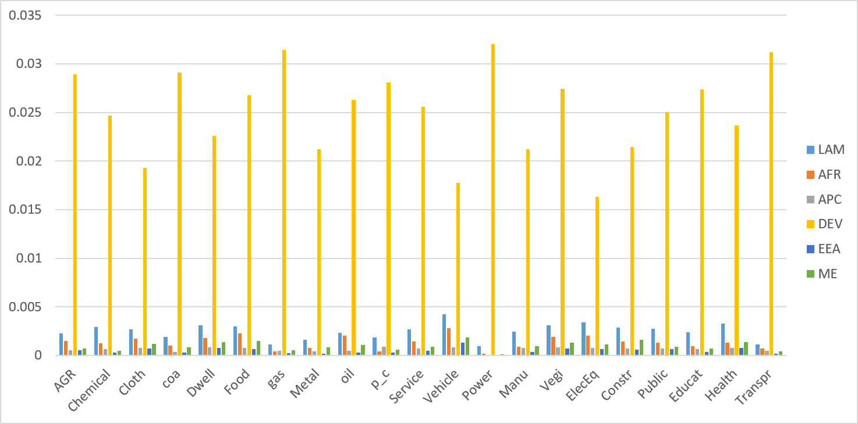

Conclusion
Internalizing value-added inputs provides a more comprehensive representation of international carbon flows embodied in trades and a more comprehensive consumption-based responsibility. However, while a wider emissions accounting scope effectively eliminates carbon leakage and induces reductions in developing regions, it exacerbates the economic burden on those same regions by raising global GDP loss and shifting burden to those regions. Combining embodied carbon price (ECP) with export subsidy may be more effective in minimizing global carbon intensity. Furthermore, carbon pricing by a wide group of developed regions may limit carbon leakage in developing regions.
Future work includes a dynamic model simulation for a more systematic evaluation of capital-stock dynamics in carbon leakage, a deeper analysis of embodied carbon prices and a fuller evaluation of ECP's role as the CBAM base, and a game-theoretic analysis of the carbon-pricing incentives of non-regulating regions under ECP- versus CP-based CBAM.

Bohringer, Carbone, Rutherford, Embodied Carbon Tariffs, The Scandinavian Journal of Economics, 2018, Online Appendix, Equations (A1)~(A3). The Equation (A1) as follows is modified to reflect the direct emission coefficients for individual fossil fuel inputs in each sector, rather than emission intensity aggregated for all the inputs for each sector (${co2e}_{ir}^{}=\sum_{j}{\{c{o2}_{jir}^{M}Z_{jir}^{M}+c{o2}_{jir}^{M}Z_{jir}^{M}}\}$), and to introduce the carbon content (cc) for value added inputs (capital, tax and labor). $cc_{ir}^{Y}Y_{ir}={co2e}_{ir}^{}+\sum_{j}{cc_{jr}^{M}Z_{jir}^{M}}+\sum_{j}{cc_{jr}^{Y}Z_{jir}^{D}}$ (A1)

