On the macro-economic impact of the bioeconomy – Introducing advanced bioeconomy sectors in a macro-economic modelling framework with a case study for the Netherlands

van Meijl H^{a1}, Tsiropoulos I^{b}, Bartelings Hª, Hoefnagels R^{b}, Smeets Eª, Tabeau Aª, Faaij A^{c}

¹Corresponding author: Hans van Meijl, hans.vanmeijl@wur.nl, +31703358169
ª LEI Wageningen UR, Wageningen University and Research centre, Alexanderveld 5, 2502 LS , The Hague, The Netherlands
^{b} Copernicus Institute of Sustainable Development, Utrecht University, Heidelberglaan 2, 3584 CS Utrecht, The Netherlands
^{c} Energy and Sustainability Research Institute, University of Groningen, Nijenborg 4, 9747 AC Groningen, The Netherlands

Keywords
Macro-economic modelling, bioeconomy, biochemicals, Computable General Equilibrium, emerging sectors

Abbreviations
1,3-PDO | 1,3-Propanediol
CDE | Constant Difference of Elasticities
CES | Constant Elasticity of Substitution
CGE | Computable General Equilibrium
EPPA | Emissions Prediction and Policy Analysis
EU | European Union
FT | Fischer-Tropsch
GDP | Gross Domestic Product
GHG | Greenhouse Gas
GTAP | Global Trade Analysis Project
I-O | Input-Output
MAGNET | Modular Applied General Equilibrium Tool
MARKAL | Market Allocation
PE | Partial Equilibrium
PEF | Polyethynene Furanoate
PLA | Polylactic Acid
PPP | Purchasing Power Parity
RES | Renewable Energy Sources
SA | Succinic Acid

Introduction
The role of biomass in today’s economies extends beyond traditional sectors such as food, feed, materials (e.g., plant fibers, lumber, paper and pulp) and traditional uses for energy (inefficient heating and cooking). While more than half of current biomass use for energy is traditional, modern and efficient bioenergy supply of electricity, heat and biofuels for road transport is growing rapidly and is expected to continue so in the future [1]. Advanced bioeconomy sectors are also being gradually introduced in regional economies. Aviation and shipping are two sectors that rely exclusively on biofuel developments to partly decarbonize their energy use [2,3]. Biochemicals and biochemical products (e.g., bioplastics) are already produced globally and consume about 4.5% of total biomass used for energy and biochemical uses [4]. In 2016, global production capacity of bioplastics reached 2 Mt and is expected to quadruple before 2020 [5].These developments indicate prospects for mid-term and long-term bioeconomy growth, which is often also seen as a strategy to secure societal challenges such as energy access, economic growth, employment and regional development, while ensuring long-term environmental sustainability [6].

Analyses of the potential macro-economic impacts of bioeconomy development can be helpful to the extent they can provide insights on such indicators. To date, such analyses are scarce because recent advances in conversion of different biomass feedstocks to an array of food, feed, material, energy and biochemicals have created complex dynamics through which biomass participates in different sectors of the economy. General equilibrium (CGE), partial equilibrium (PE) and input-output (I-O) economic models are able to address such interactions. Each modelling approach has strengths and weaknesses as they are designed to answer specific questions related to bioeconomy. Considering, however, that the bioeconomy lies at the interface of many different economic sectors and the concerns that indirect effects of biomass can be induced in indirect sectors and regions, PE and I-O models are less appropriate as they do not model the whole world economy or include price effects, respectively. CGE models, on the other hand, are more suitable and have been used to assess economy-wide impacts, capturing linkages and interactions between different sectors to demonstrate direct and indirect effects of biomass use [7,8]. The global dimension is key as the availability of biomass, international trade and sustainability issues inherently occur at global scale. For example, CGE models have been used to address implications of biofuel policies on agricultural markets, land use change and related emissions. This led to improved endogenous modelling of land markets in CGE models [9]. Recent efforts also focused on improving modeling of biofuels by introducing of ethanol, biodiesel and their by-products [10,11] and of prospective biomass feedstocks for advanced biofuels production such as corn stover, energy crops, palm oil residues [12,13].

However, most efforts have focused on biofuels and less on bioelectricity, biomass heat (bioheat) and new bioeconomy sectors (e.g., biochemicals). Thus state-of the-art CGE models provide limited information on underlying elements that can be critical for bioeconomy especially related with technology and technical change [14]. The complex characteristics of advanced biomass conversion technologies and emerging sectors that would need to be taken into account are many. Firstly, novel technologies may convert a variety of non-food biomass feedstocks such as agricultural residues and energy crops (short rotation forestry, perennial crops) to biofuels and fermentable sugars as feedstock for the chemical industry. While agricultural residues do not (directly) compete for land with food crops, energy crops could require land currently used for food[1]. Secondly, in view of emerging bioeconomy sectors, competition for the same biomass resources could intensify if demand for biochemicals and renewable jet fuels (RJF) increases. This could influence biomass cost-prices due to versatile supply and demand dynamics, it could affect the role of biomass in climate change mitigation strategies and consequently on policy design. Thirdly, biorefinery technologies gradually become an integral part of bioeconomy strategies. Advanced biorefineries, break down different biomass constituents and supply multiple material and energy outputs, which can be used by different end-use sectors [15]. At the same time, cascading biomass uses from higher value applications at the beginning of their life (e.g., bioplastics) towards lower value applications by their end-of-life (e.g., bioplastics incineration and energy recovery) increase the overall efficiency of biomass use but also the complexity on how these dynamics can be captured by models [16].

With regards to addressing biomass uses in CGE models that go beyond energy applications and in particular for biochemicals with a focus on macro-economic effects, there are additional challenges. To date, the biochemical sector is too small and there is no clear distinction in statistics and databases (e.g., Global Trade Analysis Project (GTAP)), which are used by CGE models. Furthermore, the chemical industry sector is aggregated at a high level, while in reality the sectoral flows of the industry are much more complex. As biomass conversion technologies to biochemicals may offer renewable alternatives at different levels [17], disaggregation of the chemical industry sector in CGE models is required. [18] have presented a method on how to improve the oil-refining sector in the CGE model Emissions Prediction and Policy Analysis (EPPA), however, chemical products still remain at an aggregate level. Also, there is limited information on biochemical technology cost-structures and their technological progress. [19] assessed macro-economic impacts of bioeconomy by combining the macro-economic model LEITAP with a bottom-up excel tool. However, as the authors indicate, the macro-economic model could benefit by improved cost-structures, especially on capital-intensive 2nd generation technologies that utilize low-cost biomass feedstocks. Furthermore, the biochemical sector in LEITAP has been modeled implicitly and the biochemical product portfolio is limited. [13] and [20] prepared two studies that assessed biochemicals in CGE modeling frameworks. To our knowledge none of the studies provides a comprehensive analysis of the bioeconomy that takes recent developments across the value chain into account.

On the other hand, energy system models, such as the MARKet ALlocation (MARKAL) model, are able to address more complexities, as they are technology-rich and explicit. For example, the Dutch energy system model MARKAL-NL-UU has been extended to include different biomass feedstocks linked to a large portfolio of biomass conversion technologies, including those that may deliver to emerging bioeconomy sectors (biochemicals, RJF) [17]. To date, this model is one of the few that can assess with sufficient details technology and technology progress for mid-term bioeconomy developments. While such models are not capable to assess macro-economic indicators and ignore interactions with the rest of the economy, they can be useful to improve technology details in macro-economic models.

In the present study, we expand the Modular Applied GeNeral Equilibrium Tool (MAGNET) CGE model with bioeconomy sectors and in particular 2nd generation road transport fuels, electricity, heat and chemicals from biomass. Furthermore, we improve biomass supply including agricultural residues, forestry residues and pretreatment of those feedstocks to pellets for international biomass trade. We use scenario analysis to address effects of important assumptions on technical change. In the present study the model is demonstrated for mid-term assessment of bioeconomy developments in the Netherlands to 2030. To that end, we use a framework where the energy system model MARKAL-NL-UU [17], is used side by side with MAGNET, and we compare results obtained by the two models and highlight points of interaction that can lead to improved representation of bioeconomy in CGE models.

Materials and methods
To assess the macro-economic impacts of bioeconomy development we use the multi-sector and multi-region macro-economic CGE model MAGNET [21]. In order to improve technology details in MAGNET (e.g., technology cost-structures, learning pathways, biomass conversion technology portfolio), we also use MARKAL-NL-UU, a linear cost-optimization energy system model [17]. MARKAL-NL-UU is a regional model that has been developed to demonstrate techno-economic impacts of bioeconomy developments for the Netherlands to 2030. MAGNET has the same temporal scope, and the basis for introducing new bioeconomy technologies/sectors in the model is also the Netherlands. As MAGNET is a global model, the cost-structures and technology changes are implicitly assumed to be similar for the rest of the world. Starting points, in terms of value added and production values, for different countries are different and based on statistical economic and technical data. The models use similar exogenous parameters, but due to their different modeling paradigms some inputs are differentiated (Figure 1). The output provided by MARKAL-NL-UU on promising technologies is used as a criterion on the sectoral disaggregation of MAGNET which uses MARKAL-NL-UU cost-structures as input data (section 2.2). Scenario analysis is used to assess the influence of technological learning and openness of biomass trade (section 2.1.1). Scenario assumptions of MARKAL-NL-UU and MAGNET are consistent. Finally, the modelling framework includes comparison between key outputs of the two models.

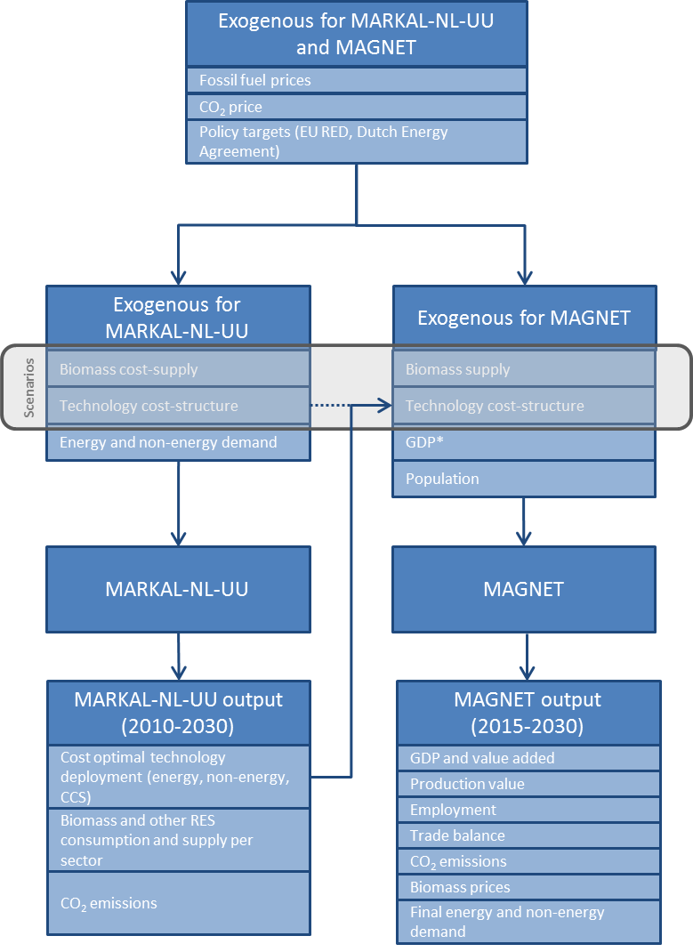
Figure 1 Modelling framework

Bottom-up scenarios and inputs to MAGNET

Description of the modeling framework
The bottom-up linear cost-optimization energy system model of the Netherlands MARKAL-NL-UU is used to assess the cost-optimal technology portfolio of biomass conversion, other renewables, and fossil fuel technologies and related GHG emissions to supply an exogenously determined demand for electricity, heat, transport, and chemicals to 2030 [17]. MARKAL-NL-UU uses fossil fuel and CO₂ prices to 2030 based on the New Policies scenario of the International Energy Agency’s World Energy Outlook 2014 [22]. Furthermore, the model assumes that targets of the EU RED on biofuel blending and renewable energy share on final energy consumption are met by 2020 [23]; these are extended based on the Dutch Energy Agreement to 2030 [24]. The exogenous inputs are consistent between MARKAL-NL-UU and MAGNET (Figure 1, Table S 2).

Biomass cost-supply
MARKAL-NL-UU includes detailed cost-supply curves of biomass supply from EU28 countries. Biomass feedstocks include sugar and vegetable oil crops, agricultural residues, forestry and primary wood processing residues, energy crops, short rotation forestry and organic waste. The supply potential in 2010-2030 is based on the EU 7th Framework Project Biomass Policies [25] and is consistent between MARKAL-NL-UU and MAGNET. In addition, MARKAL-NL-UU uses cost-prices of biomass feedstocks from the same project, while in MAGNET these are determined endogenously. Finally, MARKAL-NL-UU includes cost-supply curves for wood pellets, sugar, biofuels (bioethanol, biodiesel) and vegetable oil from global markets [17].

The influence of biomass sourcing on technology deployment is assessed using two scenario variants, namely a regional (Reg) and a global (Glob) trade scenario. The Reg scenario assumes that the EU supports bioeconomy developments only if EU resources are used, for example to ensure sustainability of supply, to reduce dependency on non-EU countries and to stimulate rural development and employment in the EU region. This scenario is also plausible if domestic biomass demand from exporting regions such as the USA increases or if strict sustainability criteria are applied by the EU thereby excluding large traded biomass resources such as primary forestry biomass due to carbon debt issues. In this scenario only EU biomass is taken into account for the potential supply.
The Glob scenario assumes that no trade barriers for biomass are imposed as development and standardization of sustainability criteria guarantee the sustainable origins of biomass. Furthermore, another precondition is that logistics infrastructure and supply of biomass take place to achieve low biomass supply costs and make biomass a tradable commodity. The same scenarios are assumed in MAGNET.

Technology cost-structure and development
MARKAL-NL-UU includes detailed cost structures of fixed and operating costs for a wide range of technologies and their development to 2030. The cost-structures for electricity production (from fossil fuels, biomass and other renewable resources), 1st generation biofuels, and bioheat are directly used as inputs to MAGNET.

To assess the deployment prospects for technologies in the mid-term for the Dutch energy and industry system, MARKAL-NL-UU incorporates two scenarios designed to assess different technology development rates. The two variants assume low (LowTech) and high (HighTech) speed of technology development. The technology development scenarios differ in terms of improvement rates in efficiency, year of commercialization, scales and technology portfolio. These parameters, ultimately affect the cost-competitiveness of biomass conversion technologies. These scenarios were developed around 2nd generation biomass conversion technologies to biofuels and biomass conversion technologies to biochemicals. More details can be found in [17].

As a result, outputs of MARKAL-NL-UU on prospective technologies for biofuels and biochemicals ultimately depend on the assumed combination of trade openness and technology development scenario(RegLowTech, RegHighTech, GlobLowTech and GlobHighTech). By supplying cost-structures of technologies of the bottom-up scenario to MAGNET

Bottom-up scenario results

Results from the bottom-up model for the four scenarios are used to provide insights and relevant data on technologies to MAGNET. In this section we focus on outcomes for the bioeconomy sectors.

- Bioelectricity is limited across the scenario variants (about 9% of total electricity output), and is produced mainly from incineration of organic solid waste and co-produced by biorefineries, in particular in the high technology development scenarios. While biomass co-firing is not found to be a cost-attractive conversion pathway, it is selected as an input to MAGNET to model electricity production from biomass.
- Industrial heat from biomass is found as the most cost-optimal solution to meet EU RED targets when compared against other fossil and renewable alternatives. In the Netherlands, biomass heat in industry replaces primarily natural gas, which remains the key fuel for heat in other sectors. This shows the importance of including bioheat as a natural gas substitute in MAGNET.
- 1st generation biofuels are supplied in low technology development scenarios, while advanced 2nd generation fuels (FT-fuels, 2nd generation ethanol) are supplied in high technology development scenarios.
- Oil naphtha remains the primary feedstock to produce chemicals. The production of sugar fermentation chemicals and bulk ethanol-based chemicals is significant. Sugar and ethanol supplied to the biochemical conversion technologies are both from 1st and 2nd generation resources.

Overview of the MAGNET model
MAGNET is a recursive dynamic, multi-regional, multi-commodity CGE model, covering the entire global economy [21]. It is built upon the standard GTAP model [26] and is the successor to LEITAP, which has been previously used to assess bioeconomy [19] and other policy analysis studies [27,28]. In the GTAP database, primary production factors (land, labor, capital, natural resources) are linked through value added chains with industries to deliver final goods and services for consumption. MAGNET uses a general multilevel sector-specific nested constant elasticity of substitution (CES) production function to allow for substitution between primary production factors and intermediate production factors and for substitution between different intermediate inputs such as land and animal feed. It includes an improved treatment of agricultural sectors with emphasis on land (imperfectly substitutable types of land, land use allocation structure, land supply function), feed components, agricultural policies and biofuel policies [27–30]. On the consumption side, a dynamic constant difference of elasticities (CDE) expenditure function is implemented which allows for changes in income elasticities when purchasing power parity (PPP) corrected real gross domestic product (GDP) per capita changes. Segmentation and imperfect mobility between agriculture and non-agriculture labour and capital are introduced in the modelling of factors markets.

New bioeconomy sectors in MAGNET
Explicit modelling of the bioeconomy in MAGNET calls for an improved representation of biomass across the whole value chain, namely on supply (new feedstocks and pretreatment) and conversion technologies that deliver to bioeconomy sectors.

Biomass supply
Agricultural and forestry residues are frequently addressed as key biomass feedstocks for energy and non-energy uses [31,32]. There is sufficient evidence to suggest that biomass residues have large supply potential, and as side-streams of primary production (forest, agriculture) or processing sectors (forest management, wood and food processing) they have low supply costs and are not associated with direct or indirect land-use changes, which has raised concerns about the emission profile of bioenergy [1]. Energy crops (plantations) on arable land may contribute most to the global total technical potential of biomass, assuming rapid efficiency improvements in agriculture [1]. A key benefit of plantations is that they can grow on marginal and degraded lands, which on the one hand may result in higher costs of supply but on the other they may offer benefits due to limited competition with food production and due to improvement of soil conditions [1]. Solid biomass from residues and plantations may be used directly by conversion sectors or they can be densified to wood pellets leading to increased cost-efficiency of the value chain due to chain due to reduced storage and logistic costs [33–35].

In MAGNET, three new sectors are included to capture the developments on the biomass supply side, namely residues, plantations and pellets.

- The residues sector collects and transports various types of forest harvest residues (forest management, logging, wood processing industry) and agricultural residues (harvesting and processing of agricultural crops). Residues can be used directly by conversion technologies or be supplied to the pellets sector;
- The plantations sector produces dedicated woody or grassy crops. Biomass from plantations can be used directly by conversion technologies or be supplied to the pellets sector;
- The pellets sector may use biomass from the residues or plantation sector;

An overview of the biomass supply sectors is provided in Figure 2.

Conversion technologies per sector

Fuels
2nd generation biofuel technologies have the potential to produce road transport fuels at lower levelized costs than fossil fuels and lead to higher avoided greenhouse gas (GHG) emissions compared to 1st generation biofuels by 2030 [1,36]. Preconditions for diffusion of 2nd generation biofuels are the availability of low cost biomass feedstocks and commercialization of 2nd generation technologies. In replacing fossil fuels, biochemical, thermochemical and other thermal or catalytic routes (e.g., pyrolysis) may supply 2nd generation biofuels.

In MAGNET, two production technologies for 2nd generation biofuels are considered:

- Biochemical, which convert lignocellulosic biomass to 2nd generation ethanol
- Thermochemical, which involve gasification of solid biomass to syngas and subsequent synthesis to Fischer-Tropsch (FT) fuels.

Other promising biofuel pathways include hydrotreatment of vegetable oils and fats, pyrolysis or other thermochemical routes that produce methanol and hydrogen. These are not included in the analysis as most representative routes are chosen. In view of emerging biochemicals, it should be noted that the selected pathways may also supply feedstocks required by chemical conversion technologies (section 2.3.2.4). The thermochemical pathways may supply naphtha and the biochemical pathways 2nd generation ethanol and sugar for further conversion.

An overview of biomass conversion to 2nd generation biofuels is provided in Figure 2.

Electricity
In order to demonstrate substitution effects in electricity supply, the electricity sector in MAGNET needs to be split to several different renewable-based and fossil-based supplying sectors in detail. More renewable options are available at competitive costs and at the same time disaggregation of fossil sectors implies a better representation of options available for GHG mitigation strategies.

Therefore, we split the electricity-producing sector in MAGNET into the six source sectors for electricity production from:

- Biomass, which includes co-firing of wood pellets in coal-based power plants
- Wind and solar
- Hydro and geothermal
- Coal
- Natural gas
- Nuclear

In addition an electricity transport and distribution sector is included.

MARKAL-NL-UU demonstrated the importance of wind energy in renewable electricity production in the Netherlands by 2030. Biomass output was limited to co-production technologies and less from co-firing with coal.

An overview of biomass conversion to electricity is provided in Figure 2.

Heat
The contribution of biomass heat to renewable energy demand is expected to be significant and in the EU and globally. For EU27, based on the National Renewable Energy Action Plans biomass heat represents approximately 65% of the final bioenergy demand, and may vary between 62-72% depending on scenario conditions [37]. [38] mention that 13-14 EJ of biomass can be economically deployed at a global level to supply industrial steam by 2030, especially if low-cost biomass residues are used.

In MAGNET, heat is modeled implicitly as a direct substitute for natural gas.

Chemicals
In the GTAP database the chemical sector is represented at an aggregate level by a single category that includes basic chemicals and other chemical products and uses only petroleum products as input [39]. However, in reality, the flows of the petrochemical industry are more complex. Different crude oil or gas products are used and are converted first to basic chemicals that are further converted to several intermediate chemicals before finally being synthesized and/or processed to consumer goods such as plastics.

Biomass conversion technologies can supply biochemical counterparts as inputs (feedstocks; e.g., the refined oil product naphtha), basic or intermediate chemicals (e.g., ethylene) or directly as consumer goods (e.g., bioplastics) [40]. The different levels where biochemicals can be introduced in the chemical sector of an economic model create the need to disaggregate the sector to be able to take these different options into account. At the same time, there are multiple conversion routes that supply a very wide range of biochemicals (e.g., fermentation, catalysis) and they incorporate different feedstocks such as fermentable sugars, ethanol or solid biomass. This increases the complexity because representative technologies need to be selected to capture both the level where competition with fossil counterparts may take place and the different biochemical routes.

Most of the chemical industry’s output is consumed for polymers [41], which is also the category we focus on the present study. Along the lines of strategies [40,42,43] that aim at providing renewable alternatives to the chemical industry those discussed the most are drop-in chemicals and new products. Drop-in chemicals could either be alternative feedstocks for steam crackers or directly chemicals that can be processed further downstream to final products. Drop-in chemicals can use existing infrastructure and compete in established markets as they share exactly the same properties with their fossil counterparts. New biochemicals require new infrastructure and may compete in the same or new markets with conventional chemicals (e.g., polylactic acid (PLA)). In order to capture the emerging sector of biochemicals in MAGNET we account for these strategies by splitting the sector and selecting representative pathways.

We identify two key representative pathways:

- Ethanol to chemicals, which uses 1st or 2nd generation ethanol to produce bioethylene. This sector uses already existing infrastructure and competes in the same markets with fossil-based alternatives. Ethylene is selected as it is the largest volume basic chemical of the chemical industry. Furthermore, bioethylene and derivatives are already produced at commercial scale, and cost-structures are available. Ethanol can be used to produce other drop-in chemicals (e.g., (e.g., propylene, butadiene) and a variety of other chemicals and could be a potential platform for the future [44].
- Direct sugar to chemicals, which can use 1st or 2nd generation fermentable sugars. Although 1st and 2nd generation ethanol also use fermentable sugars prior to converting it to ethylene, this route produces directly through fermentation products that can replace plastics. Lactic acid and its polymerization to PLA is chosen as a representative route as it is already produced at commercial scales and cost-structures are available. There is a wide number of products that can be derived from white biotechnology such as 1,3-Propanediol (PDO), succinic acid (SA) [45] or that involve catalytic conversion of sugars such as PEF [46]. While techno-economic parameters of these routes differ a lot, PLA can be considered as a representative product for using sugar as a platform for biochemicals.

In addition, to assess the option of supplying alternative feedstocks to the industry, we include FT-naphtha as a thermochemical-based feedstock. This choice is not supported by MARKAL-NL-UU outcomes, as this was not shown as a prospective technology. However, accounting for this option in the structure of the macro-economic model is essential as other options such as hydrogenated animal or vegetable oils or ethane and propane from ethanol may pick up in the future.

An overview of biomass conversion to biochemicals is provided in Figure 2.

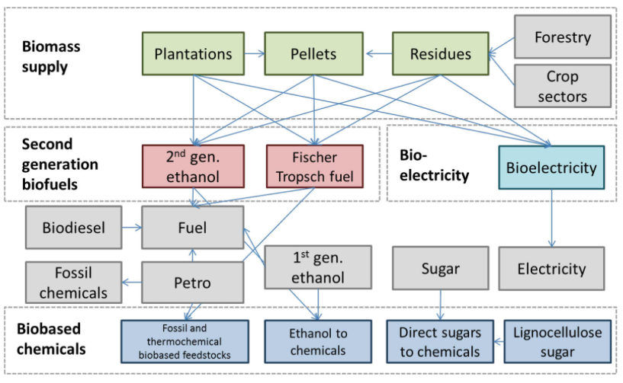
Figure 2 Overview of bio-based sectors and linkages in MAGNET
The MAGNET sector and data aggregation is presented in the Appendix (Table S 1).

Results

Macro-economic impact
Given the macroeconomic and policy assumptions the large-scale deployment of biomass might have a positive impact on the value added of the Dutch economy in the medium term (2030). Across all scenarios only RegLowTech still has a negative GDP effect of -€0.2bn in 2030 (Figure 3). Open markets and investments in technology development lead to a positive GDP effect of €0.8bn annually in 2030 (GlobHighTech scenario). High technology developments and global markets add up to €1bn to GDP on a yearly basis from 2030 onwards.

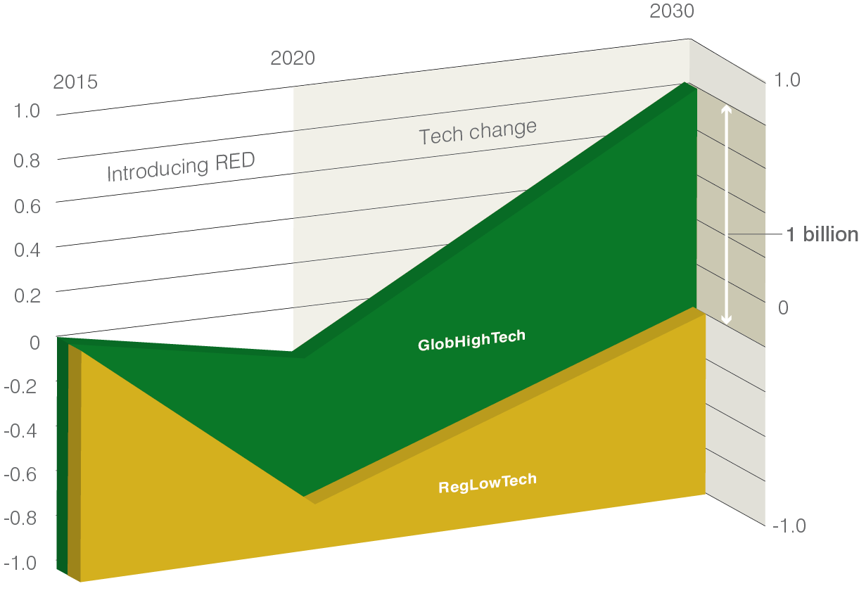
Figure 3 GDP impact of RegLowTech and GlobHightech scenarios relative to NoBioBased scenario (absolute difference, € billions)
In the 2015-2020 period, the main effect is the compliance with the renewable energy targets (RED) which leads to negative GDP effects in all scenarios in 2020 compared to a NoBioBased scenario as bioenergy technologies are not competitive to their fossil substitutes. The negative effect is stronger in the regional scenarios (-€0.8bn, see, ‘RED + Regional’ red arrow) than in the global scenarios (-€0.2bn, see ‘RED + Global’ blue arrow) as the EU cannot import (relatively cheap) biofuels from South and North America. The positive effect of technology advances becomes visible in the 2020-2030 period and is larger for HighTech (€1bn annually, see ‘High Tech’ blue arrow) than LowTech (€0.6bn annually, see ‘Low Tech’ red arrow) scenarios.

Figure 4 shows the value added of various bioeconomy sectors in the MEV II and the NoBioBased scenarios in The Netherlands in 2015 and 2030. The increase in value added of the selected bioeconomy sectors relative to the No-Biobased scenario is higher in the HighTech than LowTech scenarios with respectively about 740-760 million euro and 560-620 million euro.The emergence of the bioeconomy has a positive impact on value added of all bioeconomy sectors. Within the bioeconomy, agriculture is a key sector in terms of value added. Its value added decreases slightly (by -€160m) between 2015 and 2030 in the NoBioBased scenarios. In all four MEV II scenarios the agricultural value added in the Netherlands increases due to the emergence of a broader bioeconomy. The value added in the biochemical sectors due to new bulk biobased polymers increases by €130m in the LowTech scenarios and by €250m in the HighTech scenarios (compared to a NoBioBased scenario in 2030). Biofuel value added is modest (50 million euro) and more or less equal among the scenarios. In the regional LowTech scenario it is slightly higher (75 million euro). The bioenergy use is largely driven by policies and the value added is fairly constant across the scenarios. Relative to the NoBioBased scenario the value added of bioenergy is about €280m higher in 2030.

In the NoBiobased scenario the employment in agriculture, bioenergy and biochemical sectors is lower in 2030 than in 2015 due to a decline of employment in agriculture which is in compliance with the long-term trend. The increase of the bio-based economy only partially mitigates this effect. The highest employment impacts come from the production of bio-based chemicals in the case of the HighTech scenarios and to a smaller extent in the GlobLowTech scenario.

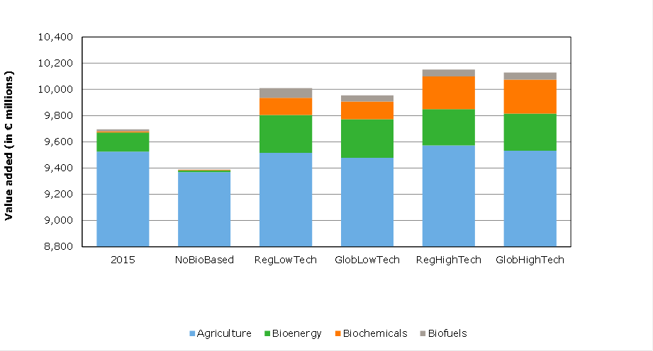
Figure 4 Value added for 2030 in different MEVII scenarios and reference (NoBiobased) in comparison with 2015

Biomass use in transport, electricity and chemical sectors

Figure 5 1st and 2nd generation biofuel shares in 2030
Figure 5 shows the impact on first and second generation biofuel shares in the Dutch economy in 2030. In the LowTech scenarios the biofuel shares are equal to the EU biofuel mandate. This implies that 7% first generation biofuels are obtained and 1.5% second generation biofuels. The latter counts double and the total adds up to 10% blending mandate in 2020 and 2030 as we assume in these scenarios that the mandate will be maintained until 2030. In the HighTech scenarios biofuels become competitive and the biofuel share increases to 11.5% in the regional scenario and due to cheaper feedstock prices to almost 14% in the global scenario.

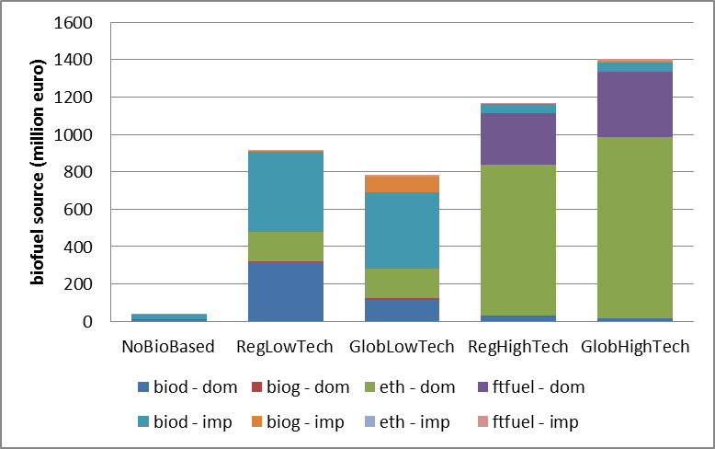
Figure 6 Biofuel composition by type and origin (2030, million euro) [Biod = biodiesel, biog = biogasoline, eth = cellulosic based ethanol, ftfuel = Fischer-Troph fuel Dom = domestic and imp = imported]
Figure 6 shows the biofuel composition in the Dutch economy in million euro in 2030. In LowTech scenarios first generation biofuels play an important role and are mostly imported. Next to imported biodiesel domestic produced biodiesel is important in the regional scenario. Biogasoline imports appear only in the global scenario as they mainly are imported from North and South America and these imports are not allowed in the regional scenario. The value of biofuels is higher in the regional LowTech scenario than in the global LowTech scenario as in the regional scenario relatively efficient and cheap biogasoline imports are blocked. In HighTech scenarios second generation biofuels (cellulosic based ethanol (eth), and Fischer-Troph fuels (ftfuel) are used that are mainly produced domestically. Second generation biofuels are domestically produced from domestically and imported biomass.

Figure 7 Electricity production by source in the Netherlands (2030)
Figure 7 shows the Electricity production by source in the Netherlands in 2030 (million euro). The energy mix is fairly constant across the scenarios as energy policies and technological change directly related to electricity production does not vary between energy technologies in the four scenarios. Fossil based electricity from coal and gas remain the main source for electricity. It is 75% in the no-biobased scenario and declines to 65% in the MEV II scenarios. Electricity from wind & solar is determined by the Dutch energy agreement and stable across all four scenarios. Bioelectricity is about 9% in all scenarios. The share is slightly lower in the high technology scenarios as more biomass is used for other applications (e.g. second generation biofuels). In the global scenarios electricity production from biomass is slightly higher than in regional scenarios as pellets are allowed to be imported from all over the world.

Figure 8 Production of biochemicals (2030 million euro)
Figure 8 shows the production of biobased chemicals and particularly new bulk biobased polymers in the Netherlands in 2030 (million euro). Technological change is key for biochemical developments. The expected high learning and\or technological change effects lead to strong increase in use of biobased chemicals especially in the high technology scenarios. The value of biobased chemicals is about 2 billion euro in the high technology scenarios and 700 million euro in the low technology scenarios. Key products are poly ethylene (PE) from second generation ethanol, PLA from lignocellulosic sugar and PLA from conventional sugar. PE obtains the highest value of 600 million euro in the LowTech scenarios and 1700 million euro in the HighTech scenarios. PLA appears sourced from both conventional sugar and lignocellulosic sugar, respectively 60 million euro and 200 million euro in the HighTech scenarios. The international dimension plays a more modest role as biomass for second generation technologies is available within Europe at reasonable prices according to the bottom up analyses. The international dimension creates additionally 30 million euro and 80 million euro in the low and high technology scenarios, respectively. Without tech change the production and use of biobased chemicals will be limited.

Comparison between the bottom-up and the top-down analyses
This section provides a general comparison between the outcomes of the bottom-up analyses and the top-down model. There are many differences between the two methodologies and despite these methodological differences the general trends are consistent between the models. Model outcomes are expected to be different as models follow different paradigms and techniques. A challenge for the model comparison is that the outcomes of MARKAL are in physical flows and those of MAGNET are in monetary terms, making direct comparison difficult. Nevertheless, we attempt to draw conclusions based on the overall picture the two models present.

End-use of biomass
This section describes the model comparison for respectively biofuel, electricity and chemical demand.

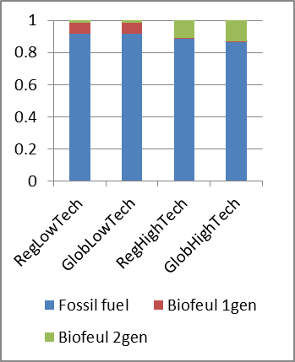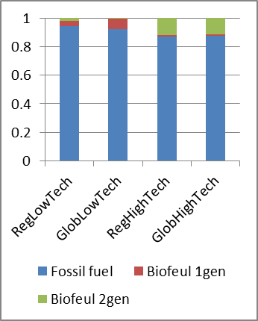
Figure 9 Transport fuel share of fossil and bio-based inputs in MAGNET (left-hand side) and MARKAL-NL-UU (right-hand side)
Figure 9 shows the transport fuel shares of fossil and bio-based inputs are consistent between MARKAL-NL-UU and MAGNET. Biofuel shares in both models are limited and primarily driven by the blending policy in the low technology scenarios. This implies that mandates of 10% are filled with 7% first-generation and 1.5% second-generation biofuels (the latter counts double for the mandate). Biofuel shares in both models are higher in HighTech scenarios as especially second-generation biofuels become competitive. In the global high technology scenario, the biofuel share in MARKAL becomes 12% and in MAGNET 13%. The main source in both models is second-generation biofuels (90-100%).

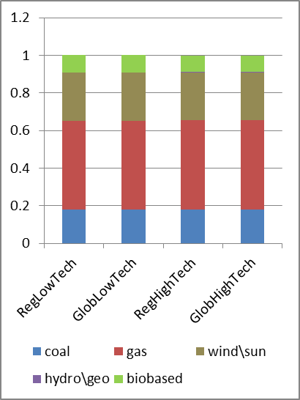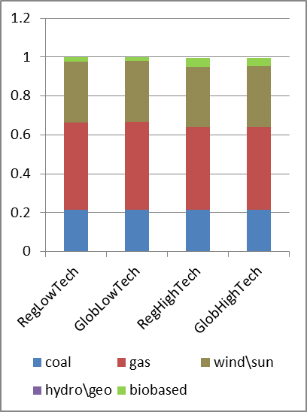
Figure 10 Electricity use in MAGNET (left-hand side) and MARKAL-NL-UU (right-hand side) (index number, Total RegLowTech =1, 2030)
Figure 10 shows the electricity use in the bottom-up and top-down modelling in 2030. Biomass use in electricity is limited across scenarios. In MAGNET, biomass use is slightly higher and constant across scenarios while for MARKAL biomass use is higher in the HighTech scenarios. Fossil energy shares are fairly equal between scenarios. Coal has a share of 20% and gas has a share of 45%. The renewable energy share is therefore also consistent between the models and equal to about 35%. For both models, wind is the key renewable energy source. In MARKAL-NL-UU, the share in electricity use in 2030 is 31% while it is 25.5% in MAGNET results. MAGNET uses relatively more biomass and less wind than MARKAL-NL-UU. This difference is caused by the assumptions regarding wind energy. If more wind energy is available, less biomass has to be used.

Figure 11 shows the bio-based and fossil use in the chemical sector in 2030 in the Netherlands. Both models have low or moderate shares of bio-based chemicals in total chemicals. In MAGNET, the share of traditional chemicals (e.g. rubber) is almost 5%, and new biochemicals (e.g. PE, PLA) contribute 1% in the LowTech and almost 4% in the HighTech scenarios. Both models show a higher increase in modern bio-based chemicals production in HighTech scenarios compared to LowTech scenarios. The bio-based chemical output in MARKAL is almost 1.8mt in the GlobHighTech scenario and the corresponding value in MAGNET is €2bn. This is consistent, given a price of €1,000 per tonne, which is plausible. The share of bio-based chemicals is lower in MARKAL-NL-UU than in MAGNET in the LowTech scenarios; this is due to the treatment of traditional bio-based chemicals (e.g. rubber) that are not modelled. Another methodological difference is that demand in MARKAL-NL-UU is fixed, and both higher technological change and a diverse technology portfolio lead to lower use of inputs. In MAGNET, demand is endogenous and technological change leads to an increase in the chemical sector and demand for inputs. Therefore, with higher technological change, the bars in the MAGNET figure increase (left, Figure 11) and the bars in the MARKAL-NL-UU figure decrease (right, Figure 11).

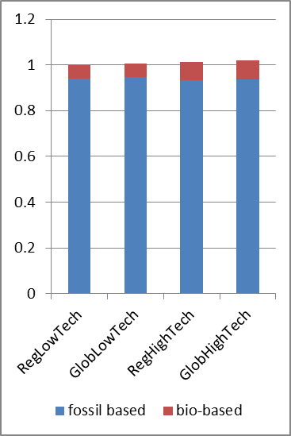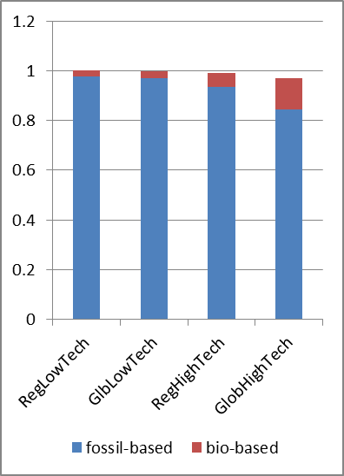
Figure 11 Bio-based and fossil input use in the chemical sector in MAGNET (left-hand side) and in MARKAL-NL-UU (right-hand side) (index Total RegLowTech =1, 2030)
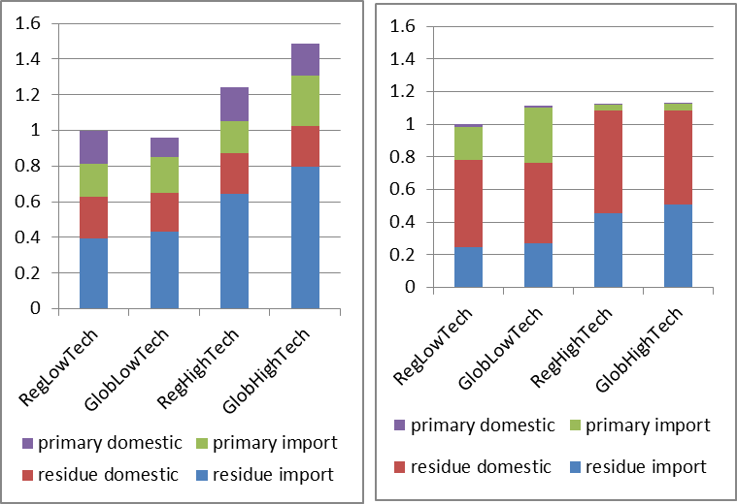
Figure 12 Biomass supply; Total level RegLowTech =1, 2030 (MARKAL-NL-UU left; MAGNET righ)
Figure 12 shows biomass supply in both models in 2030. The figures are more difficult to compare as there are differences in the biomass sources assumed in the two models, and MARKAL-NL-UU measures in PJ and MAGNET in €. Both models find that biomass use is highest in the HighTech scenarios. The increase in biomass use relative to the RegLowTech scenario in MARKAL-NL-UU (45%, physical terms) is higher than in MAGNET (13%, monetary terms). Both models find that domestic and imported residues are the largest source of biomass and that the share of domestic residues is fairly constant across scenarios, indicating that first domestic residues will be used in 2030 in the Netherlands. Residue imports increase in both models in the HighTech scenarios although the share is much higher in MARKAL-NL-UU than in MAGNET, possibly due to the higher disaggregation of feedstocks in the former model. Both models differ in the importance of primary domestic biomass. While it adds to 20% in MARKAL-UU-NL, it is minimal in MAGNET. In MAGNET, primary imports are important in the LowTech scenarios but almost disappear in the HighTech scenarios, while in MARKAL this level is fairly constant.

Discussion

Modelling scope
The temporal scope of this study (i.e., 2030) is justified to the extent that policy targets for the Netherlands and the EU are set up to 2020. Technology growth scenarios and biomass availability reflect the timeframe of the study. This offers some degree of certainty on the bioeconomy macro-economic impacts. However, a direct implication of the selected timeframe is that no insights are provided beyond 2030, which might underestimate the contribution and magnitude of biomass on the economy in the longer term. A larger temporal scope would increase the uncertainty as exogenous inputs (CO₂ tax, fossil fuel prices, policies) and scenario variables (technology growth and biomass availability) would not be as robust. Nonetheless, it can be argued that if high technology development and open trade pathways are continued beyond 2030 then the size of the bioeconomy would increase, thus calling for increased support at earlier years. The modelling framework presented in this allows the extension of the temporal scope in MAGNET. However, efforts would be required in assessing cost-structures, learning trajectories and defining scenarios of technologies that are currently very early at development stage (e.g., lignin valorization, amino-acids) but may become important beyond 2030.

Impact of policies
A significant advantage of the CGE model presented in this study is that it captures policy targets of bioeconomy sectors and can be used to assess their impacts on the total economy and other sectors. As prospective biomass conversion technologies on advanced biofuels and biochemicals are at an early stage of development to be cost-competitive with fossil alternatives, and the timeframe to achieve those targets is rather short, policy targets are a key driver of RES deployment.

On the one hand, this may create lock-ins in specific technologies (e.g., wind, biofuel conversion technologies, biochemicals) and on the other hand it does not lead to a clear demonstration of bioeconomy impacts at the macro-economic level. Therefore, direct or indirect impacts may be obscured or wrongly attributed to sectors. In addition, while policy targets to 2020 are agreed upon and there is a general consensus on the trajectory between 2020-2030 these are not mandate. These shortcomings may skew the assessment results presented in this study. To circumvent this, the sectors would need to be assessed under a level playing field basis, i.e., by removing sector-specific support, for example on wind electricity or the mandatory blending target which affects biofuels. Then a comparison with a scenario where no biomass is utilized can clearly show what can be expected by biomass conversion. Then a scenario with a baseline which does not include advanced bioeconomy sectors could shed light into the actual impacts of bioeconomy.

Another issue is that in CGE models policies are often implemented with their subsidy equivalent and not explicitly.

Land use change, feedstock supply potential and sustainability
The supply potential of domestic and EU biomass sources in this study was based on the IEE project Biomass Policies [25]. In that project, the supply potential and cost of forest, agriculture and waste biomass was determined to 2030 at the regional level (NUTS2). However, the supply of biomass is not fixed and can change substantially depending mainly on developments in agriculture management, crop choices, food demand and the political framework [47]. These parameters consequently will also have an impact on marco-economic effects and their distribution across bioeconomy sectors. A characteristic example is development assumptions on agricultural management.

In all scenarios assessed, imported solid biomass and liquid biofuels play a key role. However, the production of biomass, regardless of its end use (food, feed, materials, energy), is not always sustainable. Therefore, major efforts are required over the whole value chain to safeguard the sustainable supply of biomass. Key instruments include sustainability frameworks and certification. Although lifecycle GHG emissions from biomass supply and conversion are included, efforts to safeguard sustainability are not part of the modelling framework used in this study and are a key prerequisite in the roadmap towards a bio-based economy [42].

Sensitivity analysis parameters
The price of fossil fuels and CO₂ in the present study is based on the New Policies scenario of the International Energy Agency’s World Energy Outlook 2014. However, in the short term fossil fuel prices can fluctuate significantly as recent data show for 2015-2026. Furthermore, the CO₂ price does not reflect the levels required to achieve climate targets as estimated by the International Energy Agency. As fossil fuel and CO₂ prices are exogenous in MAGNET and at the same time they are key factors in determining the cost-competitiveness of renewable energy technologies compared to fossil fuel conversion technologies, further assessment of their impact is required. A local sensitivity analysis by varying fossil fuel and CO₂ prices while maintaining all other input parameters of the model constant could demonstrate their impact on bioeconomy, thus revealing threats or opportunities for design of bioeconomy strategies. This also entails, that the demonstrated results of the present study cannot be used for policy advice without analyzing the influence of the exogenous parameters.

Other macro-economic issues
Introducing new sectors to MAGNET can be considered a strength within the family of CGE models. However, since detailed technological developments are not taken into account and the level aggregation is still high it can also be considered as weakness, especially when compared to other model types. A main challenge is that CGEs are normally calibrated and use econometric estimates of elasticities based on historical data, which is not possible as the new bioeconomy developments started recently and there are no robust historic data on elasticities. In this study, we circumvented this by using cost-structures and learning rates from the bottom-up model. Elasticities were taken from existing products that are closely related substitutes.

To examine the complete economic picture, both the revenues from and costs of employing biomass products in different uses should be taken into account [13]. The potential revenues derived from adding millions of tonnes of biomass to the production system are relatively easy to calculate; however, the message on the cost side of the equation is more subtle. In the present study, we assumed that the production of bioethanol, biochemicals and bioelectricity substitutes the use of crude oil for gasoline and chemicals, while for bioelectricity, pellets substitute is production of electricity from coal, natural gas or other RES. The most important determinant of the macro-economic benefits of the bio-based products is the difference between the costs of the bio-based products and the price of the fossil resource-based substitute. When the bio-based alternative is cheaper than its fossil substitute, a positive impact on GDP can be expected, and vice versa, when the bio-based alternative is more expensive than its fossil substitute, a negative impact on GDP can be expected. Equilibrium models are designed precisely to model trade-offs such as the opportunity costs. By modelling an entire economy, the net benefits of a transition from a fossil resources-based economy to a bio-based economy can be determined. The GDP impact therefore depends very much on the rate of technological development and the biomass prices that influence the bio-based product and the relative price of the fossil resources-based substitute.

In the current situation, hardly any bio-based technologies are cost-competitive and can survive
without policies (see also section 5.2). Based on MARKAL-NL-UU outcomes technological change is expected to be limited in energy-related biomass technologies and therefore the impact on GDP is negative. The bottom-up studies conclude that technological change is expected to be high for second-generation biofuels and biochemicals (PLA, PE) and that they will be competitive with their fossil-based substitutes at the assumed oil price in 2030. These substitution effects will in general have a positive impact on GDP, and that is also what we see in this study. These effects are very dependent on the fossil prices and a sensitivity analysis is further required to demonstrate this.

In this study, the GDP effects are quite small. In general the GDP impact is ‘benefit over its substitute’ times the cost share in the economy. First of all, we took the opportunity costs into account, and this makes effects smaller. Secondly, the new sectors are very small and this makes it hard to get a big impact on the overall economy even if technologies are very cost-competitive. A third reason is related to the labour market. We effectively assumed that the participation rate of the workforce remains unchanged, which at the same time is theoretically consistent with a medium to longer term assumption of a fixed ‘natural rate of unemployment’. This assumption implies that there are no short-term unemployed people who will enter the labour market in the present. Reducing unemployment would have led to higher GDP effects as opportunity costs are zero. It is important to realize that behind this small GDP growth figure, a relatively large transition from fossil resources-based technologies to biomass-based resources takes place. This implies the largescale substitution of fossil fuels by bio-based alternatives in the petrol/biomass refinery, electricity and chemical industries, leading to all kinds of ‘bottlenecks’ as capital has to be attracted and built up, people have to be attracted and educated, infrastructure has to be built, export markets have to be developed, and technologies have to be invented and diffused within the sectors.

Conclusions
We extended an existing macro-economic model that is able to connect bioeconomy sectors with the rest of the economy that captures the competition with other sectors to fulfill consumer demand and with production factor markets. The model covers the complete value chain, from biomass to consumer goods, taking intermediate deliveries into account. As a global CGE model it ensures that incomes and expenditures are balanced and the Netherlands connected with other EU countries and the rest of the world via bilateral trade flows.

Summary of macro-economic outcomes
GDP effects
- The GDP effects can be positive or negative relative to a NoBioBased scenario. In the GlobHighTech scenario, a high speed of technological change and global open markets result in the highest GDP value. The RegLowTech scenario, which has low technological change and regional EU markets, results in the lowest GDP value in 2030. The GDP difference between the two scenarios is about €1,050m or 0.12% of GDP of the Netherlands.
- A €0.2bn negative GDP effect occurs in the regional LowTech scenario (compared to a NoBioBased scenario). This is the result of renewable energy policies that require the use of bio-based technologies that are not competitive.
- Higher technical change adds €350m to GDP when global biomass trade is assumed (difference between GlobHighTech and GlobLowTech) and about €750m if biomass is sourced from within the EU.
- The global dimension adds almost €700m to GDP in the LowTech situation (difference between GlobLowTech and RegLowTech) and almost €300m in the HighTech situation (difference between GlobHighTech and RegHighTech).
- Relative to the negative GDP effect in the RegLowTech scenario, opening up markets or investing in tech change induces a positive GDP effect; that is, the overall GDP effect becomes positive. Combining high technical change and open markets leads the highest positive GDP effect.

Added value
- The bioeconomy has a positive impact on the value added of the Dutch economy. Relative to a NoBioBased scenario, the bioeconomy sectors contribute €580m in the case of a LowTech scenario and almost €800m in the case of a HighTech scenario.
- Within the bioeconomy, agriculture is a key sector in terms of value added. The value added of agriculture decreases slightly (by €160m) between 2015 and 2030 in the NoBioBased scenarios. In all four MEV II scenarios the value added in the Netherlands increases due to the emergence of the broader bioeconomy. The increase in value added relative to the NoBioBased is higher in the HighTech than the LowTech scenarios by respectively about €200m and €120m. The opening up of trade has a very minor negative impact (€40m) on Dutch agricultural value added.
- The value added in the biochemical sectors increases by €130m in the LowTech scenarios and by €250m in the HighTech scenarios (compared to a NoBioBased scenario). Biofuels and bioenergy are largely driven by policies and value added is fairly constant across the scenarios. Relative to the NoBioBased scenario, the value added of bioenergy is about €280m.

Employment
- The decline in employment in agriculture between 2015 and 2030 also leads to a decline in
employment in the bioenergy & biochemical sectors. The bioeconomy only partially mitigates this effect, partly because we assume full employment in 2030 and thus the bioeconomy competes with other sectors for labour.
- The highest employment impacts come from the production of bio-based chemicals in the case of the HighTech scenarios and to a smaller extent in the GlobLowTech scenario.

Emerging sectors (biochemicals)
- The value of bio-based chemicals production is about €2bn in the high technology scenarios and €700m in the low technology scenarios.
- The production value of bio-based polyethylene is €600m in the LowTech scenarios and €1,7bn in the HighTech scenarios. The production of PLA from conventional sugar and lignocellulosic sugar increases to, respectively, €60m and €200m in the low and HighTech scenarios

Biomass trade
The total trade balance in the Netherlands deteriorates in bioeconomy scenarios. The positive impact of RED policies and technological change in chemical technologies on the energy and chemical trade balance is more than offset by increased biomass imports and especially an deterioration of the other industries and services trade balance. The latter deteriorates as resources are pulled away from these sectors to less competitive sectors. As technological change gets higher, the negative impact becomes smaller. Biomass (pellets, residues) and biofuels are imported to fulfil the RED mandates and primary agricultural exports decline. In the HighTech scenarios, the deterioration in the trade balance is less, as chemical and second-generation biofuel exports increase. In the LowTech scenario, fossil energy is substituted by first-generation biofuels, but as part of these are produced domestically the energy trade balance improves. In the HighTech scenario, substitution of fossil by bio-based substitutes occurs and also the second-generation and chemical markets grow, which implies less savings on fossil energy imports. However, this results in bio-based exports that substitute for fossil energy in other countries.

6.2. Further research
The MEV II study was designed on the basis of a midterm temporal scope (2030) and a large-scale deployment potential for biomass conversion technologies across different sectors. To a large extent, this defined the role that biomass might have as reflected by the study’s outcomes. In the discussion, the impact of this assumption on the core assumptions of this study, such as the selection of technologies, substitution possibilities and policy drivers. The time frame therefore cannot be extended simply by extrapolating from the outcomes of MEV II. We recommend further research to extend the temporal scope to e.g. 2050, whereby technological learning and economies of scale may reveal a larger role for biomass due to the improved cost competitiveness of technologies, improvements in biomass value chains, etc. Alternative renewable energy sources (wind, sun) and substitutes for materials should also be taken into account. By extending the temporal scope, it is also recommended to diversify and extend the technology portfolio covered by the study. This is particularly relevant for biomass conversion technologies to chemicals. Innovative production routes may have a significant impact (e.g. lignin valorization to high-value products). Finally, a study thatassesses a longer term can focus not only on the replacement of bulk fossil fuels but also on highvalue, low-volume products. Although such routes may not play a significant role in bridging emissionreduction gaps or in substituting large volumes of fossil fuel, they can have a large impact on the bioeconomy in terms of value added (e.g. specialty chemicals). Such a study would be more forward looking, and more bold assumptions would have to be made and the degree of uncertainty would be
larger. However, it might provide insights into which technologies require support now in order to stimulate their deployment in the future. It should include scaling-up, synergies with technologies that might improve their economics due to valorization of side-streams, and returns for the Dutch economy.

Appendix

Table S 1 MAGNET data aggregation
Sectoral disaggregation (63 commodities):
Primary agriculture (11 commodities): pdr (paddy rice); wheat (wht); other grains (grain); oilseeds (oils); raw sugar (sug); vegetables, fruits and nuts (hort); other crops (crops); cattle and sheep (cattle); pigs and milk (milk); crude vegetable oil (cvol) ;poultry (pigpoul); raw
Food and beverages (6 commodities): meat (cmt); meat product (omt) dairy (dairy); sugar processing (sugar); vegetable oils and fats (vol); other food and beverages (ofd);
Other ‘traditional’ bio-based activities (2 Commodities): fisheries (fish); forestry (frs);
Bio-mass supply (10 commodities): plantations (plan); residue processing (res); pellets (pel); agricultural residues (r_pdr, r_wht, r_grain, r_oils, r_crops, r_hort); forestry residues (r_frs);
Bio-based energy (9 commodities): first-generation biodiesel (biod); first-generation bioethanol (biog); bioelectricity (bioe); second-generation thermal technology biofuel (ft_fuel); second-generation biochemical technology biofuel (eth); biofuel feedstock grains (bf_g); biofuel feedstock molasses (bf_m); biofuel feedstock oils (bf_o); biofuel feedstock sugar (bf_s);
Bio-based chemicals (4 commodities): lignocellulose sugar (lsug); polylactic acid (pla); polyethylene (pe); mixed bio/fossil chemicals (f_chem);
Bio-based and non-bio-based animal feeds (4 commodities): bioethanol by-product distillers dried grains and solubles (ddgs); biodiesel by-product oilcake (oilcake); animal feed (feed);
Fertilizer (3 commodities): fertilizer nutrient nitrogen (fert_N), phosphorous (fert_P), potassium (fert_K);
Fossil fuels (5 commodities): crude oil (c_oil); petroleum (petro); gas (gas); gas distribution (gas_dist); coal (coa);
Electricity (6 commodities): electricity from gas (ely_g); electricity from coal (ely_c); electricity from nuclear (ely_n);
electricity from wind and solar (ely_w); electricity from hydro and thermal (ely_h); electricity transport (ely);
Other sectors (4 commodities): chemicals, rubber and plastics (chem); transport (trans); other industry (OthInd); services (serv);
Regional disaggregation (8 regions):
EU members (4 regions): Netherlands (NLD); Germany (DEU); Belgium (BEL); Rest Europe (REU);
Non-EU regions (4 regions): North America (NA); South and Central America (SCA); Africa (AF); Asia and Oceania (ASIA).

Table S 2 Exogenous inputs for MARKAL-NL-UU and MAGNET expressed in USD 2007
 |  | 2010 | 2020 | 2030 | Reference
Oil | $/GJ ($/bbl) | 12.9 (74) | 17.3 (100) | 19.1 (109) | [22]
Natural gas | $/GJ ($/MBtu) | 6.8 (7) | 9.4 (10) | 10.2 (11) | [22]
Coal | $/GJ ($/tonne) | 4.2 (94) | 4 (90) | 4.2 (96) | [22]
CO₂ | $/tonne |  | 20 | 33 | [22]

Not included are food processing, forestry and pulp and papers sectors

