Analysis of Paths of China’s Carbon Emission Peaking by 2030-based on SICGE model

(Cai Songfeng Li Jifeng Zhang Yaxiong State Information Center)
1. Introduction
China and US jointly issued the historic and landmark "Sino-US Joint Statement on Climate Change" in November 12, 2014, China intends to achieve the peaking of CO2 emissions around 2030 and to make best efforts to peak early and intends to increase the share of non-fossil fuels in primary energy consumption to around 20% by 2030.
To achieve this reduction targets, China is taking multiple measures to reduce emissions: on the one hand, on the basis of the existing seven regional carbon emissions trading system pilots, it is expected to build the national ETS in 2017; on the other hand, financial and environmental protection departments are preparing for carbon tax and resources tax; at the same time, we put forward ambitious "dual control" on total energy consumption and energy intensity, the target and quota system of renewable energy development and utilization and so on. All the policy objectives are consistent, but inevitably there are more and more cross between these policies. Our research focus on policies in different areas complements each other to reduce emissions and finding China's low-carbon development path to peak early.

2. Task Setting and Research Methods
In this research, we focus on studies of reasonable paths of carbon emission peaking in our country by 2030 from both technological and economic perspectives and hope to make suggestions on relevant energy conservation and emission reduction policies with the intention of realizing reasonable paths and under the goal-oriented principle.
In respect of research methods, we employ marginal abatement cost curve (MACC) model to estimate the technological path of carbon emission peaking by 2030 in the first place. The model covers a total of 95 emission reduction technologies in 12 industries and sectors: steel and iron, cement and other high energy-consuming industries, other non-high energy-consuming industries, power generation, heat supply and other energy supply sectors, agriculture, service industry, residential building, transportation, and other industries.
However, the MACC-based research is a comparative static research that makes a contrastive analysis of two states, so it cannot provide a dynamic path to reduce carbon emission over time. Therefore, based on this research, we use the Dynamic Computable General Equilibrium Model of National Information Center to further make studies on dynamic economic paths, compare one carbon price path scenario with another with the carbon price in the carbon market being core index reflecting cost of emission reduction, and analyze the economic efficiency and emission reduction effectiveness of different paths. At last, we also take into account both results of carbon price scenarios and technological paths worked out by means of MACC method, make a comprehensive assessment of carbon emission reduction paths and make corresponding policy suggestions on this basis.
3. The main findings and conclusions
3.1 The main conclusions of the MACC Curve
First, a carbon price will need to be as high as CNY130/ tCO2 to achieve the 1.7 billion tons carbon emissions reduction target. This requires implementing abatement measures across industry with advanced emissions reduction technology applied in not only the high emission sectors such as steel, cement, but also using alternative energy and energy efficiency measures in building, transport sector.
Second, it is estimated that currently over 0.3 billion tons emissions reduction actions are "no regret actions”. It means even without policy requirements, 0.3 billion tons emissions can be saved through energy efficiency technology adopted by the enterprises themselves, accounting for 15% of the total reduction in demand. These "no-regrets actions" will mainly come from technology advancement and deployment in the iron and steel, cement and building sectors, as well as from the enhanced transport fuel efficiency measures.

Figure 1: China's MAC curves by 2030
Third, the remaining emissions reduction target (about 1.4 billion tons) will be more expensive to achieve. The MAC analysis suggests that the main technical abatement potential can be found through the decarbonisaton of power generation, such as renewable energy, nuclear and natural gas. This can contribute to about 0.84 billion tons emissions reductions. In addition, we should continue to promote the iron and steel, building materials and energy-saving technological transformation of buildings.
Last but not least, the abatement cost of some technologies will be above CNY130/tCO2 as shown in Figure 1. These technologies are mainly the most advanced technologies in the power generation, iron and steel industry and building materials industry, such as carbon capture technology. These technologies will not be adopted unless the carbon price will be high enough to cover the investment cost. Given the carbon price can’t reach that high or unaccepted, efforts in short term should be made on technology R&D in selected sectors, testing in demonstration project or companies rather than deployment in large scale.

(2) CGE model-based research and main conclusions
In accordance with nationally unified arrangements, China plans to open up nationwide carbon market in 2017; in this research, we use CGE model to simulate emission reduction effects and economic impacts of different carbon prices after the carbon market is opened up. To this end, three carbon price scenarios are designed: (1) high carbon price scenario. It is assumed that from 2017 to 2030, the carbon price in China’s carbon market will always be controlled at about the high level of 130 yuan/ton. The scenario can be considered as the harshest scenario required by peaking. (2) Medium carbon price scenario. It is assumed that the carbon price in the market will rise gradually from 50 yuan/ton in 2017 to 130 yuan/ton in 2022 and will remain at the latter ever since. The scenario reflects that China will accelerate the development of carbon market and give play to its leading role as the primary emission reduction policy and tool. (3) Low carbon price scenario. It is assumed that the carbon price in the market will be maintained at 50 yuan/ton during 2017-2022 and then rise gradually to the target level of 130 yuan/ton by 2030. The scenario stimulates the traditional development path of carbon market, where the first five years can be considered as a transitional period similar to the first stage of EU-ETS.
The comparison of the three scenarios leads to the following conclusions:
Firstly, carbon price in the carbon market is an effective policy variable which influences the carbon emission path. Supposing the carbon price in the market under all of the three policy scenarios in this research reaches 130 yuan/ton of carbon dioxide by 2030, emission reduction effects in 2030 estimated with the CGE model will be similar. However, from 2017 to 2030, due to the difference of carbon price trends, emission path will vary greatly from one scenario to another.
In 2017, a significant reduction of carbon emission will occur in all of the three scenarios because of the opening of the carbon market. In the low carbon price scenario, however, if carbon price remains at a low level for a long time, emission reduction effects of the carbon market might attenuate quickly, with the decrease in carbon emission shrinking at a faster rate than in the baseline scenario, and will not gradually appear until carbon price begins to rise five years later. In this scenario, carbon emission will peak before 2030 at 11.4 billion tons and then gradually decrease to around 11 billion tons by 2030. With respect to peaking time, carbon emission will peak at the same year when carbon price begins to rise, which is assumed here to be the year of 2022.
In the medium carbon price policy scenario, though carbon price in 2017 will also be 50 yuan/ton, it gradually rises every year later on, which strengthens the market efforts for emission reduction to some extent, so carbon emission will increase slowly and maintain a modest increase even after carbon price will be stabilized in 2022. Although carbon emission will peak around 2030 in this scenario, it will be lower than the peak value during 2017-2030.
In the high carbon price policy scenario, as carbon price will be maintained at 130 yuan/ton of carbon dioxide since 2017, deep emission reduction will have been achieved since then and carbon emission will increase gradually later, but will also begin to peak in 2028 and remain at approximately 11 billion tons.
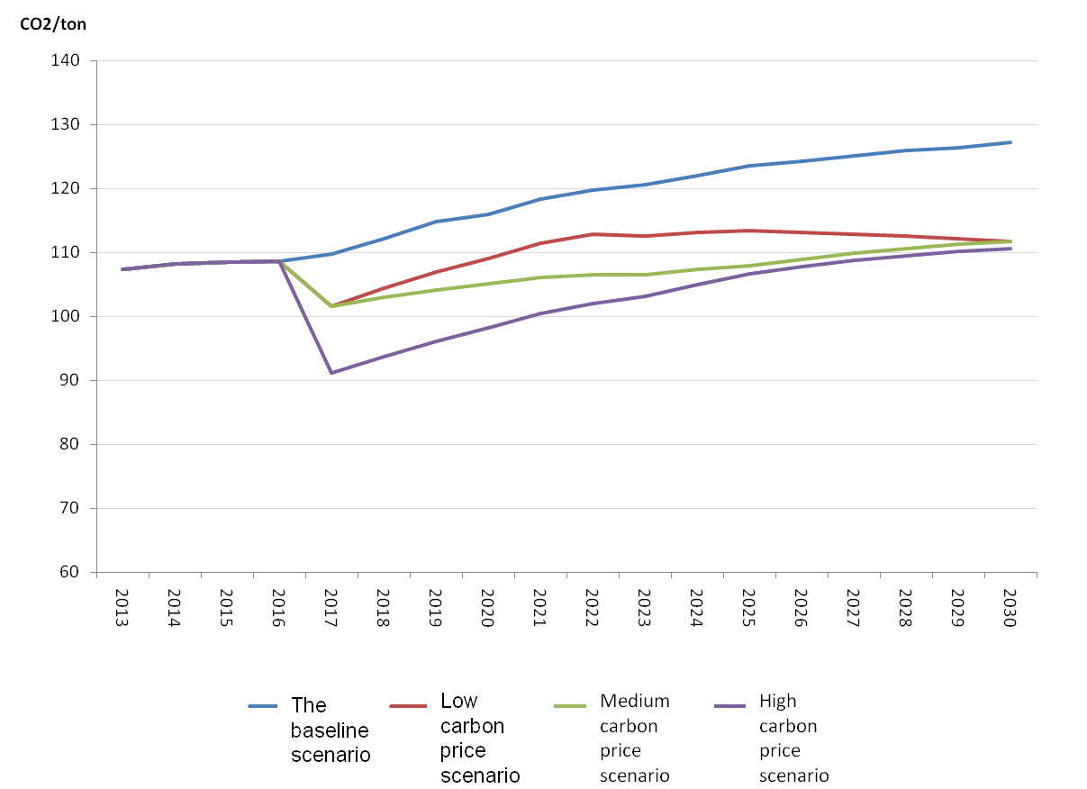

Fig.3 Comparison of Carbon Emission Paths in the Three Scenarios
Secondly, difference of carbon price trends has little effect on the economic cost of unit emission reduction.
Dynamic losses of GDP in the three scenarios relative to the baseline scenario are shown in Fig.4 below, and carbon price is obviously positively correlated to GDP loss. If GDP losses during 2017-2030 relative to the baseline scenario are aggregated, the aggregated losses in the low carbon price scenario are about 4 trillion yuan (the price in 2010) while the losses in the medium and high carbon price scenarios are 5.6 and 7.4 trillion yuan respectively (the price in 2010). But in view of cumulative emission reductions during 2017-2030 reaching 15.8, 20.5 and 26 billion tons of carbon dioxide respectively in the three scenarios, GDP losses corresponding to unit emission reduction are 256, 275 and 281 yuan/ton respectively. Consequently, in general, corresponding comprehensive economic losses of unit emission reduction in the three scenarios differ slightly from each other and the low carbon price scenario where carbon price rises at a later time shows relatively better economic efficiency.
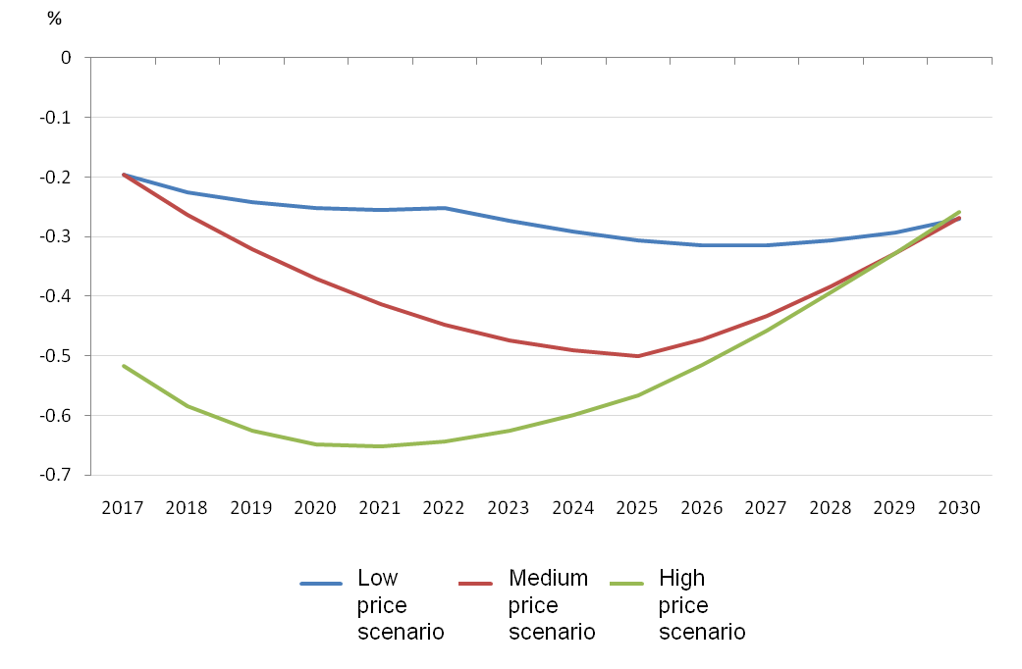

Fig.4 Influencing Paths of Carbon Price in the Three Scenarios on GDP
Thirdly, effects of carbon price trends on employment demand vary greatly from one another. The employment demand in the high carbon price scenario is 5 million people per year less than in the baseline scenario and then will return to the baseline level with restructuring and decline in real wages. In the medium carbon price scenario, the impact on employment demand will undergo a U-shaped trend, which will increase first and then decrease, with the absolute quantity of employment demand loss gradually increasing from 2.20 million to 3.40 million people per year and then gradually decreasing to 650,000 people per year by 2030. In the low carbon price scenario, the impact on employment is relatively mild and steady, which remains at one to two million people per year. With a view to the fact that maintaining stable employment is an important goal of the current macro-economic adjustment, the sharp decrease of employment demand in the high carbon price scenario is hard to swallow during the 13th Five-Year Plan period, so it is difficult for China to take the high carbon price scenario.
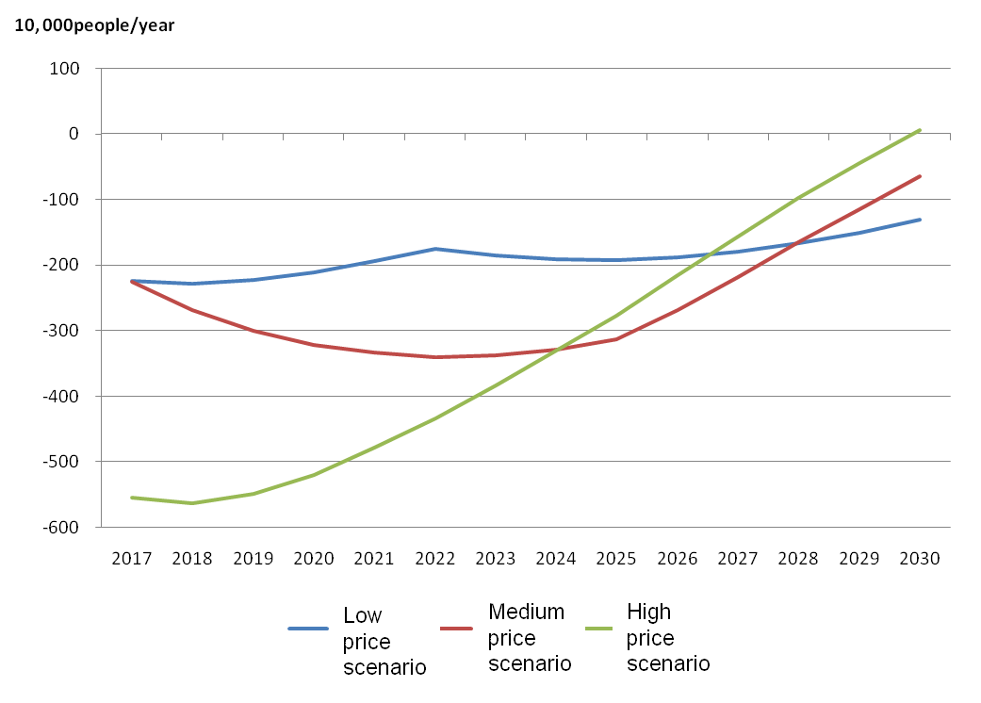

Fig.5 Impact of Carbon Price in the Three Scenarios on Employment

(3) Scenario comparative analysis based on both economic and technological impacts
The conclusion simply based on the CGE model does not take into account the advancement of emission reduction technologies in different carbon price tracks or potential of technological emission reduction in different carbon price paths. Therefore, we make analyses by combining technological combination results for carbon emission peaking by 2030 worked out through the MACC curve with carbon price tracks, as shown in Fig.6.
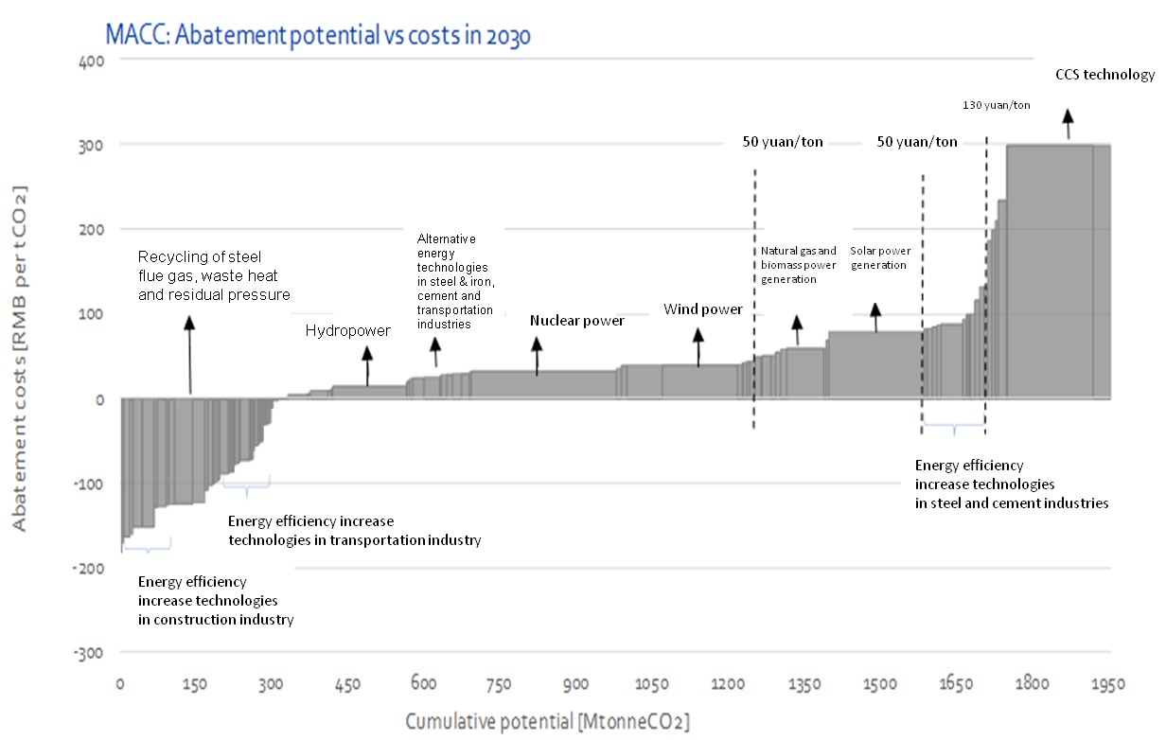
Fig.6 Combinations of Emission Reduction Technologies Based on MAC Curve at Different Carbon Price Levels
In the low carbon price scenario, as the carbon price will remain at 50 yuan/ton of carbon dioxide before 2022, the number of technologies that can be adopted is limited, especially solar and natural gas power generation technologies to be vigorously developed during the 13th Five-Year Plan period are excluded due to their costs. It should also be noted that though the MACC curve indicates a technological potential of emission reduction at negative cost being nearly 300 million tons, these technologies are not used in practice, which means introduction of these technologies has the barrier or obstacle of not being quantified to cost, while the cost is estimated to be around 100 yuan/ton. Thus, the carbon price of 50 yuan/ton is insufficient to attract these technologies. Besides, though hydropower, wind power and nuclear power are included as main emission reduction technologies, in consideration of the increasingly serious waste wind and water in recent years in China, if system reform is not well fulfilled in the energy field, the real emission reduction potential of these technologies might be reduced. Hence, though the low carbon price scenario has the best effects from the economic perspective, it is not ideal in terms of the effect of promoting emission reduction technologies.
In contrast, low-carbon technologies will be provided with sufficient incentives from the very beginning in the high carbon price scenario, so the scenario is the best for introduction of low-carbon technologies. In the medium carbon price scenario, though the carbon price will be not very high in 2017, it can reach 80 yuan/ton of carbon dioxide in 2020, i.e., the end of the 13th Five-Year Plan period, providing the popularization of solar photovoltaic power generation and natural gas power generation technologies with effective incentives via the carbon market alone. As a consequence, from the perspective of stimulating technological emission reduction, medium to high carbon price setting is of vital importance.
We make a comprehensive assessment of the three scenarios in four aspects such as emission reduction effects, economic efficiency of emission reduction, impact of emission reduction on employment and potential of technological emission reduction during the 13th Five-Year Plan period. Though we cannot screen out the best carbon price path based on this, the best path should be determined in the following three principles: 1) emission reduction should be economical and effective; 2) the impact on employment should be less than the economic affordability; 3) efforts should be made to stimulate investment in emission reduction technologies in advance and reduce the lock-in effect of investment on carbon emission.
IV. Policy Suggestions on Coordinated Development of Carbon Market Construction and Electricity Market Reform
Existing analyses indicate that to achieve the goal of carbon emission peaking by 2030, we should steadily promote carbon market construction on the one hand to render it to effectively play the role as a market-oriented emission reduction mechanism and increase economic efficiency of emission reduction; however, in view of employment shock, carbon price will not be too high in the short run, so various other policies are required to boost early application of low-carbon technologies. To effectively facilitate the connection and complementation of China’s energy polices and emission reduction policies during the 13th Five-Year Plan period and in a longer period of time is the important guiding ideology and a guide to action for China to comprehensively increase the efficiency and effects of implementing the two categories of policies and substantially advance national low-carbon and cyclic development. The research focuses policies on power industry. The following countermeasures and suggestions are proposed in combination with relevant policies and experience in Europe and America:

(1) When establishing national carbon market and determining quota allocation rules, it is required to effectively connect them with China’s electricity system
By reference to European experience in EU-ETS, easy terms might apply to quota allocation when national carbon market is established and free allocation might be adopted, which is somewhat reasonable from the perspective of cyclic construction of the carbon market itself. However, if it is true, efforts should be made to prevent the negative effect of conflicting with the current public, fair and impartial scheduling mechanism in China’s electrical power system, i.e., too low carbon price influences the process of accelerating inefficient and highly polluting coal power units required by deepening of electric power system reform. To this end, it is recommended that competent authorities concerned should strengthen communication and coordination in advance to form the effect resultant and efficiency of the optimally combined policies when determining energy conservation and emission reduction goals and its total amount and intensity index system, ascertaining carbon market quotas and mode of allocation, promoting optimized layout of power enterprises, pricing mechanism and demand side management, and advancing major policy issues such as development and distributed intelligent utilization of renewable energy resources.

(2) When consummating electricity pricing mechanism, it is required to link it with carbon pricing mechanism
After national carbon market system takes shape, power industry, as the main carbon emission industry, should become the main force accessing to the carbon market. Research on the development of European carbon market shows that carbon cost of power enterprises engaged in carbon trading will pass to downstream industries through electricity price. At present, to deepen the electricity market reform, China also focuses on introducing trading mechanism of the electricity market to create spot price and then try to relax its previous regulation on electricity price, that is, to increase the elasticity of electricity pricing mechanism, which is a big step forward from the perspective of seeking dynamic balance between supply and demand through electric power system reform. However, in view of the law that carbon cost in the carbon market will pass to downstream enterprises (including final consumers), carbon cost should also be considered on the premise of seeking elasticity of electricity pricing mechanism. For example, it is understood that government departments have set the price cap according to regulations on pilot power reform in places like Yunnan, thus influencing the elasticity of concurrent carbon cost change of power enterprises in the carbon market. If the electricity price cap is determined after electric power system reform is implemented nationwide during the 13th Five-Year Plan period, the normal elasticity of carbon cost change in national carbon market transactions will naturally be influenced. Therefore, it is recommended that in the process of comprehensive promotion of power reform, especially to determine the electricity price cap, it is required to link it with the carbon pricing mechanism in national carbon market transactions, so as to prevent setting of electricity price cap from influencing carbon cost change elasticity and the normal conducting effect.

(3) Market means in the carbon market should be made full use of to promote the solution of emission lock-in of coal power units
Since 2005, China has constructed a large number of large-scale coal power units, which will be able to serve until 2030 and even 2050 as indicated by their normal service life. This might have a certain lock-in effect on carbon emission in electric power industry in the future. By reference to English practice, carbon cost in the carbon market can be utilized to introduce the scheduling configuration mechanism of coal power units to achieve replacement of inefficient units with efficient ones in respect of generating capacity and minimize the lock-in effect on carbon emission.

