Prepared for the Nineteenth Annual Conference on Global Economic Analysis,
Washington, DC, June 15-17, 2016.

Modeling the Economy-Wide Costs of Non-Price Based Environmental Policies in an Applied General Equilibrium Framework

Richard Garbaccio, Alex L. Marten, and Ann Wolverton, et al.

National Center for Environmental Economics
U.S. Environmental Protection Agency
1200 Pennsylvania Avenue, N.W. (MC 1809T)
Washington, D.C. 20460

June 15, 2016

ABSTRACT

The social cost of air regulations has been measured using many different types of models. In this paper, we explore the use of computable general equilibrium (CGE) models to measure the social cost of policies that seek to reduce pollution emissions and improve air quality. A key focus of this exercise is providing insight into the additional information that may (or may not) be gleaned from a general equilibrium approach in practice, relative to partial equilibrium and engineering approaches, given the complex and non-price nature of most air regulations. Specifically, we explore the sensitivity of social cost estimates to key information limitations, regulatory design variations, and CGE model attributes using a detailed CGE model of the United States. Air regulations are often complex and vary widely with respect to the types of pollution addressed, sectoral and geographic scope, regulatory design, stringency, types of benefits and costs, and other dimensions. A number of these regulatory attributes are likely to influence the estimates of social cost. We provide qualitative and quantitative assessments of how these additional complexities can be introduced into a CGE model and in which cases they may impact ex ante social cost estimates to the point where practitioners should pay particular attention in applied analyses.

The views expressed in this paper are those of the authors and should not be interpreted as representing those of the U.S. Environmental Protection Agency.

Introduction
Identifying the most appropriate modeling tools for analyzing social cost depends on the regulation’s details, as highlighted in the previous two sections of the paper; data requirements; model availability; and constraints on time and budget. The EPA’s Economic Guidelines also identify several technical factors to consider in model selection, including: “the types of costs being investigated, the geographic and sectoral scope of the likely impacts, and the expected magnitude of the impacts” (U.S. EPA 2010a).
Since air regulations are complex and vary widely (e.g., magnitude of compliance costs, sectors being regulated, what effects can be quantified), it is likely that the modeling tools deemed most appropriate for cost estimation will be regulation-specific. For some regulations, an engineering or partial equilibrium approach may be adequate to capture the expected social cost. For other regulations, compliance costs or partial equilibrium welfare measures may be inadequate measures of overall social cost. In these cases, a general equilibrium approach may add value over an engineering or partial equilibrium approach.
This section considers the sensitivity of social cost estimation in a CGE framework to a number of issues associated with regulatory attributes as highlighted in Section 3. In particular, each factor is discussed with regard to how it may affect the technical merits of using a CGE model for estimating the social cost of a regulation. The intention of this section is not to review/critique past modeling approaches used by the EPA or outside groups but rather to set the stage for a broader discussion of these issues as laid out in the charge. The specific factors are:
  - Magnitude of expected compliance costs.
  - Time horizon for implementation.
  - How compliance costs are entered into a CGE model,
  - Number and types of sector(s) directly and/or indirectly affected, and magnitude of potential market effects, and
  - Degree of expected technological change
Discussion of the sensitivity of social cost to these factors has been gathered from the existing literature, though few papers look specifically at the effects of regulation; the EPA’s experience using CGE models to analyze regulations; and results from a limited set of illustrative runs using the static version of the EMPAX-CGE model, also referred to as EMPAX-S.

Magnitude of Compliance Costs
CGE models are recognized as being “best suited for estimating the cost of policies that have large economy-wide impacts, especially when indirect and interaction effects are expected to be significant” (U.S. EPA, 2010a). For instance, the EPA’s study of the prospective effects of the Clean Air Act Amendments from 1990 to 2020 (U.S. EPA, 2011a) found that there are substantial secondary effects of compliance costs on the overall economy, a large portion of which likely result from energy price increases and the diversion of capital from activities that enhance long-term productivity to investment in pollution control equipment in the industrial sector. The EPA’s Economic Guidelines also recognizes that CGE models “are generally not well suited for estimating the effects of policies that will affect only small sectors or will impact a limited geographic area” (U.S. EPA, 2010a). However, what constitutes a large (versus a smaller sector/region specific) impact that may merit use of a CGE (versus a partial equilibrium) approach is not well defined in the literature.
The EPA’s air regulations range widely with regard to magnitude of aggregate compliance costs. We distinguish between four compliance cost bins based on the estimated annual costs of air regulations promulgated between 2003 and 2013 (as reported in OMB 2014 (in 2001$)):
• $100 million – this is the threshold at which Executive Order 12866 requires BCA,
• $0.5 billion – many air regulations had compliance costs near this amount during the time period
• $3 billion – many air regulations had compliance costs in the $1 - $3 billion range during the time period
• $10 billion – no air regulation had higher compliance costs than $10 billion during the time period
To better understand how the magnitude of compliance cost is reflected in economy-wide social cost estimation, we used the EMPAX- S CGE model to conduct a set of simulations. For each of the 25 manufacturing sectors in the model, we entered each of the four compliance cost amounts listed above and calculated the equivalent variation (EV) – for a total of 100 simulations.
Figure 2 shows the range (horizontal gray bar) and average (vertical black bar) of the EV calculated for the 25 sectors for each of the four compliance cost amounts. The range of estimates is wide and expands in both relative and absolute terms as compliance costs increase. The average tends toward the lower end of the range. In the case of the set of $10 billion compliance cost simulations, in a number of simulations EV is smaller than the compliance cost. All of these occurrences are for sectors where base year total production costs are in the $20-30 billion range. We include these sectors for illustrative purposes but to avoid the extreme values problem, we next perform simulations where compliance costs are set at a percentage of base year total production costs.

Figure2: EV: Range and average for 25 manufacturing sectors
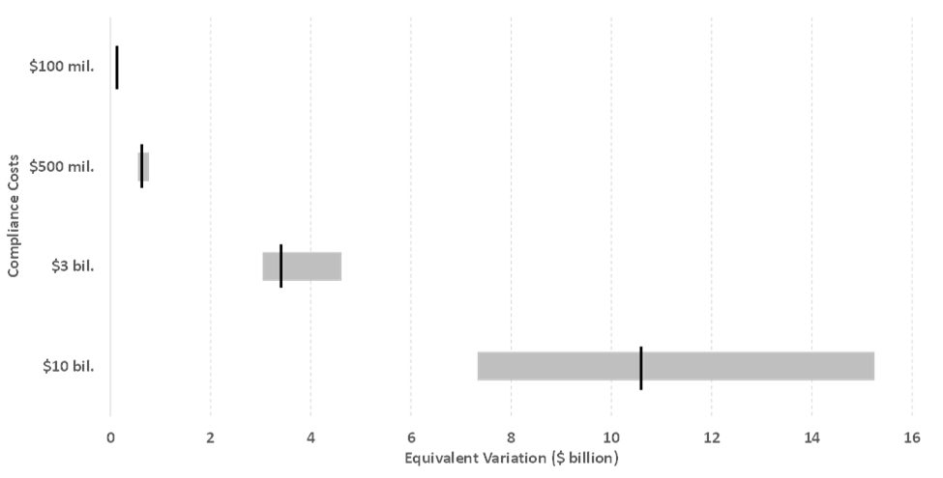

Figure 3 shows the range and average of the percentage difference between EV and compliance costs, where compliance costs are entered as 1, 2, 3, and 4 percent of base year production costs. Although the averages tend toward the lower end of the ranges, the ranges themselves are quite wide. For the 1 percent compliance cost case, the range extends from 9 percent to 54 percent. As compliance costs increase, the upper end of the range decreases slightly while the lower expands enough that the overall range is greater. The average difference between EV and compliance cost decreases slightly from 17 percent to 15 percent as compliance costs increase from 1 percent to 4 percent of base year production costs. While these simulations use a single static model only, they demonstrate that differences between partial and general equilibrium estimates of cost can vary greatly by sector and simple a priori generalizations should be avoided.

Figure 3: Percent EV differs from compliance cost: Range and average for 25 manufacturing sectors
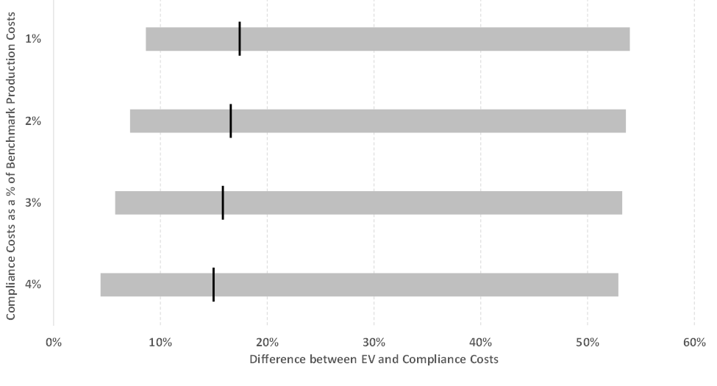

Time Horizon
Often the EPA estimates the social cost of a regulation at a given (future) point in time. Such estimates provide snapshots of the expected costs for firms, government, and households but do not allow for behavioral changes from one time period to affect responses in another time period. However, effects over time may be important when investment in capital to comply with the regulation in one period affects investment decisions in future periods. Pizer and Kopp (2005) note that static productivity losses from environmental regulations are amplified over time due to their effect on capital accumulation (a lower capital stock over time reduces economic output and therefore welfare). A static model would miss this effect. Pizer and Kopp (2005) state that the “additional cost of this accumulation effect on welfare can be as much as 40 percent above the static cost that ignores changes in capital stock.” Hazilla and Kopp (1990) and Jorgenson and Wilcoxen (1990) have also shown that this effect is potentially significant. It is important to note, however, that this conclusion is based on studies of large-scale changes in environmental regulation (i.e., Hazilla and Kopp, and Jorgenson and Wilcoxen examine the combined welfare effects of the 1972 Clean Water and 1977 Clean Air Acts).
In addition to capital-induced growth effects, the evaluation of social cost in a dynamic framework may be important when a regulation is expected to affect product quality, productivity, innovation, and changes in markets indirectly affected by the regulation in a way that impacts consumer and producer surplus over time (U.S. EPA, 2010a).
The time interpretation of a CGE model depends on whether the model is static (one period) or dynamic (multiple periods). Static models produce a single-period representation of how the economy responds to a policy shock. Dynamic CGE models are long-run models, often calibrated to a starting year, that produce estimates for a set of future years relative to a projected baseline. The EPA’s Economic Guidelines advises that if the intertemporal effects of a regulation on non-regulated sectors are expected to be significant, a dynamic CGE model may yield useful insights. That said, the evolution of variables in the model sometimes depends on exogenously imposed assumptions. For instance, modelers sometimes need to constrain the pace at which some variables in the model change (e.g., how quickly technology changes) based on an external assessment of what is technically feasible. Static and dynamic models are discussed in more detail in section 5.2. The representation of technological change is discussed in sections 4.4 and 5.6 of this paper.
Regulatory Representation and Timing
Another important time-related issue is how far out into the future a CGE model produces estimates. The EPA’s Economic Guidelines states that, “generally, the duration of important effects of a policy determines the period chosen for the analysis and baseline.” Since a static CGE model can only produce a snapshot of the social cost of a regulation for a given year (e.g., 2020) it may or may not be representative of the policy’s effects. Even when an analyst determines that it is important to estimate the social cost of regulation over a longer period of time, a dynamic CGE model may stop short of the end-year for capturing important regulatory effects, in which case social cost estimates might be biased downward. When compliance costs are not available for all future years, a forward-looking CGE model has a greater ability to smooth costs over time. However, this may mask the full economic impact of a policy. To ensure that the model does not underestimate costs when policy costs persist into the future, one may need to extrapolate costs to the end of the CGE model horizon.
In dynamic models, time steps between periods are chosen to provide enough detail to show the adjustment to policy over time, while using a manageable number of time periods for computational reasons. Because dynamic CGE models are often solved over periods of 50 years or more, it is not always practical to solve each individual year. A five-year time step is used in models such as the dynamic version of EMPAX-CGE (also referred to as EMPAX-D) and EPPA. In recursive models, time steps represent shocks that move the baseline economy from one period to the next. The Global Trade Analysis Project (GTAP)-Dyn model describes shocks to the time variable, t, as defining the model period, and “shocks to other exogenous variables represent accompanying changes in external circumstances” (Ianchovichina and McDougall, 2000). This implies that, when using a dynamic CGE model, the year in which a regulation comes into effect may not be explicitly modeled. Due to the expense and time requirements to adjust the baseline, adding a new solution year may not be an option. For MATS, the EPA used 2015 as a proxy for the year in which compliance with the regulation begins (i.e., 2016). Regulations that are introduced gradually or vary timing of compliance by region or state pose additional challenges for model representation.

How Compliance Costs Are Entered into the Model
We previously noted that the imposition of a regulation in a CGE model is frequently modeled as a “productivity shock,” in which complying with the regulation creates a need for additional inputs in addition to those already used to produce the good or service of the regulated sector. The total cost of these additional inputs may be derived from detailed estimates of compliance costs from an engineering or partial equilibrium model. This, however, begs the question of how to allocate estimated total abatement cost among inputs specified in the CGE model.

As detailed information about the composition of abatement costs and/or how to map them into inputs in a CGE model is often lacking, one frequently used approach is to allocate the abatement costs in direct proportion to the inputs – capital, labor, and intermediate goods – used in the regulated sector of the CGE model. In other words, regulatory requirements do not change the proportion of labor, capital, or other inputs in the firm’s production function. This “Hicks-neutral” allocation is the approach taken by Hazilla and Kopp (1990) and Jorgenson and Wilcoxen (1990). Ballard and Medema (1993) allocate all of the abatement costs to capital and labor inputs only.

Using a CGE model of the German economy with a separately defined sector for pollution control based on detailed abatement cost data, Nestor and Pasurka (1995a, 1995b) compare the impacts of abatement costs allocated across inputs consistent with the German data with impacts simulated using Hicks-neutral and capital-labor only abatement cost allocations. They find that there are significant differences in sectoral impacts between the simulations using the German data for the cost allocation and those using the more ad hoc allocations. In particular, relative to the data-driven specification, the Hicks neutral cost allocation approach tends to underestimate output changes because it allocates a smaller proportion of abatement expenditures to labor and capital than occurs in reality. In contrast, the capital-labor only abatement cost allocation approach tends to overestimate output changes because it assumes abatement processes do not rely on intermediate inputs; thus, it fails to account for offsetting indirect effects.

Nestor and Pasurka (1995b) focus on sectoral impacts in their comparison of the allocation of abatement costs in CGE models instead of how the allocation of abatement costs may affect economy wide measures. To do so, as in section 4.1 where we looked at the effect of the magnitude of compliance costs on economy wide impacts, we perform a set of simulations using the EMPAX- S static CGE model. As a bounding exercise, in succession for each of the 25 manufacturing sectors in the model, we allocate $1 billion of compliance costs to (i) capital only, (ii) labor only, and (iii) intermediates only. We also allocate the $1 billion of compliance costs according to Hicks-neutral shares.

Figure 4 shows the range (horizontal gray bar) and average (vertical black bar) of the EV calculated for the 25 sectors for each of the four cost allocations. The differences are quite large. For the capital-only allocation, the range of EVs calculated with the model extends from 50 percent greater than the compliance costs, to almost 100%. The average for the 25 sectors is 60 percent. For the intermediates-only allocation, on the other hand, the range goes from 2 percent less than the $1 billion in compliance costs to 16 percent more, with an average of 2 percent. The range for the labor-only cost allocation is narrower than for the capital-only allocation and the average is lower at 38 percent. The average for the Hicks-neutral allocation is 17 percent, lying between the factor-only and intermediate-only allocations, as the Hicks-neutral shares include both types of inputs.

Figure 4: EV with $1 billion in compliance costs for 25 manufacturing sectors: Range and average
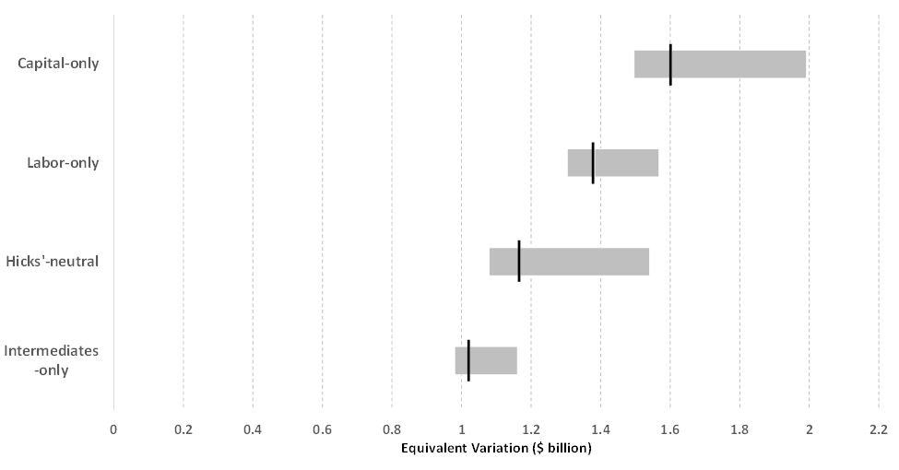

As demonstrated by Fullerton and Heutel (2010), non-revenue raising environmental regulations can have significant effects on factor prices and in turn on real incomes. In our simulations, a productivity shock, regardless of the cost allocation, lowers factor prices. Productivity shocks with capital-only and labor-only allocations have a greater combined effect on factor prices than is the case with the intermediate-only allocation as the factor-only shocks place a greater overall burden on the factors. In the EMPAX-S static CGE model, capital is able to move between sectors, but the total stock is fixed. Labor supply, however, responds to changes in both the wage rate and non-labor income (e.g. through changes in a representative agent’s income from ownership of the capital stock). In our simulations of the capital-only allocation, labor supply falls, increasing the impact of the productivity shock. With all of the other allocations, however, labor supply increases, reducing the impact of the shock. We can see this in Figure 5, where we have run the same simulations but with a fixed labor supply. The average for the capital-only allocation is now lower, while for all of the other allocations, the average is greater. Without the impact of the change in labor supply, the averages for the capital-only and labor-only allocations are almost identical (although the range is still wider for the capital-only allocation).

Figure 5: EV with $1 billion in compliance costs for 25 manufacturing sectors: Range and average
(Labor supply fixed)
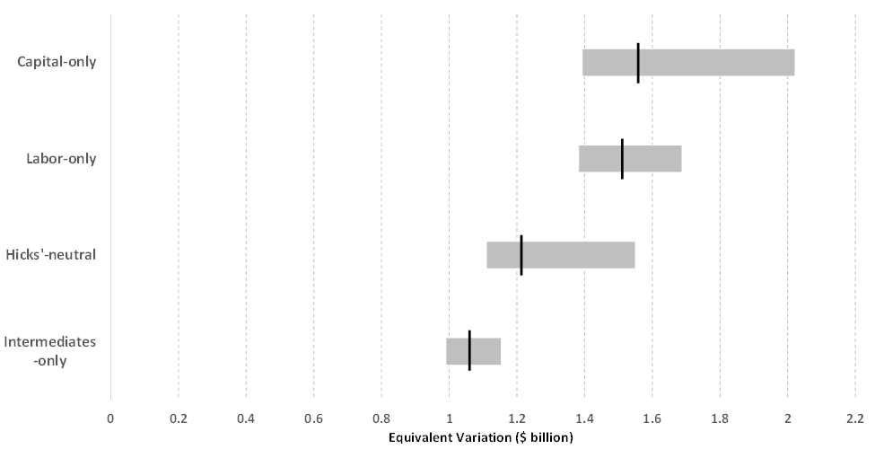

Expected Technological Change from Air Regulations
Estimating the social cost of an air quality regulation over a relatively long time horizon requires assumptions about future technological change. It has long been recognized that both the stringency and approach of environmental regulation that is taken (i.e., technology standard, performance standard, or economic instrument) may influence the degree to which it induces technological change (e.g., Magat, 1978; Fischer et al., 2003).
Jaffe et al. (2002) lay out a conceptual framework for understanding how technological change in response to environmental regulation may affect the relationship between inputs and output, ultimately reducing the unit costs of production. They represent the economy’s aggregate production function in logarithmic form, where y_{t} is the growth rate in output (Y) over time, and l_{t}, k_{t}, and e_{t} are the growth rates for the inputs to production, labor (L), capital (K), and an environmental input (E), respectively:
y_{t} = A_{t} + β_{Lt}l_{t} + β_{Kt}k_{t} + β_{Et}e_{t} .
Hicks neutral technological change is represented in this framework through a change in A_{t} ; in other words, an increase in A_{t} means overall productivity increases. It is possible to produce more output using the same conventional inputs (L, K, and E) as before (or conversely, to produce the same level of output from smaller quantities of inputs). There is also the potential for “biased” technological change. An environmental regulation may affect the growth rate of one or more inputs over time or change the relative productivity of inputs to production, which is captured by a change in one or more of the βs.
Whether innovation induced by an individual regulation is more appropriately modeled as a change in A or in one or more βs is an empirical matter. Compliance with an environmental regulation may result in the adoption of existing technology, improvement of or application of existing technology to a new use, and/or development of entirely new technologies or processes (Sue Wing, 2006a). Newell et al. (1999) point to evidence of technological change that is biased toward or away from energy efficiency in appliances over time, but find that the direction of the bias is related to changes in relative energy prices instead of regulation. The EPA’s Economic Guidelines notes that, “despite its importance as a determinant of economic welfare, the process of technical change is not well understood. Different approaches to environmental regulation present widely differing incentives for technological innovation. As a result, the same environmental end may be achieved at significantly different costs, depending on the pace and direction of technical change.”
The empirical literature also has noted that variable costs of production or environmental abatement tend to decline over time with cumulative experience. While the explanations for why this occurs vary, the evidence for such “learning” is compelling enough that OMB now asks agencies to consider the potential for learning effects when analyzing the cost of regulation. For instance, the EPA has applied technology-specific learning curves to a select set of new technologies when estimating compliance costs for light duty vehicle regulations. When analyzing the prospective costs and benefits of the Clean Air Act Amendments from 1990 – 2020 (U.S. EPA 2011a), the EPA adjusted the costs of compliance (for local controls in non-attainment areas) downward by 10 percent, on average, for every doubling of emission reductions. However, when a CGE model is also used to evaluate social costs, a key question is how assumptions regarding technological innovation that are applied to engineering estimates interact with assumptions about technological innovation already integrated into a CGE model.

Number and Type of Sectors
As noted in the EPA’s Economic Guidelines “[a]s the number of affected markets grows, it becomes less and less likely that partial equilibrium analysis can provide an accurate estimate of social cost. Similarly, it may not be possible to accurately model a large change in a single regulated market using partial equilibrium analysis” (U.S. EPA, 2010a). While a general equilibrium approach is recommended in these cases, how to determine what constitutes a large number of sectors or in which types of sectors a large change in a single market may matter from a general equilibrium perspective is left to the analyst.
The literature offers little additional guidance. Kokoski and Smith (1987) find that while a partial equilibrium model adequately captures welfare effects for a fairly large single sector shock (up to a 42 percent unit cost increase), use of this approach to analyze a small multi-sector shock results in large errors in welfare relative to a fairly simple, highly aggregate CGE model. The size of the error is related to the direction and magnitude of the relative price change in the directly regulated sector compared to other consumer goods. For instance, while the partial and general equilibrium models produce estimates of similar magnitude for price changes in the directly and indirectly affected sectors for the small multi-sector policy shock, the direction of the price changes differ, amplifying the disparity of effects across sectors.
Pizer et al. (2006) find that reduced-form sector representations in a CGE model and partial equilibrium sector models that hold input prices and output constant result in similar predictions of emissions responses to a carbon price in the commercial building, industrial, and household transportation sectors. This is not the case in the electricity sector where a substantial portion of emission reductions stem from reductions in output, particularly as marginal costs of achieving reductions rise. However, the partial equilibrium and general equilibrium approaches produce markedly different estimates of the marginal welfare cost in all four sectors. They are “about $10 to $15 per ton of carbon higher than costs measured by the permit price in the building and electricity sectors, $10 per ton lower in the industrial sector and $50 per ton lower in household transportation.” The main reason for the differences in estimates is the presence of pre-existing taxes in these sectors.
We also researched whether other Federal agencies offer specific guidance on how the number or type of sectors analyzed affects model choice. The International Trade Commission, which uses both partial and general equilibrium approaches to evaluate the effects of changes in trade and non-trade barriers, highlights a particular challenge when using general equilibrium models to analyze policy changes in a narrowly defined industry. Using the example of studying the effects of removing a tariff from the frozen bakery product sector (standard industrial classification (SIC 2053), they note that, in the CGE model, “frozen bakery products are included together with several dozen other slightly related but not identical industries. For example, bottled and canned soft drinks (SIC 2086), cereals (SIC 2043), and chewing gum (SIC 2067) are included in the combined sector of ‘food products.’ Thus, the frozen cake industry may be too small a part of the model’s food products sector to give meaningful results due to ‘aggregation bias.’ Put another way, there are too many products in the model’s sector to accurately isolate the frozen bakery products industry. To study a narrowly defined industry, the partial equilibrium model would be a better choice” (Rivera 2003). (The economic impacts white paper will discuss how aggregation issues affect an analyst’s ability to adequately estimate sectoral effects from regulation.)

Sensitivity of Results to Parametric Assumptions
Model structure and parameter assumptions have long been recognized as important drivers of in applied CGE analysis. Of particular interest are estimates of elasticities that help define potential production processes and agent preferences, as the results are often highly sensitive to these parameters. For instance, Shoven and Whalley (1984) observe that results from CGE analyses of the U.S. tax system are sensitive to labor supply, saving, and commodity-demand elasticity assumptions. Fox and Fullerton (1991) find that estimates of welfare changes associated with tax reform are more sensitive to assumptions about the elasticity of substitution between labor and capital than the actual level of detail about the U.S. tax system in the model. More recently, Elliot et al. (2012) confirmed that CGE analysis is likely far more sensitive to uncertainty around elasticity parameter assumptions than other data inputs such as the benchmark social accounting matrix.
The sensitivity of results to parameter values has been the subject of much discussion given the common approach of selecting values through a calibration process (Hansen and Heckman, 1996). However, selecting econometrically estimated parameter values from the literature is not without its own concerns due to inconsistencies between the empirical analyses and the structure of the CGE model and a large range of potentially contradictory studies that provide elasticity estimates (Shoven and Whalley, 1984; Canova, 1995). To address these concerns, some researchers have chosen to econometrically estimate the parameters of their model in a framework that is structurally consistent with the CGE model (e.g., Jorgenson et al., 2013).
To better understand the implications of uncertainty around parameters to which modeling results might be sensitive, researchers also have considered different approaches for characterizing the range of changes that might be induced by a policy shock. For instance, some cases studies have relied on basic comparative statics, or slightly more involved sensitivity analysis. However, it has been noted that varying only one, or a few, parameters at a time could potentially provide an incomplete characterization of the uncertainty surrounding the results due to important interactions between parameters within complex and highly non-linear CGE models (Abler et al., 1999). Therefore, researchers also have considered more formal approaches to accounting for uncertainty by defining probability distributions over parameters and integrating over the distributions using Gaussian Quadrature to obtain mean values for the results (e.g., Hertel et al., 2007) or Monte Carlo simulations to obtain sampling distributions for the results (e.g., Selin et al. 2009). (The uncertainty white paper will include a more complete discussion of approaches to characterizing uncertainty in the results of applied GE analysis, including additional approaches such as inter-model comparisons exercises and potential validation and verification exercises.)

References

Abler, D., Rodriguez, A., and Shortle, J. 1999. “Parameter Uncertainty in CGE Modeling of the Environmental Impacts of Economic Policies.” Environmental and Resource Economics 14: 75-94.
Arora, V. 2013. “An Evaluation of Macroeconomic Models for Use at EIA.” Working Paper. U.S. Energy Information Administration. December.
Ballard, C., and Medema, S. 1993. “The marginal efficiency effects of taxes and subsidies in the presence of externalities” Journal of Public Economics 52(2):199-216
Canova, F. 1995. “Sensitivity Analysis and Model Evaluation in Simulated Dynamic General Equilibrium Economies.” International Economic Review 36(2): 477-501.
Chan, G., Stavins, R., Stowe, R., and Sweeney, R. 2012. “The SO2 Allowance Trading System and the Clean Air Act Amendments of 1990: Reflections on Twenty Years of Policy Innovation.” National Bureau of Economic Research, Working Paper #17845.
Fischer, C., Parry, I., and Pizer, W. 2003. “Instrument Choice for Environmental Protection When Technological Innovation is Endogenous.” Journal of Environmental Economics and Management 45: 523-545.
Fox, T., and Fullerton, D. 1991. “The irrelevance of detail in a computable general equilibrium model.” Economic Letters 36(1): 67-70.
Fullerton, D. and Heutel, G. 2010. “The General Equilibrium Incidence of Environmental Mandates.” American Economic Journal: Economic Policy 2(3): 64-89.
Hazilla, M. and Kopp, R. 1990. “Social Costs of Environmental Quality Regulations: A General Equilibrium Analysis.” Journal of Political Economy 98(4):853-873.
Hertel, T., Hummels, D., Ivanic, M., and Keeney, R. 2007. “How confident can we be of CGE-based assessments of free trade agreements?” Economic Modelling 24(4): 611-635.
Ianchovichina, E., and McDougall, R. 2000. “Theoretical Structure of Dynamic GTAP.” GTAP Technical Paper, 17. Available at: https://www.gtap.agecon.purdue.edu/resources/res_display.asp?RecordID=480
Jacoby, H., Reilly, J., McFarland, J., and Paltsev, S. 2006. “Technology and technical change in the MIT EPPA model” Energy Economics 28(5-6): 610-631.
Jorgenson, D., Jin, H., Slesnick, D., and Wilcoxen, P. 2013. “An Econometric Approach to General Equilibrium Modeling.” In P. Dixon and D. Jorgenson (Eds.), Handbook of Computable General Equilibrium Modeling. Elsevier.
Jorgenson, D., and Wilcoxen, P. 1990. “Environmental Regulation and U.S. Economic Growth.” RAND Journal of Economics 21(2): 314-340
Kokoski, M., and Smith, K. 1987. “A General Equilibrium Analysis of Partial Equilibrium Welfare Measures: The Case of Climate Change.” American Economic Review 77(3): 331-341.
Magat, W. 1978. “Pollution Control and Technological Advance: A Dynamic Model of the Firm.” Journal of Environmental Economics and Management 5: 1–25.
Nestor, D., and C. Pasurka, C. 1995a. “CGE model of pollution abatement processes for assessing the economic effects of environmental policy.” Economic Modelling 12(1): 53-59.
Nestor, D., and Pasurka, C. 1995b. “Alternative specifications for environmental control costs in a general equilibrium framework.” Economics Letters 48(3-4): 273-280.
Newell, R., Jaffe, A., and Stavins, R. 1999. “The induced innovation hypothesis and energy-saving technological change.” Quarterly Journal of Economics 114(3): 941–975.
Office of Management and Budget (OMB). 2014. 2014 Draft Report to Congress on the Benefits and Costs of Federal Regulations and unfunded Mandates on State, Local, and Tribal Entities.
Pizer, W., Burtraw, D., Harrington, W., Newell, R., and Sanchirico, J. 2006. “Modeling Economy-Wide versus Sectoral Climate Policies Using Combined Aggregate-Sectoral Policies.” The Energy Journal 27(3): 135-168.
Pizer, W., and Kopp, R. 2005. “Calculating the Costs of Environmental Regulation” in K-G. Mäler and J. Vincent (Eds.). The Handbook of Environmental Economics (pp. 1307-1351). Elsevier. Vol. 3.
Selin, N., Wu, S., Nam K.-M., Reilly, J., Palsev, S., Prinn, R. 2009. “Global Health and Economic Impacts of Future Ozone Pollution.” Environmental Research Letters 4: 1-9.
Shoven, J., and Whalley, J. 1984. “Applied General-Equilibrium Models of Taxation and International Trade: An Introduction and Survey.” Journal of Economic Literature 22 (3): 1007-1051.
Sue Wing, I. 2006a. “Representing induced technological change in models for climate policy analysis.” Energy Economics. 28(5-6):539-562.
U.S. EPA .1995a. “The U.S. Environmental Protection Industry: A Proposed Framework for Assessment.” Available at: http://yosemite.epa.gov/ee/epa/eerm.nsf/vwAN/EE-0217A-1.pdf/$file/EE-0217A-1.pdf
U.S. EPA. 1995b. “The U.S. Environmental Protection Industry: The Technical Document.” Available at: http://yosemite.epa.gov/ee/epa/eerm.nsf/vwAN/EE-0217B-1.pdf/$file/EE-0217B-1.pdf
U.S. EPA. 2010a. Guidelines for Preparing Economic Analyses. Report Number EPA 240-R-10-001. Available at: http://yosemite.epa.gov/ee/epa/eerm.nsf/vwAN/EE-0568-50.pdf/$file/EE-0568-50.pdf
U.S. EPA. 2011. The Benefits and Costs of the Clean Air Act from 1990 to 2020. Final Report. Available at: http://www.epa.gov/air/sect812/feb11/fullreport_rev_a.pdf.

EV is a monetary measure of the change in utility brought about by changes in prices and incomes, and focus on changes in consumer welfare rather than on changes in total final demand (U.S. EPA, 2010a). See section 6 for more discussion of this and other measures of economic welfare.
The 2005 Pollution Abatement and Expenditure Survey (PACE) reports capital abatement expenditures to reduce air emissions as about 3 percent of total new capital expenditures (from the Annual Survey of Manufacturers) for all reporting industries combined. Some industries report a much larger proportion of abatement expenditures – paper manufacturing has abatement capital expenditures that are 6.8 percent of total new capital expenditures while petroleum and coal products manufacturing has abatement capital expenditures of almost 14 percent - while others report noticeably lower expenditures to reduce air emissions – the machinery manufacturing sector has abatement capital expenditures that are 0.3 percent of total new capital expenditures while fabricated metal products manufacturing has abatement capital expenditures of 1.2 percent. It is important to keep in mind, however, that capital expenditures reported to PACE are for requirements across all Federal air regulations combined, while the focus of this white paper is on how to analyze social cost associated with a single air regulation.
“For example, if a regulation requires firms in the electric utility sector to invest in pollution control equipment, they may not invest as much in electric generation capacity as they would have in the absence of the regulation. This may result in slower growth in electricity output” (U.S. EPA 2010a).
For alternatives to this approach to modeling the introduction of a regulation see Aiken et al. (2008).
Nestor and Pasurka, and others use surveys and other data to construct 41-sector input-output tables for the U.S. that separate out environmental protection activities (U.S. EPA, 1995b). The input-output tables are constructed for the years 1977 and 1982. In a separate paper (U.S. EPA, 1995a), they estimate vectors for inputs purchased for air, water, and solid waste environmental protection activities for 1991. Data from these studies are used to allocate inputs in CGE model simulations for the EPA’s prospective study of the benefits and costs of the Clean Air Act from 1990 to 2020 (U.S. EPA, 2011a). Unfortunately, collection of some of the survey data used by Nestor and Pasurka has been discontinued and extensions of their work to more recent years have not been attempted.
We chose not to allocate costs using a subset of the Nestor-Pasurka data for this exercise.
Technological change represents a change in the way in which productive activity occurs. Jaffe, et al. (2002) define technological change as a process that incorporates invention, innovation, and diffusion.
Another well-studied program is the 1990 Clean Air Act Amendment SO₂ cap-and-trade system for power plants. Chan et al. (2012) note that research finds it spurred improvements in scrubber performance, the use of different mining techniques to extract low-sulfur coal, and blending of low and high-sulfur coal.
Technological change also is widely accepted to be one of the most critical, albeit less understood, factors that determine future levels of GHG emissions and the associated cost of reducing them (Jacoby et al, 2006).
The commercial buildings and electricity sectors have relatively high indirect business taxes; the industrial sector has relatively low indirect business taxes; household transportation is not covered by the income tax on capital.
See section 5.5 for a discussion of sensitivity of results to Armington trade elasticity assumptions as well as calibration versus econometric estimation in this context.
CGE models typically calibrate structural or behavioral parameters so that the model is able to reproduce the social accounting matrix (SAM), which “records all the transactions and transfers between production activities, factors of production, and agents in an economy” (Arora 2013).
Shoven and Whalley (1984) note that CGE modelers “typically place[s] a lot of reliance on literature surveys of elasticities and, as many of the modelers have observed …, it is surprising how sparse (and sometimes contradictory) the literature is on some elasticity values.”

