A Shared Socio-economic Pathway Approach to Assessing the Future of the New Zealand Forest Sector
Adam Daigneault, University of Maine School of Forest Resources
Anne-Gaelle Ausseil, Landcare Research New Zealand
Miko Kirschbaum, Landcare Research New Zealand

Overview
This analysis focuses on impacts of climate and socio-economic change through 2100 on the New Zealand forest sector. The industry is based around sustainably managed exotic plantation forests, covering 1.8 million hectares, or 7% of New Zealand's land area. About 90% of plantations are Radiata pine (Pinus radiata), with Douglas-fir and eucalypts largely accounting for the remaining area. Although New Zealand is a small player in the global forestry industry, contributing just over 1% of the world's total industrial wood supply, it a significant industry in New Zealand. Economy-wise, the sector accounts for 3% of New Zealand's GDP and wood products are New Zealand's third largest export, behind dairy and meat (MPI, 2016). Furthermore, 30% of the country is covered in forest which sequesters about 20 million tons of carbon dioxide equivalent, (MtCO-e/yr), thus reducing the country’s total GHG emissions by about 1/3 (MfE, 2016a). New Zealand also has some of the highest erosion rates in the world, and sediment loads in many areas are largely mitigated by its extensive forest cover (Dymond et al 2010).
We use a global integrated assessment model that is focused on the land use sector to model 20 different scenarios that vary climate and socio-economic pathways to analyze the potential impacts on the New Zealand forest sector. The dynamic model includes a global computable CGE model, a global timber supply model, and a detailed New Zealand land-use sector model that utilizes agriculture and forest production models that estimate forest, pasture, and livestock yields under varying climatic conditions. Key outputs include land use area, forest carbon sequestration, timber harvest, and management regime. This study provides insight on the key drivers that are most likely to affect New Zealand’s forest sector, including population change, commodity prices, agricultural yields, and pricing land-based GHG emissions. It also offers valuable insight on possible methods to utilize ‘downscaled’ global climate projections and region-specific socio-economic assumptions into national and sub-national scale integrated assessments.
Methodology
We take a scenario modelling approach that adopts two global elements from a scenario toolkit (Ebi et al., 2013) to estimate a wide range of possible changes to the New Zealand and global forest market as a result of climate and socio-economic change. The scenarios we analyze follow the framework by van Vuuren and Carter (2013) to illustrate combinations of Representative Concentration Pathways (RCPs) and Shared Socioeconomic Pathways (SSPs). We then describe potential climate change mitigation and/or adaptation options specific to New Zealand to weave the RCP and SSPs together using methods similar to Riahi et al. (2016). A combination of four RCPs (2.6, 4.5 6.0 and 8.5 W/m²) and five SSPs (1-5) were run through a dynamic integrated assessment model using a mix of exogenous input assumptions and endogenous model responses to assess and the potential outcome of 20 distinct scenarios.
The New Zealand climate change projections for are based on four RCPs modelled via the Coupled Model Inter-comparison Project (CMIP5) of numerous Earth System Models or General Circulation Models (GCM). We use dynamic downscaled estimates from six GCMs to update and improve regional-scale projections of New Zealand climate trends and variability to 2100 (MfE 2016b). The key output variables are precipitation, maximum and minimum air temperature, relative humidity, vapor pressure, solar radiation, and wind speed. Each variable was estimated for New Zealand on a regular grid (0.05°, approximately 5km) at a daily, monthly and annual temporal resolution for the 1971–2100 period and bias-corrected relative to a 1986–2005 climatology (Tait and Turner 2005).
For scenario modelling, we used the New Zealand Integrated Assessment Modelling System (NZIAMS) to estimate impacts of climate and socio-economic change through 2100 on the global forests, with a detailed focus on New Zealand land use (Lennox et al., 2013). The integrated approach links (a) the Climate and Trade Dynamic General Equilibrium (CliMAT-DGE) (Fernandez and Daigneault 2015), (b) the Global Timber Model (GTM), (Tian et al 2016) and (c) the New Zealand Forest and Agriculture Regional Model (NZFARM) (Daigneault et al. 2017) to form a multi-regional, multi-sectoral, dynamic optimization model. While the CGE component of the model can track all major sectors of the global economy, NZIAMS has been parameterized to focus particularly on the forest and agriculture sectors, where the objective is to maximize net farm revenue subject to a range of input and land use change constraints.
Climate impacts on the NZ forest sector are modelled at the 5km grid scale level using the process-based ecophysiological forest productivity model, CenW (Kirschbaum and Watt 2011), that was recently updated to account for the downscaled CMIP5 climate projections. In addition to the effect of standard model parameters such as temperature and precipitation, we estimate the possible impacts of climate change on NZ forests under constant and increasing CO₂. Similar approaches were also used to estimate climate change impacts on agricultural crops (Holzworth et al. 2014) and pasture (Keller et al. 2014) yields to ensure that all major land uses are accounted for.
The productivity estimates from the agriculture and forestry yield models serve as input into the NZIAMS land use models along with global (e.g, population & GDP growth) and national (e.g., land management preferences) level SSP assumptions to establish the key global and NZ-drivers that can have an effect on commodity prices, GHG prices, and resulting land use and forest management. For these scenarios, we assumed that forest Figure 1 illustrates the key components of NZIAMS and how they are integrated.
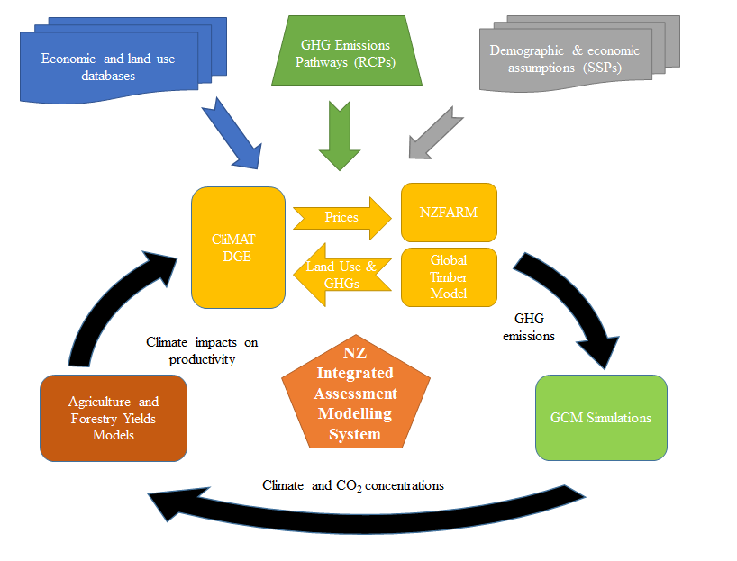
Figure 1. New Zealand Integrated Assessment Modelling System (NZIAMS)

Preliminary Results
Forest productivity estimates across the RCP-only scenarios (i.e. only climate change impacts) varied most by assumption about whether plants respond to changes in CO₂. As expected, results varied by RCP and GCM, with the greatest impacts occurring under the RCP 8.5. For simulations with constant CO₂, we estimate a 0-8% decline in NZ forest plantation productivity relative to today by 2100. For simulations with increasing CO₂, growth increased by about 10-40%. Scenarios that also accounted for SSP-related assumptions and thus socio-economic impacts in addition to climate change produced a wide range of results. In general, scenarios including RCP 8.5 resulted in relatively small change in NZ’s forest area, timber production, and carbon sequestration due to the lack of an environmental drivers such as a carbon price to influence landowners to afforest their land. The RCP 8.5/SSP 3 scenario resulted in the largest decline for the forest sector, which is consistent with recent global analyses (e.g. Popp et al. 2016). On the other extreme, RCP 2.6 estimated that a global GHG prices of $500/tCO2-e or more by 2100 were required to meet the emissions reduction targets, regardless of the SSP assumptions. The effect of placing a price on all sectors of the economy, including crops and livestock, dominated all other drivers, resulting in forest area and related outputs in NZ nearly doubling. In addition, the large increase in forest carbon sequestration coupled with the decline in emissions from other sectors is likely to make the country a net GHG sink by the end of the century. More details and insight on these and other findings will be provided in the full paper and presentation.
References
Daigneault A et al. 2017. Economic impacts of multiple agro-environmental policies on New Zealand land use. Environmental and Resource Economics. In press.
Kirschbaum MUF, Watt MS. (2011). Use of a process-based model to describe spatial variation in Pinus radiata productivity in New Zealand. Forest Ecology and Management 262: 1008-1019
Holzworth DP, Huth NI, Devoil PG et al. (2014) APSIM – Evolution towards a new generation of agricultural systems simulation. Environmental Modelling & Software, 62, 327-350.
Dymond JR, Betts HD, Schierlitz C (2010) An erosion model for evaluating land-use scenarios. Environmental modelling and software, 25, 289-298.
Ebi KL, Hallegatte S, Kram T et al. (2013) A new scenario framework for climate change research: background, process, and future directions. Climatic Change, 122, 363-372.
Fernandez M, Daigneault A (2015) The Climate Mitigation, Adaptation and Trade in Dynamic General Equilibrium (CLIMAT-DGE) model. Landcare Research LC2156 for the Ministry for the Environment.
Keller ED, Baisden WT, Timar L, Mullan B, Clark A (2014) Grassland production under global change scenarios for New Zealand pastoral agriculture. Geosci. Model Dev., 7, 2359-2391.
Lennox J. et al. (2013). Integrated Assessment, Trade- Related Impacts of Global Climate Change & Climate Policies. Landcare Research Report LC1632 prepared for Ministry of Primary Industries.
Ministry for the Environment (MfE). (2016a). New Zealand's Greenhouse Gas Inventory 1990–2014. Wellington. MfE publication ME 1239.
MfE (2016b). Climate Change Projections for New Zealand: Atmosphere Projections Based on Simulations from the IPCC Fifth Assessment. Wellington: Ministry for the Environment.
NZ Forest Owners Association (FOA). (2016). Facts and Figures, 2015/2016.
Popp A. et al. 2016. Land-use futures In the Shared socio-economic pathways, Global Env Change.
Riahi K. et al. 2016. The shared socioeconomic pathways and their energy, land use, and greenhouse gas emissions implications: an overview. Global Environmental Change.
Tait A, Turner R (2005) Generating multiyear gridded daily rainfall over New Zealand. Journal of Applied Meteorology, 44, 1315-1323
Van Vuuren DP, Carter TR (2013) Climate and socio-economic scenarios for climate change research and assessment: reconciling the new with the old. Climatic Change, 122, 415-429

