The long term impact of climate change on forestry

Alice Faveroª, Robert Mendelsohnb and Brent Sohngenc

ª Georgia Institute of Technology, 365 Cherry Street, Atlanta, Georgia 30303, USA. (Corresponding author); ^{b} Yale University, 195 Prospect Street, New Haven, Connecticut 06511, USA; ^{c} Ohio State University, 2120 Fyffe Rd, Columbus Ohio 43210, USA.

April 14, 2017

Abstract
It is well known that the forestry sector is sensitive to climate change but most studies have examined impacts only through 2100. Within this time frame, global forests are predicted to generally expand and become more productive which will be beneficial to the global timber supply. This study links the LPX-Bern Global Dynamic Vegetation Model with an extended version of the Global Timber Model in order to study climate change impacts out to 2250. This allows the study to examine much more extreme climate scenarios including warming to 9°C. Warming through 2150 appears to be beneficial, but as temperatures start to exceed 5°C, additional warming starts to be harmful to forestry.

Key words: Climate change impacts, Forest, Land, Timber market, Carbon sequestration, NPP, fire, RCP 8.5
- Introduction
The forestry sector is sensitive to climate change and it is likely that changing temperature and precipitation pattern will produce a strong direct impact on both natural and modified forests (Kirilenko and Sedjo 2007). On the one hand, climate change can accelerate vegetation growth caused by a warmer climate, longer growth seasons, and elevated atmospheric CO2 concentrations as well as affect forest composition (Harsch et al. 2009, Mann et al. 2012). On the other hand, the climate change-induced modifications of frequency and intensity of forest wildfires, outbreaks of insects and pathogens, and extreme events will vary the net effect of climate on forests over time and space (Scholze et al 2006, Bachelet et al 2008, Gonzalez et al 2010).
The way in which markets adapt to climate change-induced changes in forest growth and dieback will have important effects on projections of timber outputs, forest stocks, and the carbon stored in forested ecosystems. A number of models have been developed to capture ecological impacts and to assess the potential economic effects of climate change on the forestry sector (e.g., Joyce et al 1995, Sohngen and Mendelsohn 1998, Sohngen et al. 2001; Perez-Garcia et al., 2002; Hanewinkel et al., 2014. See additional studies in Table A1). These studies have shown that climate change could have a large impact on timber supply, altering global timber prices, and changing the incentives to manage forests.
All of the existing studies, however, have focused on a century or less of potential change, assuming that carbon emissions ultimately will fall, and climate will stabilize in the long run. However, given the difficulties of organizing global mitigation, it is possible that greenhouse gas concentrations will not stabilize and will in fact lead to continued warming beyond 2100. This study utilizes climate model forecasts that have been made through 2300 in order to understand how ecosystems will change and how this could affect the forest sector. The study will consequently evaluate much more severe warming scenarios than the literature has examined before including warming up to 9°C above 1900 levels.
These scenarios will be examined in the context of an ever evolving ecosystem and forestry sector. The dynamic ecosystem response will be captured by the LPX-Bern Global Dynamic Vegetation Model (Stocker et al. 2013; Mendelsohn et al. 2016). An extended version of the Global Timber Model GTM (Sohngen et al. 2003) is developed to study how the forest sector will respond to these future challenges. We compare the modest warming associated with the 2.6 RCP scenario against the severe warming associated with the 8.5 RCP scenario.
The LPX-Bern Model predicts three changes in ecosystems as a result of climate change. First, the growth of timber will change. Second, some of the standing stock will be lost to dieback from direct temperature effects, forest fires, and insects. Third, the distribution of biomes and timber species over space will change as species move poleward and to higher altitudes. All of this happens at particular dynamic rates which are part of the ecosystem model.
The GTM model is a forward looking model that examines what changes should be made in advance of all these future effects. For example, the model will predict increasing harvest rates of stands that have an ever increasing rate of dieback. The model will encourage planting of new trees that will prosper given the future climate that they will endure. The model will intensify management in places that become more productive and will reduce management intensity in places that become less productive. Finally, the model will predict future timber prices that will dictate the amount of land that will be managed for forestry and the amount of land that will remain unmanaged.
This article is organized as follows. Section 2 describes the method and the model used for the analysis. In Section 3, we analyze the results of the model in terms of changes in forestland, timber market and carbon sequestration under the RCP 2.6 and 8.5 scenario. Finally Section 4 summarizes the results and discusses the policy implications.

- Methods
  - Model
The Global Timber Model GTM (Sohngen et al. 2001; 2003) used in this study contains 200 forest types i in 16 regions that can be aggregated into four broad categories: boreal, temperate hardwood, temperate softwood, and tropical. The model assumes there is a social planner maximizing the present value of net of the difference between consumer surplus and the costs of holding timberland and managing it over time. It is an optimal control problem given the aggregate demand function, starting stock, costs, and growth functions of forest stocks. It endogenously solves for timber prices and the global supply of timber and optimizes the harvest of each age class, management intensity, and the area of forestland at each moment in time. GTM is forward looking with complete information.
The problem is written formally as:
(1)
where ρ is a discount factor, is wood demand, is the cost of harvesting and transporting timber to the mill, is the price of management intensity , is planted acreage, is the cost of new forestland, is the opportunity cost of land . The model assumes that management intensity is determined at the moment of planting and planting costs vary depending upon management intensity.
The timber demand function,, is assumed to grow over time as the global economy grows:
, (2)
where A is a constant, is the projected global consumption per capita over time (see Section 2.2), θ is the income elasticity of 0.87, is the international price of wood and ω is the price elasticity. We use the consumption per capita forecasts of the SSP’s to predict future income (SSP Database).
To determine the quantity produced in each region, the model chooses the age class to harvest trees. Thus, the total quantity harvested will be obtained by summing the volume of timber on each hectare harvested in each age class. The total timber area is tracked by the stock variable and it adjusts over time. Timber shifts from one age class to the next, unless harvests occur.
GTM takes into account the competition of forestland with farmland using a rental supply function for land (Sohngen and Mendelsohn, 2003). In Equation (1) is the rental cost function for holding timberland.
In order to include climate change impacts on world forests, we include in the model three expected impacts of climate change as predicted by the LPX-Bern Global Dynamic Vegetation Model: (a) changes in the growth of timber; (b) changes in dieback; (c) changes in the distribution of biomes and timber types. The LPX-Bern Global Dynamic Vegetation Model generates outputs at the 0.5° spatial resolution at a yearly time step, the outputs were then were aggregated to decadal averages across world regions for use in the forestry model.
In the forestry model the volume of timber is a function of the cumulative effect of the annual change in NPP as predicted by LPX-Bern Model and management intensity . The changes in the growth of timber is calculated as:
(3)
The literature has examined the impact climate is expected to have on timber through 2100. However, the warming that can happen through 2100 is quite limited so that no scenario has ever explored warming above 4°C. By extending the analysis to 2300, this analysis both longer term effects as well as climate scenarios reaching much higher temperatures. Ecosystems will have longer to respond and so there can be much more dramatic changes.
We include the effect of dieback by assuming higher dieback rates, , affect all existing stocks as follows:
(4)
Where is the annual mortality rate from dieback as predicted by the vegetation model. We assume that all age classes have equal probability of dieback. Dieback also alters timber harvests because some of the stock that dies back will be salvaged. The salvage enters the equation for net market surplus through harvests.
Finally, forest stock is also a function of the movement of biomes across the land. In this study, we include the changes in biomes due to climate change from the vegetation model. In the model, we separate the timber stocks into stocks which shift from one type to another during climate change and stocks which remain in their initial timber type. The distribution of biomes from the vegetation model is derived from the simulated vegetation composition and structure following Prentice et al. (2011). Initial forest stocks are given, and all choice variables are constrained to be nonnegative.
The scenarios are written and solved using GAMS software and the MINOS solver. The models include a nonlinear objective function. The model is solved in decadal time steps starting in 2010. Terminal conditions are imposed on the system for the 300th year in order to solve the model and results are shown until 2250.

  - Scenarios
The study estimates the future potential climate impacts on the world’s forests using the two extreme Representative Concentration Pathway (RCP) scenarios of 2.6 and 8.5 W/m² radiative forcing level in 2100 (Riahi et al. 2011; van Vuuren et al. 2011) and compare them with a No Climate Change scenario. Climate scenarios are developed using climate change projections from the climate model HadGEM2 and then used in the LPX-Bern Global Dynamic Vegetation Model to simulate vegetation response to climate change from the present to year 2300. The vegetation Model generates outputs at the 0.5° spatial resolution at a yearly time step, the outputs were then were aggregated to decadal averages across world regions for use in the forestry model.
Most of the Integrated Assessment Models reviewed by the IPCC AR5 predict lower concentrations than RCP 8.5 (Intergovernmental Panel on Climate Change IPCC 2015) for a no mitigation scenario. Riahi et al. (2017) found that only the SSP 5 baseline scenarios of three models (AIM/CGE, REMIND-MAGPIE and WITCH-GLOBIOM) reach radiative forcing levels as high as the one from RCP 8.5. On the other hand, all the SSP’s reach the target of 2.6W/m² with the exception of the SSP3 (Riahi et al. 2017). Thus, for this study we examine just the socioeconomic scenario SSP5 since it can generate both the 2.6 and the 8.5 RCP scenarios. For both the RCP 2.6 and RCP 8.5 scenarios, we use the 2010-2100 consumption and population from the SPP5 projections to calculate global consumption per capita. In order to extend these scenarios to 2300, we assume population growth rates decline linearly, reaching zero in the year 2200 and economic growth rate declines linearly, reaching zero in the year 2300 (Interagency Working Group on Social Cost of Carbon IAWG, 2010). Given these assumptions, global consumption per capita follows an S-shaped function as shown in Figure 1. By 2100, average global consumption has risen to $65,000 per capita and by 2250, consumption has risen to $300,000-$400,000 per person..

- Results
The increase in CO₂ fertilization and warming during the twenty-first century under the RCP 8.5 will increase forest productivity at the aggregate level. Productivity is projected to increase by around 30% by 2100 and 90% globally by 2250 under the RCP 8.5 relative to the RCP 2.6. Table 1 shows that temperate forests will experience the highest increase on average while tropical productivity will be less affected by climate change.
The rapid increase in income assumed in Figure 1 causes the demand for timber to increase over time. Even without climate change, the timber sector would have to increase timber prices in order to supply more wood. The higher timber prices would in turn permit a larger forest area to be managed for timber. The higher timber prices would also increase management intensity, increasing supply. Of course, the higher timber prices would also serve to temper demand. Without climate change, the market equilibrium prices would rise rapidly at first and only start to slow down by 2190 (Figure 2b). Global wood supply would gradually increase as timber prices increase.
Even if global wood output does not change very much under the two scenarios, the output in some regions changes significantly in particular in temperate regions. Under the 8.5 RCP scenario almost all the world regions will experience an increase in their average yearly timber production for 2010-2100 with respect to the 2.6 RCP scenario. If we extend our analysis until 2250 results change with some regions still experiencing increases while others will contract their average annual supply of wood. The largest increase in timber production (in percentage terms) will occur in temperate regions (Table 3). Timber output will be higher in the 8.5 RCP than the 2.6 RCP due to an average increase in forest productivity and in management intensity even if dieback will increase and potential forestland availability will decrease.
In the 8.5 RCP scenarios wood prices are projected to increase at about 1% per year over the century and then at about 0.2% for 2110-2250 (Figure 2a). Globally, timber output increased by around 68% and 45% in the RCP 8.5 and RCP 2.6 respectively by 2100 relative to 2010 and it has more than doubled by 2250 in both scenarios (Figure 2b). The 8.5 relative to the 2.6 leads to a reduction in timber prices through about 2180. After 2180, the benefit starts to get smaller and they get to be about the same again by 2150. This result is echoed in the timber supply figure.
Changes in climate are likely to affect the timber market at the global and regional level. Changes in the output are driven not only by the changes in forest productivity but also by changes in dieback since higher dieback can increase the output through salvage and spatial migration of valued ecosystems.
An important predicted ecosystem change caused by warming is the shift of biomes over space. Warming is expected to cause temperate forests to expand into where boreal forests are now and tropical savanna to expand into where tropical forests are now. In the long run, a portion of high productivity ecosystems will be substituted by low-productivity ecosystems such as deserts, semi-arid grasslands and tundra (Figure 3).
By 2250 total forestland will be reduced by 40% under the RCP 8.5 with respect to the 2.6 RCP (Table 2). Boreal forest is predicted to undergo the greatest contraction of area due to vegetation migration and lost to fire and in Canada it will be completely replaced by temperate forestland and parkland by the end of this century. Under the RCP 8.5 scenario, global natural forest will be reduced by 40% by 2250 with respect to the RCP 2.6 scenario and natural tropical forest will be the most affected experiencing a 60% shrinkage of forestland.
Under the 8.5 RCP scenario, total above ground carbon stock is expected to decrease in the future as a result of climate change (Table 4). In 2250 the global stock of aboveground carbon will be 38% lower than the 2.6 RCP mainly due to biomes shifting across space and extinction risks rise for selected species like boreal forest. Under the RCP 8.5 forests will shift to savanna, tundra and parkland (depending on the location) affecting the overall forest carbon mitigation potential. That is, climate-induced vegetation migration and carbon loss to fire offset the carbon benefits of increasing forest productivity.

- Conclusions
The analysis is the first timber analysis to consider possible catastrophic ecosystem outcomes and compare them to other climate change scenarios out to 2300. For each scenario analyzed the study will assess the long-term effects of climate change on the timber sector (timber production and timber prices) and its potential climate mitigation contribution via carbon sequestration.
There are several reasons for this extension. The most important is that the analysis includes more extensive warming scenarios that take much longer to evolve. In the most severe scenario, temperatures warm to 9°C above 1900 levels. Second, the paper explores long run adjustments of forests that may occur well beyond 2100. The analysis is consequently the first timber analysis to consider possible “catastrophic” ecosystem outcomes.
Results show that forest ecosystem will be significantly affected by climate change due to changes in forest productivity, dieback loss and biome spatial distribution in the long run. This will produce effects on the timber market with a slight reduction in the international price of wood (-8% wrt 2.6 RCP in 2250) and increasing wood supply (+20% wrt 2.6 RCP in 2250). A more significant effect will occur on forest carbon sequestration potential where aboveground carbon stock will be reduced by 28% in 2250.

- List of Figures
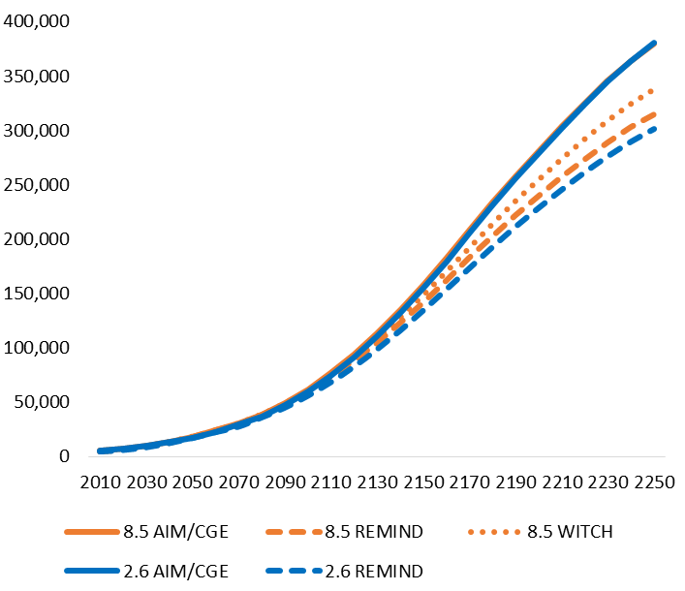
Figure 1: Global consumption per capita under the SSP 5 for the RCP 2.6 and RCP 8.5 scenarios (2010-2250) (USD per capita)

(a) (b)
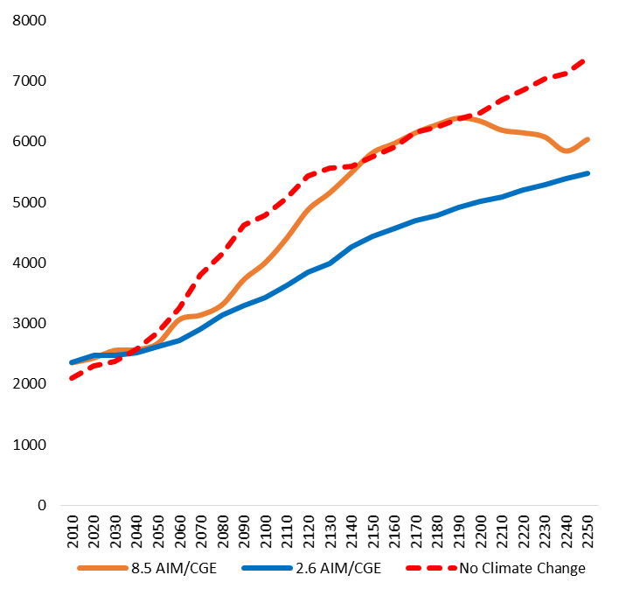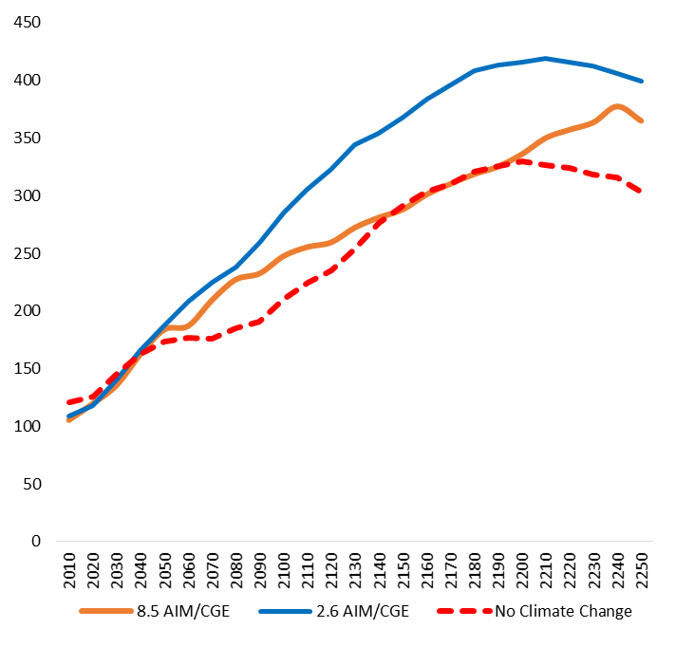
Figure 2: (a) Global wood supply (million m³/yr) and (b) International price of wood (USD/m³) under the No Climate Change, RCP 2.6 and RCP 8.5 scenarios
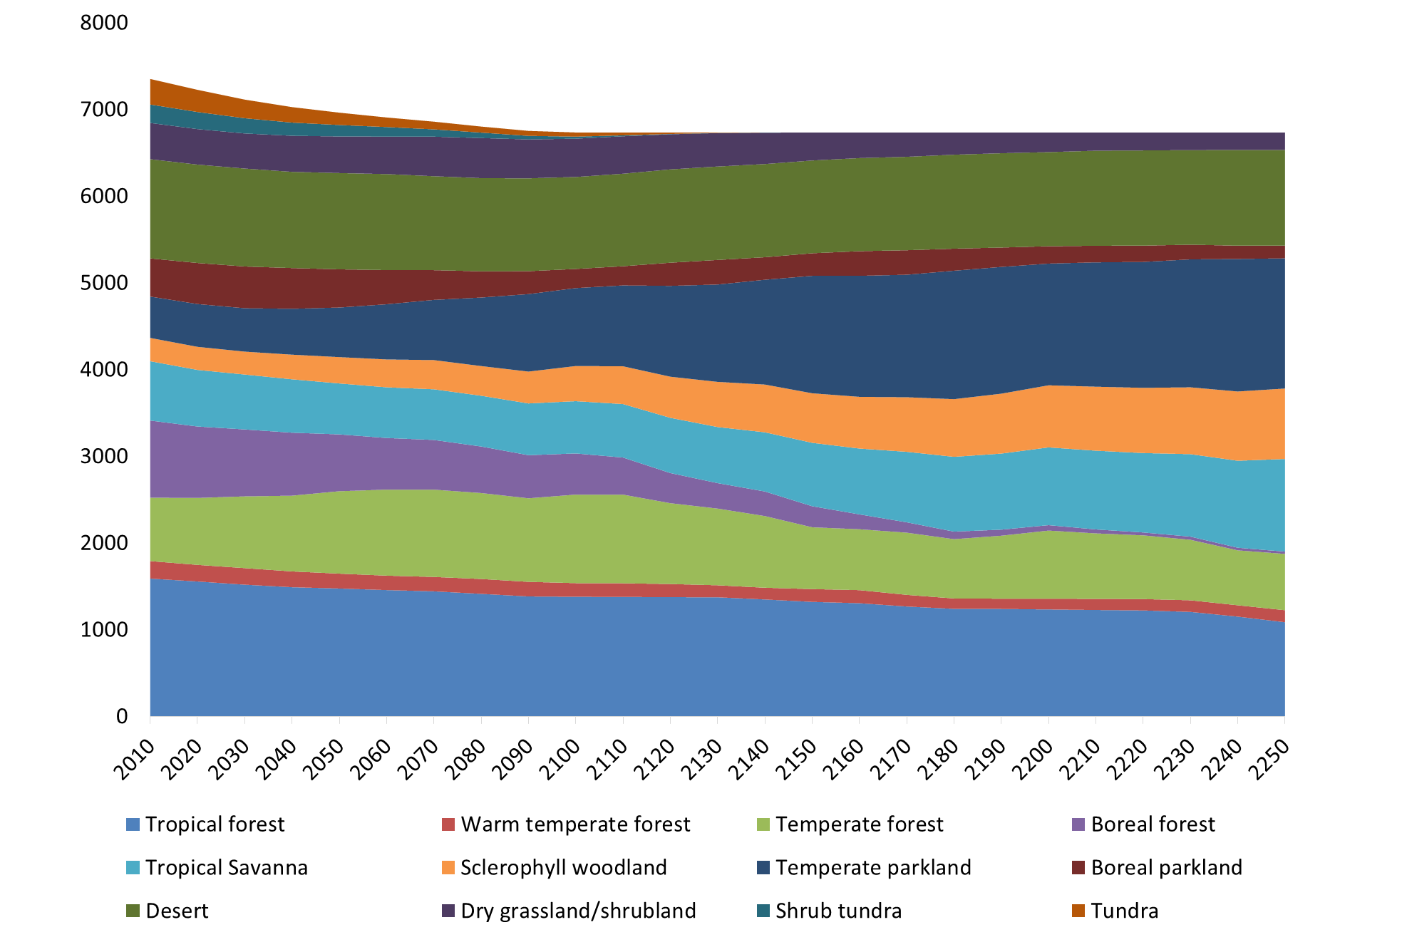
Figure 2: Distribution of natural land under the RCP 8.5 scenario (Mha)

- List of Tables
 | 2050 | 2100 | 2200 | 2250
US | -25% | 160% | 138% | -41%
China | 8% | 43% | 23% | 209%
Canada | 24% | 17% | 84% | 112%
Russia | 0% | 16% | 218% | 76%
Europe | 23% | -31% | -14% | 502%
Oceania | 3% | 36% | 327% | -96%
Japan | -65% | 228% | 24% | 112%
East Asia | 8% | 46% | 99% | -65%
Temperate | -1% | 29% | 76% | 115%
Brazil | 1% | 12% | 59% | 23%
South Asia | 86% | 258% | 121% | -51%
Central America | 10% | 38% | 115% | 96%
Rest of South America | 9% | 17% | 120% | 256%
Sub-Saharan Africa | -2% | 53% | 404% | 183%
South East Asia | 24% | 20% | 95% | -64%
North Africa and Middle East | 20% | 326% | 102% | -15%
Tropical | 14% | 33% | 114% | 31%
World | 4% | 30% | 90% | 91%
Table 1: Percentage change in forest productivity under the RCP 8.5 with respect to the RCP 2.6 scenario

 | 2050 | 2100 | 2200 | 2250
US | -5% | -29% | -53% | -38%
China | -2% | -13% | -58% | -65%
Brazil | 1% | 0% | -20% | -52%
Canada | -7% | -13% | -46% | -56%
Russia | -1% | -10% | -30% | -23%
Europe | -3% | -8% | -18% | -46%
South Asia | 2% | -1% | -34% | -32%
Central America | 9% | -28% | -45% | -89%
Rest of South America | 0% | -1% | -31% | -43%
Sub-Saharan Africa | 2% | -20% | -62% | -79%
South East Asia | -1% | 1% | -24% | -39%
Oceania | 6% | 2% | -14% | -10%
Japan | -17% | 0% | 0% | 0%
North Africa and Middle East | -16% | -37% | -41% | -56%
East Asia | -9% | -16% | -51% | -52%
World | -1% | -9% | -34% | -42%
Table 2: Percentage change in regional forestland under the RCP 8.5 with respect to the RCP 2.6 scenario

 | RCP 8.5 |  |  |  |  | RCP 2.6
 | 2010-2059 | 2060-2109 | 2110-2159 | 2160-2209 | 2210-2250 | 2010-2059 | 2060-2109 | 2110-2159 | 2160-2209 | 2210-2250
US | 394 | 491 | 623 | 726 | 939 | 402 | 412 | 676 | 751 | 949
China | 183 | 283 | 254 | 360 | 303 | 173 | 260 | 260 | 337 | 383
Canada | 381 | 444 | 574 | 682 | 558 | 360 | 454 | 449 | 523 | 485
Russia | 121 | 149 | 555 | 391 | 77 | 123 | 149 | 156 | 131 | 98
Europe | 465 | 611 | 1046 | 1282 | 1798 | 440 | 520 | 707 | 923 | 1018
Oceania | 117 | 220 | 460 | 672 | 492 | 110 | 152 | 253 | 321 | 358
Japan | 93 | 205 | 269 | 275 | 398 | 106 | 149 | 217 | 244 | 283
East Asia | 13 | 11 | 12 | 22 | 4 | 13 | 11 | 14 | 16 | 14
Temperate | 1766 | 2414 | 3792 | 4409 | 4569 | 1728 | 2106 | 2733 | 3245 | 3588
Brazil | 309 | 396 | 470 | 553 | 443 | 305 | 375 | 460 | 533 | 577
South Asia | 57 | 85 | 117 | 129 | 105 | 46 | 61 | 96 | 101 | 114
Central America | 35 | 40 | 52 | 62 | 49 | 33 | 38 | 51 | 57 | 63
Rest of South America | 111 | 191 | 268 | 373 | 413 | 107 | 176 | 250 | 336 | 342
Sub-Saharan Africa | 101 | 149 | 191 | 280 | 245 | 99 | 133 | 167 | 205 | 222
South East Asia | 169 | 205 | 264 | 374 | 249 | 162 | 201 | 259 | 303 | 364
North Africa and Middle East | 9 | 15 | 24 | 23 | 18 | 9 | 12 | 17 | 17 | 20
Tropical | 790 | 1081 | 1386 | 1795 | 1522 | 760 | 995 | 1300 | 1553 | 1702
World | 2556 | 3495 | 5178 | 6204 | 6091 | 2488 | 3102 | 4033 | 4798 | 5289
Table 3: Average annual timber production for 2010-2100 and 2010-2250 for each world region for RCP 8.5 and RCP 2.6 scenarios (million m³/yr)
 | 2050 | 2100 | 2200 | 2250
US | (1) | (5) | (19) | (25)
China | - | - | (13) | (12)
Canada | (10) | (37) | (45) | (48)
Russia | (68) | (101) | 3 | 34
Europe | 5 | 3 | 4 | 25
Oceania | - | 1 | 10 | 1
Japan | - | 2 | 6 | 6
East Asia | - | - | (1) | (2)
Temperate | (74) | (137) | (54) | (21)
Brazil | 4 | 6 | (22) | (103)
South Asia | 2 | 3 | (1) | (1)
Central America | 1 | (3) | (6) | (18)
Rest of South America | 1 | 5 | (22) | (33)
Sub-Saharan Africa | 1 | (10) | (35) | (46)
South East Asia | 4 | 6 | (16) | (44)
North Africa and Middle East | (1) | (2) | (2) | (2)
Tropical | 14 | 6 | (103) | (246)
World | (61) | (131) | (157) | (267)
Table 4: Changes in above ground carbon stock under the RCP 8.5 scenario relative to the RCP 2.6 (GtCO₂)

- Appendix A
Study | Time | Models | Scenario |  | Results
Global
Sohngen et al. (2001) | 2000-2140 | GTM¹, two GCMs and BIOME3 | GHGs stabilization level of 550 ppmv in 2060 | Climate change is predicted to increase global timber production as producers in low-mid latitude forests (South America and Oceania) react quickly with more productive short rotation plantations, driving down timber prices.  Producers in mid-high latitude forests are likely to be hurt by the lower prices, dieback, and slower productivity increases because of long-rotation species.  Consumers in all regions benefit from the lower prices, and the overall impacts of climate change in timber markets are expected to be beneficial, increasing welfare in those markets from 2% to 8%.
Perez Garcia et al. (2002) | 1994-2040 | CGTM², Terrestrial Ecosystem Model (TEM), EPPA model | GHGs stabilization levels of 592 ppmv , 745 ppmv and 936 ppmv in 2100 | The global changes in welfare are positive, but small across all scenarios.  At the regional level, the changes in welfare can be large and either negative or positive.  Regions with the lowest wood fiber production cost (America West, New Zealand and South America) are able to expand harvests and force higher-cost regions (Canada) to decrease their harvests.  Trade produces different economic gains and losses across the globe even though, globally, economic welfare increases
Lee and Lyon (2004) | 1990-2085 | TSM2000³, Hamburg global circulation model and ecological model (BIOME3) |  | Global warming has a positive effect on the global timber market through an increase of timber production (most substantially in the US and Russia) causing pulpwood and solid wood prices to be (25% and 34%) lower than they otherwise would have been.  Global warming is economically beneficial to society with a global welfare 4.8% higher than in no climate change scenario through the global timber market.
Reilly et al. (2007) | 2000-2100 | MIT Integrated Global Systems Model (IGSM) and Emissions Prediction and Policy Analysis (EPPA) | A baseline scenario and alternative climate mitigation policy scenarios | Climate and CO2 effects are generally positive for forestry yields over most of the world and controlling GHG emissions tends to reduce these beneficial effects.  National and regional economic effects are strongly influenced by trade effects such that yield effects that are positive for a region, may lead to negative economic effects if the other countries gain more.
Buongiorno (2015) | 2000-2065 | GFPM⁴ and exogenous change in forest growth | IPCC AR4, A1B, A2, and B2. | CO₂ fertilization will raise the level of the world forest stock in 2065 by 9-10 % for scenarios A2 and B2 and by 20% for scenario A1B.  The rise in forest stock will be in part counteracted by its stimulation of the wood supply which resulted in lower wood prices and increased harvests.
Tian et al. (2016) | 2010-2100 | GTM¹, MIT Integrated Global Systems model (IGSM) and MC2 DGVM | 9 W/m², 4.5 W/m² , 3.7 W/m² | Climate change will cause forest outputs (such as timber) to increase by approximately 30% and timber prices fall by 15-30% over the century.  In the mitigation scenarios: saw timber prices are 1.5% higher and pulpwood prices are 3.5% higher than in the 9 W/m² scenario.

United States
Joyce et al. (1995) | 1990-2040 | ATLAS⁵ and TEM (Terrestrial Ecosystem Model) | temperature range: 2.4-4.2°C and precipitation range: +7.8-11% | The effects of climate change in productivity was positive for all timber types.  The largest increases in NPP occurred in the northerly ecosystems with some responses exceeding 40%.  Productivity responses for the maximum and minimum scenarios varied more than 10% from the average response in the eastern forests in both the north and southern regions.
Sohngen and Mendelsohn (1998) | 1990-2100 | GTM¹, two GCMs, three biogeographical models and three biogeochemical models |  | Climate change expanded long run timber supply under all scenarios.  Welfare effects were relatively small, with an average present value of about +$20 billion.  Across the different model combinations, they exhibited a wide range, from $1 billion to $33 billion of benefits.
Irland et al. (2001) | 1990-2100 | FASOM⁶, two GCMs and two EPMs |  | Climate change scenarios would be generally beneficial for the timber-products sector over the 120-year projection.  Increased forest growth leads to increased log supply and hence to reductions in log prices that, in turn, decrease producers’ welfare (profits) in the forest sector.
McCarl et al. (2000) | 40 years | FASOM⁶ and exogenous change in forest growth |  | The aggregate forest sector welfare effects are relatively limited even under extreme scenarios, this arises because of marked economic welfare shifts between producers and consumers.  Yield increases induced by climate change were found to benefit consumers but not producers, while yield decreases have the opposite effect.
Alig et al. (2002) | 2000-2100 | FASOM⁶ and combinations of two GCMs and two vegetation models |  | Less cropland is projected to be converted to forests, forest inventories generally increase, and that aggregate economic impacts (across all consumers and producers in the sector) are relatively small.  The overall yield increases induced by climate change were found to benefit consumers but not producers. Producers’ income is most at risk.
Wear et al. (2013) | 2010-2060 | Forest Dynamic Model and three general circulation models (GCMs) | IPCC SRES A1B, A2 and B2 | While climate change will have important impacts in the future, the dominant impacts on forests are related to shifts in demand due to climate mitigation policy and changes in human use of land.
Beach et al. (2015) | 2010-2100 | FASOM-GHG⁶ and MC1 dynamic global vegetation model | set of stabilization scenarios developed under the US EPA’s Climate Change Impacts and Risk Analysis (CIRA) project | Climate change has a net positive impacts on forests due to CO2 fertilization that largely outweighs negative climate impacts and reallocation of forests amongst other marketable species.  Reducing global GHG emissions under the Policy case is found to increase total surplus in the forest by a cumulative $32.7 billion for the 2015–2100.

Europe
Nabuurs et al. (2002) | 1990-2050 | EFISCEN⁷ and climate scenario HadCM2 | IS92a emission scenarios: Increase in temperature of 2.5C (1990-2050) and increase in annual precipitation of 5-15% | 18% Increase in stemwood growth by 2030, slowing down on a long term (2050)
Solberg et al. (2003) | 2000-2020 | EFI-GTM⁸ | Three alternative forest growth (baseline, 20-40% increase in forest growth by 2020) | The output in western parts of Europe will increase, while they forecast a reduction in the eastern parts.  The overall positive welfare effect is derived from lower prices of forest products.
Schroeter et al. (2004) | 2000-2100 | EFISCEN⁷ and four general circulation models (GCMs; PCM, CGCM2, CSIRO2, HadCM3) | IPCC SRES emissions scenarios (A1f, A2, B1, B2) | All investigated climate scenarios increased forest growth throughout Europe.  Management had a greater influence on the development of growing stock than climate or land use change: depending on the scenario, management accounted for 60 – 80% of the stock change between 2000 and 2100, climate change explained 10 – 30% of the difference, and land use change had the smallest impact of 5 – 22%.
Hanewinkel et al. (2013) | 2010-2100 | EFFISCEN⁷ and 8 different combinations of GCMs and RCMs | IPCC SRES scenario: A1FI, A1B, B2 | Large reduction (14 and 50%) in the value of forests in the EU by 2100.  By 2100, between 21 and 60% of EU forest lands will be suitable only for a Mediterranean oak forest type with low economic returns for forest owners and the timber industry and reduced carbon sequestration.
Canada
Ochuodho et al. (2012) | 2010-2080 | a series of regional CGE models and exogenous change in forestry and logging sector output (according to each scenario considered) | IPCC SRES B1 and A2 | Timber supplies in Canada could change in the range of −30.8% to 1.6% by 2080, depending on the climate change scenario and region considered.  British Columbia and Rest of Canada bear the largest negative percentage changes in GDP while Atlantic Canada and Alberta experience mostly moderate negative GDP impacts; Ontario and Quebec GDP impacts oscillate from moderately positive to negative values. The most negative impacts on output, GDP, and compensating variation occur under rapid economic growth, high climate change, and pessimistic scenarios.  When adaptation activities are included in the analysis, the negative regional economic impacts of climate change on Canadian forests is reduced significantly.
India
Aaheim et al. (2010) | 2005-2085 | Economic model GRACE-IN and ecological model IBIS | Reference scenario without climate change and climate impact scenario based on the IPCC A2-scenario | Biomass stock increases in all zones but the Central zone.  The increase in biomass growth is smaller, and declines in the South zone, despite higher stock. In the four zones with increases in biomass growth, harvest increases by only approximately 1/3 of the change in biomass growth due to more harvest and higher supply of timber. As a result, also the rent on forested land decreases.
Notes: ¹ GTM = Global timber model; ²CGTM = CINTRAFOR Global Trade Model; ³TSM2000 = Timber supply model; ⁴GFPM = Global Forest Products Model; ⁵ATLAS = Aggregate Timberland Assessment Model; ⁶ FASOM = Forest and Agriculture Optimization Mode, ⁷EFISCEN= Forest resource scenario model; ⁸EFI-GTM = Global forest sector model
Table A1: Summary of studies on climate change impacts on forests
- Reference
Aaheim, Asbjørn, Rajiv Kumar Chaturvedi, and Anitha A. Sagadevan. "Integrated modelling approaches to analysis of climate change impacts on forests and forest management." Mitigation and Adaptation Strategies for Global Change 16.2 (2011): 247-266.
Alig, R. J., Adams, D. M., & McCarl, B. A. (2002). Projecting impacts of global climate change on the US forest and agriculture sectors and carbon budgets. Forest Ecology and Management, 169(1), 3-14.
Bachelet D, Lenihan J, Drapek R and Neilson R. (2008). VEMAP versus VINCERA: a DGVM sensitivity to differences in climate scenarios Glob. Planet. Change 64 38–48.
Beach, R. H., Cai, Y., Thomson, A., Zhang, X., Jones, R., McCarl, B. A., ... & DeAngelo, B. (2015). Climate change impacts on US agriculture and forestry: benefits of global climate stabilization. Environmental Research Letters, 10(9), 095004.
Buongiorno, J. (2015). Modeling some long-term implications of CO 2 fertilization for global forests and forest industries. Forest Ecosystems, 2(1), 1.
Cramer, W., Bondeau, A., Woodward, F. I., Prentice, I. C., Betts, R. A., Brovkin, V., Cox, P. M., Fisher, V., Foley, J. A., Friend, A., et al. (2001) Global Change Biol. 7, 357–373.
Foley, J. A., DeFries, R., Asner, G. P., Barford, C., Bonan, G., Carpenter, S. R., Chapin, F. S., Coe, M. T., Daily, G. C., Gibbs, H. K., et al. (2005) Science 309, 570–574.
Gonzalez P, Neilson R P, Lenihan JMand Drapek R J. (2010). Global patterns in the vulnerability of ecosystems to vegetation shifts due to climate change Glob. Ecology Biogeography 19 755–68.
Hanewinkel, M., Cullmann, D. A., Schelhaas, M. J., Nabuurs, G. J., & Zimmermann, N. E. (2013). Climate change may cause severe loss in the economic value of European forest land. Nature Climate Change, 3(3), 203-207.
Harsch, M.A., Hulme, P.E., McGlone, M.S. and Duncan, R.P., (2009). Are treelines advancing? A global meta‐analysis of treeline response to climate warming. Ecology letters, 12(10), pp.1040-1049.
Interagency Working Group on Social Cost of Carbon. (2010). Technical Support Document: Social Cost of Carbon for Regulatory Impact Analysis, Under Executive Order 12866, United States Government.
Irland, L. C., Adams, D., Alig, R., Betz, C. J., Chen, C. C., Hutchins, M & Sohngen, B. L. (2001). Assessing Socioeconomic Impacts of Climate Change on US Forests, Wood-Product Markets, and Forest Recreation The effects of climate change on forests will trigger market adaptations in forest management and in wood-products industries and may well have significant effects on forest-based outdoor recreation. BioScience, 51(9), 753-764.
Joyce L A, Mills J R, Heath L S, McGuire AD, Haynes RWand Birdsey R A. (1995). Forest sector impacts from changes in forest productivity under climate change J. Biogeography 22 703–13.
Kirilenko, Andrei P., and Roger A. Sedjo. "Climate change impacts on forestry." Proceedings of the National Academy of Sciences 104.50 (2007): 19697-19702.
Lee, D. M., & Lyon, K. S. (2004). A dynamic analysis of the global timber market under global warming: an integrated modeling approach. Southern Economic Journal, 467-489.
Mendelsohn, R., Prentice, I. C., Schmitz, O., Stocker, B., Buchkowski, R., & Dawson, B. (2016). The Ecosystem Impacts of Severe Warming. The American Economic Review, 106(5), 612-614.
Nabuurs, G. J., Pussinen, A., Karjalainen, T., Erhard, M., & Kramer, K. (2002). Stemwood volume increment changes in European forests due to climate change—a simulation study with the EFISCEN model. Global Change Biology, 8(4), 304-316.
Ochuodho, T.O., Lantz, V.A., Lloyd-Smith, P., Benitez, P., 2012. Economic impacts of climate change and adaptation in Canadian forests: a CGE modeling analysis. For. Policy Econ 25, 100–112.
Perez-Garcia J, Joyce L A, McGuire ADand Xiao X. (2002). Impacts of climate change on the global forest sector Clim. Change 54 439–61.
Prentice, I. C., S. P. Harrison, and P. J. Bartlein. "Global vegetation and terrestrial carbon cycle changes after the last ice age." New Phytologist 189.4 (2011): 988-998.
Reilly, J., Paltsev, S., Felzer, B., Wang, X., Kicklighter, D., Melillo, J., ... & Wang, C. (2007). Global economic effects of changes in crops, pasture, and forests due to changing climate, carbon dioxide, and ozone. Energy Policy,35(11), 5370-5383.
Riahi, K., van Vuuren, D.P., Kriegler, E., Edmonds, J., O’Neill, B.C., Fujimori, S., Bauer, N., Calvin, K., Dellink, R., Fricko, O. and Lutz, W., 2016. The shared socioeconomic pathways and their energy, land use, and greenhouse gas emissions implications: an overview. Global Environmental Change.
Scholze, M., Knorr, W., Arnell, N.W. and Prentice, I.C., (2006). A climate-change risk analysis for world ecosystems. Proceedings of the National Academy of Sciences, 103(35), pp.13116-13120.
Sohngen B, Mendelsohn R and Sedjo R. (1999). Forest management, conservation, and global timber markets Am. J. Agric. Econ.81 1–13.
Sohngen, B., & Mendelsohn, R. (2003). An optimal control model of forest carbon sequestration. American Journal of Agricultural Economics, 85(2), 448-457.
Sohngen, B., Mendelsohn, R., & Sedjo, R. (2001). A global model of climate change impacts on timber markets.Journal of Agricultural and Resource Economics, 326-343.
Sohngen, Brent, and Robert Mendelsohn. An optimal control model of forest carbon sequestration" American Journal of Agricultural Economics 85.2 (2003): 448-457.
Solberg, B., Moiseyev, A., & Kallio, A. M. I. (2003). Economic impacts of accelerating forest growth in Europe.Forest Policy and Economics, 5(2), 157-171.
Stocker, Benjamin D., et al. Multiple greenhouse-gas feedbacks from the land biosphere under future climate change scenarios." Nature Climate Change 3.7 (2013): 666-672.
Tian, X., Sohngen, B., Kim, J. B., Ohrel, S., & Cole, J. (2016). Global climate change impacts on forests and markets. Environmental Research Letters, 11(3), 035011.
Wear, D. N., Huggett, R., Li, R., Perryman, B., & Liu, S. (2011). Forecasts of forest conditions in US regions under future scenarios. A technical document supporting the Forest Service 2010 RPA Assessment. USDA For. Serv. Gen. Tech. Rep. SRS-170.

The proportion of salvage in each timber type varies from zero to .60 depending on access and value. For instance in inaccessible regions we assume there is no salvage while in highly valuable timber regions, salvage is assumed to be 0.6.
For the 2.6 RCP scenario the vegetation model terminates its projections in 2100, after that we assume that ecological conditions are stable or fixed at their 2100 conditions but economic growth and forestry markets continue to grow.
Only two models namely AIM/CGE and REMIND provides socioeconomic estimates for both the RCP 2.6 and RCP 8.5 under the SSP 5. In this study we present only the AIM/CGE results, in the support information we include also estimates from the other models

