Conference draft – please do not cite or circulate without authors’ permission.

Projections of African agricultural land and agri-food sector development: how much regional aggregation of Africa matter
Andrzej Tabeau, Willem-Jan van Zeist, Ezra Berkhout, Jonathan Doelman, Stefan van der Esch, Hans van Meijl, Elke Stehfest

Abstract
The publication of the scenario report for the Global Land Outlook report elicited interest into more detailed insight into those regions that are projected to see major changes in land use and where land degradation is an important issue. There appears to be a general dearth of regional scenarios consistent with the SSPs, and for Sub-Saharan Africa in particular. Regional scenarios can have most added value in those regions expected to see major changes. In addition, the major effects of land use and land management are local or regional, reinforcing the need to assess these issues at the regional scale. Finally, our hypothesis is that a more detailed regional analysis will increase the extremes of the results, also increasing policy relevance.
Specifically for East Africa, the UNCCD and UNDP have called for regional – as opposed to global – scenario analysis with direct strategic use for national level policymakers. The analysis should highlight future challenges in land use and land condition and their implications for agricultural production and food security in this region. The current level of regional detail in IMAGE modelling framework used for projections and scenarios is too coarse for such a detailed sub-Saharan Africa region analysis. To overcome this deficiency and to get some detailed insight into sub-Saharan Africa regional development the MAGNET/IMAGE modelling system is used.
This paper employs the MAGNET model to develop projections of land use, production, consumption and trade of agricultural commodities up to 2050 with special attention given to sub-Saharan Africa. In order to identify hotspots of land use, food production and consumption in more detail, this study increases the regional aggregation in Africa from 5 regions (the default MAGNET/IMAGE specification) to 13 countries and countries. The research investigates also whether and how much regional aggregation matters within Africa for land use and production results.
The scenario results provide insights in land use in sub-Saharan Africa and seem to confirm the hypothesis of increasing the extremes in the results. For example Nigeria is a main hotspot for increased land prices and additional need for land use intensification and Ethiopia and Tanzania for increased agri-food prices. Comparison of results for 5 and 13 regions shows higher land use in the coarser aggregation of 5 regions, especially in Eastern Africa. The available agricultural land is better utilized for aggregated regions since areas not used in land-rich subregions can be used for agricultural production in aggregated region.

1 Introduction
The scenario assessment for the first edition of the Global Land Outlook (van der Esch et al., 2017, United Nations Convention to Combat Desertification, 2017) provided an assessment of future changes to the condition of land and the consequences for ecosystem functions, in the context of future land use changes based on three SSP scenarios. This global assessment led to requests by the UNCCD Secretariat and UNDP into more detailed insight into those regions that are projected to see major changes in land use and where land degradation is an important issue. There appears to be a general dearth of regional scenarios consistent with the SSPs, and for Sub-Saharan Africa in particular (IPBES, 2018). Regional scenarios can have most added value to policymaking in those regions expected to see major changes. In addition, the major effects of land use and land management are local or regional, reinforcing the need to assess these issues at the regional scale. Finally, our hypothesis is that a more detailed regional analysis will increase the extremes of the results, also increasing policy relevance.
The scenario assessment specifically prompted the need for more detailed insight into Sub-Saharan Africa. Specifically for East Africa, the UNCCD and UNDP have called for scenario analysis which can be useful for national level policymakers. The analysis should highlight future challenges in land use and land condition and their implications for agricultural production, food and water security in this region. Current level of regional detail in IMAGE modelling framework used for projections and scenarios is too coarse for such detailed Sub-Saharan Africa region analysis. To overcome this deficiency in some extent and to get some detailed insight into Sub-Saharan Africa regional development the MAGNET/IMAGE modelling system is proposed to use. This paper aims to use MAGNET model to develop projections of production, consumption and trade of agricultural commodities, agricultural land use and food demand and availability until 2050 with special attention given to Sub-Saharan Africa. In order to identify hotspots of land use and food production and consumption in more detail than, this study increases the regional aggregation in Africa from 5 regions (the default MAGNET/IMAGE specification) to 13 countries and countries.
Since predicted economic and population growth differs for different African countries and also climate, drought, land and its degradation are highly local, the question of the effect of country and regional disaggregation of Africa in model computations arises. Aggregated regions in integrated assessment models can mask local and context specific land developments. Therefore, the second aim of the paper is to investigate whether and how much regional aggregation matters within Africa for land use and production results. This will help to assess how important the more regionally disaggregated analysis is compared to the aggregated one.
Besides the detailed background data of the recently published FAO alternative pathways (FAO, 2018), we are not aware of any studies that add country level details for Sub-Saharan Africa to the global scenario analysis. This study aims to take the first step to achieving this by enhancing the level of detail for projections of the agricultural economy in the IMAGE/MAGNET integrated assessment modelling framework.

2 Methods

2.1 Models used
For projections, two models are used: the general equilibrium model MAGNET (Woltjer et al. 2014) and the integrated assessment model IMAGE (Stehfest et al. 2014).
MAGNET
The MAGNET model is a multi-regional, multi-sectoral, applied general equilibrium model based on neo-classical microeconomic theory. It is an extended version of the standard Global Trade Analyses Project (GTAP) model (Hertel 1997). It covers all main sectors of the economy (agriculture, manufacturing and services) and all regions and major countries in the world. The core of MAGNET is an input–output model, which links industries in value added chains from primary goods to final goods and services for consumption. Input and output prices are endogenously determined by the markets to achieve supply and demand equilibrium.
The MAGNET model uses a multilevel sector specific nested CES - Leontief production function which allows for substitution between primary production factors (land, labour, capital and natural resources) and some (depending on sector) intermediate input factors (e.g. land - fertilizer or land - feed substitution) and for substitution between different intermediate input components (e.g. energy sources or animal feed components). Figures 1 and 2 show the production function structures for the crops and livestock sectors respectively. An elasticity of substitution between land and fertilizer, and between (grass) land and animal feed (from crops and compound feed) is based on OECD’s Policy Evaluation Model (PEM) parameter values (OECD 2001, Table A2.9). In case of land fertilizer elasticity we assume relatively high elasticity (0.75) for low developed regions which is decreasing, when regions become richer, towards low elasticity (0.25) for developed regions. Within animal feed, we assume high elasticity (3) between the similar commodities (grains and their by-products or oils and oil cake) and low elasticities (0.1) between different types of commodities.
Figure 1. Crop production function structure

Figure 2. Livestock production function structure
The crop sectors can also substitute between the land-fertilizer and labour-capital bundles and livestock sectors between land-feed and labour-capital bundles with elasticities of substitution equal 0.25 for low developed regions/countries with high difference between observed and potential yield and with elasticities of substitution 0.1 for other regions and country. These elasticities are within the range of estimated figures provided by Salhofer 2000 (Table 1).
On the consumption side, one household per region is distinguished. It distributes its income across savings, and government and private consumption expenditures according to fixed budget shares (Cobb-Douglas expenditure function). Private consumption expenditures are allocated across commodities according to a non-homothetic constant differences of elasticity (CDE) expenditure function. The specification of the CDE function in MAGNET allows for changes in income elasticities when PPP-corrected real GDP per capita changes. In particular, income elasticities of food consumption decreases with increasing income level.
Government expenditures are modelled according Cobb-Douglas expenditure function which results in the allocation of government expenditures across commodities according to fixed shares. The commodities consumed by firms, government and households are CES composites of domestic and imported commodities. In addition, the imported commodities are differentiated by region of origin using Armington elasticities.
Demand for investment (equal to savings) depends on rates of return to capital and the price of capital goods. Commodity composition of capital good is governed by a fixed structure.
Regional endowments of labour, capital and natural resources which are different from fossil fuels resources are fixed and fully employed. Fossil fuel natural resources and land supply and modelled by supply functions.
Land supply function (Meijl et al. 2006, Dixon et al. 2016) describes total land resources used for agriculture as a function of real land price given agricultural land availability constraint represented by the asymptote function. The agricultural land availability constraint represents biophysical availability of agricultural land (potential area of suitable land) and institutional factors (agricultural and urban policy, conservation of nature). 2011 land supply elasticities for African countries and regions varies from 0.028 for Kenya to 0.76 for Albertine Rift countries (Tabeau 2017).
Land is a heterogeneous production factor which is introduced by using 3-level nested CET transformation functions which allocate total land resource to agricultural sectors (Figure 3). The model distinguishes several types of land use with different suitability. The lower nest describes a substitution between land use for horticulture, other crops (e.g. rice, plant-based fibres) and the group “field crops and pastures (FCP)” (pasture land use for cattle and milk, sugarcane and beet, and cereal, oilseed and protein crops group of crops). The middle nest models substitution between land used for crops included in “field crops and pastures”, “sugar crops” and “oilseed and protein crops (COP)”, i.e. wheat, other grains and oilseeds. The highest nest describes substitution among wheat, other grains and oilseeds. Values of the elasticities are based on PEM (OECD 2006) and Hertel et al. 2009 are equal to -0.2, -0.4 and -0.8 for the lowest (σ₁), middle (σ2), and the highest (σ3) nest respectively.
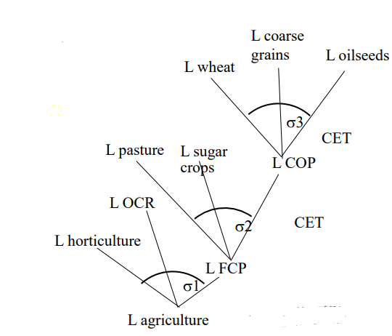
Figure 3. Land allocation tree in MAGNET
MAGNET includes two regimes of capital and labour mobility between sectors. Following the standard GTAP model specification, perfect capital and labour mobility between sectors can be assumed. The second approach assumes that capital and labour markets are segmented between agriculture and non-agricultural sectors (De Janvry et al. 1991). In such a case, capital and labour are fully mobile within each of these two sectors, but imperfectly mobile across them. This leads to differences in prices of capital and labour between agriculture and non-agriculture. The capital and labour market segmentation is introduced by specifying a CET structure (Keeney and Hertel 2005) with the elasticity of transformation equal to 1 which is twice as high as those used in PEM (OECD, 2006) since our simulation periods are relatively long (10-years). Next to this, labour is divided into two categories: skilled and unskilled. These categories are considered imperfect substitutes in the production process.
Since currently high migration from rural areas to cities in Africa is observed (IOM, 2015) and since we assume high GDP per capita growth in African countries which should lead to employment increase in industry and services, we use perfect labour and capital mobility for low developed African countries considered in this paper.
IMAGE
IMAGE is an integrated assessment modelling framework that simulates the interactions between human activities and the environment (Stehfest et al. 2014), to explore long-term global environmental change and policy options in the areas of climate, land and sustainable development. IMAGE consists of various sub-models describing land use, agricultural economy, the energy system, natural vegetation, hydrology, and the climate system. Most socio-economic processes are modelled at the level of 26 regions. Most environmental processes are modelled on the grid-level at 30 or 5 arc-minutes resolution. Data exchange takes place either through hard-coupling with annual exchange of data, or soft-coupling using an iterative approach of scenario data exchange. Land supply, suitability and potential agricultural yields are evaluated on a grid-scale in IMAGE and provided to MAGNET and used to model land as a production factor described by a land supply curve.

2.2 Data base
The analysis used an adjusted version 9 the GTAP database (Angel at al. 2016). Original GTAP database contains detailed bilateral trade, transport and protection data characterizing economic linkages among regions, and consistent individual country input-output databases which account for intersectoral linkages. All monetary values of the data are in millions of US dollars and the base year is 2011. It distinguishes: 140 regions and 57 sectors. For MAGNET applications, the data base was adjusted in order to implement two new sectors or by-products of sectors concerning agriculture, fishery, bio-based economy and electricity. So, the MAGNET database includes 94 sectors and 105 traded commodities.

2.3 Scenario implementation
For projections, we use the Shared Socioeconomic Pathway 2 (SSP2) developed to explore possible future socio-economic and technological developments in respect of climate change (O’Neill at al. 2012 and 2015, van Vuuren et al 2014). Socio-economic development in SSP2 scenario is characterized by moderate economic growth in low-income countries and slower economic growth in high-income countries. The overall population increase is moderate and much higher in low-income countries than in high-income countries. Income gaps between these two groups of regions are slowly closing and some international cooperation and technology transfer exists. Some progress in reducing fossil fuels and energy dependency is observed. SSP2 is often seen as the business as usual (BAU) scenario.
The SSP2 scenario uses quantitative GDP and population projections corresponding to the SSP2 scenario narrative which are taken from SSP Database - Version 2.0. Additional assumptions concerning agriculture are taken from O'Neill et al. 2015 and are quantified as drivers by IMAGE. Table 1 shows main macro-economic and land supply assumptions for African countries and regions. The scenario is run is using the MAGNET model coupled to IMAGE. MAGNET uses information from IMAGE on agricultural land availability, crop yield changes, pasture use intensification and changes in livestock production systems. In this way, also biophysical feedback such as depletion of high-yield land and climate impact on yields are implemented in MAGNET. For the current scenario, the standard data exchange for SSP2 from IMAGE to MAGNET was used, excluding shocks from climate change.
For the scenario experiments, the MAGNET database is aggregated to 59 sectors and, depending, on aggregation level of Africa (see below), to 28 or 36 countries or regions. The sectoral aggregation distinguishes among others agricultural sectors that use land (e.g. rice, grains, wheat, oilseed, sugar, horticulture, other crops, beef cattle, milk, and other cattle), landless meat production (e.g. pigs and poultry), processed food producing sectors, energy sectors, chemical sectors, other industries and services.

Two version of regional aggregation were applied, which differ by the disaggregation level of Africa. The aggregated Africa version uses the IMAGE disaggregation of Africa which includes five large aggregated regions: Northern Africa (NAF), Western Africa (WAF), Eastern Africa (EAF), Rest of Southern Africa (RSF) and South Africa (ZAF). The disaggregated Africa vision includes Northern Africa and South Africa, and eleven regions in sub-Saharan Africa (Figure 4):
- Western Africa (WAF) region: Western Sahel (WAS), West African Coast (WAC), Central Africa (CAF), Nigeria (NIG);
- Eastern Africa (EAF) region: Rest African Horn (AFH), Ethiopia (ETH), Kenya (KEN), Albertine Rift (ALBR), Madagascar Islands (MAIS)
- Rest of Southern Africa (RSF) region: Tanzania (TAN), Other Southern Africa (RSAF).
The split of Sub-Saharan Africa is determined based on data availability in the GTAP 9 database and similarities of biophysical and political/socio-economic circumstances. The number of regions was kept limited for practical purposes, as well as the desire to retain the possibility to re-aggregate to the original regions for comparison. Besides the Africa regions, the regional setup includes 23 of the most important countries and regions of the world (e.g. USA, Canada, Brazil, EU, Former Soviet Union, India, China Region, Southern Asia, Indonesia Region, Japan and Oceania).
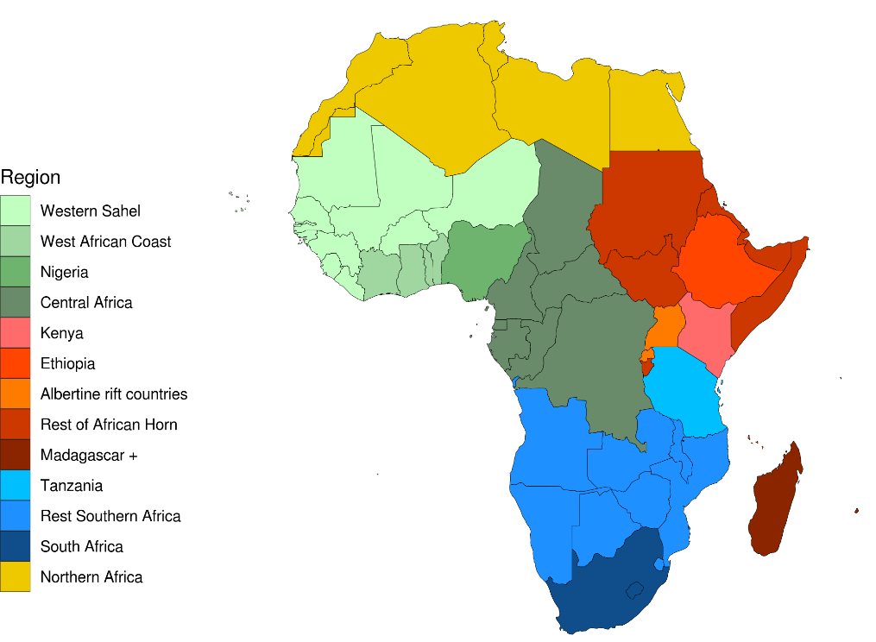
Figure 4. Africa regions
Two scenarios are run, one with aggregated African region (SSP2 scenario) and one with more disaggregated sub-Saharan Africa region (SSP2A scenario). The scenarios are constructed through recursive updating of the database for three consecutive time steps, 2011–2020, 2020–2030, 2030–2040 and 2040-2050 in such away such that exogenous GDP targets are met given the exogenous estimates on factor endowments - skilled labour, unskilled labour, capital and natural resources - and population. The procedure implies that an additional technological change is endogenously determined within the model. This technological change is translated to the sectoral level using a sector-specific growth ratio of total factor productivity based on CPB 2003. Sector-specific growth ratio of total factor productivity is relatively high in agriculture (3.1), relatively low in services (1.0) and vary between 1.0 and 3.4 in industry depending on the sector. CPB assumed that all inputs achieve the same level of technical progress within a sector (i.e., Hicks neutral technical change). We deviate from this approach by, e.g., using additional information on yields in agricultural sectors, assuming no capital related technological change, and assuming no primary agriculture related technological change in processed food (to preserve calorie balances) and no energy related technological change in energy sectors (to preserve energy balances).
Table 1. Macro-economic and land use efficiency and supply assumptions.
 | GDP and capital | Population and employment | GDP per capita | Exogenous average crop yield | Exogenous livestock-grassland efficiency | Exogenous average feed efficiency | Ratio (%) agricultural land use 2011 to land availability in: |  | Land supply elasticity 2011
 | 2010-2050 (% change) |  |  |  |  |  | 2011 | 2050
Northern Africa (NAF) | 363 | 40 | 232 | 32.6 | 21.8 | 5.0 | 97 | 98 | 0.19
Western Africa (WAF) | 909 | 113 | 375 | 45.3 | 54.2 | -1.0 | 59 | 64 | 0.24
Western Sahel (WAS) | 1209 | 116 | 506 | 45.1 | 53.6 | -1.7 | 52 | 57 | 0.33
West African Coast (WAC) | 891 | 89 | 425 | 47.3 | 55.0 | -2.6 | 62 | 71 | 0.18
Central Africa (CAF) | 596 | 76 | 295 | 43.9 | 55.0 | -1.2 | 60 | 64 | 0.18
Nigeria (NIG) | 926 | 129 | 348 | 45.4 | 55.0 | 5.1 | 90 | 90 | 0.07
Eastern Africa (EAF) | 761 | 100 | 330 | 43.2 | 70.5 | 10.4 | 80 | 84 | 0.20
Ethiopia (ETH) | 973 | 87 | 473 | 42.4 | 66.4 | 9.1 | 45 | 47 | 0.22
Kenya (KEN) | 709 | 88 | 331 | 44.6 | 71.4 | 7.5 | 65 | 72 | 0.03
Rest African Horn (AFH) | 644 | 85 | 303 | 42.7 | 70.7 | 10.7 | 97 | 99 | 0.21
Albertine Rift (ALBR) | 1200 | 156 | 409 | 44.2 | 71.4 | 13.1 | 75 | 83 | 0.10
Madagascar Islands (MAIS) | 518 | 106 | 200 | 43.4 | 71.4 | 10.8 | 80 | 91 | 0.04
Rest of Southern Africa (RSF) | 496 | 101 | 197 | 53.3 | 40.3 | 19.3 | 60 | 67 | 0.37
Tanzania (TAN) | 1072 | 122 | 429 | 53.5 | 40.4 | 31.9 | 45 | 52 | 0.33
Other Southern Africa (RSAF) | 430 | 94 | 173 | 53.2 | 40.3 | 17.3 | 63 | 70 | 0.37
South Africa (ZAF) | 254 | 25 | 184 | 49.4 | 38.5 | 5.2 | 91 | 100 | 0.33

Table 1 shows macro-economic and land supply assumptions of the scenarios. It shows that macroeconomic assumptions (GDP, population and technological progress) differ substantially in countries and regions within Western Arica, Eastern Africa and Rest of Southern Africa regions. For GDP, population and land availability, the average values of the disaggregated regions are consistent with the larger regions. Assumptions concerning exogenous land use efficiency for individual crops and livestock differ between aggregated regions but they are the same within the regions. The differences in average efficiency within the regions are consequences of different production composition of individual crops and livestock. The same concerns feed efficiency ratios. Land availability differs considerably within the regions. In IMAGE, some land is considered unavailable for agricultural production due to biophysical reasons such as low productivity, steep slopes, permafrost, ice cover, or wetlands. Land is also excluded for other reasons such as nature conservation in protected areas and urban areas (Doelman et al. 2018). The resulting agricultural land in use includes extensive grasslands, so the values can be high for example in AFH, in which Sudan has large areas of low intensity grazing. Decreasing availability of agricultural land in 2050 compared with 2011 situation is a consequence of biodiversity protection, where, protected areas are expanded to achieve the Aichi biodiversity target in which 17% of terrestrial environments are protected (CBD, 2010).

3 Agricultural sector development in African countries and regions

3.1 Food security
High increase of GDP per capita and related increase of per capita incomes leads to an increase of per capita demand for food in all African countries and regions. The smallest increase of calories availability is observed in ZAF and NAF (267 and 295 kcal per capita per day respectively) where calories supply is already relatively high in 2011 (around 3000 kcal per capita per day), and NIG where land supply is very limited and where population growth is very high and much higher than exogenous yields increase. The highest increase is in RSAF (more than 1000 kcal per capita per day) where calories supply in 2011 is the lowest among African regions (1569 kcal per capita per day). Also calories supply in KEN is increasing strongly (more than 700 kcal per capita per day) as the population increase in this regions is relatively low compared with exogenous land use efficiency increase) and a lot of unused land is available. In the remaining countries/regions calories availability increases by 400 - 500 kcal per capita per day (Figure 5). Despite considerable increase of food consumption, the share of food in total consumption is decreasing considerably as result of substantial income increase. The Africa wide average share of food in total consumption is 23% in 2050 compared with 48% in 2001 but it is much higher the OECD share equal to 6%
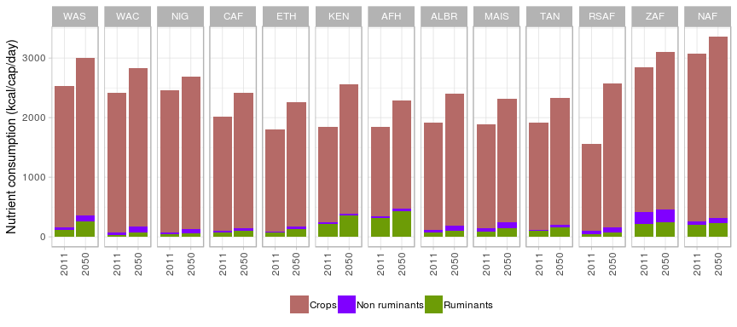
Figure 5. Per capita per day calories supply
Food access measured by average agricultural and agri-food (which includes processed foods) price level is more diverse (Figure 6). In almost all regions these prices move together in the same directions but the ruminants commodities prices are increasing considerably more than non-ruminants since ruminant sectors use land as important production factor. In most of the African regions real food prices are increasing which result in decreased food accessibility. Decreasing food prices resulting in improving food access is observed in only five regions: NAF, WAC, AFH, RSAF and ZAF. In all these regions, much land is available for agriculture at relatively low cost (land supply elasticities are relatively high) and at the same time difference between population growth and assumed (exogenous) yield growth is relatively low which means that a pressure from population growth on land and land prices is relatively low. ETH, ALBR and TAN suffer from very high (between 50 and 60 percent) food prices increase. This is due to several factors. They are net agri-food products exporters and export is a significant share of their production which increases demand for agricultural sector output which in turn lifts prices. Next to this, their agriculture is labour and capital intensive and prices of these production factors increase in these regions. Finally, ALBR population increases much faster than assumed exogenous yield growth which results in high land prices. However, despite food prices increase, food becomes more affordable also in these regions because income growth is higher than price growth.
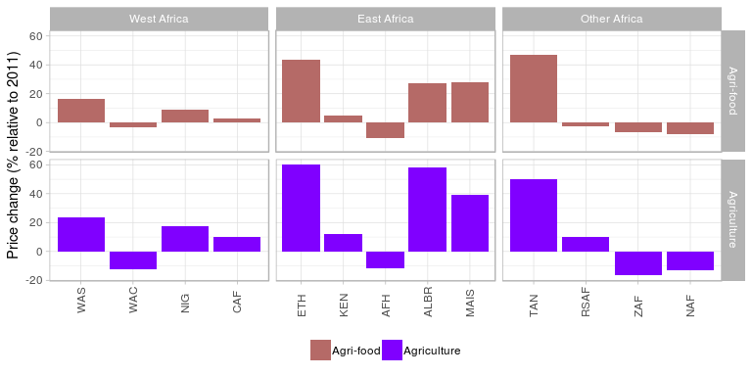
Figure 6. Real agricultural and agri-food price, changes relative to 2011 values (production price, real market prices)..
The high level of income leads to a higher share of calories of animal origin and lower share of calories originated from cereals. The only exception is RSAF. The shares of animal calories in total calories consumption increases by 20 - 130 percent depending on region. The highest increase is observed in WAF countries (93% on average) while the lowest in the RSF region (16% on average). In most of the regions increase of non-ruminants calories supply is higher than ruminant calories since non-ruminant meat does not requires grassland as a production factor. However, despite of significant increase of animal products supply, their share in total calories consumption is low in most of the regions (in whole Africa 9% on average in 2050) compared with OECD countries with on average about 26%. The reason for this is because the 2011 share is very low in Africa (7.2%). In many regions share of wheat and oil seeds in total consumption increases in expense of other crops which leads to more nutritious diets.
The low animal calories supply in RSAF is consequence of low income per capita growth in this region. Also, in 2011, the majority of animal product consumption is on-farm consumption (63%), the share of which in total consumption relatively decreases when income increases.
Increasing per capita demand for food together with significant growth of the population leads to increase of agricultural production (Table 2). Following consumption trends, in the most of the regions animal commodities production is growing faster the crop production. On average for whole Africa animal production volume increases by 209% and crops production by 150% in 2011. The exception are ZAF and NAF which have relative high income elasticities of consumption for other processed food products compared with meat products, Another exception is Kenya where 80% of non-ruminant meat consumption is on farm consumption and this type consumptions is gradually decreasing when incomes increase.
Table 2.Percentage change of the production volume in 2011 – 2050.
 | WAS | WAC | NIG | CAF | ETH | KEN | AFH | ALBR | MAIS | TAN | RSAF | ZAF | NAF
Agriculture | 250 | 88 | 181 | 166 | 164 | 88 | 226 | 202 | 162 | 233 | 199 | 103 | 101
Crops | 222 | 80 | 168 | 164 | 125 | 72 | 226 | 190 | 111 | 217 | 197 | 115 | 101
Livestock | 454 | 296 | 339 | 176 | 324 | 278 | 227 | 342 | 247 | 307 | 207 | 91 | 101
Non-ruminants | 482 | 321 | 466 | 159 | 362 | -8 | 239 | 378 | 252 | 349 | 221 | 62 | 109
Ruminants | 424 | 194 | 302 | 202 | 313 | 289 | 220 | 335 | 246 | 288 | 200 | 112 | 99

The production distribution of crop and livestock products shows that in all regions except of ZAF, the share of livestock products in total agricultural production volume (in 2011 $) is increasing (Figure 7a). When the production is measured in quantity terms (tonnes) the livestock shares are decreasing not only in ZAF but also in AFH and NAF (Figure 7b). Also, livestock output shares are lower in quantity terms than in volume terms. This is the base year price effect. Apparently, livestock prices in ton of output are higher the crop prices in 2011.
When production in volume terms is considered, (in 2011 $), NIG is the most important agricultural commodities producer. It produces 44% of total volume of agricultural production in Africa in 2050. Since 2011, its share is increasing by 3% while share of the second biggest African producer - ZAF - decreases in the same period from 20% to 16%. In terms of quantity, NIG is still the most important producer but its share is 22%. The other important producers are NAF, WAS and RSF with production shares between 12 and 14 percent.
In total, African production of agricultural commodities is more than sufficient to cover the domestic demand. The related self-sufficiency ratio is equal to 102% for Africa as a whole in 2050 and it increases by 2% compared with 2011. The self-sufficiency ratio differs by region and vary from 92% for NAF to 147% for ZAF (Figure 8) but is higher than 100% for most of the regions. The exceptions are NIG, KEN, MAIS and NAF where land is scarce and/or expensive. However, for most of the regions, self-sufficiency rates are decreasing. The exceptions are WAS, AFH and TAN which are the land rich regions, and NAF region where food consumption is already high in 2011 and where population increases only a little bit faster than exogenous use land efficiency.
a)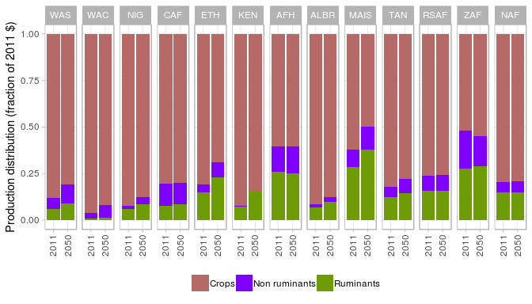
b) 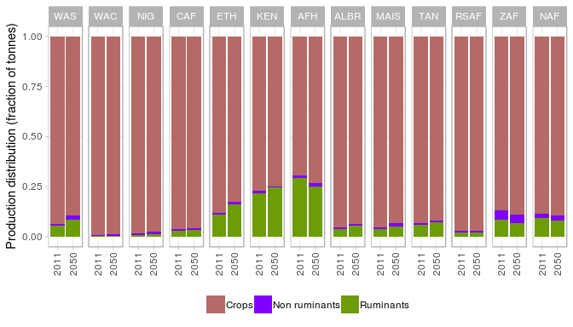
Figure 7. Production volume distribution among crops, ruminants and non-ruminants: a) fraction in volume terms (2011 $) and b) fraction in quantity terms (tonnes).
Differently than for primary agricultural commodities, Africa as a whole is not self-sufficient in agri-food production (i.e. the aggregate of agricultural and processed food commodities) and the reflated self-sufficiency ratio is 95% In majority of regions self-sufficiency rate decreases in time. The exceptions are WAS, CAF, AFH, TAN and NAF which shows slight increase in agri-food self-sufficiency, and ZAF where food self-sufficiency ratio is increasing by 15% in the 2001 - 2050 and reaches 118%.
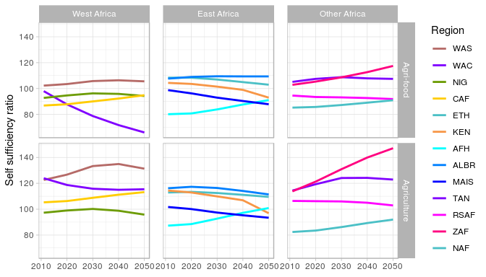
Figure 8. Self-sufficiency ratio (%) for agricultural commodities and for agri-food commodities.

3.2 Land use
Overall, land use increases in all regions except KEN and ZAF (Table 3). The total increase of agricultural is 23% for whole Africa in the period 2011 - 2050. The highest increase of land use, between 26 and 56 percent, is observed in WAS, CAF, ETH, TAN and RSAF regions which have the highest and not expensive reserves of agricultural land. The opposite situation is observed in NAF, KEN, AFH, MAIS and ZAF were demand for agricultural land is barely increasing or slightly decreasing. In the AFH region, especially in Sudan, much of the land already in use is low-intensity pasture area, and the only expansion of agricultural land is due to increase in cropland. In WAC, NIG, KEN, and MAIS, crop areas are decreasing, while at the same time livestock areas are increasing.
Table 3. Percentage change of land use in 2011 – 2050. Agriculture represents the combined land use of crops and livestock.
 | West Africa |  |  |  | East Africa |  |  |  |  | Other Africa
 | WAS | WAC | NIG | CAF | ETH | KEN | AFH | ALBR | MAIS | TAN | RSAF | ZAF | NAF
Agriculture | 56 | 10 | 10 | 26 | 40 | -1 | 1 | 19 | 0 | 56 | 35 | -1 | 1
Crops | 22 | -2 | -4 | 22 | 18 | -20 | 12 | 21 | -6 | 36 | 31 | 14 | 15
Livestock | 67 | 25 | 29 | 27 | 55 | 5 | 0 | 16 | 1 | 68 | 36 | -3 | -2

Following higher demand and production growth of ruminants than crops, grassland area is increasing much stronger than crop area. For Africa as a whole, ruminant production and grassland is increasing 11% faster than crop production and area. There are significant differences in increase of grassland among African regions. In WAS, ETH, TAN and RSAF, where a lot of agricultural land is available, the increase of grassland is the most pronounced: between 36 and 68 percent. The opposite situation in observed in NAF, KEN, AFH, MAIS and ZAF. Overall, share of grassland area in total agricultural area in Africa is very high: 78% in 2001 and 80% in 2050 (Figure 9).
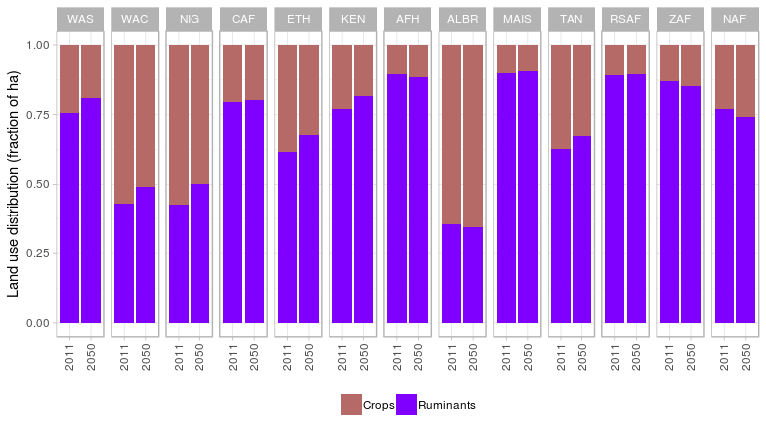
Figure 9. Agricultural land use distribution between cropland and grassland (share).
Increase of agricultural land leads to depletion of available land resources (Figure 10). This is consequence of increasing demand on agricultural land as well as decreasing land availability caused by biodiversity protection. The land reserve is decreasing substantially in Eastern and Western Africa, from 60 to 90 percent of land available in use by agriculture, and remains at high levels, approaching 100%) in southern and northern Africa. A number of countries, KEN, ZAF, and MAIS in particular, show little to no agricultural expansion (Table 3); the increase of percentage land in use is due increases of protected areas implemented in the scenarios which limits the amount of land available for agriculture.
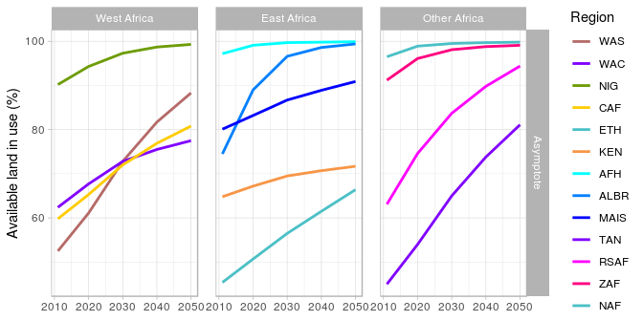
Figure 10. Percentage of available agricultural land in use.
Increase of agricultural area is associated with high increase of real land prices (Figure 11). We use real land value added per hectare as a measure of real land price. On average, real land price increase (11 times) and outperform the OECD prices by 6.7% in 2050. The highest increase of land prices (21 times) is observed in NIG and ALBR where pressure on land (measures difference between population growth and exogenous land use intensification) is the highest. For most of the regions the real price of crops is higher than for grassland.
a)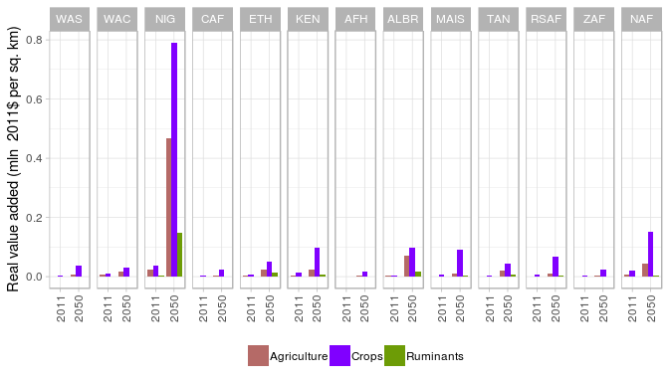
b) 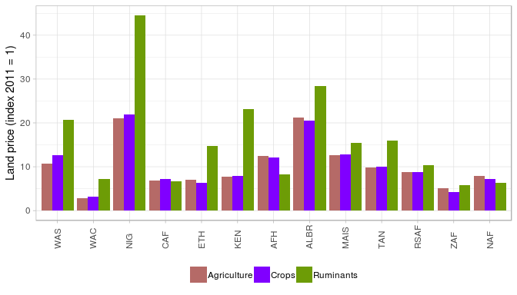
Figure 10. Real land value added per hectare in 2050: a) mln 2011 $ per sq. km, b) index 2011 = 1 .
The overall land productivity in Africa is more than doubling (Figure 12). The productivity increase is higher in crop than in ruminant production: 115% and 106% respectively from which 45% and 51% is due to exogenous land productivity improvement and the remaining part due to intensification, which is 12% higher in crop than in ruminant sector. For example, in West Africa on average, the yield of grains (maize and tropical cereals) is projected to double from a little less than 1 ton/ha to 2.2 ton/ha in 2050.
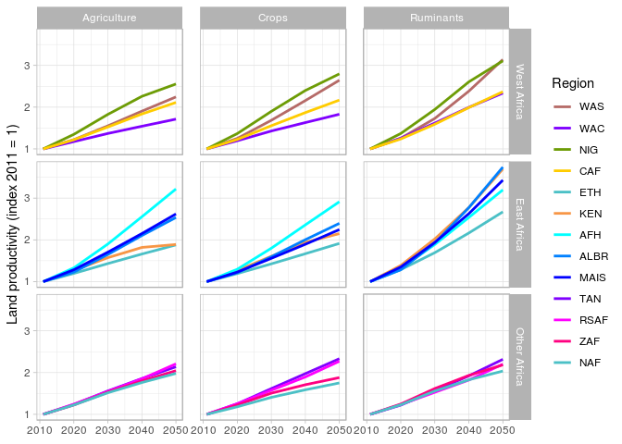
Figure 11. Agricultural land productivity index 2011 = 100.
High increase of land prices leads to intensification of agricultural production, i.e. in using relatively more capital, feed and fertilizer than land in the production process (Figure 13). At the same time less labour is used in agriculture since labour prices are relatively higher than other production factor prices (Figure 14). Labour prices increase more than other input prices since labour in constrained factor increasing slower than GDP and capital. The high intensification in the crop sector leads to decrease of crop area in WAC, NIG, KEN and MAIS regions.

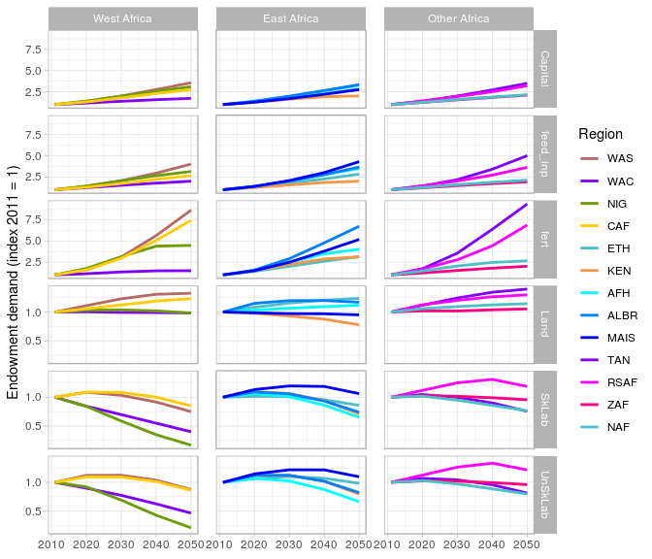
Figure 12. Primary production factors, feed and fertilizer used in agriculture: index 2011 = 100.
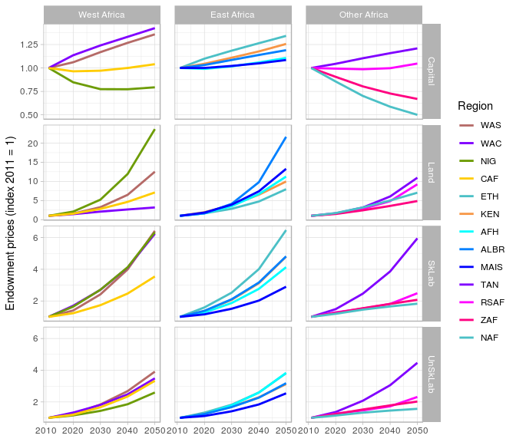
Figure 13. Primary production factors, feed and fertilizer real price index 2011 = 100.

3.3 Trade
Volume of African exports, imports and net exports of primary agricultural commodities increases in the period 2011 – 2050 (Figure 14 and 15). The increase of exports volume is almost two times higher than imports volume. Only two regions show decreasing exports and net-exports: KEN and MAIS. The net exports decrease also for NIG. Increase of imports is driven by increasing domestic demand. Exports increases because African exports to China, India, Rest of South Asia, South East Asia and Indonesia. In 2050, more than 54% of African exports (this share for particular African countries varies from 20% to 68%) goes to these five regions where agricultural prices increase more than in Africa and this drives the African export. In 2050, intra-African trade (exports volume) consists only 14% of total African exports which is 2% more than 2011.
Trade in processed food behaves differently than in agricultural commodities (Figure 15). Both, exports, imports of processed food increase for almost all African countries and regions (the exception is WAC and KEN exports), but imports increase 50% faster than exports which results in negative next exports change in all African regions. So, Africa is net exporter of agricultural commodities but net importer of processed food and has negative trade volume balance in agri-food trade.
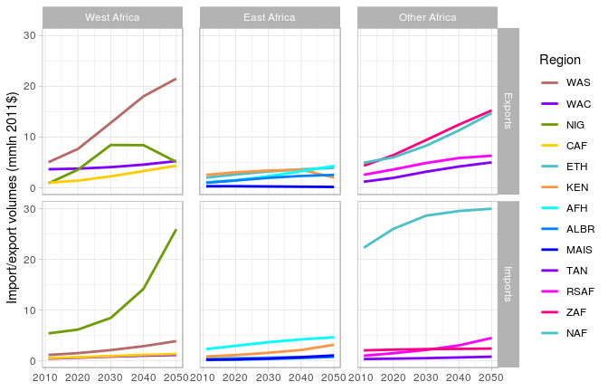
Figure 14. Export and imports volume of agricultural commodities in 2011$
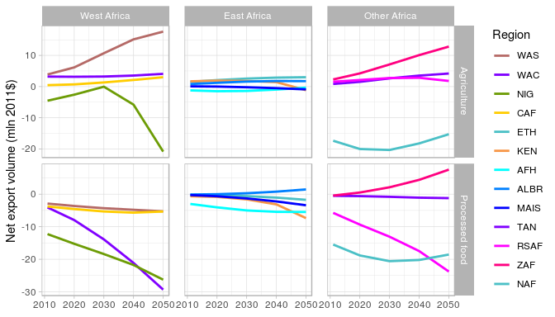
Figure 15. Net exports volume of agricultural commodities in 2011$

4 Comparison of SSP2 and SSP2A scenario results for aggregated regions
The compare of SSP2 and SSP2A scenario results, we show both results next to each other and provide percentage difference between SSP2 and SSP2A scenario results. We start the analysis with comparing results for regions which have been disaggregated to subregions in SSP2A, i.e. EAF, WAF and RSF. The results show that agricultural area increase is higher in SSP2. The available agricultural land is better utilized for aggregated regions since areas not used in land-rich subregions can be used for agricultural production in land scarce subregions of aggregated region. The agricultural area in EAF region is considerably higher (8.7% in 2050) in SSP2 than in SSP2A (Figure 16). This is an effect of land scarcity in AFH and MAIS subregions which use 74% of agricultural area of EAF. For WAF and RSF regions, this difference is much smaller (around of 2.1% and 1% respectively at the end of simulation period). In is also worth to notice that differences in land areas stabilize in time when land reserves are getting depleted.
The higher use of agricultural land in EAF and RSF is a consequence of higher grassland area (by 11% and 1.3% respectively) while cropland area is lower in both regions (by 1.8% and 1.1% respectively) in SSP2 compared with in SSP2A. In WAF both grassland and cropland areas are higher but cropland area change in percentage terms is higher than grassland (5.4% versus 0.9%).
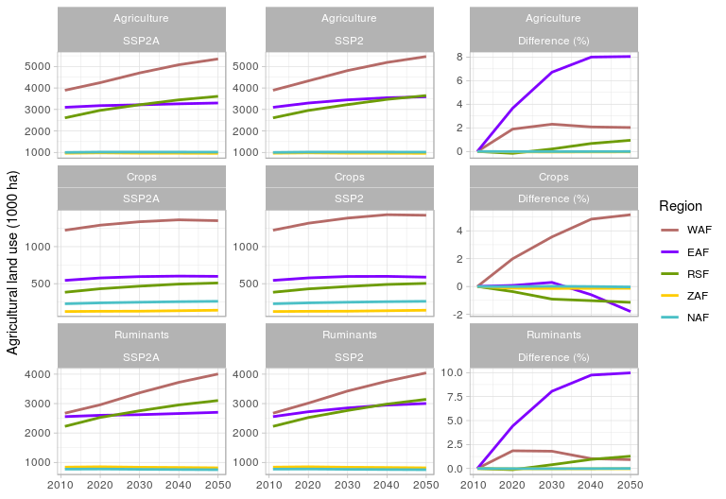
Figure 16. Agricultural area
Higher supply of agricultural land results in higher consumer demand, domestic demand and production in volume terms in EAF, WAF and RSF in SSP2 compared with SSP2A (Figure 17). Production is increasing more than domestic demand in EAF and WAF which results in higher net exports and self-sufficiency of these regions in SSP2 (Figure 18). The level of production is significantly higher in EAF and WAF (12% and 9% respectively) and only slightly higher in RSF in SSP2 compared with SSP2A. Difference for RSF is much lower because the RSF subregions are much more homogenous in respect of land characteristics than EAF and WAF. However, RSF subregions differs importantly by macroeconomic characteristics. In particular, TAN GDP per capita is growing 250% more than RSAF. This difference in GDP growth results in higher income elasticities of consumption in RSF in SSP2 than average elasticities of TAN and RSAF in SSP2A. This, in contrast with EAF and WAF, leads to higher increase of domestic demand (by about 3%) than production in RSF in SSP2 compared with SSP2A.
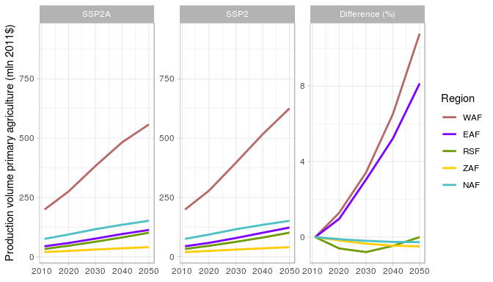
Figure 17. Agricultural primary production volume in mln 2011$
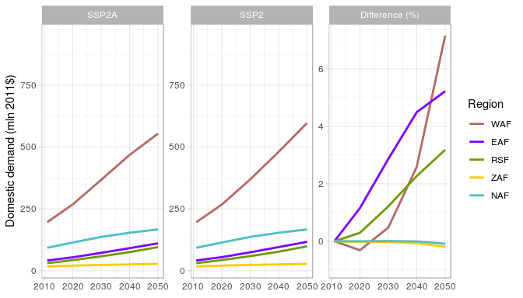
Figure 18. Volume of domestic demand for agricultural primary commodities in mln 2011$
In WAF, production is growing faster than land which is an effect of increasing land productivity resulting from more intensive use of land. Land productivity in these region increases gradually in time is 10% higher in 2050 in SSP2 than in SSP2A (Figure 19). Very high agricultural land use in EAF in SSP2 results initially in lower land productivity in this scenario compared with SSP2A. Only, in 2050 land productivity in EAF in SSP2 is slightly (by 0.1%) higher than in SSPA. In RSF, land use is growing faster than production which results in 0.9% lower land productivity in SSP2 compared with SSP2A.
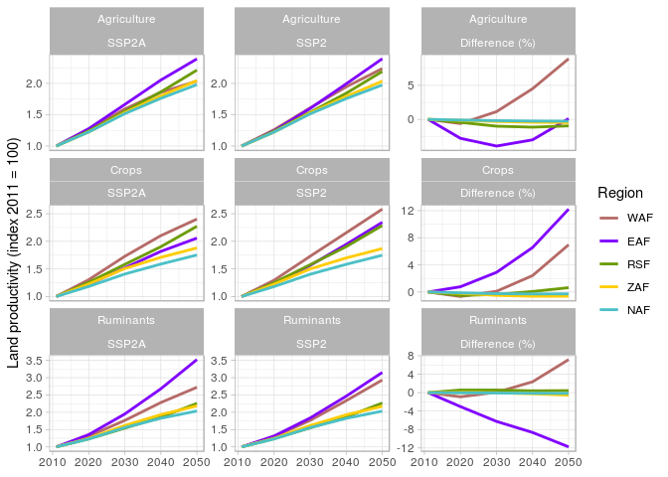
Figure 19. Total agricultural productivity change (index 2011=1)
The land prices comparison (Figure 20) shows a mixed picture since land prices development depends on shape of land supply function which in turn depends on land price elasticity and land availability in aggregated regions and their subregions. In case aggregated WAF and EAF, the land constrain is weaker but probably does not change a lot in RSF since RSF subregions are similar in respect of land characteristics. The results shows 15% and 17% lower land price in WAF and EAF respectively, and 4% higher in RSF in SSP compared with SSPA. The cropland and grassland prices are changing in the same direction as total land price.
Decrease of land prices and land and productivity growth results in decrease of agricultural prices WAF and EAF (by 6% and 10% respectively) and increase RSF (by 1.4%) in SSP2 compared with SSP2A (Figure 21). The food prices are changing in the same direction but differences between SSP2 and SSP2A are much smaller.
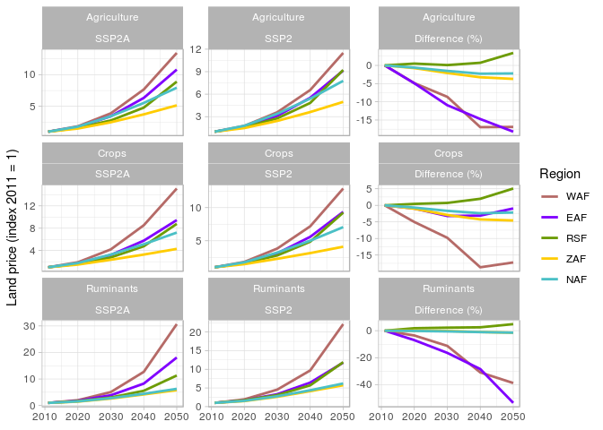
Figure 20. Real land price (index 2011=1)
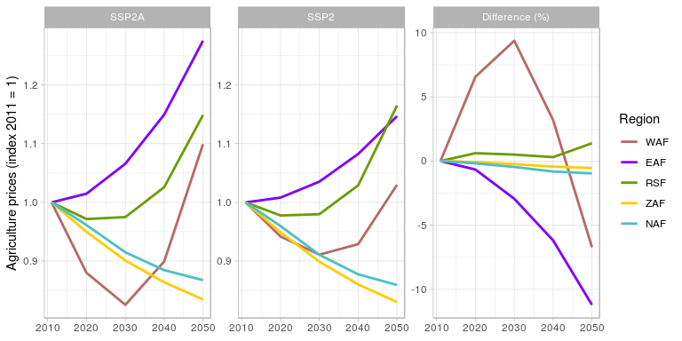
Figure 21. Real market prices of agricultural primary commodities (index 2011=1)
The difference between SSP2 and SSP2A for EAF, WAF and RSF are driven by supply difference in agricultural land. In case of RSF the demand factor plays also a role. The differences for NAF and ZAF are driven by external demand changes. Supply of agricultural commodities on the world market by EAF and WAF is increasing in SSP2 compared with SSP2A and this leads to slight lowering of exports imports and production of agricultural commodities. In both regions, differences between SSP2 and SSP2A are marginal. Land use almost does not change and production of agricultural commodities increases only by a fraction of a percent.

5 Conclusions
Our results of the MAGNET scenarios analysis with 13 African subregions highlight key challenges that face these regions. For all regions, high population and GDP growths are projected, which directly translates into growing food demand and thus increases in agricultural production. We find that food prices on average increases for sub-Saharan Africa from 2011 to 2050 but not for all sub-regions. The still relatively low cost of land and significant land productivity and feed efficiency increase makes it possible to keep prices low compared to income growth. The share of animal products in diets almost doubles, but still the overall share of calories consumed of animal products stays below 10% in 2050. Agricultural production increases range from +88 to +250%, with an emphasis on increased production of livestock. Following higher demand and production growth of ruminants than crops, grassland area is increasing much stronger than crop area. In some cases, due to high intensification, there is actually decrease in crop areas (also related to land not being taken from grassland).
Land use change per Sub-Saharan countries and regions differs considerably and varies from -1% decrease for Kenya (KEN) to 56 % increase for Western Sahel (WAS) and Tanzania (TAN) depending on availability of cheap agricultural land. Nigeria (NIG) is the main hotspot for increased land prices and additional need for land use intensification resulting from high pressure on the food demand given low agricultural land availability and relatively low land use efficiency increase compared with population growth Rest of African Horn (AFH) shows similar high land use intensification as Nigeria. This is mainly observed in in crops production where rather low exogenous land use intensification compared with grassland is assumed. This locks land in livestock sector. In AFH, and other regions to a lesser degree, almost 90% of agriculture in 2011 is classified under (extensive) grassland. Land prices remain low so there is no strong drive to conversion of cropland to pasture. These highlight the challenge of determining the amount of land available for agriculture and how much currently defined as pasture could be converted to cropland. Additionally, this highlights the need to focus on grazing management improvements as well as intensification as contributions to increasing food production.
Food availability, measured by calories supply per capita, increases significantly for all sub-Saharan Africa countries and regions (by 22% on average in the 2011 - 2050 period and with minimum of 2170 kcal per capita per day in Rest of African Horn (AFH)) and diet is more nutritious. However, the picture of food access measured by average agricultural and food price level is less optimistic. In most Sub-Saharan countries and regions real food prices are increasing which result in decreased food accessibility. Ethiopia (ETH) and Tanzania (TAN) are the main hotspot for increased agri-food prices (they increase by 44% and 47% respectively). In these two countries, GDP per capita is increasing the most which, from one side, drives demand for food and, form other side, drives demand and prices of unskilled labour which is important primary production factor for agri-food commodities.
The comparison of SSP2 (with 5 regions) and SSPA (13 regions) shows that agricultural area increase is higher in SSP2. The available agricultural land is better utilized for aggregated regions since areas not used in land-rich subregions can be used for agricultural production in land scarce subregions of aggregated region. Higher supply of agricultural land results in higher consumer demand, domestic demand and production in volume terms in EAF, WAF and RSF in SSP2 compared with SSP2A. Especially, the agricultural area in Eastern Africa (EAF) region is considerably higher (8.7% in 2050) in SSP2 than in SSP2A which is a consequence of considerable heterogeneity of EAF subregions in respect of land availability. This is not a case for Western Africa (WAF) and especially in Rest of Southern Africa (RSF) which results in rather small differences in land use between scenarios. It is also important to notice that that differences in land areas increase in time and then stabilize when land reserves are getting depleted.

References
Angel A., at al., 2016. An Overview of the GTAP 9 Data Base. Journal of Global Economic Analysis 1, no. 1 (June 3,2016): 181-208.

CPB, 2003. Four futures of Europe. Netherlands Bureau for Economic Policy Analysis, The Hague, The Netherlands.

De Janvry A., M. Fafchamps M. and E. Sadoulet E., 1991. Peasant household behaviour with missing markets: some paradoxes explained. Economic Journal, 101: 1400-1417.

Dixon P, H. van Meijl H., M. Rimmer M., L. Shutes L. and A. Tabeau, 2016, RED versus REDD: Biofuel policy versus forest conservation, Economic Modelling, Vol. 52, pp 366-374.

Hertel, T., W. 1997. Global trade analysis: modelling and applications. Cambridge University Press.

IPBES, 2018. The IPBES assessment report on land degradation and restoration. Montanarella, L., Scholes, R., and Brainich, A. (eds.). Secretariat of the Intergovernmental Science-Policy Platform on Biodiversity and Ecosystem Services, Bonn, Germany. .

IOM, 2015. World Migration Report 2015. International Organization for Migration.

Keeney, R. and T. Hertel, 2005. GTAP-AGR: A framework for assessing the implications of multilateral changes in agricultural policies. GTAP Technical Papers 1869. Department of agricultural Economics, Purdue University

OECD, 2001. Market Effects of Crop Support Measures. Organization for Economic Co–operation and Development, Paris.

O’Neill B.C., at al., 2012, “Meeting Report of the Workshop on The Nature and Use of New Socioeconomic Pathways for Climate Change Research, Boulder, CO, November 2–4, 2011. http://www.isp.ucar.edu/socio-economic-pathways

O’Neill B.C., at al., 2015, “The roads ahead: Narratives for shared socioeconomic pathways describing world futures in the 21st century”, Global Environmental Change. http://dx.doi.org/10.1016/j.gloenvcha.2015.01.004

Salhofer K. 2000. Elasticities of substitution and factor supply elasticities in european agriculture: a review of past studies. Diskussionspapier Nr. 83-W-2000. Department of Economics, Politics, and Law at the Universität für Bodenkultur Wien.

Stehfest E., at al., 2014, “integrated assessment of global environmental change with IMAGE 3.0. Model description and policy applications”, The Hague: PBL Netherlands Environmental Assessment Agency.

SSP Database - Version 2.0,
https://tntcat.iiasa.ac.at/SspDb/dsd?Action=htmlpage&page=about#v2

Tabeau, A., J. Helming, J., Philippidis, G., 2017. Land supply elasticities, overview of available estimates and recommended values for MAGNET, JRC Technical Report No EUR 28626.

United Nations Convention to Combat Desertification. 2017. The Global Land Outlook, first edition. Bonn, Germany.
van der Esch S., B. ten Brink, E. Stehfest, M. Bakkenes, A. Sewell, A. Bouwman, J. Meijer J, H. Westhoek, M. van den Berg, 2017. Exploring future changes in land use and land condition and the impacts on food, water, climate change and biodiversity: Scenarios for the Global Land Outlook. PBL Netherlands Environmental Assessment Agency, The Hague.
van Meijl, H., T. van Rheenen, A. Tabeau and B. Eickhout, 2006. The impact of different policy environments on land use in Europe, Agriculture, Ecosystems and Environment, Vol. 114, pp. 21-38.

van Vuuren D., at al., 2016, “Energy, land-use and greenhouse gas emissions trajectories under a green growth paradigm”, submitted to Global Environmental Change.

Woltjer G.B., at al., 2014, “The MAGNET model - module description”, The Hague: LEI - part of Wageningen University and Research Centre.

International Organization for Migration, 2015: World Migration Report 2015.

A food affordability index is the ratio of price of a food to wages or income.

