Effective Capacity Expansion of Renewable Energy for Decarbonization

Mei Yuan, Karen Tapia-Ahumada², David Montgomery

¹ MIT Joint Program on the Science and Policy of Global Change
² MIT Energy Initiative

June 19, 2019

Abstract
U.S. is moving towards more renewable generation. With the aim for a transition to a low-carbon energy system, many states have proposed to extend or increase their renewable portfolio standards (RPS) targets. The policy ambition of integrating more renewable generation together with other greenhouse gas mitigation efforts brings challenges for the power system operation. The path to de-carbonization through fast expansion of renewable generation will impact not only the electricity sector but other sectors such as transportation, energy-intensive industry, energy conversion and supply sectors. Increasing dependence on renewables demands greater system flexibility such as the deployment of fast-response electric generating units, additional reserve requirements, transmission interconnections across regions, and energy storage units. Investment in renewable capacity as well as ancillary capacities as a backup to resolve intermittency competes with investment in other low-carbon energy sources or technologies.
To evaluate the RPS policy proposals, we use an integrated top-down bottom-up modeling framework that combines a regional chronological hourly-dispatch and capacity expansion electricity model with a multi-region multi-sector dynamic general equilibrium model of the U.S. economy. This model explicitly addresses the intermittency of renewable electricity in order to answer questions about how tighter RPS requirements would affect the delivered cost of electricity and the marginal investment cost of RPS in carbon reduction. We set up scenarios that enable us to trace out a marginal investment cost curve for RPS by interpolating between the scenarios results. In addition, we ask how tighter RPS requirements affect the share of investment that must be devoted to capacity expansion due to increasing renewable generation relative to the need to fund and develop other low-carbon strategies, such as programs to induce low-carbon transportation fuels. By comparing the costs of tighter RPS standards across regions we investigate how they affect the time profile of generation costs.

Introduction
U.S. is moving towards more renewable generation. With the aim for a transition to a low-carbon energy system, many states have proposed to extend or increase their renewable portfolio standards (RPS) targets. The policy ambition of integrating more renewable generation together with other greenhouse gas mitigation efforts brings challenges for the power system operation. The path to de-carbonization through fast expansion of renewable generation will impact not only the electricity sector but other sectors such as transportation, energy-intensive industry, energy conversion and supply sectors. Increasing dependence on renewables demands greater system flexibility such as the deployment of fast-response electric generating units, additional reserve requirements, transmission interconnections across regions, and energy storage units. Investment in renewable capacity as well as ancillary capacities as a backup to resolve intermittency competes with investment in other low-carbon energy sources or technologies.

An Integrated Approach
Renewable energy is constrained by regional resources and characterized by intermittent supply. Hence, an approach to the issues ought to accurately represent renewable generation spatially and temporally. A capacity expansion and operational model with profiles on hourly demand and hourly supply of wind and solar by geographic region can provide a reasonable spatiotemporal representation of the electricity system. To address power operation issues and policy effectiveness, we develop an integrated model that combines two paradigms used by policy and decision makers, namely top-down (TD) and bottom-up (BU) approaches that combines a regional chronological hourly-dispatch and capacity expansion electricity model with a multi-region multi-sector dynamic general equilibrium model of the U.S. economy. This approach incorporates interactions among different aspects of the economy and generates a set of internally consistent solutions, serving as an analytical tool to reliably guide future operations, investments, and policies decisions.

The Top-Down Model
The top-down component of the integrated model is the MIT U.S. Regional Energy Policy (USREP) model, a multi-region multi-sector energy-economic general equilibrium model of the U.S. economy (Rausch et al., 2010, 2011, 2014, Yuan et al., 2017). USREP is built on a state-level economic dataset of the U.S. economy, called IMPLAN (IMPLAN, 2008) covering all transactions among businesses, households, and government agents for the base year in 2006. For the purpose of energy and environmental policy study, we improve the characterization of energy markets in the input-output dataset prepared by IMPLAN by replacing its energy accounts with physical energy quantities and energy prices from Energy Information Administration State Energy Data System (EIA-SEDS, 2009) for the same benchmark year 2006. The final dataset is rebalanced using constrained least-squares optimization techniques to produce a consistent representation of the economy.
The standard version of USREP aggregates 509 commodities in the IMPLAN dataset to five energy sectors and six non-energy sectors. The energy sectors include coal (COL), natural gas (GAS), crude oil (CRU), refined oil (OIL) and electricity (ELE). The non-energy sectors include energy-intensive industries (EIS), agriculture (AGR), commercial transportation (TRN), personal transportation (HHTRN), services (SRV) and all other goods (OTH). In each sector, output is produced using inputs of labor, capital, energy and intermediate material goods. Primary energy production sectors (crude oil, shale oil, coal, natural gas) use depletable natural resources (crude oil, coal, and natural gas). The model also includes primary energy production sectors that use renewable, non-depletable resources (wind and biomass). Agriculture and biomass production use land. Production is modeled assuming constant-elasticity-of-substitution (CES) functions that is constant returns to scale. Firms operate in perfectly competitive markets and sell their products at a price equal to marginal costs. In each region, a single government entity approximates government activities at all levels - federal, state, and local. Government consumption is paid for with income from tax revenue net of any transfers to households.
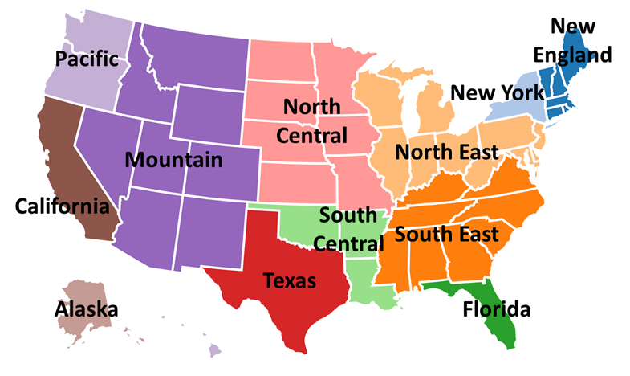
Figure 1: USREP Regions
USREP represents the U.S. by twelve geographic regions, namely Alaska, California, Florida, New York, New England, South East, North East, South Central, North Central, Mountain, Pacific and Texas (see Figure 1) to account for variations in energy consumption and production across the country. The regions correspond roughly to electricity power pool regions in which electricity produced in that region can serve any household or industry in that region. In each region, we model nine households that differ in the income level as well as the composition of income sources from wages income and rents from the ownership of capital and natural resources. Households of different income levels consume different bundles of goods.
The investment sector in USREP is specified based on the IMPLAN dataset to account for investment demand by private and public entities. The investment sector produces an aggregate investment good equal to the level of savings determined by the representative agent’s utility function. The accumulation of capital is calculated as investment net of depreciation according to the standard perpetual inventory assumption. USREP is a recursive-dynamic model, and hence savings and investment decisions are based on current period variables. Capital is assumed fungible across regions and labor is assumed immobile across regions.
To represent historical changes in energy and economic structure, the model is calibrated up to 2015 based on information from Energy Information Administration (EIA)’s Annual Energy Outlooks (AEO). To establish a reference case consistent with official projections, we calibrate the model to match GDP growth through 2050 in EIA’s AEO2018 Reference case (EIA, 2018) by updating regional labor productivity growth rates. Policies affecting the U.S. energy system and end-use energy efficiency, such as the regional RPS for electric power generation and a national CAFE standards (and a separate CAFE standards for California) for vehicle transportation are represented in our reference case to reflect regulations currently on the books.

The Bottom-Up Model
The bottom-up component of the integrated model is a capacity expansion and economic dispatch model intended to capture the long-term adaptation of a system to the penetration of intermittent renewable generation in the U.S. (Tapia-Ahumada et al., 2014, 2015). There are a wide range of electricity sector models with different levels of detail, covering timeframes that range from milliseconds to years or decades. Capacity planning considers investment in power plants with lifetimes of 20 to 30 years or more, and therefore focuses on years to decades (Figure 2). On the other end are concerns about stability of the grid, and network flows at minutes, seconds, and milliseconds.
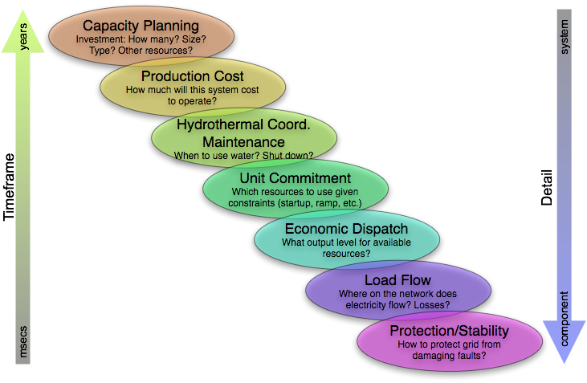
Figure 2. Hierarchical decision-making process in power systems (Palmintier, 2013).
To understand future low carbon pathways within electric systems, it is necessary to look at periods of years to decades, with a major focus on what types of electricity generation will be needed to meet low carbon constraints. Intermittent renewables make these analyses more difficult as the decision to invest in wind, solar, nuclear or gas depends on the differential costs of dealing with the great variability of net demand brought about by the intermittency and variability of renewables.
The electric power system model (EleMod) is formulated at the same regional level as in USREP. Following the approach proposed by Perez-Arriaga and Meseguer (1997), EleMod determines the most cost-effective electric generation expansion and operation subject to technical and policy constraints, such as environmental limitations, short-term operating reserves and long-term adequacy requirements in order to maintain acceptable reliability levels. The model incorporates hourly regional load demands, hourly regional wind and solar profiles estimates, resource estimates for wind and solar taking into consideration geospatial limitations, and several technology categories such utility-scale storage, fossil-fuel based technologies including gas-fired and coal-fired plants, and nuclear plants. In the model, existing regional transmission interties are approximated and electricity trade among regions is possible, except among the Texas, Western, and Eastern interconnects.
The model is formulated as either a Mixed Integer Quadratic Program (MIQP) or a Mixed Integer Linear Program (MILP) problem. In the first case, the formulation maximizes the total social welfare, i.e. the difference of consumers’ benefit and overall costs of producing electricity by power suppliers, subject to system operational, security and policy constraints (Equation 1). This formulation is critical for the evaluation of demand response in the long-term and hence for the integration of USREP and EleMod.
$$Max Welfare=\sum_{r}{\left(p_{r}^{0}∙d_{r}∙\left(1-\frac{\left(d_{r}-2∙d_{r}^{0}\right)}{2∙d_{r}^{0}∙ε_{r}^{0}}\right)-{Cost}_{r}\right)}$$ | (1)
Alternatively, EleMod when formulated as a MILP, minimizes the total cost of producing electricity considering capital invests costs, fixed and variable O&M, and other operational costs such as fuel-related costs, start-up costs and non-serve energy cost (Equation 2).
$$Min Cost=\sum_{r}{\left[\left(C_{r}^{fixCap}+C_{r}^{fixOM}\right)+\left(C_{r}^{varOM}+C_{r}^{varFuel}+C_{r}^{varCO2}\right)+C_{r}^{StUp}+C_{r}^{NSE}\right]}$$ | (2)
Under both formulations, the model is deterministic with a recursive-dynamic structure. Optimal solutions are computed sequentially for every two-year period, adding new capacity as needed to meet growing demand, replace retired units, or meet new policy constraints. It includes three decision timeframes defined as capacity expansion planning, operational commitment planning and operational hourly dispatch decisions.
As Equation 3 show, the model relies on annualized costs of producing electricity in a region $r$, considering annualized investment costs for each conventional fossil-based technologies $n$ ($c_{r, n}^{fixInv})$, wind class $c$ ($c_{r,c}^{fixInv_wind})$ and solar renewables ($c_{r}^{fixInv_solar})$, and pumped hydro storage ($c_{r}^{fixInv_phs})$. Accordingly, main decisions variables include not only operational decisions such as daily connected power and hourly production, but also generation investments to install for fossil fuel technologies ${(K}_{r,n})$, wind and solar $(K_{r,c}^{wind}, K_{r}^{solar})$ and pumped hydro storage ($K_{r}^{phs})$.
$$C_{r}^{fixCap}=\sum_{n}{K_{r,n}∙c_{r, n}^{fixInv}}+\sum_{c}{K_{r,c}^{wind}∙c_{r,c}^{fixInv_{wind}}}$$  $$+ K_{r}^{solar}∙c_{r}^{fixInv_{solar}}+K_{r}^{phs}∙c_{r}^{fixInv_phs} ∀r$$ | (3)
In the particular case of renewables, their hourly profile estimates are incorporated based on historical and/or numerical weather prediction models time series. Wind hourly profiles are taken from National Renewable Energy Laboratory (NREL) data and aggregated at the regional level of the model. These are far less variable than a single site as they integrate over fairly large regions. However, there are still large swings in wind resource availability hour-by-hour, from near full capacity to little or no availability, and also monthly and seasonal variations among regions. Solar hourly profiles are simulated using NREL’s System Advisor Model model at state level, for various latitude locations and then aggregated at regional level. In general, solar profiles show the strong diurnal pattern of availability with no resource during night time, and higher availability in summer months than in winter, with some day-to-day variation reflecting cloudiness and regional time zone differences. Both wind and solar generation can be curtailed depending on technical constraints and system’s oversupply conditions.
For hydro generation, the model currently does not endogenously optimize existing hydro power dispatch. We represent variation in their profiles at regional scale to approximate the electricity production coming from non-intermittent renewable resources. Based on historical records using USGS data (UCS, 2012) as described in Boehlert et al. (2016), we established wet, medium, and dry annual hydro supply conditions and for this paper we simulate a medium scenario.
Fossil fuel-based generation options include 12 conventional technologies. Their representation requires simplified cost and performance characteristics, minimum loading requirement, availability factors, forced outage rates, and heat rates for thermal plants. As noted earlier, costs include fixed and variable O&M, capital, start-up, and fuel. There is also a capacity reserve requirement to ensure long-term reliability of the system to unexpected peaks in demand, assumed to be between 10 and 18% depending on the region. Existing installed capacity per technology is represented in the base year 2016 as the total capacity for each technology in each region based on EIA/AEO reports. We have generally assumed that technology costs, in the reference case, are those used by the EIA/AEO (2017), except for wind and solar where we have assumed costs continue to decline for both at 3% per year.
Finally, we assume a prescribed annual demand path for electricity and fuel prices projections based on the EIA/AEO (2018). The most relevant ones being gas, coal, and nuclear fuel costs which rise slowly over time. See Appendixes A and B for details about technology costs, operational parameters, demand and fuel prices.

The TD-BU Integration
The solution method to couple both models is based on the decomposition algorithm proposed by Böhringer and Rutherford (2009). Iterations between the USREP and EleMod involve passing back and forth electricity supply and fuel demand and prices information until both models converge. Figure 3 illustrates the iterative process and the information that each model needs to exchange in order to reach general equilibrium conditions.
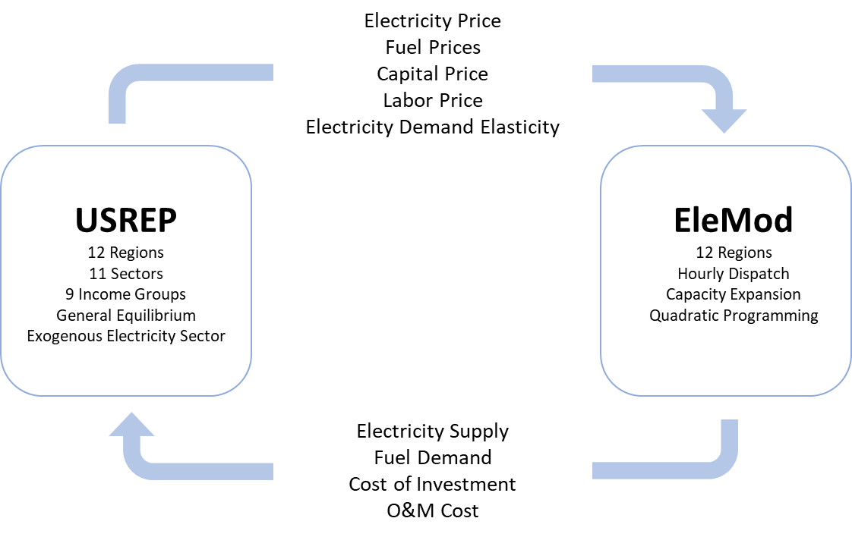
Figure 3: Coupling the TD and BU models – Information exchange
For each year in the reference case, we feed the regional electricity supply and fuel prices based on EIA/AEO projection to EleMod which in turn determines generation by technology type, generation input demand (fuel demand, capacity investment, O&M costs) and electricity supply price comprised of generation cost, RPS compliance cost, cost of operating reserve and marginal reserve requirement. EleMod passes electricity supply, generation input demand and electricity supply price to USREP in which the CES production function of electricity generation is replaced with an exogenous electricity supply. We calibrate USREP to the electricity supply, electricity input demand as well as electricity supply price. We impose a zero-profit condition for the electricity sector by allocating the electricity sector profit/loss to household. In such a sequence, we run the models in a two-year step to 2050 and achieve consistency between the models in electricity supply, generation input demand and electricity supply price.
In the counterfactual scenario, the TD-BU model runs iteratively as illustrated in Figure 3. To a new policy regime, EleMod responds with changes in electricity supply, generation input demand and electricity supply price as a result of maximizing the total surplus of generation characterized by reference electricity supply, price, and demand elasticity. We pass the updated electricity supply and generation input demand to USREP which produces a general equilibrium response in prices to both the change in policy regime and the changes in electricity supply and generation input demand. We then pass the changes in prices of electricity demand, fuel supply, capital and labor supply to EleMod and update the reference electricity price, fuel prices, fixed O&M cost and variable O&M cost, respectively. In addition, we update the reference electricity supply in the quadratic objective function to be consistent with the reference electricity price. To speed up the convergence, we derive the electricity demand elasticity in USREP and update the elasticity parameter in the quadratic objective function in EleMod. The iteration between the TD and BU model continues until both models agree on electricity price. That is, the electricity supply price generated by EleMod and the electricity demand price generated by USREP converge.
Iteration between the models is important because demand for resources – fuels, capital, labor, and materials – in the BU model must be communicated in a consistent way to the macro model so as to recognize the limited supply of those resources in each time period. Likewise, the changes in prices must be communicated back to the BU model in a manner that is consistent with the variables incorporated in the BU model. Given the different temporal resolution and databases of the two models, this is a nontrivial task.

Scenarios
We proposed in this paper to discuss results for a reference scenario with existing policy and for three scenarios that represent different RPS requirements.
- (REF) USREP generates its own reference projection based on its resource supply and demand characterizations, and EleMod is calibrated to the EIA/AEO reference case. Our baseline includes existing RPS policies that is consistent with AEO assumption in their reference projection
- (RPS20a) One scenario that raises all regional RPS requirements by 20 percentage points by 2050 with linear interpolation of the RPS requirements from 2020 to 2050
- (RPS40a) One scenario that raises all regional RPS requirements by 40 percentage points by 2050 with linear interpolation of the RPS requirements from 2020 to 2050
- (RPS50a) One scenario that raises all regional RPS requirements by 50 percentage points by 2050 with linear interpolation of the RPS requirements from 2020 to 2050
These scenarios will enable us to trace out a marginal cost curve for RPS by interpolating between the scenarios results. This marginal cost curve will be different for each region and hour represented in the modeling system. We will develop graphic tools to compare these results across scenarios to address the following types of questions: Is the marginal cost curve different between regions? What can we say in general about hourly prices from EleMod? Does RPS increase or decrease peak vs average prices?

Results
Figure 4 provides total installed capacity (GW) by technology for the US in the Ref, RPS20, RPS40 and RPS50 cases for the 2020-2050 timeframe. We observe that higher RPS requirements promote the expansion of mostly wind and solar. Although storage (represented by pumped hydro, PHS) is a technology that we did not include as a RPS eligible resource, we note that PHS also increases with more stringent goals. The incorporation of more intermittent and variable resources like wind and solar into the electric power system requires also the incorporation of flexibly technologies, like storage, that can enable a smoother hour-by-hour operation in terms of ramping capabilities and operational reserves, both essential to cope with highly variable net demands. Also, the share of capacity of wind and solar combined is higher relative to RPS requirement (in terms of generation) because their capacity factors are normally below 40%, which lowers even more when considering curtailments in the system. We also note that nuclear and coal technologies are phased out over time, and gas and oil-based technologies keep an important share as they are still required by the system for supplying electricity and for short-term operational reserves and regional long-term reliability requirements.
Figure 4: Cumulative Installed Capacity [GW] for the US per Technology for Ref, RPS20, RPS40 and RPS50 cases
Figure 5 provides annual generation (GWh.yr) by technology for the US in the Ref, RPS20, RPS40 and RPS50 cases for the analyzed time horizon. Aggregated RPS share by 2050 is approximately 30%, 40%, 50%, 60% for each case respectively, and levels of curtailments of wind and solar represent more than 10% (up to 18%) of the electricity produced by 2050. Nuclear and coal electricity production decreases over time, while oil-based technologies are used mostly during peaking hours with a very low capacity factor, below 8% considering all scenarios. Gas technologies still play a key role, although in scenarios with high RPS requirements their generation share decreases over time from 30% in 2020 to less than 25% by 2050, and capacity factors close at or less than 40%.
Figure 5: Evolution path of the generation mix [GWh.yr] for the US per Technology for Ref, RPS20, RPS40 and RPS50 cases
Our integrated model has the capability to simulate regional results. Although we modeled 12 regions, Figure 6 and Figure 7 show the evolution overtime of the generation mix for only New England (NENGL) and California (CA) in order to highlight the impacts of RPS policies on regions with diverse resources. CA has more solar resources than NENGL which in addition to wind maxing out its resource limit by 2030, solar becomes heavily used to reach RPS goals (60%, 80%, 100%, 100% for each case by 2050 as shown in Appendix C. We note similar trend in NENGL where solar dramatically increases after year 2040 when wind reaches it maximum potential. In addition, nuclear and coal generation are almost completely phased out by the end of the time period. In both regions, we observe both gas technologies and inter-regional power trading to play a significant role in the integration of intermittent renewables. This would suggest that much of the electricity generated by gas technologies is either being used for trading to neighboring regions and used to charge storage systems that could be later used to match imbalances between demand and wind and solar.
Figure 6: Generation [GWh.yr] for New England per Technology for Ref, RPS20, RPS40 and RPS50 cases
Figure 7: Generation [GWh.yr] for California per Technology for Ref, RPS20, RPS40 and RPS50 cases
Figure 7 also illustrates the potentially perverse results of requiring that extremely high percentages of electricity demand be satisfied from intermittent sources. In both New England and California, when annual RPS goals are set at 90% and 100%, natural gas continues to be used as a generation fuel. Likewise, conventional hydro and nuclear generation that does not count toward the RPS goal continues. In both regions, with 100% RPS goals, natural gas and the other nonqualifying still constitute about 20% of generation by 2048.
The reason for this anomaly is that in some hours, the stochastic nature of wind and solar availability means that there will not be enough generation from these sources to meet demand. Natural gas is burned in the backup combined cycle generating capacity to fill the gap. Pump hydro storage is also utilized, but it is not a resource that can be ramped up to meet high frequency variations in renewable supply.
A typical hour in which demand exceeds solar and wind capacity, requiring use of natural gas, is shown in Figure 8, i.e., the hour 4400, 4420, 4440, 4520, 4540, etc.
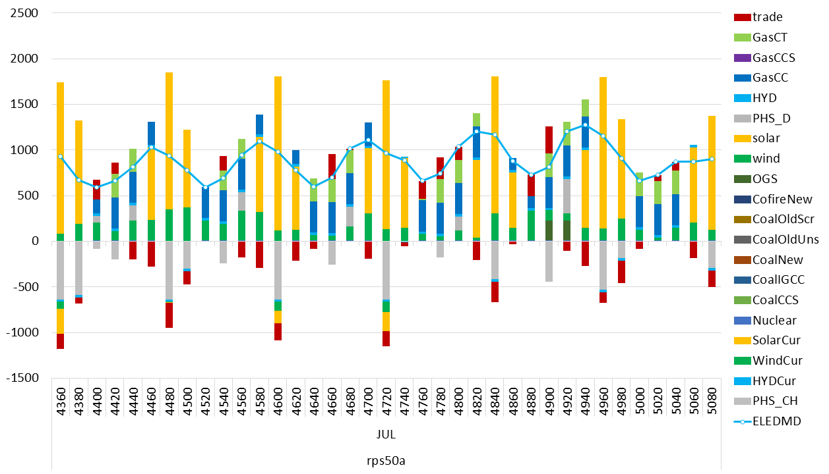
Figure 8: Hourly Electricity Generation vs. Electricity Demand and Electricity Trade in CA (July 2050) under the RPS50a scenario [GWh.hour]
Both regions reach their limits on wind generation well before 2048, so that incremental renewable capacity must be solar. The USREP model finds a less costly means of meeting a 100% RPS goal than building additional solar and storage capacity to meet demand in all hours with renewables. Just as there are some hours when solar and wind generation reach their maximum before all demand is satisfied, there are other hours when solar and wind generation exceeds total demand. By using the excess to charge pump storage, the excess wind and solar generation is disposed of without harm to the system and counts toward the RPS goal.
A typical hour in which wind and solar exceed demand, leading to zero generation from natural gas and an increase in pump storage equal to excess supply, is shown in Figure 8 as well. There are a handful of hours that can demonstrate the case. For example, in hour 4360, part of the excess supply of solar and wind generation is used to charge pump hydro storage and the rest is exported.

This can be seen in the otherwise inexplicable increase in charging of pump storage from 2032 – 2048 as the RPS goal ramps up to 100%. Thus we see that in 2048, total wind and solar generation exactly equals demand in both regions. Both must burn some natural gas in some hours to meet demand, which without the opportunity to “store” renewable generation permanently in pump storage would make it impossible for wind and solar to satisfy 100% of demand. The increase in pump storage is just enough to “ground out” the excess generation of wind and solar, thus allowing the meters at the generating units to report enough generation to meet the 100% goal.
The RPS scenarios being covered for this paper have considered only wind and solar as technologies being eligible resources, and we have not made technology specific differentiations at regional level. Also, we have not specified storage to be co-located with a particular technology nor specific technology to be used for power trading, so this might be the reason why we observe gas to still have a relevant portion of the final generation mix.
Figure 9 depicts the annual average marginal price for generation ($/MWh) for New England and California for the Ref case and all scenario cases. Wholesale prices in our BU model are determined on an hourly basis, and then aggregated to the annual average weighted by electricity load in the region. We observe that CA has in general higher prices that NENGL as demand levels are higher (especially during summer) and existing capacity limits on transmission reduce trade from regions with lower prices. The general trend in all policy cases shows a decline of the average marginal prices mostly because of the enforcement of wind and solar resources, with zero or negligent variable costs. The tighter the RPS policy, the higher the price decline. The price drop indicates that there is increasing number of hours during the year with zero (or negative) marginal prices, due to curtailments or periods with generation technologies at their minimum technical load -- hence not being able to accommodate wind or solar production.
Figure 9: Annual Average Marginal Costs for Generation [$/MWh] for California and New England
Figure 10 compares the annual average marginal costs associated to the various RPS targets for New England and California. For both regions we observe that costs increase as the RPS target gets more stringent, and NENGL has a lower RPS compliance cost compared to that in CA for the Ref case and for those years before the RPS target reaches 60% of its electricity demand. As NENGL needs to rely more in solar generation (wind has maxed out his resource potential), results would suggest that this technology would make the system to incur in additional costs because of its low capacity factor and lower correlation with demand in the region.
Figure 10: Annual Average Marginal Costs associated to RPS goals [$/MWh] for Ref, RPS20, RPS40 and RPS50 cases for California and New England
As stronger RPS targets drive up the wholesale electricity prices, the delivered electricity prices increase as well for most regions (see Table 1). Price impacts are relative larger in the regions with ambitious existing RPS targets, i.e. CA, NY, NENGL.
Table 1: Delivered Electricity Price to the Service Sector (percent change from the reference level)
 | rps20a |  |  |  | rps40a |  |  |  | rps50a
 | 2030 | 2040 | 2050 |  | 2030 | 2040 | 2050 |  | 2030 | 2040 | 2050
AK | 0.1 | -0.9 | -0.9 |  | 0.5 | -1.7 | -1.1 |  | 0.8 | -1.8 | -1.1
CA | 3.4 | 8.0 | 11.7 |  | 7.4 | 17.4 | 26.2 |  | 7.5 | 17.4 | 26.5
FL | 3.5 | 3.1 | 1.2 |  | 7.2 | 9.5 | 13.7 |  | 9.3 | 15.2 | 35.1
NY | 5.6 | 14.9 | 15.4 |  | 13.7 | 29.5 | 32.9 |  | 17.0 | 36.5 | 41.2
TX | 2.3 | 0.6 | -0.2 |  | 4.6 | 3.0 | 0.2 |  | 5.7 | 4.6 | 2.1
NENGL | 2.8 | 14.9 | 19.5 |  | 5.7 | 32.5 | 44.2 |  | 7.5 | 42.0 | 56.2
SEAST | 4.1 | 5.5 | 3.5 |  | 9.0 | 13.2 | 12.9 |  | 11.7 | 18.1 | 25.3
NEAST | 0.9 | -0.3 | 5.0 |  | 1.7 | 2.1 | 7.2 |  | 1.3 | 3.9 | 10.3
SCENT | 0.7 | 1.2 | 1.7 |  | 1.5 | 2.3 | 1.0 |  | 3.9 | 2.1 | 2.3
NCENT | 0.5 | 4.1 | 2.0 |  | 1.4 | 4.4 | 2.4 |  | 0.7 | 5.1 | 2.6
MOUNT | 0.5 | -1.3 | -1.0 |  | 0.6 | -1.4 | -1.5 |  | 1.0 | 0.5 | -0.1
PACIF | 3.0 | 5.4 | 4.5 |  | 6.1 | 11.6 | 10.2 |  | 8.3 | 15.6 | 15.0

Higher RPS targets induce adjustment in generation portfolio to displace fossil-fired generation with renewable generation. Generation gas demand drops substantially compared to the change in demand for coal and oil (see Figure 11), implying that coal and oil technology fare better by gaining a comparative advantage over gas generation when the RPS compliance raises the marginal electricity price.
Figure 11 shows the changes of fuel demand by the electricity and non-electricity sector. Tighter RPS targets lead to reductions in fuel demand by electricity generation that leads to lower fuel prices which in turn generate a rebound effect in demand by the non-electricity sector which partially offsets the reduction in generation fuel demand. Another offsetting increase in fuel demand is driven by the relative price change between electricity and fuels, providing an incentive to substitute more costly electricity with cheaper fossil fuels. The rebound and substitution effect both partially offset the reduction in generation fuel demand and fuel prices, ending up with a price reduction of 5% and 4.5% by 2050 for natural gas and coal, respectively, in the rps50 case relative to the reference level (see Figure 12).
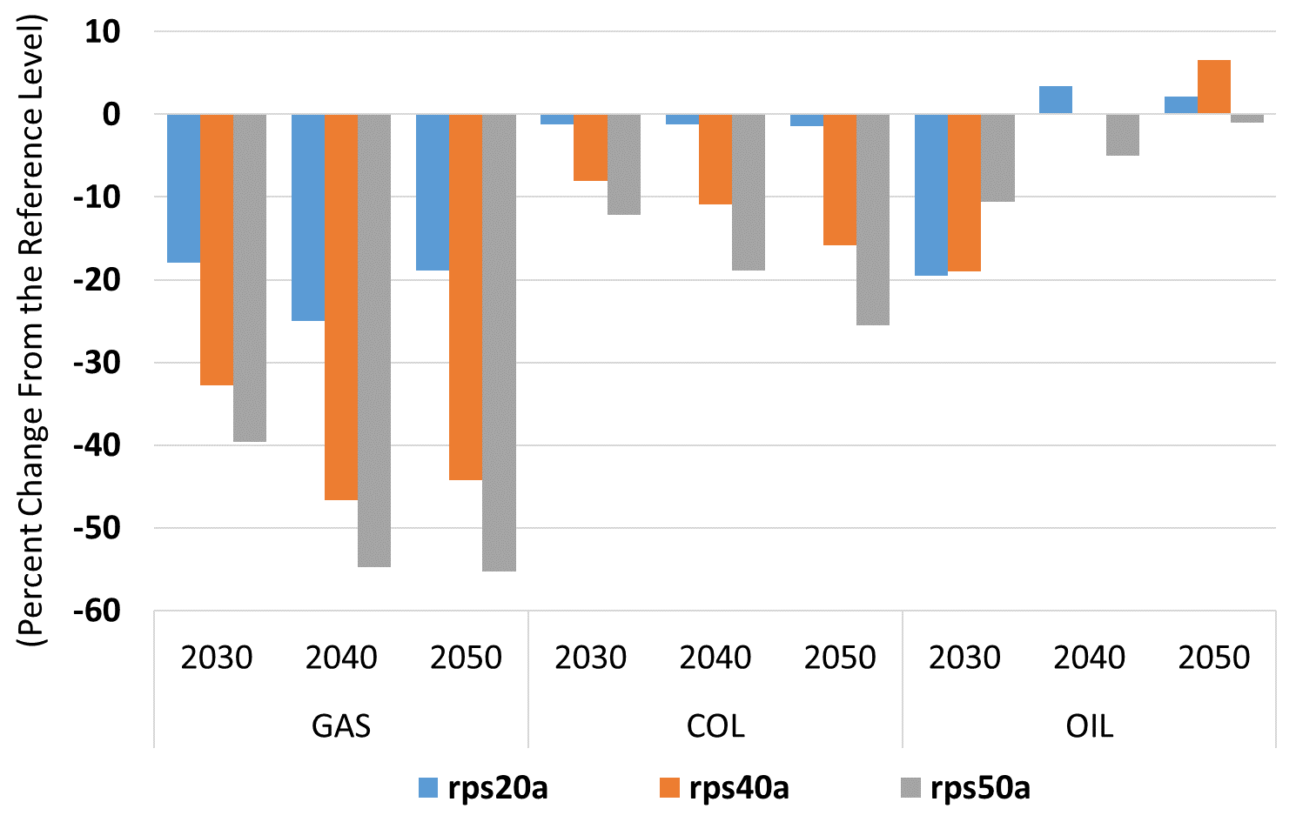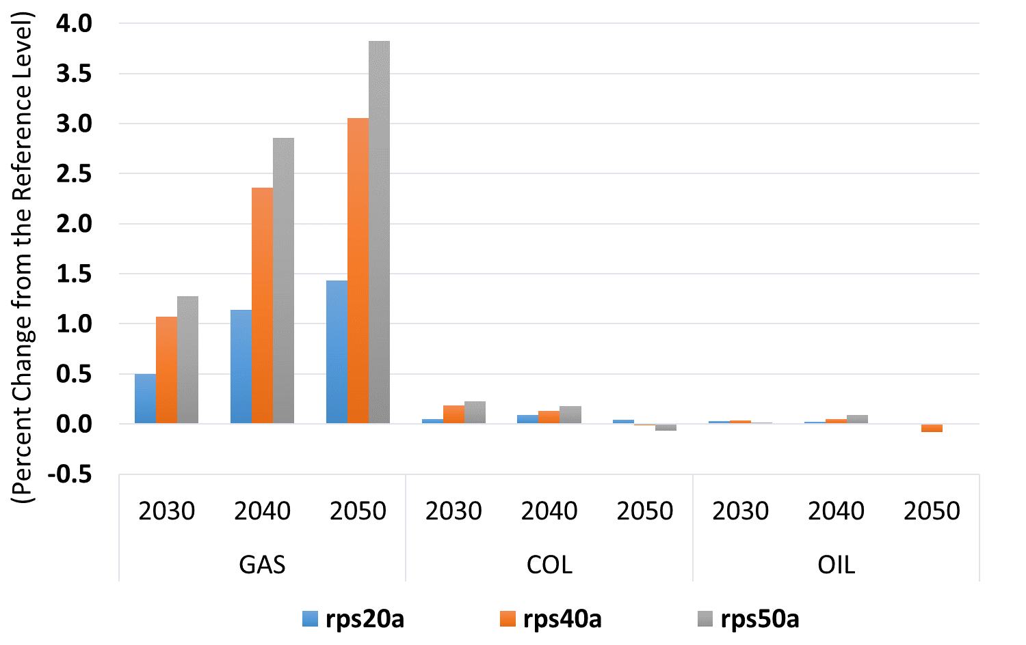
- Electricity Sector Fuel Demand | (b) Non-Electricity Sector Fuel Demand
Figure 11: Fuel Demand (percent change from the reference level)

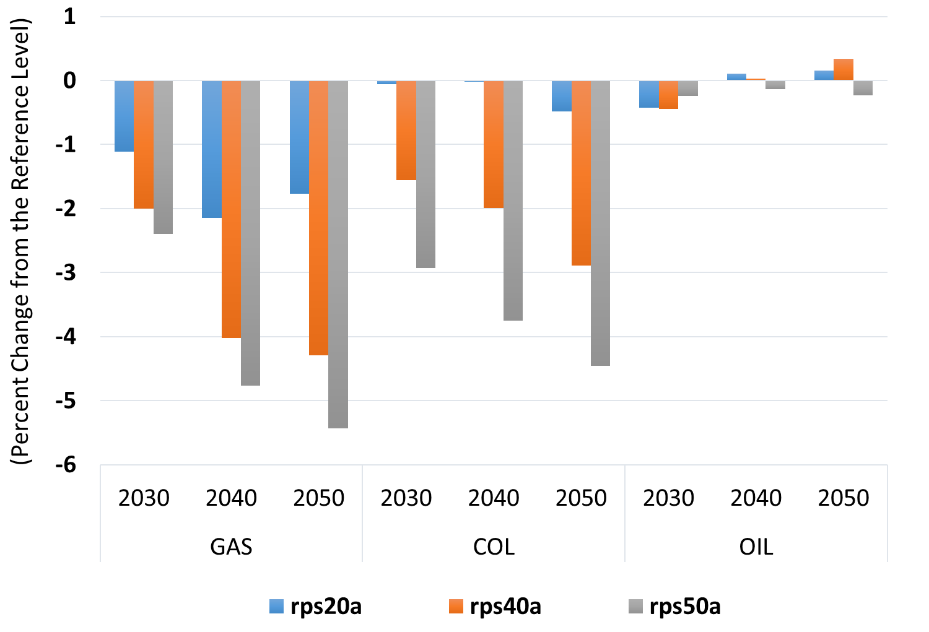
Figure 12: Fuel Producer Prices (percent change from the reference level)
Consistent with the changes in fuel demand, the electricity sector emissions decrease whereas the non-electricity sector emissions increase. Figure 12 shows the changes in carbon emissions by the electricity and non-electricity sector. In the rps20 case, the increase in RPS targets by 2040 leads to a further reduction of carbon emissions relative to the reference level by about 200 million metric ton of carbon dioxide (MMTCO₂) in the electricity sector and an offsetting increase in the non-electricity sector emissions by about 15 MMTCO₂. Despite the partial offset from the non-electricity sector, the overall emissions decrease by 2-7% in the short run and 3-11% in the long run in the cases we analyzed.
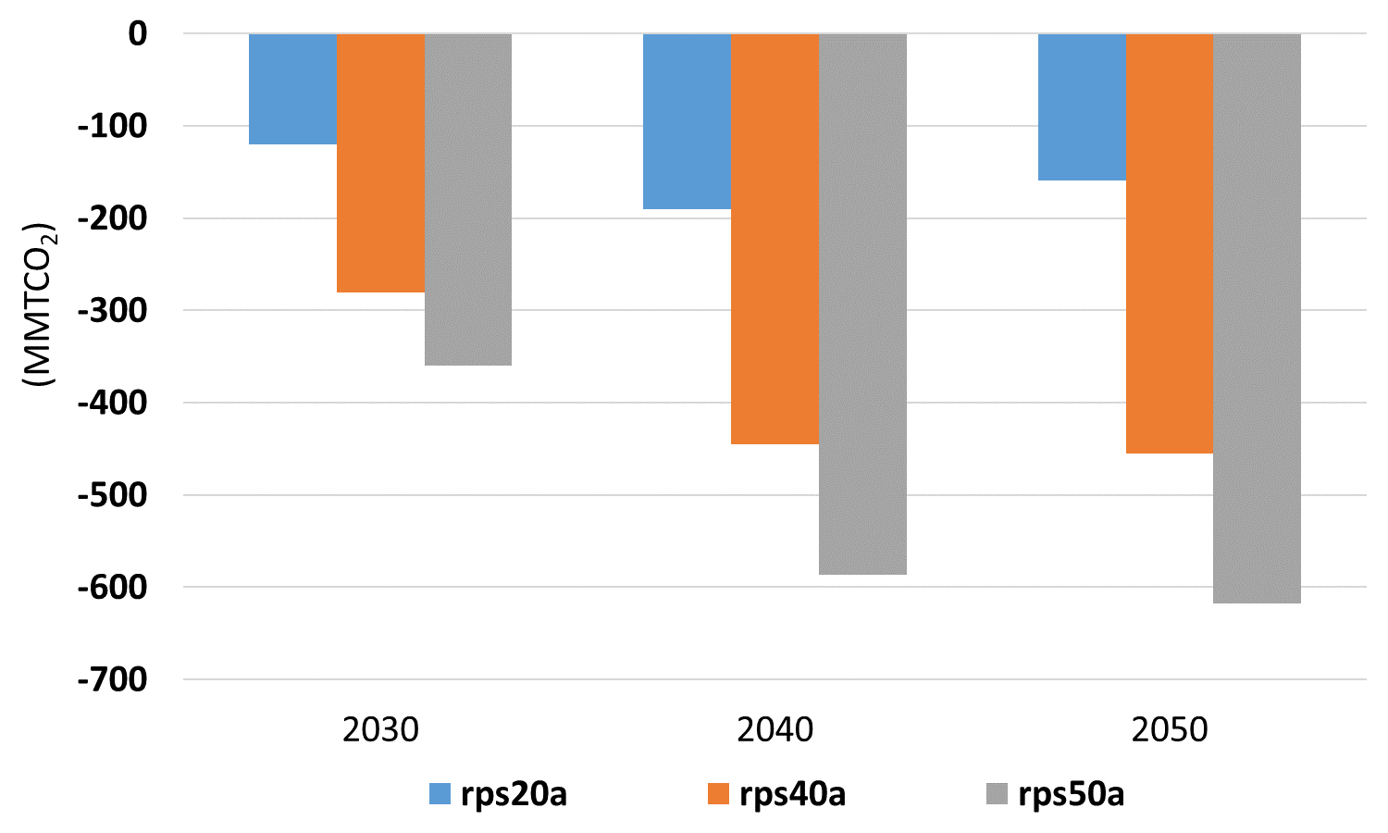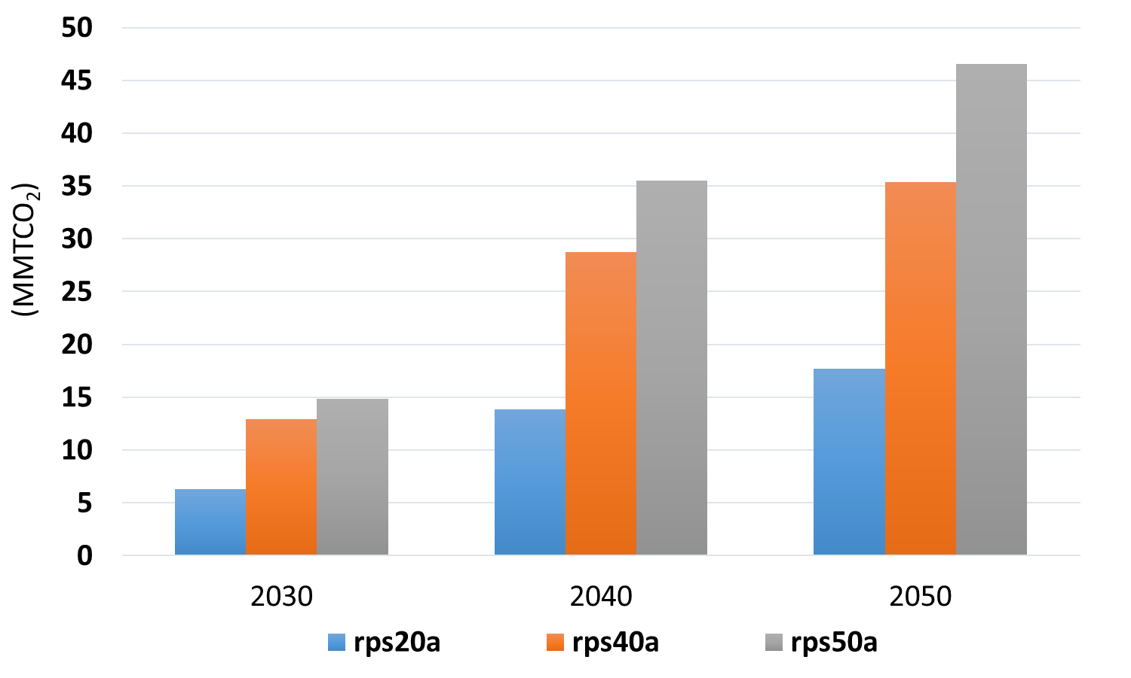
- Electricity Sector Emissions | (b) Non-Electricity Sector Emissions
Figure 13: Carbon Emissions (change from the reference level - MMTCO₂)
Tighter RPS brings about two issues: (1) the intermittency of renewable power supply that challenges grid stability; and (2) the power curtailment driven by the temporal and spatial mismatch of the renewable power supply and the power demand. Grid stability requires stable power supply with complementary technologies that can ramp up and supply when wind does not blow and sun is shadowed. The cost of installing, operating and maintaining the complementary technologies is part of the power system cost and does not decline as fast as the renewable capacity increases. Gas-fired generation unit is a best candidate complementary technology because it can ramp up fast. However, the results show that gas-fired generation declines much faster than coal-fired generation, consistent with the changes in electricity fuel demand. Moreover, we found in the results that the curtailment becomes a more pronounced issue when renewable capacity expands and supplies more than 30% of electricity, implying an efficiency loss in capacity investment in renewable generation technologies.
The resulted changes from the model lead us to question the effectiveness of renewable capacity expansion for emissions reduction. We derive the marginal investment cost per ton of carbon emission reduction by calculating a ratio of change in total investment in the electricity sector that must be devoted to capacity expansion due to increasing renewable generation relative to the reference level to the change in emissions reductions relative to the reference level (see Figure 14). We focus on the regions with ambitious existing RPS targets with an anticipation that tighter renewable requirements in these regions may lead to efficiency loss in reducing emissions. Both the New England and NY region show higher cost with tighter RPS targets whereas CA exhibits lower cost with tighter RPS targets that calls for further investigation.

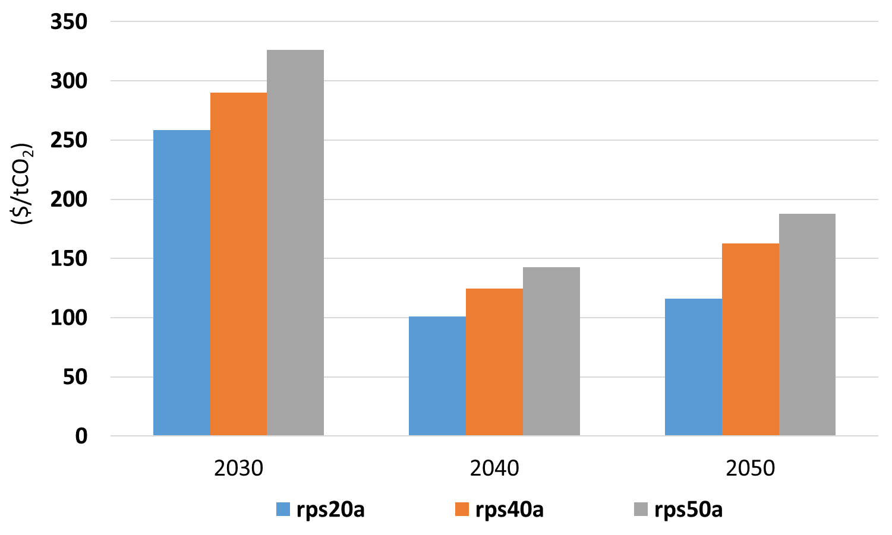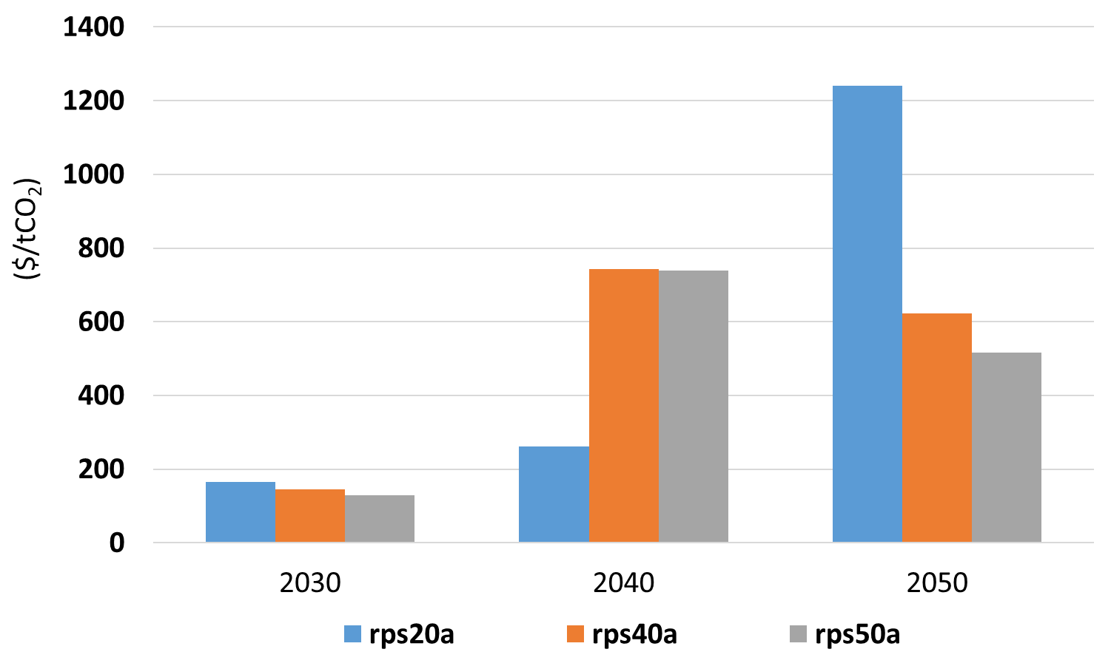
- New England (NENGL) | - California (CA)
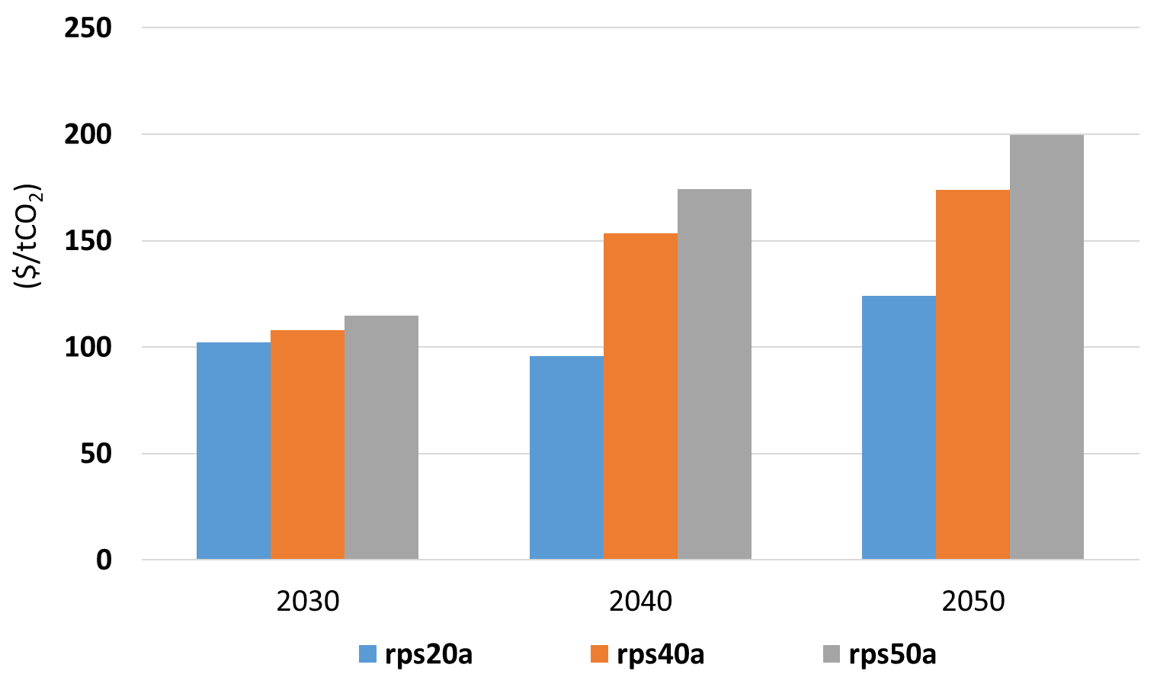
- New York (NY)
Figure 14: Marginal Investment Cost of Carbon Emissions Reduction in the Electricity Sector ($/tCO₂)
The proposed research will serve to inform of potential opportunities for enhancing integration across the U.S. while deploying energy and climate policies at the regional level. We compare our estimates of the marginal cost of carbon reduction and electricity generation under different levels of the RPS to those of other studies that have a less detailed representation of the intermittency and hourly availability of generating resources relative to demand. Currently we adopt a demand profile with a fixed pattern where all hourly demand scales up or down based on the change in overall demand. Investigating at the time profile of generation cost will help us extend to adopt a build-in demand elasticity that accounts for hourly demand response.

Reference
Böhringer, B. and T. F. Rutherford, 2009. “Integrated assessment of energy policies: Decomposing top-down and bottom-up,” Journal of Economic Dynamic Control, vol. 33, no. 9, pp. 1648–1661.
EIA-SEDS [Energy Information Administration – State Energy Data System], 2009. State Energy Data System. Energy Information Administration, Washington, DC.
EIA [Energy Information Administration], 2018. Annual Energy Outlook 2018. Energy Information Administration, Washington, DC. (https://www.eia.gov/outlooks/archive/aeo18/tables_ref.php).
IMPLAN, 2008. State-Level U.S. Data for 2006. MIG Inc., Huntersville, NC. (http://support.implan.com).
Palmintier, Bryan S., 2013. “Incorporating Operational Flexibility into Electric Generation Planning: Impacts and Methods for System Design and Policy Analysis,” Thesis (Ph.D.), Massachusetts Institute of Technology, Engineering Systems Division.
Perez-Arriaga, I. and C. Meseguer, 1997. “Wholesale marginal prices in competitive generation markets,” IEEE Trans. Power Syst., vol. 12, no. 2, pp. 710–717.
Rausch, S., G. E. Metcalf, J. M. Reilly, and S. Paltsev, 2010. “Distributional Implications of Alternative U.S. Greenhouse Gas Control Measures,” B. E. J. Economic Analysis Policy, vol. 10, no. 2.
Rausch, S., G. E. Metcalf, and J. M. Reilly, 2011. “Distributional impacts of carbon pricing: A general equilibrium approach with micro-data for households,” Energy Economics, vol. 33, no. SUPPL. 1, pp. S20–S33.
Rausch, S. and M. Mowers, 2014. “Distributional and efficiency impacts of clean and renewable energy standards for electricity,” Resource Energy Economics, vol. 36, no. 2, pp. 556–585.
Tapia-Ahumada, K., C. Octaviano, S. Rausch, and I. Pérez-Arriaga, 2015. “Modeling intermittent renewable electricity technologies in general equilibrium models,” Economic Modeling, vol. 51, pp. 242–262.
UCS (Union of Concerned Scientists), 2012. The UCS EW3 Energy Water Database. (https://www.ucsusa.org/sites/default/files/attach/2016/03/UCS-EW3-Energy-Water-Database.xlsx)
Yuan, M., G.E. Metcalf, J. Reilly and S. Paltsev, 2017. “The Revenue Implications of a Carbon Tax,” Joint Program Report Series Report 316.

Appendix A: Technology Costs and Operational Performance Parameters

Table A1: Conventional Generation Technologies: Operational Parameters and Performance
Sources: Data mostly based on reports from EIA AEO, NREL’s ReEDS, and 2016 ATB reports.

Table A2: Technology Costs (2017$)
Sources: EIA AEO 2017, NREL ATB 2016, NREL reports.

Appendix B: Annual Demand and Fuel Prices

Table B1: Demand and Fuel Costs (2017$) Projections
Source: EIA AEO 2017 report.

Appendix C: RPS Levels versus Electricity Demand for New England and California

Figure C1: RPS Levels versus Electricity Demand [GWh.yr] for New England for Ref, RPS20, RPS40 and RPS50 cases

Figure C2: RPS Levels versus Electricity Demand [GWh.yr] for California for Ref, RPS20, RPS40 and RPS50 cases

Corresponding authors: yuanmei@mit.edu, katapia@mit.edu
Lacking information on ownership of the electricity sector, we allocate electricity profit/loss to households in proportion to capital income.
Rather than running iterations between USREP and EleMod in the reference scenario, we simplify the model linking process by calibrating USREP to EleMod without sending feedback in prices of fuel supply, capital and labor supply back to EleMod.
Since fuel prices are not calibrated in the reference case, we pass the percent change of fuel supply prices relative to the reference case from USREP to EleMod. Despite an omission in fuel prices convergence, this approach maintains consistency in fuel price response to generation fuel demand changes.
Our datasets include only onshore wind and utility scale PV, which depending on the quality of the regional resource, their capacity factors are in average 31% for wind and 18% for solar.
Trade levels can be observed in the figures as the difference between black dashed (ELE) lines and technology stacked bars.

